|  |
| --- |
| Experiment No. 13 |
| Program to demonstrate CRUD (create, read, update and delete) operations on database (SQLite/ MySQL) using python |
| Date of Performance: 12/04/2024 |
| Date of Submission: 19/04/2024 |

**Experiment No. 13**

**Title:** Program to demonstrate CRUD (create, read, update and delete) operations on database (SQLite/ MySQL) using python

**Aim:** To study and implement CRUD (create, read, update and delete) operations on database (SQLite/ MySQL) using python

**Objective:** To introduce database connectivity with python

**Theory:**

In general CRUD means performing Create, Retrieve, Update and Delete operations on a table in a database. Let’s discuss what actually CRUD means,

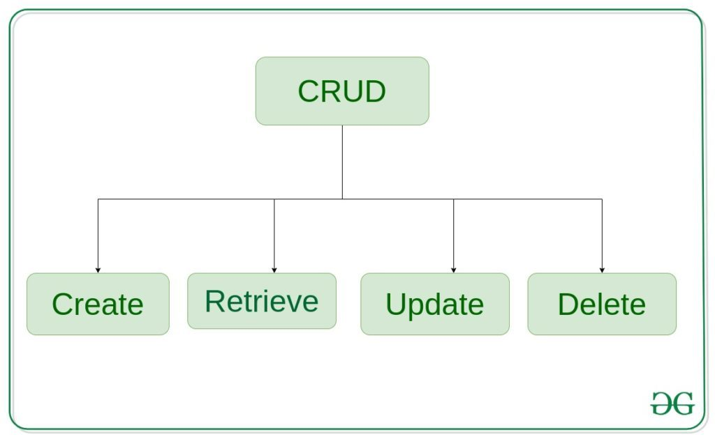

**Create** – create or add new entries in a table in the database.   
**Retrieve** – read, retrieve, search, or view existing entries as a list(List View) or retrieve a particular entry in detail (Detail View)   
**Update** – update or edit existing entries in a table in the database   
**Delete** – delete, deactivate, or remove existing entries in a table in the database

**Program:**

import mysql.connector

# Function to create a new record

def create_record(conn, values):

cursor = conn.cursor()

cursor.execute('''INSERT INTO records (name, age) VALUES (%s, %s)''', values)

conn.commit()

print("Record created successfully")

# Function to read all records

def read_records(conn):

cursor = conn.cursor()

cursor.execute('''SELECT * FROM records''')

rows = cursor.fetchall()

print("ID\tName\tAge")

for row in rows:

print("{}\t{}\t{}".format(row[0], row[1], row[2]))

# Function to update a record

def update_record(conn, record_id, values):

cursor = conn.cursor()

cursor.execute('''UPDATE records SET name=%s, age=%s WHERE id=%s''', (*values, record_id))

conn.commit()

print("Record updated successfully")

# Function to delete a record

def delete_record(conn, record_id):

cursor = conn.cursor()

cursor.execute('''DELETE FROM records WHERE id=%s''', (record_id,))

conn.commit()

print("Record deleted successfully")

# Main function

def main():

conn = mysql.connector.connect(

host="localhost",

user="root",

password="om@21",

database="exp_13"

)

cursor = conn.cursor()

# Create table if not exists

cursor.execute('''CREATE TABLE IF NOT EXISTS records

(id INT AUTO_INCREMENT PRIMARY KEY, name VARCHAR(255), age INT)''')

while True:

print("\n1. Create Record\n2. Read Records\n3. Update Record\n4. Delete Record\n5. Exit")

choice = input("Enter your choice: ")

if choice == '1':

name = input("Enter name: ")

age = int(input("Enter age: "))

create_record(conn, (name, age))

elif choice == '2':

read_records(conn)

elif choice == '3':

record_id = int(input("Enter record ID to update: "))

name = input("Enter new name: ")

age = int(input("Enter new age: "))

update_record(conn, record_id, (name, age))

elif choice == '4':

record_id = int(input("Enter record ID to delete: "))

delete_record(conn, record_id)

elif choice == '5':

break

else:

print("Invalid choice")

conn.close()

if __name__ == "__main__":

main()

**Output:**

1. Create Record

2. Read Records

3. Update Record

4. Delete Record

5. Exit

Enter your choice: 1

Enter name: try_1

Enter age: 19

Record created successfully

1. Create Record

2. Read Records

3. Update Record

4. Delete Record

5. Exit

Enter your choice: 1

Enter name: try_2

Enter age: 20

Record created successfully

1. Create Record

2. Read Records

3. Update Record

4. Delete Record

5. Exit

Enter your choice: 2

ID Name Age

1 try_1 19

2 try_2 20

1. Create Record

2. Read Records

3. Update Record

4. Delete Record

5. Exit

Enter your choice: 3

Enter record ID to update: 1

Enter new name: update_1

Enter new age: 25

Record updated successfully

1. Create Record

2. Read Records

3. Update Record

4. Delete Record

5. Exit

Enter your choice: 2

ID Name Age

1 update_1 25

2 try_2 20

1. Create Record

2. Read Records

3. Update Record

4. Delete Record

5. Exit

Enter your choice: 4

Enter record ID to delete: 1

Record deleted successfully

1. Create Record

2. Read Records

3. Update Record

4. Delete Record

5. Exit

Enter your choice: 2

ID Name Age

2 try_2 20

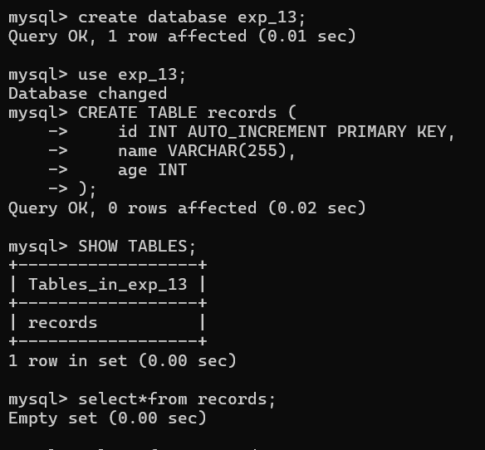

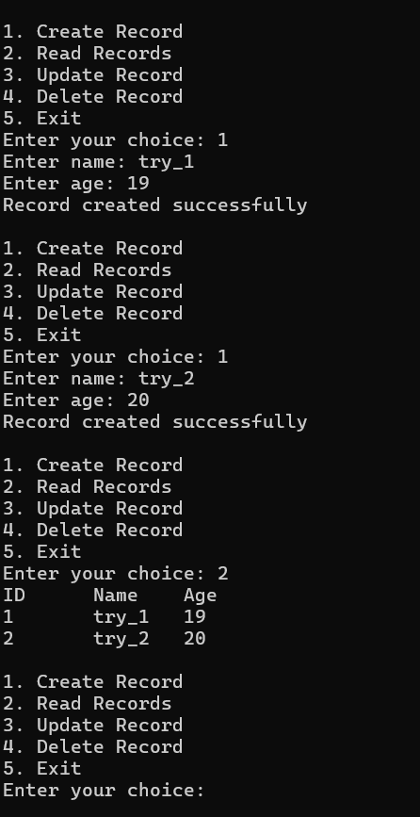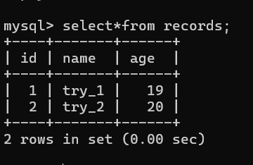

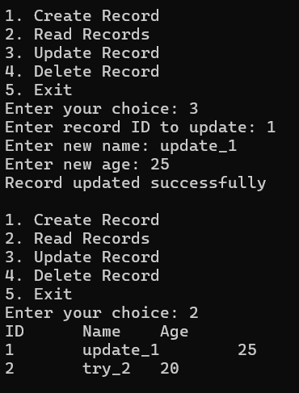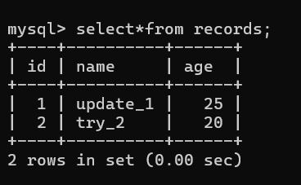

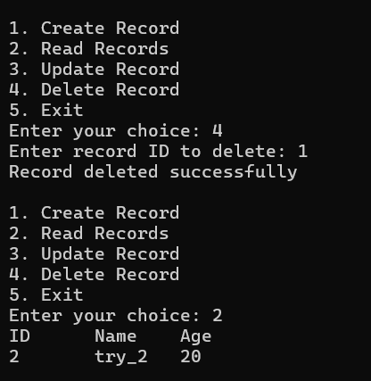

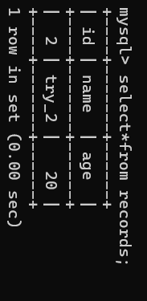

**Conclusion:**

The Python program effectively demonstrates CRUD operations on a MySQL database, showcasing the creation, reading, updating, and deletion of records. Through user-friendly prompts, it illustrates seamless interaction with the database, allowing users to manipulate data efficiently. This implementation underscores the practicality and versatility of Python in database management tasks, facilitating an understanding of fundamental CRUD principles. Overall, the program serves as a concise yet comprehensive introduction to database connectivity and manipulation using Python.