A CASE-STUDY BASED REPORT
ON
BANKRUPTCY PREDICTION USING DECISION TREES AND RANDOM FOREST
WITH PRECISION-RECALL ANALYSIS
submitted in partial fulfilment of the requirements for the Course
MACHINE LEARNING
BACHELOR OF TECHNOLOGY
in
A.Y.: 2026-27
by
S. Svara Haasini Roll No. 2520090170
Bujangari Snigdha Roll No. 2520090160
Under the Esteemed guidance of
Dr. Y. Lakshmi Prasanna
Assistant Professor, Department of CSIT
DEPARTMENT OF CSIT



INDEX
Abstract 3
Introduction 4
Background 4
Motivation for the Project 4
Overview of the Work Carried Out 5
Scope and Responsible-Use Statement 5
Problem Statement 6
Case-Study Scenario 6
Central Case-Study Question 6
Formal Problem Definition 6
Objectives that Guide the Study 7
Assumptions and Limitations 7
Dataset and Exploratory Data Analysis 8
About the Dataset 8
Purpose of EDA 8
Preparation Steps Actually Performed 9
EDA Exploration - Implementation 9
Summary of EDA Findings 11
Algorithm Selection and Implementation 12

Conclusion 16

Signature of the Team members 17

Abstract
Bankruptcy prediction is a critical task in financial risk management because early identification of financial distress can help banks, investors, lenders, companies and regulatory authorities take corrective action before losses become irreversible. This project implements a machine-learning-based system to predict whether a company is likely to belong to the bankrupt or non-bankrupt class using financial indicators. Two supervised classification algorithms are compared: a Decision Tree Classifier and a Random Forest Classifier. The Decision Tree provides an interpretable sequence of threshold-based decisions, while the Random Forest combines multiple decision trees to improve generalisation and reduce overfitting.
The implementation uses the UCI Taiwanese Bankruptcy Prediction dataset containing 6,819 companies and 95 financial features. The target variable is 'Bankrupt?'. The workflow first creates a stratified 70% training and 30% testing split. Median imputation is fitted on the training partition only, and a Random Forest feature selector is also fitted only on the training partition. The ten highest training-only feature importances are then selected for the final models. This design prevents information from the held-out test partition from influencing preprocessing or feature selection.
Because only 220 of the 6,819 companies are bankrupt, corresponding to approximately 3.23% of the dataset, the project does not rely on accuracy alone. Precision, recall, F1-score, Average Precision, ROC-AUC, confusion matrices and Precision-Recall analysis are used to evaluate the minority bankrupt class. On the untouched test set, the Decision Tree achieved 91.94% accuracy, 22.35% precision, 60.61% recall and 32.65% F1-score, while the Random Forest achieved 94.77% accuracy, 30.84% precision, 50.00% recall and 38.15% F1-score. The Random Forest also achieved a higher Average Precision of 30.57% and ROC-AUC of 91.23%. The resulting system is intended as a decision-support and educational ML case study rather than a replacement for professional financial judgement.

INTRODUCTION
Bankruptcy refers to a condition in which a company is unable to meet its financial obligations and repay outstanding debts to creditors. It generally represents the final stage of financial distress, which can develop through declining profitability, weakening liquidity and increasing difficulty in meeting short-term and long-term commitments. Early identification of such signals is important because timely intervention can support debt restructuring, changes in credit exposure, or revision of investment decisions.
Traditional assessment of corporate financial health commonly depends on manual analysis of financial statements and ratios. Such analysis can be time-consuming, depends on analyst expertise and may not efficiently process a large number of financial indicators. Machine learning provides an alternative by learning patterns from historical financial data and applying those patterns to classification of companies as bankrupt or non-bankrupt.
This case study focuses on two tree-based classifiers. A Decision Tree is intuitive because its internal nodes represent decision rules and its leaves represent predicted classes. A Random Forest extends this idea by training many decision trees and combining their predictions. Since bankruptcy is a minority class in the dataset, the study gives particular attention to precision, recall, F1-score and Precision-Recall analysis.

Background
The project is based on supervised binary classification. Each company is represented by financial indicators and is associated with a target label: 0 for non-bankrupt and 1 for bankrupt. The implementation uses the Taiwanese Bankruptcy Prediction dataset (UCI Dataset 572). The project contains a reproducible Colab/Jupyter notebook, a Python training pipeline, saved model artifacts, generated EDA assets and a local prediction dashboard.
A key methodological requirement is to avoid data leakage. The implementation therefore performs the train/test split before preprocessing and feature selection. The imputer is fitted using the training partition only, and the feature-selection Random Forest is also trained only on the training partition. The final Decision Tree and Random Forest are trained using the selected ten features, and the 30% test partition is kept untouched until final evaluation.

Motivation for the Project
The motivation is to demonstrate how machine learning can support early identification of financial distress while addressing a realistic challenge in financial classification: severe class imbalance. In this dataset, a model can obtain high accuracy simply by predicting the majority non-bankrupt class for most companies. Therefore, the project emphasises metrics that describe minority-class detection and the trade-off between false alarms and missed bankrupt companies.
A second motivation is methodological reliability. Rather than selecting features from the entire dataset and then evaluating the same data, the project uses a leakage-safe training workflow. This makes the final evaluation more meaningful because the reported test results are obtained from data that was not used for preprocessing, feature selection or model fitting.

Overview of the Work Carried Out
The complete work is organised into the following stages:
- Load and validate the Taiwanese Bankruptcy Prediction dataset.
- Inspect dimensions, target distribution, missing values, duplicate rows and feature correlations.
- Create a stratified 70% training and 30% test split using random_state = 42.
- Fit median imputation on the training partition only.
- Train a 95-feature Random Forest selector on the training partition and rank features by importance.
- Select the top ten features and fit a second training-only median imputer for the selected feature set.
- Train a Decision Tree Classifier and a Random Forest Classifier with class_weight='balanced'.
- Evaluate both models once on the untouched test partition using accuracy, precision, recall, F1-score, Average Precision and ROC-AUC.
- Generate confusion matrices, feature-importance and Precision-Recall visualisations and store the results as report assets.
- Provide a local prediction application that uses the saved models for inference and includes unseen examples from the held-out test partition.

Scope and Responsible-Use Statement
The scope of this project is academic and decision-support oriented. It demonstrates a machine-learning workflow for binary classification of corporate bankruptcy status from historical financial indicators. The system is not presented as an autonomous financial decision-maker, credit approval engine or legal determination of bankruptcy.
Predictions should therefore be interpreted as model outputs rather than guaranteed future outcomes. Real-world financial decisions require current financial statements, industry context, market conditions, expert review, regulatory requirements and other information that is not represented in this case study. The project should not be used as the sole basis for lending, investment, restructuring or regulatory action.

PROBLEM STATEMENT
Given a company's financial indicators, the problem is to classify the company into one of two classes: non-bankrupt or bankrupt. The central challenge is to detect the relatively rare bankrupt class while controlling incorrect bankruptcy predictions. The solution must therefore provide a reproducible preprocessing and training pipeline and evaluate the models using metrics appropriate for an imbalanced classification problem.

Case-Study Scenario
Consider a financial-risk assessment setting in which an analyst receives a collection of company-level financial indicators. The analyst wants an early screening tool that can identify companies whose financial profiles resemble those of companies labelled bankrupt in historical data. The proposed ML system accepts the financial indicators, applies the same selected-feature preprocessing used during training, and produces predictions and probabilities from the trained Decision Tree and Random Forest models.
For demonstration, the project dashboard includes an unseen non-bankrupt test row and an unseen bankrupt test row. These examples originate from the held-out 30% test partition and were not used for model training, so they provide a meaningful live demonstration of inference on unseen data.

Central Case-Study Question
Which of the two tree-based classifiers—Decision Tree or Random Forest—provides the more useful balance between detecting bankrupt companies and avoiding incorrect bankruptcy predictions when trained on financial indicators from the Taiwanese Bankruptcy Prediction dataset?

Formal Problem Definition
Let X represent the vector of 95 financial indicators for a company and let y ∈ {0,1} denote the target class, where y=0 represents non-bankrupt and y=1 represents bankrupt. The task is to learn a classification function f(X) → y from labelled historical observations. The implementation first partitions the observations into stratified training and testing subsets, fits preprocessing and feature selection on training data only, selects ten features, and learns two classification functions: a Decision Tree and a Random Forest. The learned models are then evaluated on the untouched test subset.
Because the positive class is rare, model quality is assessed using precision, recall, F1-score, Average Precision and ROC-AUC in addition to accuracy. The confusion matrix is used to inspect the numbers of true negatives, false positives, false negatives and true positives.

Objectives that Guide the Study
- To build a binary classifier for company bankruptcy prediction using financial indicators.
- To perform descriptive exploratory data analysis on the complete dataset.
- To create a leakage-safe stratified 70/30 train/test design.
- To perform training-only feature selection and reduce the original 95 features to the ten most important features.
- To train and compare a Decision Tree and a Random Forest classifier.
- To evaluate minority-class detection using precision, recall, F1-score, Average Precision and ROC-AUC.
- To visualise class distribution, feature importance, confusion matrices and the Precision-Recall curve.
- To provide a reproducible notebook/training pipeline and a local inference dashboard for demonstration.

Assumptions and Limitations
- The historical dataset is assumed to be representative enough for demonstrating the stated classification task.
- The target label 'Bankrupt?' is treated as the ground-truth class for supervised learning.
- The selected ten features are chosen from training-only Random Forest feature importance and are not claimed to be universally sufficient for real-world bankruptcy assessment.
- The current dataset contains zero missing values and zero duplicate rows; the pipeline nevertheless includes median imputation to make preprocessing robust to future missing values.
- The class distribution is highly imbalanced, so accuracy can be misleading and the minority-class metrics are more informative.
- The dataset contains 6,819 historical company records; real-time economic conditions, industry effects and changing accounting practices are outside the scope of the case study.
- The reported model performance is specific to the held-out test partition and should not be interpreted as a guarantee of performance on future external data.
- The dashboard performs inference using previously trained model artifacts; it does not retrain the model for each prediction.

DATASET AND EXPLORATORY DATA ANALYSIS

The dataset and EDA stage establishes the structure and quality of the data before model training. The project uses the Taiwanese Bankruptcy Prediction dataset and generates reproducible EDA assets including the class-distribution chart, correlation analysis, train/test split visualisation and feature-importance visualisation.

About the Dataset
The project uses the Taiwanese Bankruptcy Prediction dataset, identified in the project documentation as UCI Dataset 572. It contains 6,819 companies, 95 financial features and one target column named 'Bankrupt?'. The target contains 6,599 non-bankrupt companies and 220 bankrupt companies.
Dataset Property | Value
Dataset | Taiwanese Bankruptcy Prediction
UCI dataset ID | 572
Number of companies | 6,819
Original financial features | 95
Target column | Bankrupt?
Non-bankrupt companies | 6,599
Bankrupt companies | 220
Bankrupt percentage | 3.23%
Missing values | 0
Duplicate rows | 0

The strong class imbalance is immediately visible: the bankrupt class represents only about 3.23% of all observations. This imbalance motivates the use of class_weight='balanced' in the final tree-based models and the emphasis on precision-oriented evaluation.

Purpose of EDA
The purpose of EDA is to understand the dataset before modelling, verify its basic integrity and identify patterns that are relevant to the classification task. The project examines the number of observations and features, missing values, duplicate rows, class distribution and feature-to-target correlations. Correlation analysis is treated as descriptive EDA only; it is not used to select the deployed features. The actual selected features are obtained from a Random Forest fitted only on the training partition.

Preparation Steps Actually Performed
1. The input dataset is loaded from CSV/XLSX-compatible files and column names are stripped of leading/trailing whitespace.
2. The target column 'Bankrupt?' is separated from the 95 financial features.
3. The target is converted to an integer binary representation.
4. A stratified 70/30 train/test split is created before preprocessing, using random_state=42.
5. Median imputation is fitted on training data only. The current dataset has zero missing values, but this step is retained as a robust preprocessing mechanism.
6. A 500-tree Random Forest with class_weight='balanced' and max_depth=10 is fitted on the training partition to rank all 95 features by importance.
7. The top ten training-only features are retained for the final models.
8. A selected-feature median imputer is fitted on the training partition only.
9. The final Decision Tree uses max_depth=8 and class_weight='balanced'.
10. The final Random Forest uses 300 trees, max_depth=10, class_weight='balanced' and n_jobs=-1.
11. The final models are evaluated only on the untouched 30% test partition.

EDA Exploration - Implementation
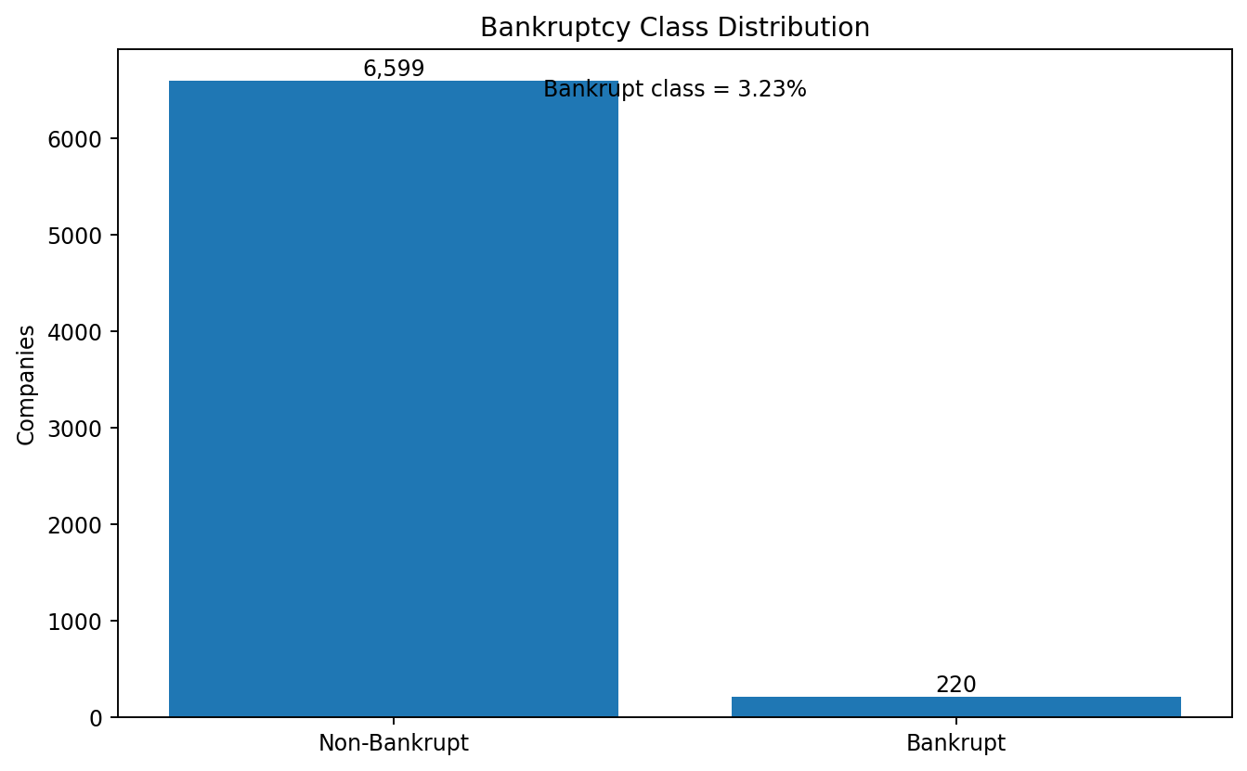
Figure 1. Bankruptcy class distribution in the complete dataset.
The class-distribution plot shows the severe imbalance between non-bankrupt and bankrupt companies. Of the 6,819 observations, 6,599 are non-bankrupt and 220 are bankrupt. This imbalance means that a classifier that mainly predicts the majority class can obtain high accuracy without being useful for detecting bankrupt companies.
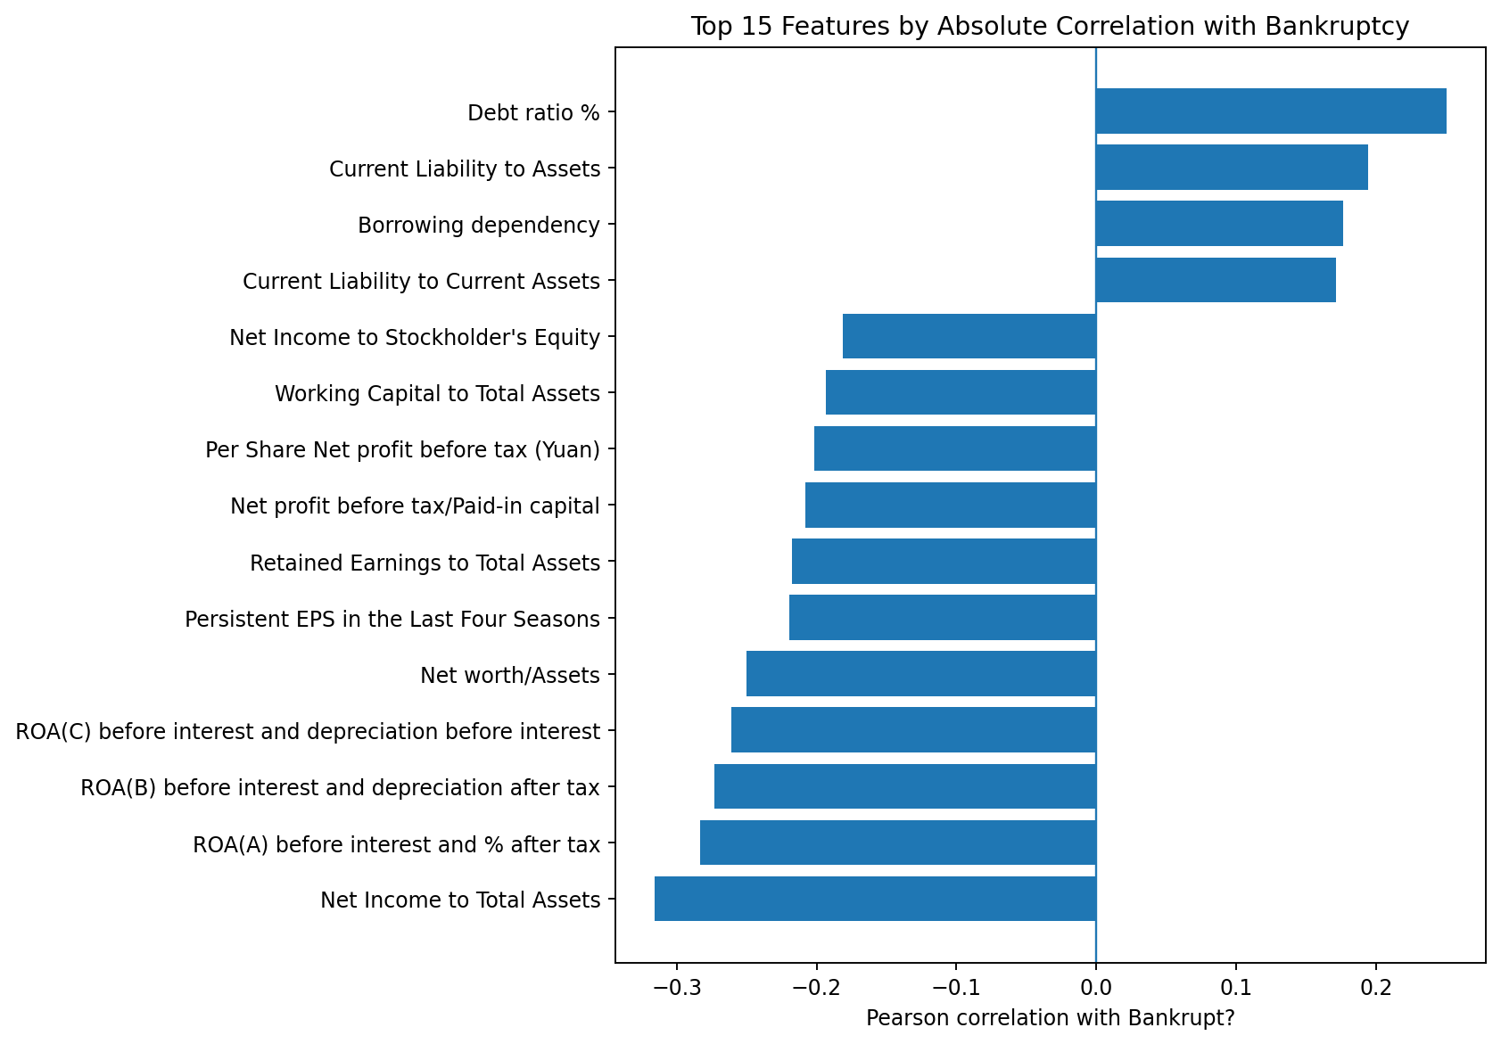
Figure 2. Top 15 absolute feature-to-target correlations from descriptive EDA.
The descriptive correlation analysis identifies Net Income to Total Assets as the strongest absolute correlation with the target among the examined financial features, with a correlation of approximately -0.3155. Other relatively strong relationships include several ROA measures, Net worth/Assets and Debt ratio %. Correlation values describe linear association and are not, by themselves, proof of causal influence or sufficient grounds for final feature selection.
Feature | Correlation | Absolute Correlation
Net Income to Total Assets | -0.3155 | 0.3155
ROA(A) before interest and % after tax | -0.2829 | 0.2829
ROA(B) before interest and depreciation after tax | -0.2731 | 0.2731
ROA(C) before interest and depreciation before interest | -0.2608 | 0.2608
Net worth/Assets | -0.2502 | 0.2502
Debt ratio % | 0.2502 | 0.2502
Persistent EPS in the Last Four Seasons | -0.2196 | 0.2196
Retained Earnings to Total Assets | -0.2178 | 0.2178
Net profit before tax/Paid-in capital | -0.2079 | 0.2079
Per Share Net profit before tax (Yuan) | -0.2014 | 0.2014

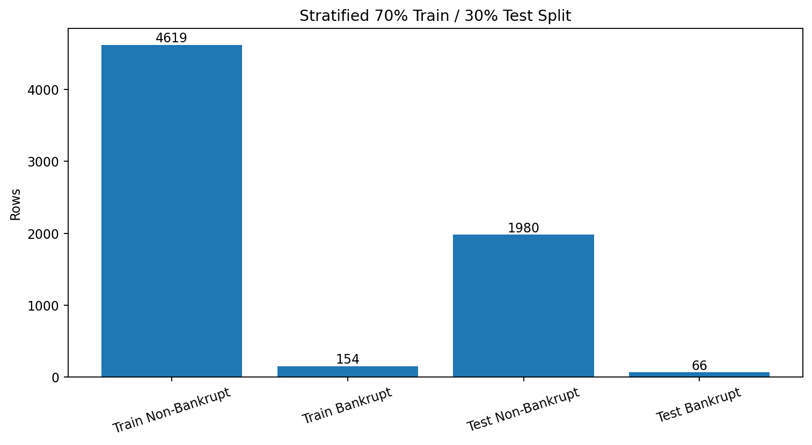
Figure 3. Stratified 70/30 train-test split used before preprocessing and feature selection.
The split produces 4,773 training observations and 2,046 test observations. Stratification preserves the minority-class proportion across the two partitions: the training set contains 154 bankrupt and 4619 non-bankrupt companies, while the test set contains 66 bankrupt and 1980 non-bankrupt companies.

Summary of EDA Findings
- The dataset is structurally suitable for binary classification, with 6,819 company records and 95 financial indicators.
- No missing values and no duplicate rows were detected in the current dataset.
- The target is strongly imbalanced: only 3.23% of companies are labelled bankrupt.
- Net Income to Total Assets has the largest absolute descriptive correlation with the bankruptcy target among the features shown in the top-correlation analysis.
- The EDA confirms that evaluation must go beyond accuracy and should explicitly examine minority-class precision, recall, F1-score and Precision-Recall behaviour.
- The final deployed feature set is not chosen from the full-data correlations; instead, it is selected by a training-only Random Forest after the train/test split.

ALGORITHM SELECTION AND IMPLEMENTATION

Two supervised tree-based algorithms are implemented: Decision Tree Classifier and Random Forest Classifier. Both models are appropriate for tabular financial data and can capture non-linear relationships between financial indicators and the bankruptcy class.

Decision Tree Classifier
The Decision Tree recursively partitions the selected financial feature space using threshold-based rules. In this implementation, the maximum depth is restricted to 8 and class_weight='balanced' is used to give additional importance to the minority bankrupt class. The main advantage is interpretability: a single tree can be inspected as a sequence of decisions. The limitation is that a single tree can be sensitive to the training data and can overfit if allowed to grow excessively.

Random Forest Classifier
The Random Forest is an ensemble of decision trees. For the final classifier, 300 trees are trained with max_depth=10, class_weight='balanced', random_state=42 and parallel processing enabled with n_jobs=-1. The ensemble averages or votes across many trees, which generally reduces the variance of an individual tree and improves generalisation.

Training-Only Feature Selection
A separate Random Forest containing 500 trees is first trained on the 70% training partition using all 95 financial features. The features are ranked by training-only Random Forest importance, and the ten highest-ranked features are selected. The held-out test partition is not used at this stage.
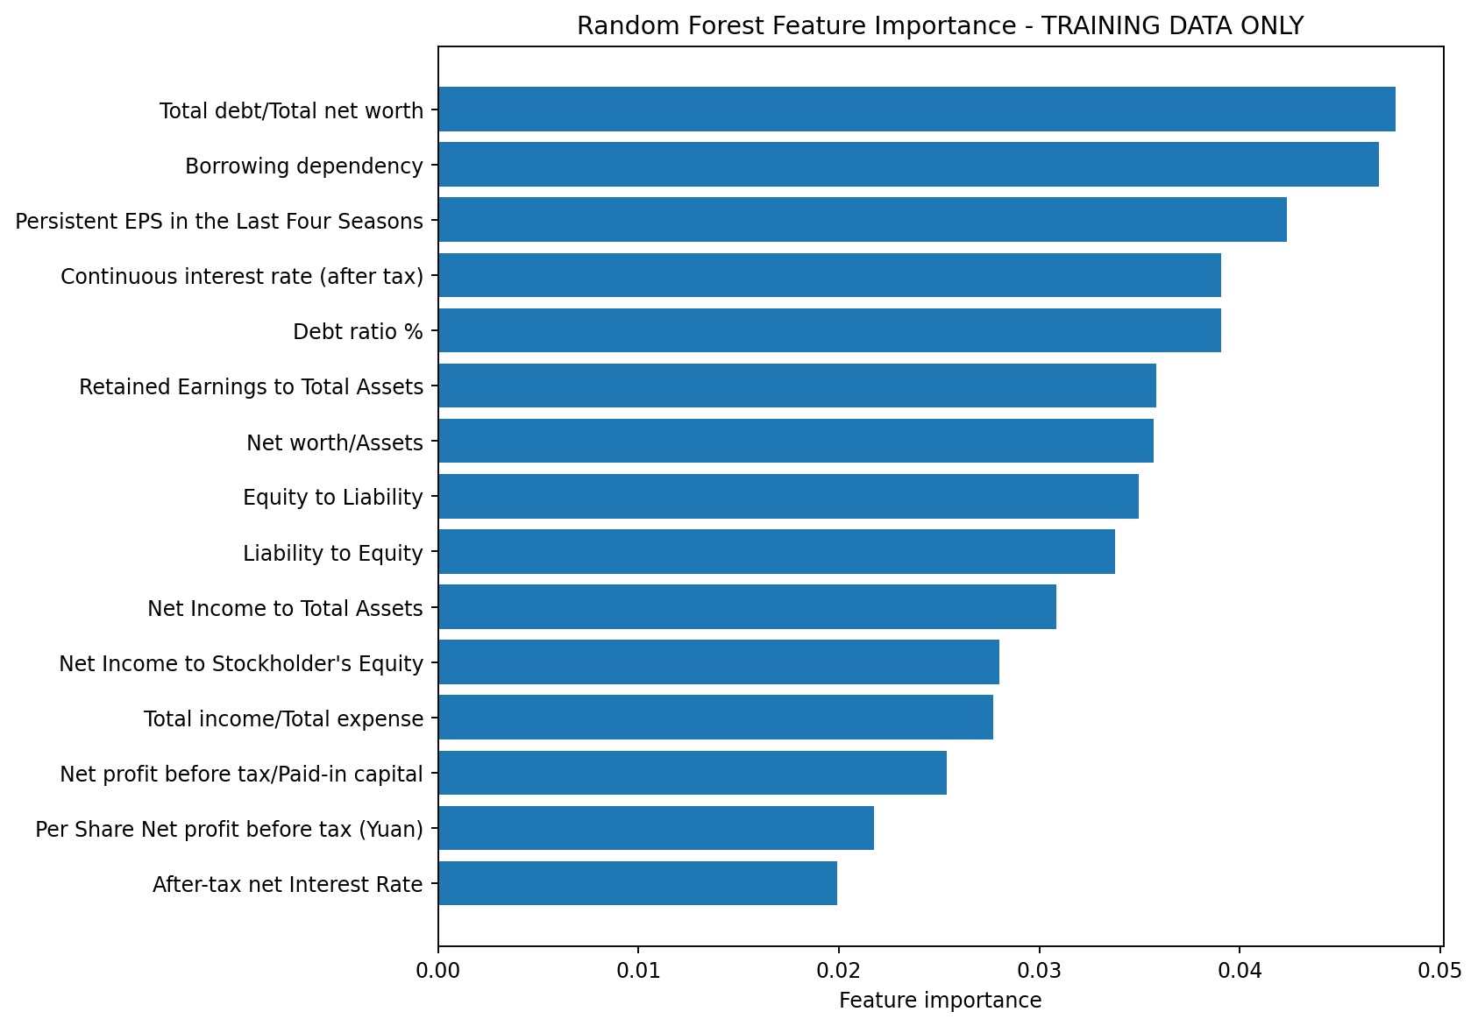
Figure 4. Training-only Random Forest feature importance used to select the final ten features.

Rank | Selected Feature | Importance
1 | Total debt/Total net worth | 0.04778
2 | Borrowing dependency | 0.04695
3 | Persistent EPS in the Last Four Seasons | 0.04234
4 | Continuous interest rate (after tax) | 0.03909
5 | Debt ratio % | 0.03907
6 | Retained Earnings to Total Assets | 0.03583
7 | Net worth/Assets | 0.03571
8 | Equity to Liability | 0.03498
9 | Liability to Equity | 0.03377
10 | Net Income to Total Assets | 0.03086

The ten selected features are: Total debt/Total net worth; Borrowing dependency; Persistent EPS in the Last Four Seasons; Continuous interest rate (after tax); Debt ratio %; Retained Earnings to Total Assets; Net worth/Assets; Equity to Liability; Liability to Equity; and Net Income to Total Assets.

Train/Test Methodology and Model Evaluation
The final models are trained on the selected ten features from the 70% training partition. The test partition remains untouched until prediction and metric calculation. This separation is important because it ensures that the final performance values measure behaviour on observations not used during preprocessing, feature selection or model fitting.
Metric | Decision Tree | Random Forest
Accuracy | 91.94% | 94.77%
Precision | 22.35% | 30.84%
Recall | 60.61% | 50.00%
F1-score | 32.65% | 38.15%
Average Precision | 24.06% | 30.57%
ROC-AUC | 77.62% | 91.23%

The Random Forest gives the higher accuracy, precision, F1-score, Average Precision and ROC-AUC. The Decision Tree, however, gives higher recall for the bankrupt class (60.61% versus 50.00%). This means the Decision Tree identifies a larger fraction of the actual bankrupt companies in the test set, while the Random Forest produces fewer false bankruptcy predictions and achieves stronger overall ranking performance as measured by ROC-AUC and Average Precision.
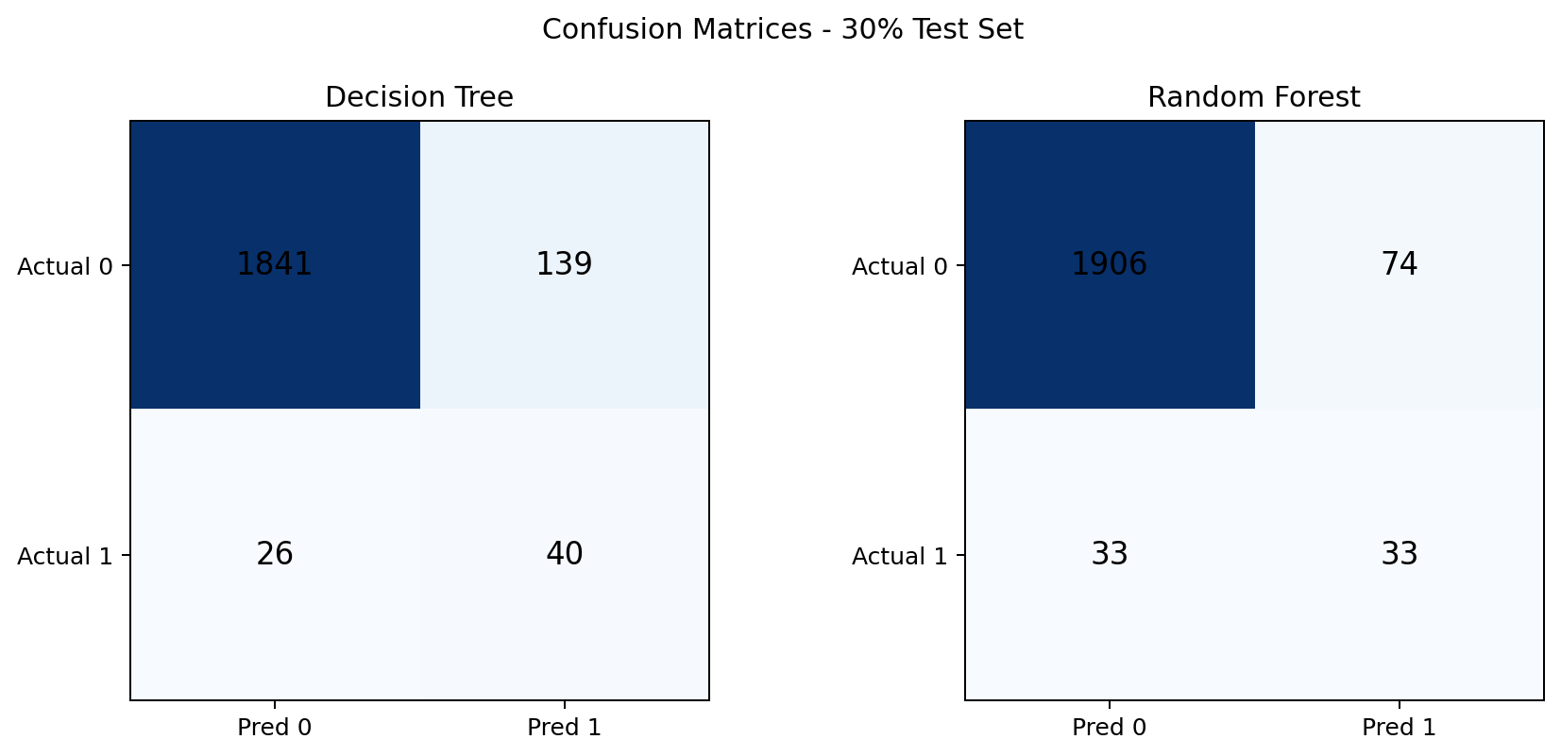
Figure 5. Confusion matrices for Decision Tree and Random Forest on the held-out test set.
The Decision Tree confusion matrix is [[1841, 139], [26, 40]], while the Random Forest confusion matrix is [[1906, 74], [33, 33]]. For the Random Forest, 33 of the 66 bankrupt companies are correctly identified and 33 are missed, while 74 non-bankrupt companies are incorrectly flagged as bankrupt. The Decision Tree identifies 40 of the 66 bankrupt companies but produces 139 false positive predictions. These results illustrate the precision-recall trade-off directly.

Precision-Recall Analysis
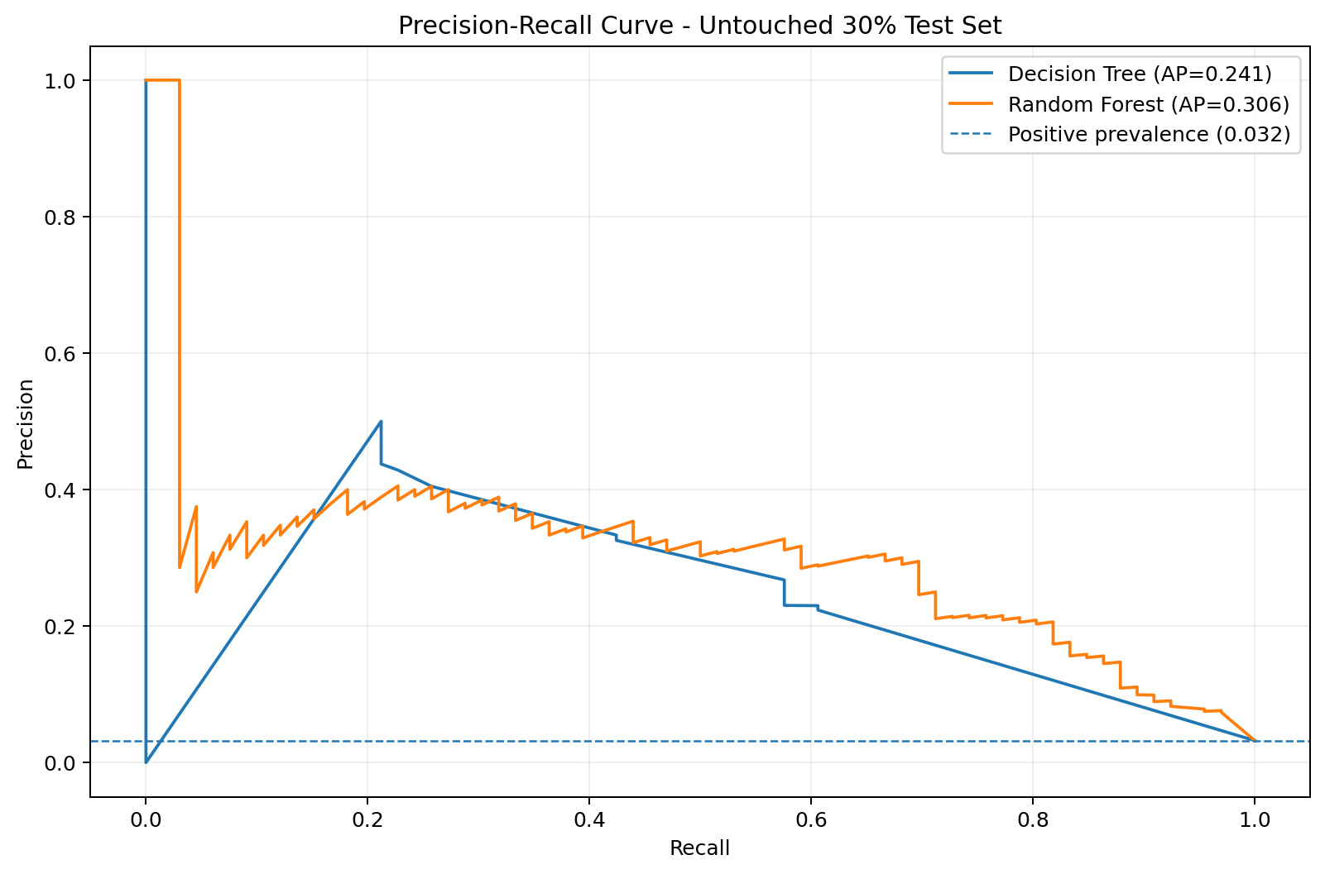
Figure 6. Precision-Recall curve comparing the Decision Tree and Random Forest.
Precision-Recall analysis is particularly important because the bankrupt class is rare. Precision measures how many companies predicted as bankrupt are actually bankrupt, while recall measures how many of the actual bankrupt companies are successfully detected. The Average Precision score summarises the precision-recall performance across thresholds. The Random Forest obtains an Average Precision of 30.57%, compared with 24.06% for the Decision Tree.
The evaluation demonstrates why accuracy should not be interpreted in isolation. Although the Random Forest reaches 94.77% accuracy, its minority-class precision is 30.84% and recall is 50.00%. The Decision Tree reaches 91.94% accuracy but has higher bankrupt-class recall at 60.61%, with lower precision at 22.35%. The preferred model therefore depends on the practical cost of false positives versus missed bankrupt companies.

Implementation and Demonstration Flow
1. Dataset loading and validation.
2. Descriptive EDA and class-distribution inspection.
3. Stratified train/test split.
4. Training-only preprocessing and feature selection.
5. Final Decision Tree and Random Forest training.
6. Evaluation on the held-out test partition.
7. Saving model artifacts and report assets.
8. Inference through the local dashboard using the saved models.
9. Demonstration using unseen test-set examples that were not used during training.
The project separates training from inference. Clicking 'Analyze Company' in the dashboard performs inference using the saved model artifacts; it does not retrain the models. A separate retraining launcher and the complete training script are provided so that the training stage can be reproduced when required.

CONCLUSION
This case study developed and evaluated a machine-learning system for bankruptcy prediction using the Taiwanese Bankruptcy Prediction dataset. The project followed a leakage-safe workflow in which the data was first split into stratified training and test partitions, preprocessing and feature selection were fitted only on the training partition, and final evaluation was performed on the untouched test partition.
The study compared a Decision Tree and a Random Forest using ten training-selected financial features. The Random Forest achieved the stronger overall test performance in terms of accuracy (94.77%), precision (30.84%), F1-score (38.15%), Average Precision (30.57%) and ROC-AUC (91.23%). The Decision Tree achieved higher recall for the bankrupt class (60.61%), showing that it detected more of the actual bankrupt companies in the held-out test set but at the cost of more false positive predictions.
The results reinforce the importance of Precision-Recall analysis in imbalanced financial classification. The project demonstrates a complete workflow from EDA and leakage-safe preprocessing through feature selection, model training, evaluation and inference. For real-world use, further validation on external and more recent data, threshold tuning, calibration, domain expertise and responsible financial governance would be required.

SIGNATURES OF THE TEAM MEMBERS
Bankruptcy Prediction Using Decision Trees and Random Forest
with Precision-Recall Analysis
Team Member | Roll Number | Signature
S. Svara Haasini | 2520090170 | ________________________
Bujangari Snigdha | 2520090160 | ________________________
Date: ____________________
Guide / Faculty Signature: ______________________________

