Linux Shell and Basic Commands-

- pwd: Print working directory paths.
- ls: List contents of the current directory.
- cd: Change directories (cd .. moves back).
- mkdir: Create a brand new directory folder.
- rmdir: Remove an entirely empty directory.
- cp: Copy files or folders (cp source.txt backup.txt).
- mv: Move or rename a file or directory.
- rm: Delete a file from the disk space.
- cat: Display whole text file data to stdout.
- echo: Print strings or variable values to screen.
- find: Scan for files (find . -name "*.c").
- history: Output the terminal's execution log history.

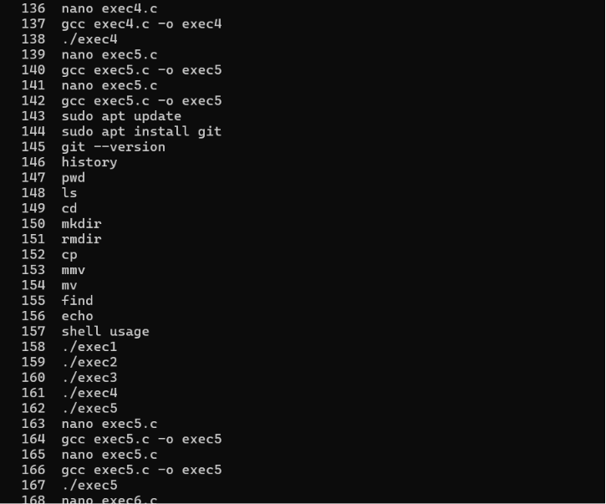

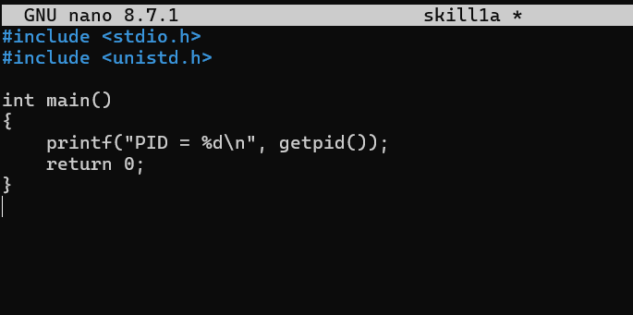

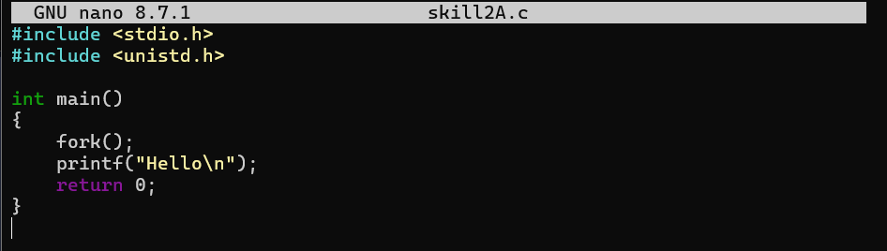
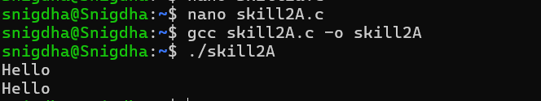

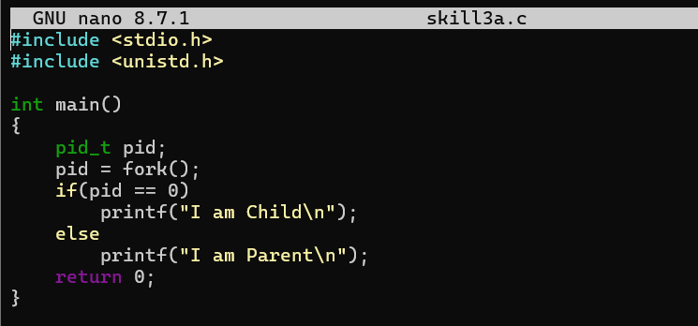
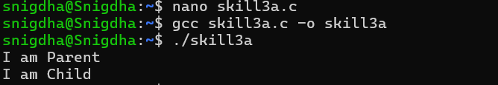

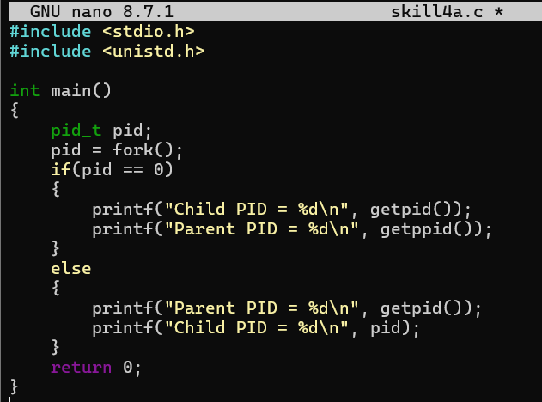
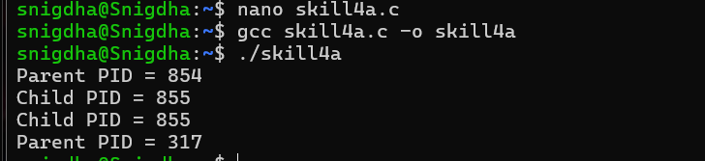

Process Creation using fork() - Process abstraction, fork(), parent and child processes, getpid(), getppid(), multiple fork() examples
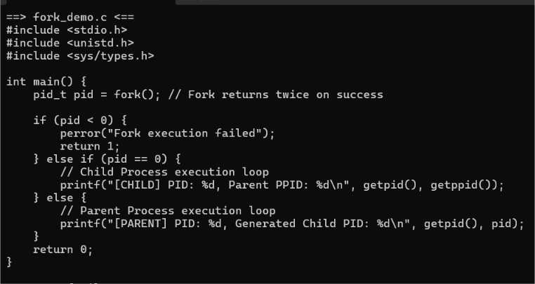
Process Replacement using the exec() Family- execl(), execv(), execvp(), replacing the current process, executing Linux commands from C
