**Bhavishya India Website Description**



Bhavishya India logo

**In the starting page,**

We want to show the registration page i.e sign up after that the home page will be shown to the user as want everyone to register first.

**Sign up Details:**

Full Name – text box

Email – optional*

Contact No. – Verification with an OTP

These are some basic details that we want in our home page.

Please refer to the below image and let us know if anything else we can add in home page.

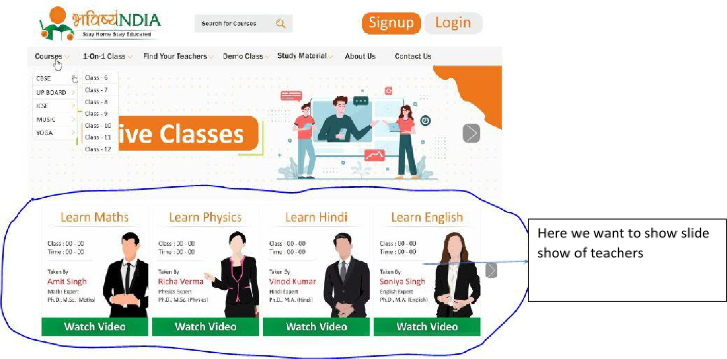

**video**→. Wewill appear

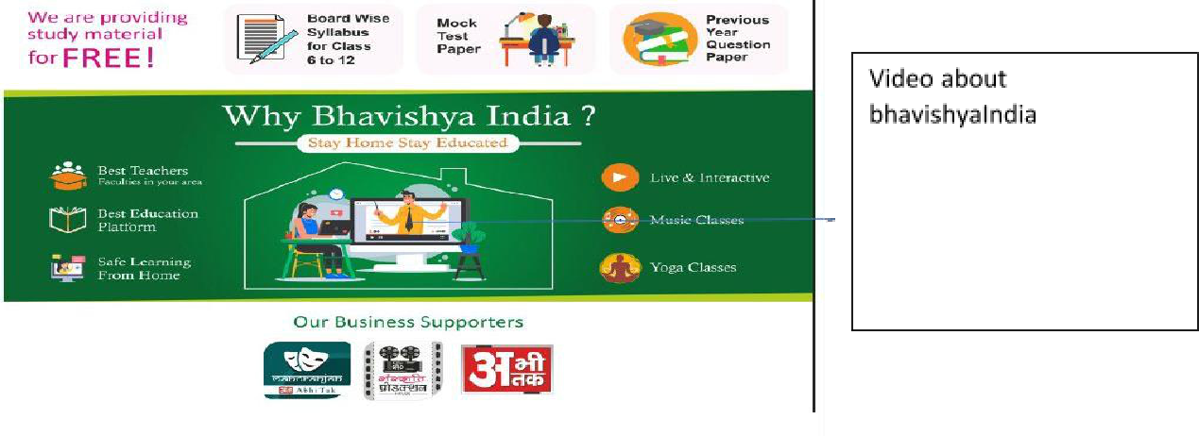

Moving further we want following tabs -

1. **Course Tab**–When the user hover on it then shows board CBSE, ICSE, UP,MUSIC. When user hover on CBSE, ICSE OR UP board then shows Class 6 to class 12 vertically.
2. **1 – on – 1 class** –Show same as course tab.
3. **Find your teacher** –When user click on it we want to go to a web pagewhere top portion will be same as home page. Then we want to provide 3 search box to search teacher by name, by subject and by class. Then below of page we want to show some profile of teachers as listing with demo videos.
4. **Gallery** –When users click on it, a page opened where student can

select the **board**→ **class**→ **subjects**→ **teacher’s** **profile**→ **watch**



want to let student watch demo video, After the end will be stopped and a **pop-up** to take a subscriptions.

1. **Free Study Material** –Here we want to provide following in optionwhen anyone hover on this tab and download the pdf.

**a. NCERT Solution**→ **board**→ **class 6-12**

**b.** Last 10 years question **paper**→**board**→ **class 10 and 12th**



**c.** **Syllabus**→ **board**→ **class 10 & 12**



**d. Sample Paper**→ **board class 6-12**



1. About us:
2. Contact us

Moving further we want a slide show where we want to show following options.

**Subscription page –**

This page only for capturing student data. Student can find the rate chart teacher wise in find your teacher tab. Student can directly pay through payment gateway.

**Payment gateway** can be through upi of paytm, google pay, phone pay or throughdebit and credit card.

We will send you the updated subscription sheet if any.

**Live class** –If student has subscription clicking on this will redirect to playstore to download the app. If not then provide a **pop-up** to ask for **subscription**.

**Course tab** –When anyone click on class 6 under course tab. We want below page toappear:

Here are categories of subject class wise.

1. **Class 6 to 8** –Subjects will be Math, Science, Hindi, English, Computer,Social Science
2. **Class 9 & 10** - Subjects→Maths, Science (physics,chemistry,biology),English, Computer, Social Science, Hindi
3. **Class 11 to 12 (Science)** –Maths, Physics, Chemistry, Biology, English,Computer.