**MANUAL TESTING**

**Software Testing Concepts - Session #14**

**State Transition Testing Technique**

This technique is used when features of a system are represented as states which transform into one another.

Example:

ATM system feature, where if the user enters the **invalid password three times the account will be locked.**

If the user enters a **valid password** in any of the **first three attempts** the user will be **logged in successfully.**

If the user enters the **invalid password** in the **first or second try**, the user will be asked to re-enter the password. And finally, if the user enters incorrect **password 3rd time**, the **account will be blocked.**

There are two main ways to represent or design state transition, State transition diagram, and state transition table.

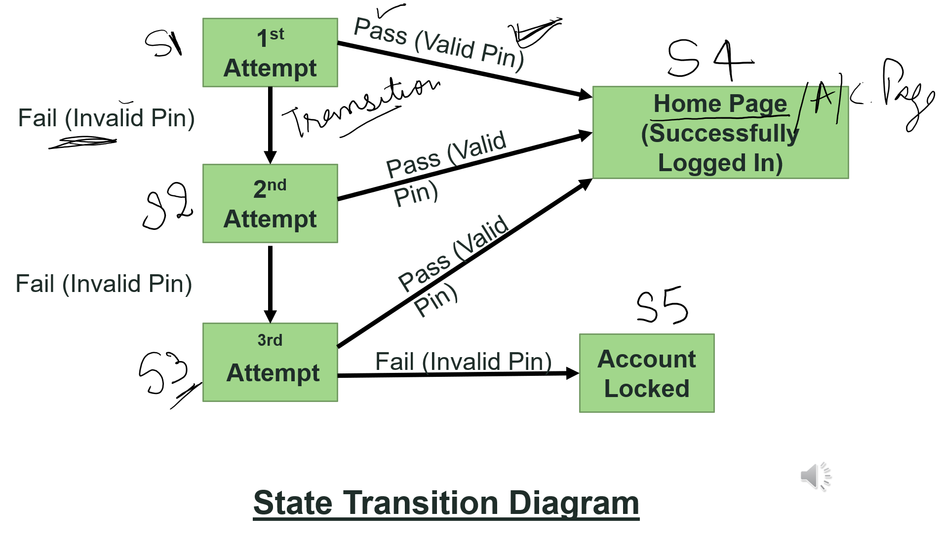

|  |  |  |  |  |  |  |
| --- | --- | --- | --- | --- | --- | --- |
| **Test Case** | **TC1** | **TC2** | **TC3** | **TC4** | **TC5** | **TC6** |
| State | S1 | S1 | S2 | S2 | S3 | S3 |
| Input | Correct Pin | Incorrect Pin | Correct Pin | Incorrect Pin | Correct Pin | Incorrect Pin |
| Output | Home Page | 2nd Attempt | Home Page | 3rd Attempt | Home Page | Account Locked |
| Finished State | S4 | S2  **State Transition Table** | S4 | S3 | S4 | S5 |

Convert above State Transition to formal test case

|  |  |  |  |
| --- | --- | --- | --- |
| TC ID | Description | Steps | Expected Result |
| TC1 | Validate that the system is able to do the transition from 1st attempt to Home Page on correct pin input | 1. Open the application 2. input correct pin | User shall be directed to Home Page |
| TC2 | Validate that the system is able to do the transition from 1st attempt to 2nd attempt on incorrect pin input | 1. Open the application 2. input incorrect pin | User shall be directed to 2nd attempt |
| TC3 |  |  |  |
| TC4 |  |  |  |
| TC5 |  |  |  |
| TC6 |  |  |  |