1. Loaded the dataset Sales_details. –‘ALTER TABLE PROJECT_STORE_SUPPLIES.PUBLIC.SALES_DATA_PROJECT ADD primary key (ORDER_DATE);’
2. ALTER TABLE PROJECT_STORE_SUPPLIES.PUBLIC.SALES_DATA_PROJECT DROP Primary Key;

ALTER TABLE PROJECT_STORE_SUPPLIES.PUBLIC.SALES_DATA_PROJECT ADD primary key (ORDER_ID);

1. DESC Table PROJECT_STORE_SUPPLIES.PUBLIC.SALES_DATA_PROJECT; Order date and ship date can be defined as Date also.

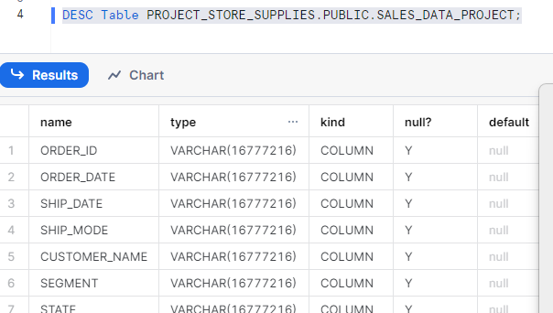

1. Alter Table IF EXISTS PROJECT_STORE_SUPPLIES.PUBLIC.SALES_DATA_PROJECT Add column order_extract Number(10);

UPDATE PROJECT_STORE_SUPPLIES.PUBLIC.SALES_DATA_PROJECT

SET order_extract= SUBSTR(ORDER_ID,REGEXP_INSTR(ORDER_ID,'-',1,2)+1);

1. SELECT *,

(CASE WHEN Discount > 0 THEN 'YES' ELSE 'NO' END) AS Discount_flag

FROM PROJECT_STORE_SUPPLIES.PUBLIC.SALES_DATA_PROJECT;

1. Alter Table PROJECT_STORE_SUPPLIES.PUBLIC.SALES_DATA_PROJECT Add Column process_days Varchar(30);

Update PROJECT_STORE_SUPPLIES.PUBLIC.SALES_DATA_PROJECT

Set process_days= DATEDIFF(day,coalesce(TRY_TO_DATE(order_date,'MM-DD-YYYY'),TRY_TO_DATE(order_date,'MM/DD/YYYY')),coalesce(TRY_TO_DATE(ship_date,'MM-DD-YYYY'),TRY_TO_DATE(ship_date,'MM/DD/YYYY')));

1. Select * ,

(Case when process_days<=3 Then 5

when process_days>3 and process_days<=6 Then 4

when process_days>6 and process_days<=10 Then 3

else 3

end ) As Rating

from PROJECT_STORE_SUPPLIES.PUBLIC.SALES_DATA_PROJECT;