**Load test report**

**Load :**

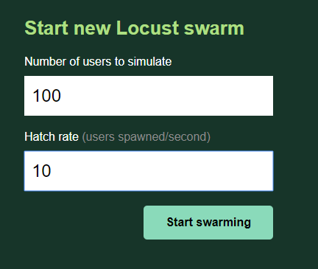

**Testing**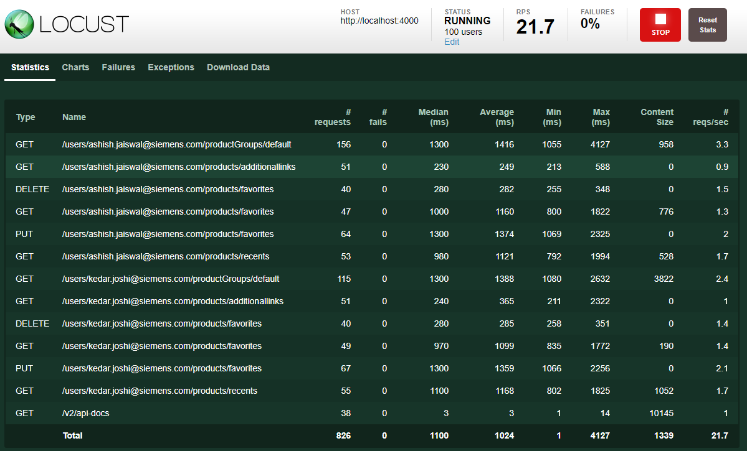

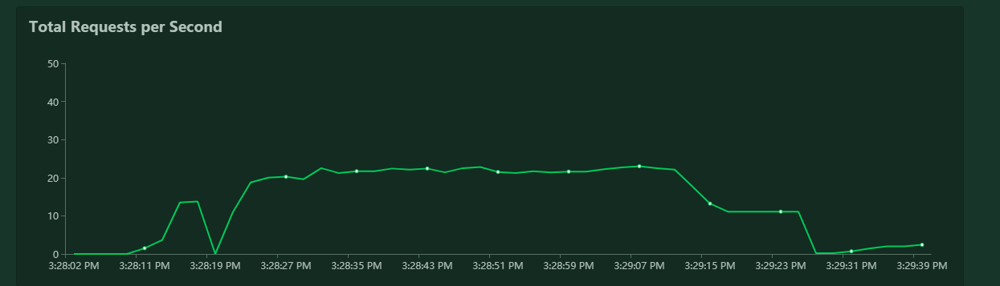

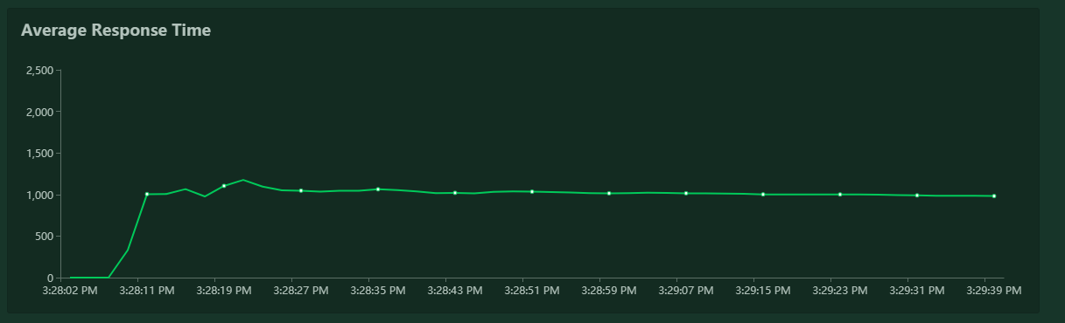

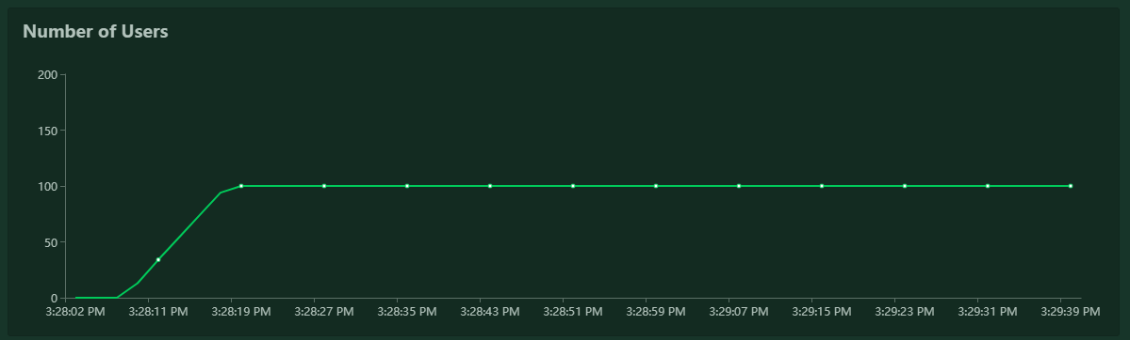

**Request – Response Report**



**Test script :**



**Test command :**

locust -f locustfile.py --host=https://ccuserpreferencesservice.dev.plmcloud.net