# Assets API Rest Calls

* <http://admin.synergic.gr:9030/getAllOrganizations>

Φέρνει όλους τους οργανισμούς που υπάρχουν στο σύστημα

Παραμετροι:

start:number υποχρεωτικό

limit:number υποχρεωτικό

address:string

email:string

phone:string

name:string

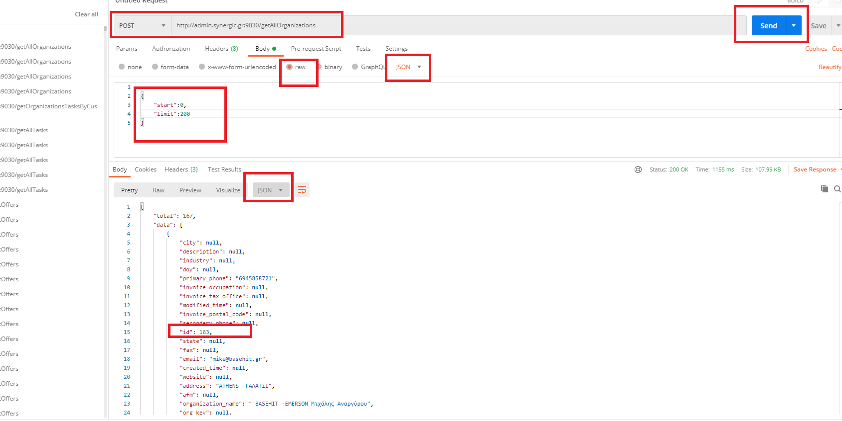

Request

{

    "start":0,

    "limit":200

}

Response

{

"total": 167,

"data": [

{

"city": null,

"description": null,

"industry": null,

"doy": null,

"primary_phone": "6945858721",

"invoice_occupation": null,

"invoice_tax_office": null,

"modified_time": null,

"invoice_postal_code": null,

"secondary_phone": null,

***"id": 163,***

"state": null,

"fax": null,

"email": "mike@basehit.gr",

"created_time": null,

"website": null,

"address": "ATHENS ΓΑΛΑΤΣΙ",

"afm": null,

"organization_name": " BASEHIT -EMERSON Μιχάλης Αναργύρου",

"org_key": null,

"invoice_address": null,

"invoice_vat": null,

"org_id": null,

"org_rev": null,

"organization_number": null

},

{

"city": null,

"description": null,

"industry": null,

"doy": null,

"primary_phone": "",

"invoice_occupation": null,

"invoice_tax_office": null,

"modified_time": null,

"invoice_postal_code": null,

"secondary_phone": null,

***"id": 146,***

"state": null,

"fax": null,

"email": "",

"created_time": null,

"website": null,

"address": "USA ",

"afm": null,

"organization_name": "( IPTN ) International Playback Theatre Network",

"org_key": null,

"invoice_address": null,

"invoice_vat": null,

"org_id": null,

"org_rev": null,

"organization_number": null

}

]

}

* <http://admin.synergic.gr:9030/getAllActiveOrganizations>

Ίδια Με την προηγούμενη χωρίς start και limit

* <http://admin.synergic.gr:9030/getOrganizationsTasksByCustomerId>

Φερνει τα tasks για εναν συγκεκριμένο Οργανισμό

To orgId αντιστοιχεί στο id της προηγούμενης μεθόδου που παίρνουμε σαν response για εναν συγκεκριμένο οργανισμό.

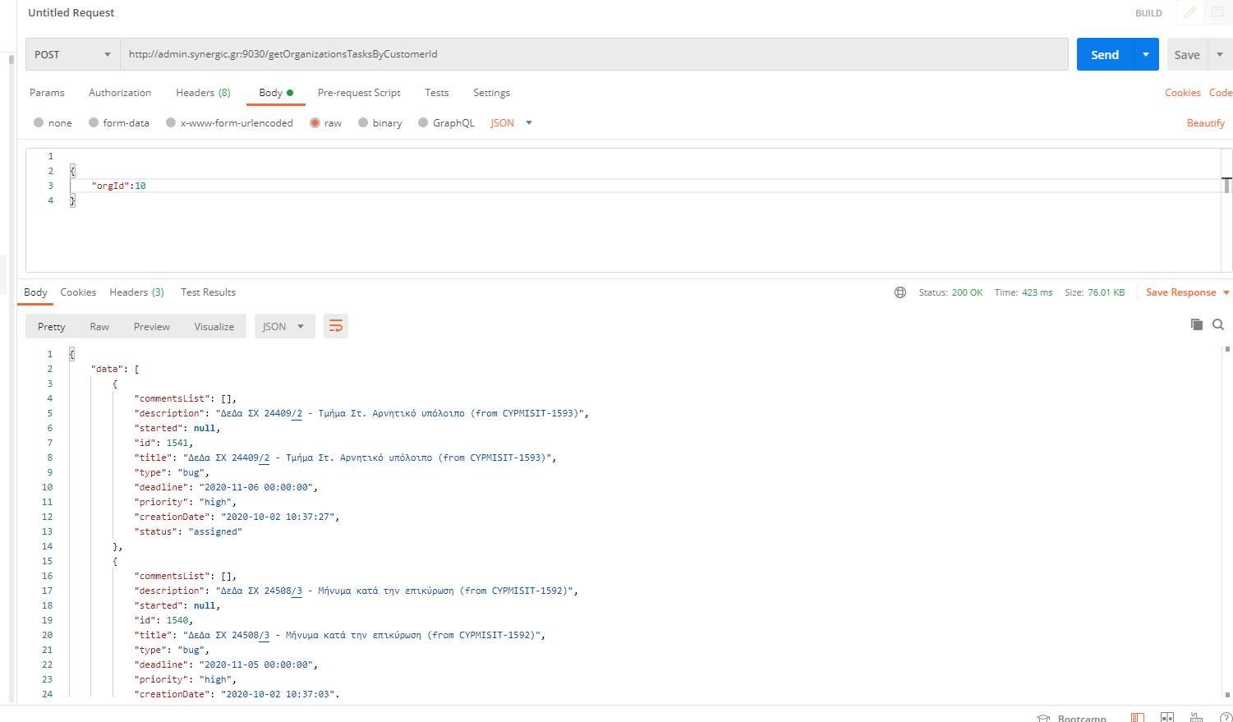

Request

{

    "orgId":10

}

Response

{

"data": [

{

"commentsList": [],

"description": "ΔεΔα ΣΧ 24409/2 - Τμήμα Στ. Αρνητικό υπόλοιπο (from CYPMISIT-1593)",

"started": null,

"id": 1541,

"title": "ΔεΔα ΣΧ 24409/2 - Τμήμα Στ. Αρνητικό υπόλοιπο (from CYPMISIT-1593)",

"type": "bug",

"deadline": "2020-11-06 00:00:00",

"priority": "high",

"creationDate": "2020-10-02 10:37:27",

"status": "assigned"

},

{

"commentsList": [],

"description": "ΔεΔα ΣΧ 24508/3 - Μήνυμα κατά την επικύρωση (from CYPMISIT-1592)",

"started": null,

"id": 1540,

"title": "ΔεΔα ΣΧ 24508/3 - Μήνυμα κατά την επικύρωση (from CYPMISIT-1592)",

"type": "bug",

"deadline": "2020-11-05 00:00:00",

"priority": "high",

"creationDate": "2020-10-02 10:37:03",

"status": "assigned"

},

{

"commentsList": [],

"description": "Αναφορά Προκαταβολών από ΟΠΣ - λανθασμένοι υπολογισμοί (from CYPMISIT-1584)",

"started": null,

"id": 1539,

"title": "Αναφορά Προκαταβολών από ΟΠΣ - λανθασμένοι υπολογισμοί (from CYPMISIT-1584)",

"type": "bug",

"deadline": "2020-11-04 00:00:00",

"priority": "high",

"creationDate": "2020-10-02 10:36:41",

"status": "assigned"

}

],

"message": "success",

"dataCount": 6,

"status": "ok"

}

* <http://admin.synergic.gr:9030/getAllProjects>

΄Φέρνει όλα τα project που ειναι περασμενα στο σύστημα

Παραμετροι:

status:string υποχρεωτικό

Request

{

"status": "Active"

}

Response

{

"data": [

{

"all": 14,

"new": 1,

"paused": 5,

"orgName": "Cubik",

"waiting": 0,

"endDate": "2020-11-20 00:00:00",

"colorDeadline": "none",

"endDateTimestamp": 1605826800000,

"testing": 0,

"inprogress": 0,

"totester": 0,

"title": "Cubik SW Platform",

"type": "Enterprise",

"done": 2,

"orgId": 119,

"sysdate": 1605631531726,

"sumEstTime": "192:45",

"closed": 32,

"assigned": 8,

"id": 5,

"startDate": "2018-06-04 00:00:00",

"sumSpendTime": "199:27",

"status": "active"

},

{

"all": 2,

"new": 0,

"paused": 1,

"orgName": "Cubik",

"waiting": 0,

"endDate": "2020-11-30 00:00:00",

"colorDeadline": "none",

"endDateTimestamp": 1606690800000,

"testing": 0,

"inprogress": 0,

"totester": 0,

"title": "CUBIK BI",

"type": "Enterprise",

"done": 0,

"orgId": 119,

"sysdate": 1605631531728,

"sumEstTime": "32:00",

"closed": 1,

"assigned": 1,

"id": 9,

"startDate": "2019-09-22 00:00:00",

"sumSpendTime": "9:16",

"status": "active"

},

{

"all": 6,

"new": 0,

"paused": 2,

"orgName": "InnJobs.net",

"waiting": 0,

"endDate": "2020-11-17 00:00:00",

"colorDeadline": "orange",

"endDateTimestamp": 1605567600000,

"testing": 0,

"inprogress": 0,

"totester": 0,

"title": "Innjobs fr",

"type": "Web Presence",

"done": 3,

"orgId": 55,

"sysdate": 1605631531730,

"sumEstTime": "104:00",

"closed": 12,

"assigned": 4,

"id": 41,

"startDate": "2020-07-20 00:00:00",

"sumSpendTime": "318:01",

"status": "active"

},

{

"all": 8,

"new": 0,

"paused": 3,

"orgName": "Vasilis Mpouklakos",

"waiting": 5,

"endDate": "2020-11-26 00:00:00",

"colorDeadline": "none",

"endDateTimestamp": 1606345200000,

"testing": 0,

"inprogress": 0,

"totester": 0,

"title": "e-RentAll",

"type": "e-Commerce",

"done": 16,

"orgId": 157,

"sysdate": 1605631531732,

"sumEstTime": "121:30",

"closed": 0,

"assigned": 0,

"id": 46,

"startDate": "2020-09-11 00:00:00",

"sumSpendTime": "167:41",

"status": "active"

},

{

"all": 7,

"new": 0,

"paused": 3,

"orgName": "INTERNOVA TRANSPORT & LOGISTICS",

"waiting": 0,

"endDate": "2021-01-28 00:00:00",

"colorDeadline": "none",

"endDateTimestamp": 1611788400000,

"testing": 0,

"inprogress": 1,

"totester": 0,

"title": "INTERNOVA MIS ",

"type": "Enterprise",

"done": 1,

"orgId": 160,

"sysdate": 1605631531734,

"sumEstTime": "91:00",

"closed": 1,

"assigned": 3,

"id": 48,

"startDate": "2020-09-17 00:00:00",

"sumSpendTime": "69:50",

"status": "active"

},

{

"all": 3,

"new": 0,

"paused": 3,

"orgName": "Diakosmein",

"waiting": 0,

"endDate": "2020-11-18 00:00:00",

"colorDeadline": "orange",

"endDateTimestamp": 1605654000000,

"testing": 0,

"inprogress": 0,

"totester": 0,

"title": "Diakosmein",

"type": "e-Commerce",

"done": 4,

"orgId": 155,

"sysdate": 1605631531736,

"sumEstTime": "32:00",

"closed": 0,

"assigned": 0,

"id": 45,

"startDate": "2020-09-01 00:00:00",

"sumSpendTime": "47:33",

"status": "active"

},

{

"all": 2,

"new": 0,

"paused": 1,

"orgName": "cannalab",

"waiting": 1,

"endDate": "2020-11-24 00:00:00",

"colorDeadline": "none",

"endDateTimestamp": 1606172400000,

"testing": 0,

"inprogress": 0,

"totester": 0,

"title": "Cannalab",

"type": "e-Commerce",

"done": 5,

"orgId": 161,

"sysdate": 1605631531739,

"sumEstTime": "21:00",

"closed": 0,

"assigned": 0,

"id": 49,

"startDate": "2020-09-01 00:00:00",

"sumSpendTime": "22:43",

"status": "active"

}

],

"totalAcctivesTasks": 203,

"message": "success",

"status": "ok"

}

* <http://admin.synergic.gr:9030/getOrganizationsWithTasks>

Φέρνει μόνο τους ορανισμούς που έχουν ανοικτα τασκ συστημα

Request

{

 "taskStatus": "all"

}

Response

{

"totalAcctivesTasksOrgs": 65,

"data": [

{

"all": 1,

"new": 0,

"paused": 1,

"orgName": "Gatoskilo - Κουνάβης",

"waiting": 0,

"testing": 0,

"index": 8,

"inprogress": 0,

"totester": 0,

"done": 0,

"orgId": 171,

"primaryPhone": "",

"sumEstTime": "0:00",

"closed": 0,

"assigned": 0,

"email": "",

"sumSpendTime": "6:41"

},

{

"all": 1,

"new": 0,

"paused": 0,

"orgName": "Νικολούλη",

"waiting": 1,

"testing": 0,

"index": 9,

"inprogress": 0,

"totester": 0,

"done": 0,

"orgId": 172,

"primaryPhone": "6944965861 - Σοφια Χωριανοπουλου",

"sumEstTime": "1:00",

"closed": 0,

"assigned": 0,

"email": "s.chorianopoulou@alphatv.gr",

"sumSpendTime": "3:51"

},

{

"all": 4,

"new": 1,

"paused": 1,

"orgName": "ZAMPETAS ( Ζαμπετας ) Camping Megastore ",

"waiting": 0,

"testing": 0,

"index": 15,

"inprogress": 0,

"totester": 0,

"done": 1,

"orgId": 121,

"primaryPhone": "",

"sumEstTime": "74:00",

"closed": 21,

"assigned": 2,

"email": "info@zampetas.gr",

"sumSpendTime": "58:53"

},

{

"all": 6,

"new": 0,

"paused": 0,

"orgName": "Auto-Planet",

"waiting": 2,

"testing": 0,

"index": 22,

"inprogress": 0,

"totester": 0,

"done": 5,

"orgId": 93,

"primaryPhone": "210 2316058",

"sumEstTime": "123:30",

"closed": 33,

"assigned": 4,

"email": "contact@auto-planet.gr",

"sumSpendTime": "251:00"

},

{

"all": 22,

"new": 14,

"paused": 3,

"orgName": "Army-Market.gr",

"waiting": 0,

"testing": 0,

"index": 24,

"inprogress": 0,

"totester": 0,

"done": 3,

"orgId": 103,

"primaryPhone": "2541021622",

"sumEstTime": "151:00",

"closed": 51,

"assigned": 5,

"email": "info@army-market.gr",

"sumSpendTime": "200:25"

}

],

"message": "success",

"status": "ok"

}

* <http://admin.synergic.gr:9030/getAllTasks>

παραμετροι

developer:number

limit: number υποχρεωτικό

orgId: number

start: number υποχρεωτικό

status: string υποχρεωτικό

Η μέθοδος αυτή φέρνει τα τικετς αναλογα με τους παραμετρους developer,orgId

*\*\*Για το πεδίο developer το παίρνουμε από την μέθοδο <http://admin.synergic.gr:9030/getAllUsers> (post no params empty json object {} )*

Request

{

 "developer": "0",

 "limit": 15,

 "orgId": 0,

 "start": 0,

 "status": "all"

}

Response

{

"total": 279,

"data": [

{

"updateDate": null,

"code": null,

"colorDeadline": "none",

"description": "Set up payments based on customer feedback",

"title": "08. Set up payments ",

"type": "task",

"assignedTo": null,

"orgId": 170,

"project_organization": "-",

"id": 1792,

"deadline": null,

"developerName": "-",

"projectTitle": "STARTER eShop - PharmacyOne",

"orgTitle": "PharmacyOne",

"colorStartDate": "none",

"priority": "medium",

"creationDate": "2020-11-09",

"sharpCode": "#1792",

"realTime": ".00",

"developer": "",

"estimatedHours": "2:00",

"position": null,

"projectId": 58,

"startDate": "-",

"status": "new",

"spendTime": "0:00"

},

{

"updateDate": null,

"code": null,

"colorDeadline": "none",

"description": "Set up all shipping data based in customer info ",

"title": "09. Set up shipping data",

"type": "task",

"assignedTo": null,

"orgId": 170,

"project_organization": "-",

"id": 1793,

"deadline": null,

"developerName": "-",

"projectTitle": "STARTER eShop - PharmacyOne",

"orgTitle": "PharmacyOne",

"colorStartDate": "none",

"priority": "medium",

"creationDate": "2020-11-09",

"sharpCode": "#1793",

"realTime": ".00",

"developer": "",

"estimatedHours": "2:00",

"position": null,

"projectId": 58,

"startDate": "-",

"status": "new",

"spendTime": "0:00"

}

],

"total2": 279,

"message": "success",

"status": "ok"

}

* <http://admin.synergic.gr:9030/addTask>

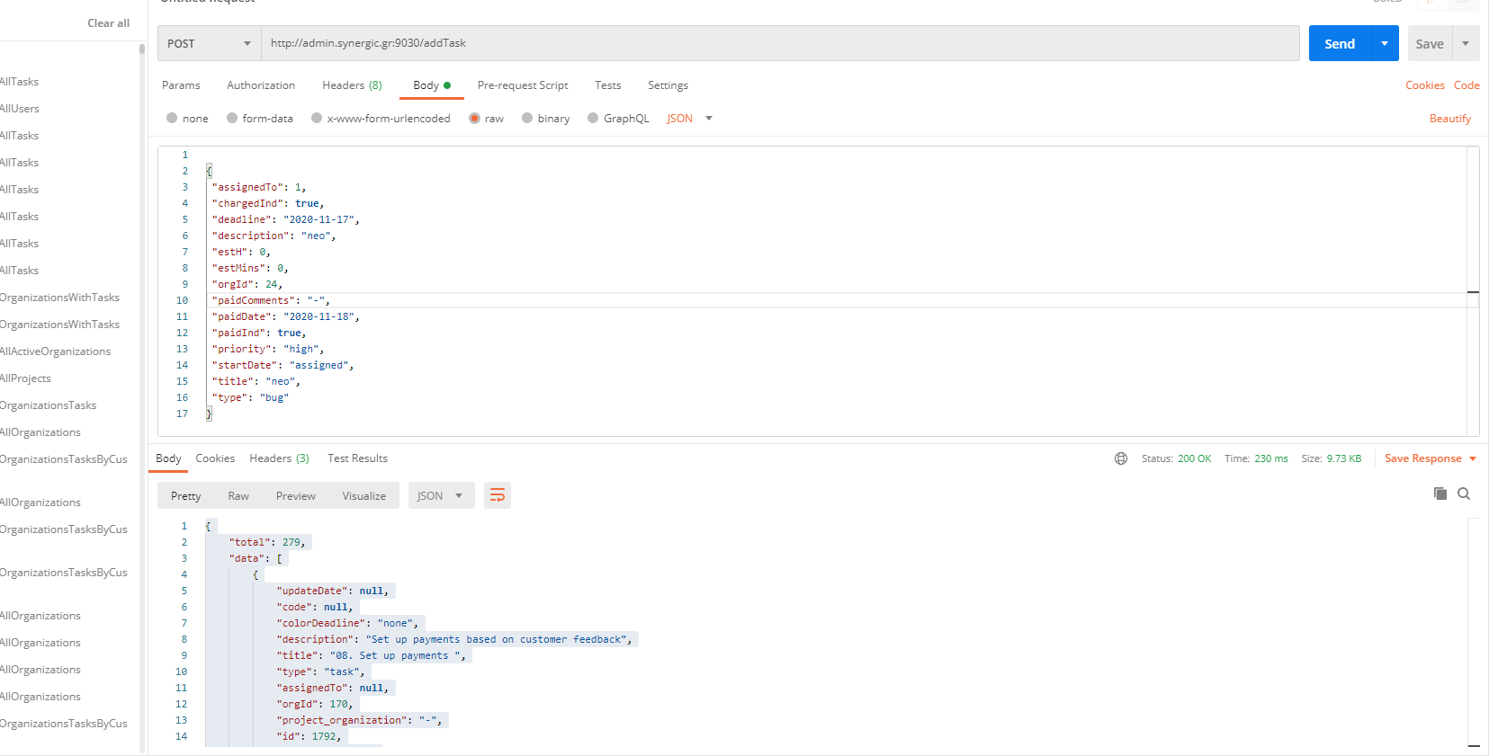

Παραμετροι

assignedTo: number υποχρεωτικο (το id του developer)

chargedInd: paidInd:boolean

deadline: "string υποχρεωτικο

description: string υποχρεωτικο

estH: number υποχρεωτικο

estMins: number υποχρεωτικο

orgId: number υποχρεωτικο

paidComments: string

paidDate: string

paidInd:boolean

priority: string υποχρεωτικο(low,medium,high,urgent)

startDate: string υποχρεωτικο

title: string υποχρεωτικο

type: string υποχρεωτικο (bug,new requirement,change requirement,support,data correction,incident)

Request

{

 "assignedTo": 1,

 "chargedInd": **true**,

 "deadline": "2020-11-17",

 "description": "neo",

 "estH": 0,

 "estMins": 0,

 "orgId": 24,

 "paidComments": "-",

 "paidDate": "2020-11-18",

 "paidInd": **true**,

 "priority": "high",

 "startDate": "assigned",

 "title": "neo",

 "type": "bug"

}

Response

**{"taskId":1872,"status":"ok","message":"Η καταχώρηση έγινε με επιτυχία."}**

* <http://admin.synergic.gr:9030/updateTask>

παραμετροι

assignedTo: 1

chargedInd: false

deadline: string

description: string

estH: number

estMins: number

estimatedHours: string

id: number

orgId: number

paidComments: string

paidDate: string

paidInd: boolean

priority: string

projectId: string

startDate: string

status: string

title:string

type: string

Request

1. assignedTo: 1
2. chargedInd: false
3. deadline: "2020-11-17"
4. description: "neo2"
5. estH: 4
6. estMins: 0
7. estimatedHours: "4:00"
8. id: 1872
9. orgId: 24
10. paidComments: "-"
11. paidDate: "2020-11-18"
12. paidInd: false
13. priority: "medium"
14. projectId: null
15. startDate: "2020-11-17"
16. status: "assigned"
17. title: "neo2"
18. type: "task"

RESPONSE

{"taskId":1872,"status":"ok","message":"Η ενημέρωση έγινε με επιτυχία."}