**Preface:**

This guide assumes you know the [rules of chess](http://en.wikipedia.org/wiki/Chess_rules). Make sure you know how each piece moves. Make sure you know about the special rules: [Castling](http://en.wikipedia.org/wiki/Castling) and [En Passant](http://en.wikipedia.org/wiki/En_Passant). Not only should you understand the rules of chess, but you will also want to know how to read [Algebraic Notation](http://en.wikipedia.org/wiki/Algebraic_notation_(chess)). If you do not know these things, you need to start there before reading this guide.

**Chapter 1:** Value and Advantage

Let’s just jump RIGHT into it.

I think the first important idea to learn is that each chess piece has varying value. I think most people who have ever played a game of chess realized that some pieces were better than others. There is a point system associated with each piece, to give it a value which you can compare to other pieces. These values are somewhat subjective, and many grandmasters have had slightly differing opinions on the exactly values for each piece, but after hundreds of years, pretty much everyone agrees on one particular assignment. Here is that assignment:  
  
King Invaluable OR 3 points  
Queen 9 points  
Rook 5 points  
Bishop 3 points  
Knight 3 points  
Pawn 1 point

This would mean that a queen is about as valuable as bishop, a rook, and a pawn. This would mean that a bishop and a knight are of the same value. This would mean that two Rooks are better than a Queen. You get the point. Let’s address the elephant in the room – the king’s value. King is obviously the most important piece in the game, the 3 point assignment is to give some relative measurement to its usefulness, instead of just its importance. Its offensive and defensive capabilities add up to be about as useful as a Knight or Bishop. However, you cannot safely use its full power until many of the scary pieces that will kill him are removed from the board. If you watch a bunch of chess games, you will see that the king in the early game quickly hides in a corner, and then once the board settles down, he is one of the most active pieces, racing into the action to give that extra edge.

“Slow down, Mike, you started off saying ‘each piece has varying value’, and then you gave a chart with concrete values for each piece; this doesn’t add up.” Hopefully that ran through your head just now. The value chart above is just a rough guide to follow, the context of the board and placement of the other pieces matters a LOT. This is called “position”. Every advantage you have over your opponent can be classified as either a positional advantage, or a material advantage.   
  
**Material Advantage –** you have a material advantage if the sum of the values of all your remaining pieces is a larger number than that of your opponent. If I have 2 queens and a rook, and you have 1 pawn and 1 knight, I have a material advantage (I have 23 points, you have 4). A material advantage of more than 1 point is often all it takes to slowly grind out a win. A 1 point lead often leads to a draw or a win.

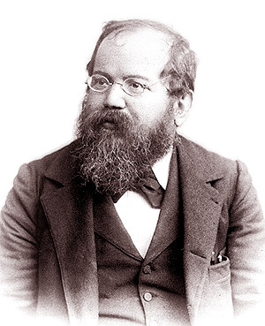**Positional Advantage –** If I could fully explain a positional advantage in such a short paragraph as I did material advantage, you would need no further information about chess to be the best. Every other complication in chess is a battle over a positional advantage. A positional advantage is separate from the material advantage. You could have a material advantage, but I could have a positional advantage at the same time. A piece could be worth only 1 point on a particular square, but be worth 20 points on its ideal square. This is all contextual, and tends to run into subjectivity and extremely complex analysis.

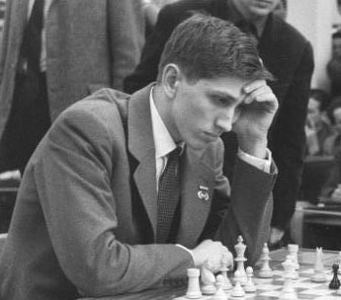

[**Steinitz**](http://en.wikipedia.org/wiki/Wilhelm_Steinitz): The first world chess champion

[**Fischer**](http://en.wikipedia.org/wiki/Bobby_fischer): the greatest American Grandmaster

**Chapter 2:** Tactics – acquiring material gain in the short term

The best place for a new player to start learning, is to learn what we call tactics. Tactics refers to a combination of moves which will give you an immediate material advantage. What do I mean by material advantage? I mean to make an exchange of pieces in such a way that your team has more value points total than the other team. If you take a piece without losing any pieces, that is a material gain. If you trade a less valuable piece of yours for a more valuable piece of the opponent, that is a material gain. This second material gain would be called “up the exchange” (you got the upper hand in that exchange).

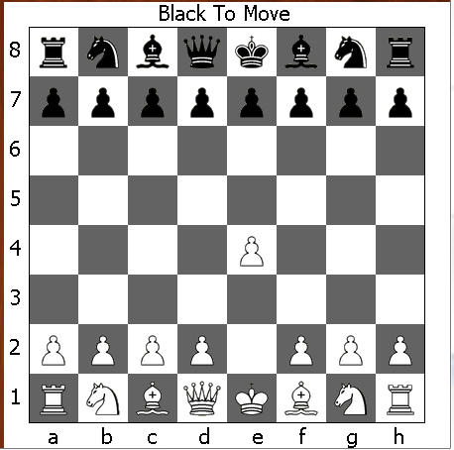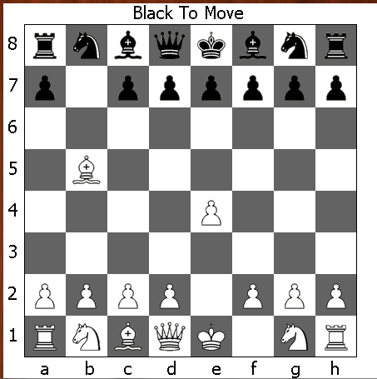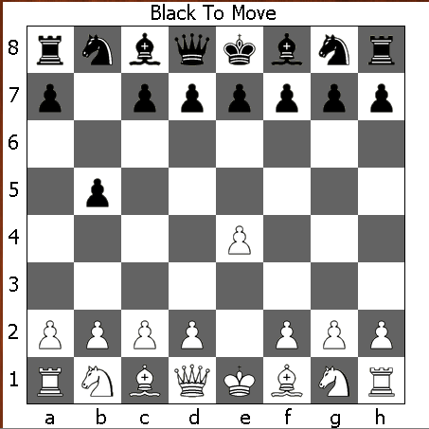 As you play more and more chess games, you start to notice certain patterns in someone’s plans to gain material advantage. There are some extremely common patterns of moves, and we have given these tactical tricks their own names. While most games you play will be unique, certain aspects of tactics will be very similar to situations you have faced in the past. The best way for a new player to quickly get better is to master the common tactics, and use them frequently to familiarize yourself with them.   
  
 **Tactic 1**: *The Hanging Piece*  
This tactic is the first one players spot and most beginners easily understand. A piece is said to be “hanging” when there is no ally “protecting“ it. That means that the piece could be captured by the enemy, and the enemy piece which killed our piece cannot be immediately recaptured. Here is an example:

1. e4 1. … b5 2. Bxb5

In this example, black “left his piece hanging” on his first move, when he put his pawn on b5. White is able to capture this with his bishop (Bxb5) without suffering retaliation. New players are extremely prone to these mistakes, and in order to improve, it is mandatory that you make a consistent habit of minimizing this mistake. It is important to note that a piece does not have to be in immediate danger to be “hanging”, it just needs to be unprotected. So, a hanging piece is not necessarily a mistake in itself, it is when you have a hanging piece that the enemy can capture that makes it a mistake. In this example, white’s pawn on e4 is hanging, but that is perfectly OK. White will just have to pay special attention to that pawn for when black threatens it. When a hanging piece is threatened, you need to either move it, or protect it with another piece, or you will suffer a loss in material.

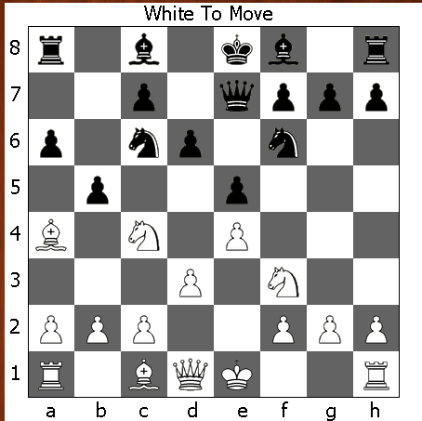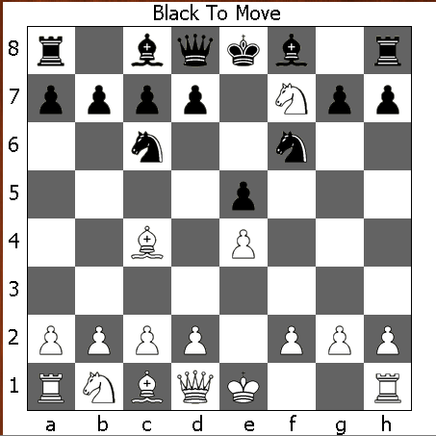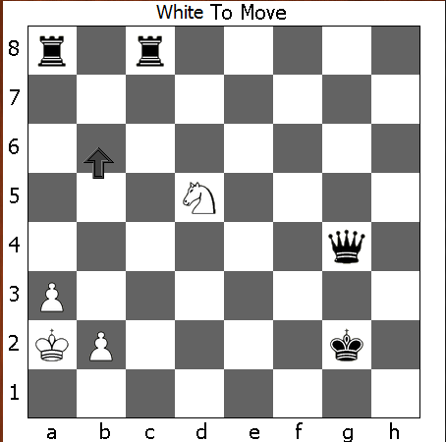 **Tactic 2**: *The Fork*  
  
If the white knight moves to the square indicated by the arrow (b6), it is “forking” the two black rooks. It is called a fork, because you can imagine 2 paths, like 2 prongs of a fork, that the knight can take from that position (b6) in which it will kill an enemy piece. A fork is only considered a good move if both pieces it will threaten are unprotected, or (as in this case) both pieces being threatened are of higher value than the forking piece (rooks are more valuable than knights). If you “fork” two pawns which are protected, people won’t even consider that as a fork because there is no threat – it would be stupid to trade a knight for a pawn, in most cases. In this example, black can use a tactical trick to escape this fork, but I will cover that later in the Check Abuse tactic.  
  
To the right is probably the most common example you will  
run into as a newer player. The knight is threatening the rook  
and the queen. Both pieces are of higher value than it, so   
if black sent extra protection to either piece, that would not   
alleviate the loss he is going to suffer. It is important to note  
that the king is not allowed to capture the knight, because  
that would put him in check via the bishop on c4. The best play from black here would be to move the queen out of harm’s way. A queen is more valuable than a rook, so he would rather the rook die than the queen.

The fork tactic is most commonly associated with the knight and the queen because their mobility is especially good at creating these situations. Pawns can also be especially good at forking pieces if they move into a protected square and threaten 2 pieces at the same time. The pawn on b5 is forking the bishop on a4 and the knight on c4.

**Tactic 3**: *The X-Ray (Pins and Skewers)*

To understand these tricks, you will need to imagine that the bishop and queen and rook project their offenses with beams. The bishop shoots beams out on the diagonals; the queen shoots beams on diagonals, ranks(rows), and files(columns); and the rook shoots beams out on ranks and files. Unlike knights, these pieces cannot move through other pieces, so their “beams” may be blocked by a piece. When an enemy piece is blocking a beam, you can often use that to your advantage. If an enemy piece is blocking a beam which would be attacking some other piece behind it, this is referred to as an X-ray.

*Tactic 3.1: The Pin*  
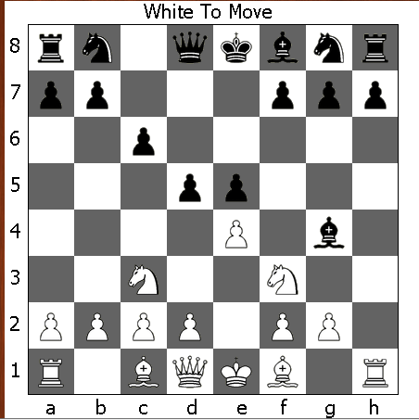A pin is an X-ray where the piece that blocks a beam is less valuable than the piece behind it.

In this example, black’s bishop on g4 is pinning white’s knight on f3 to white’s queen on d1. It is called a pin because white’s queen is more valuable, so the knight is “pinned” (imagine sticking a pin/needle through the knight to the queen) because white would definitely NOT want to move that knight, or its queen will die. Therefore, the white knight is pinned down and should not move until this pin is broken.

White has a move available to him this turn which would unpin his knight from the queen. Can you see it?  
(Be2).

*Tactic 3.2: The Skewer*

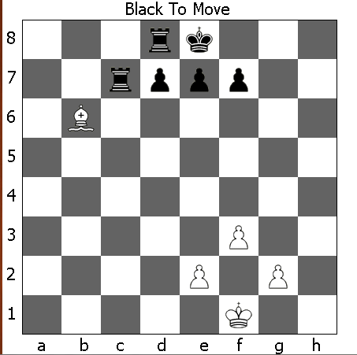 A pin is when the piece blocking the beam is less valuable than the piece behind it. A skewer is the opposite – when the piece blocking the beam is more valuable than the piece behind it. In most cases, you will need to immediately move the blocking piece (so that it doesn’t die) at the loss of the piece behind it. If both pieces are of equal material, it is still called a skewer, because there is no pressure to keep the blocking piece in place (its not “pinned” to that square).

In this example, white’s bishop is skewering the black rooks. Black actually has a way of untangling itself from this mess. Can you see it? (Hint: I will cover this later in Check Abuse).

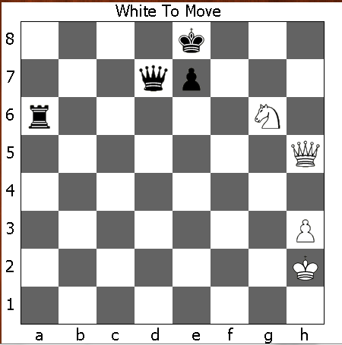 *To recap:*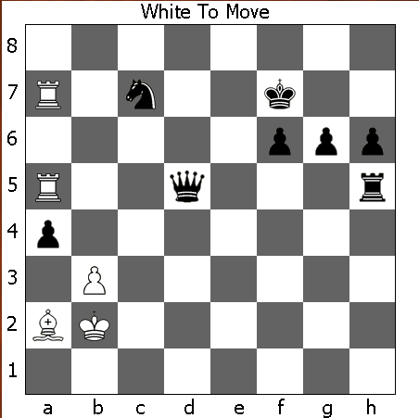In this situation, there are 2 X-Rays going on at the same time. White’s rook on a7 is X-Raying the black knight with the black king, and the rook on a5 is X-Raying the black queen and the black rook.  
  
Which X-Ray is the pin, and which is the skewer? (Hint: if the piece blocking the beam is worth more than the piece behind it, it is a skewer. If the piece behind it is more valuable than it, it is a pin).  
  
You should have been able to determine that the black rook on h5 is being skewered through the queen on d5, and that black’s knight on c7 is being pinned to the king on f7.   
  
  
  
  
  
**Tactic 4**: *The Discovered Attack*

If you count the material in this position, it would appear  
that black is ahead. However, as it is white move and he has a devastating combo, he can make short work of this game. You will notice that white’s queen is X-Raying the black king through his own knight. This is extremely powerful, because white can, at any time, move that knight and place black in check. When he does this, black cannot respond to the knight’s move, because he has to deal with the queen checking his king. Can you spot the devastating move which white can make?

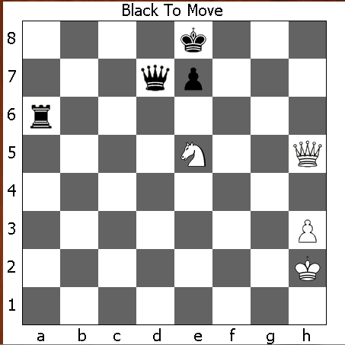Typically, the trick to making the most of a discovered attack is to move the blocking piece into the most threatening position as possible. By moving his knight to threaten black’s queen, white can now trade his knight for black’s queen. Black MUST move out of check (Kd8 – Kf8 loses immediately) and then white can take the queen with his knight.

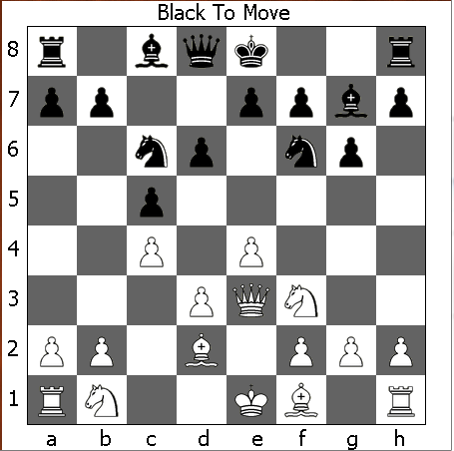

That first example was intentionally really simple. In most cases, discovered attacks are very subtle and hard to spot, which makes them especially powerful.

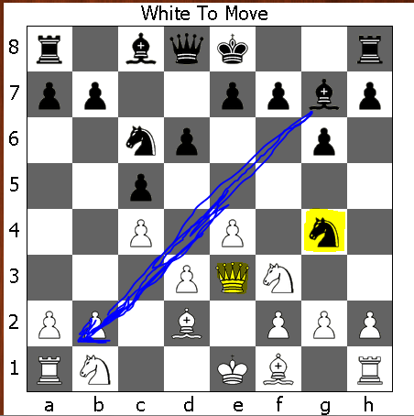Can you spot the discovered attack for black in the position to the right?  
  
If you look at the pieces which can X-ray, only the bishop is set up for a discovered attack. If we move the knight, the bishop will then be threatening the hanging pawn on b2. Once our bishop is on b2, it will be guaranteed to also trade up with the rook. But, in order to do that, we need to make a threat with our knight which cannot be ignored. Ng4 threatens to take the queen, so he will probably try to protect the queen over the pawn.

What is white going to do? He obviously wants to move his queen, but his knight on b1 keeps his rook trapped on a1, and he cannot move his queen into a position to protect the pawn on b2 without exposing the queen to the bishop on g7. White’s queen can’t make any counter threats this turn – the knight on g4 is protected by the bishop on c8. She can either go to d2, f4, or g5. White is just down a rook in this situation.

**Tactic 5:** *Check Abuse*

This is a “tempo” tactic. What that means, is that this tactic is used to “gain time” or to make multiple important moves without your opponent being allowed to make his own important/desired move. In this tactic, you “gain time” by moving a piece and checking the enemy king. This forces him to deal with the check, and then you get to move again.



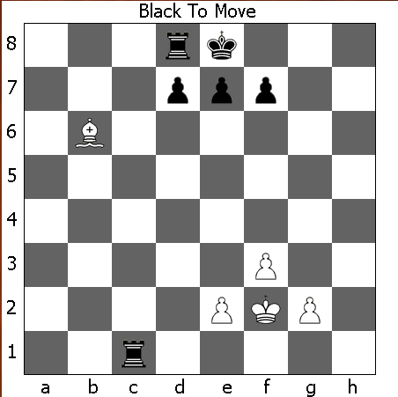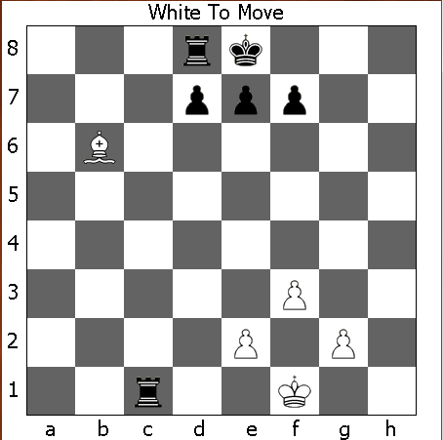This example was used in the previous “skewer” tactic. Normally, white would be guaranteed to get at least one rook with his bishop, but black may “gain time” by checking the enemy king. If black moves Rc1+, white must move the king, and then black will be allowed to move his other rook before white can take with the bishop.

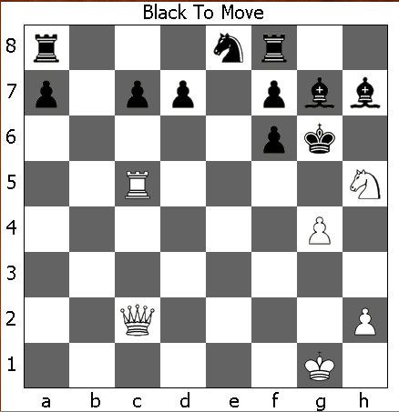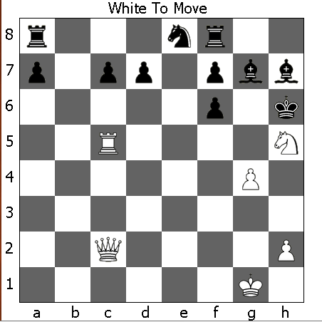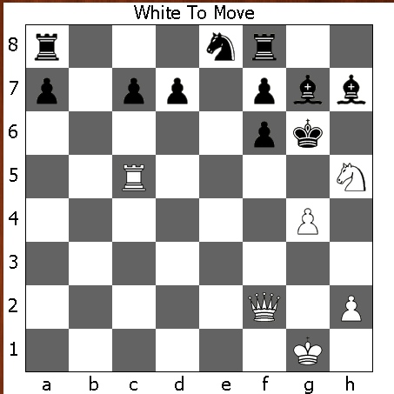Gaining time on the King can also be a very offensive maneuver. As you approach lategame, and clutter in the middle of the board clears up, the queen becomes a devastating piece because of her mobility. In this example, the queen can manufacture a material advantage seemingly out of nowhere by continuously gaining time on the black King. If you count up the material, it looks like black is winning (24 to 19), but white can take the forcibly seize the advantage with his queen. To understand how he does this, we need to see how we can take advantage of black’s exposed king. The king is stuck between two squares, g6, and h6. We can check him over and over again by moving the queen back and forth from the b1-h7 diagonal, and the c1-h6 diagonal. However, moving the queen back and forth between the same two squares is going to get  
us nowhere. We need to make slow progress towards  
the desired square.

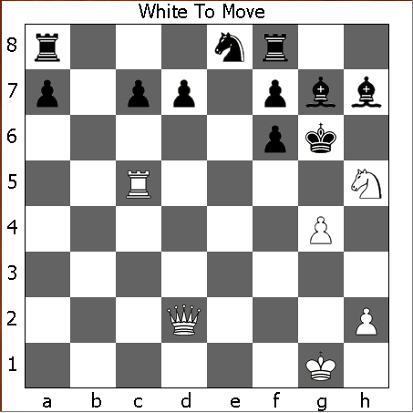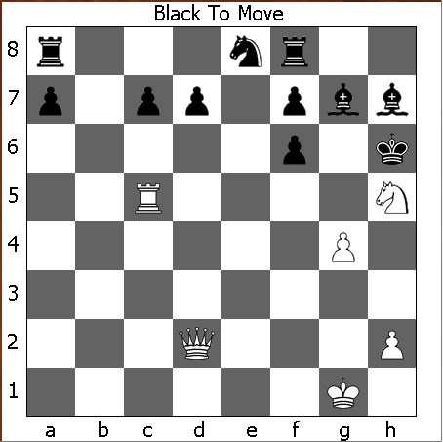Qc2+, getting us to one of the key diagonals, the king must now move, so we will get to check again. If we are going to try to nab some free materials, we can’t aim at any protected pieces, as the queen is more important than any single piece that black has. Therefore, we can determine that we need to aim for an unprotected piece. The unprotected rook on a8 is the best unprotected material that black has. Our queen can’t approach from the same row or column as the rook, or the rook will just kill the queen. We must attack the rook from the diagonal.

The key square which checks the king and threatens the rook is e4. So we want to make progress towards that square. This will take a few moves, since we are only progressing one adjacent square at a time.

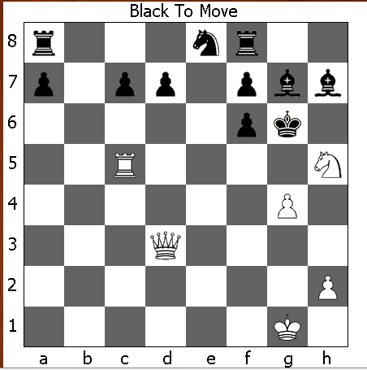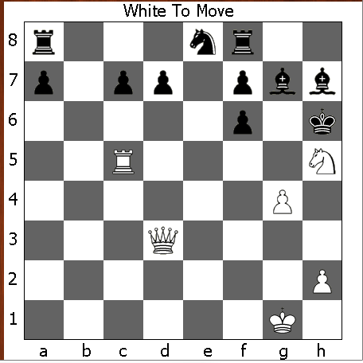

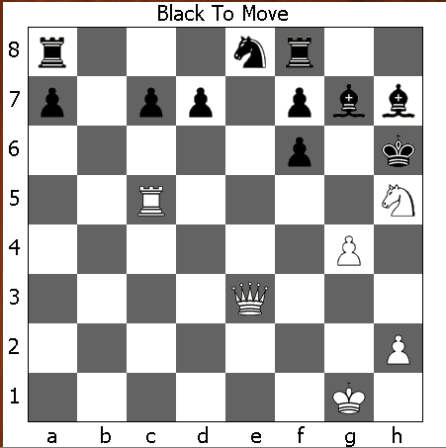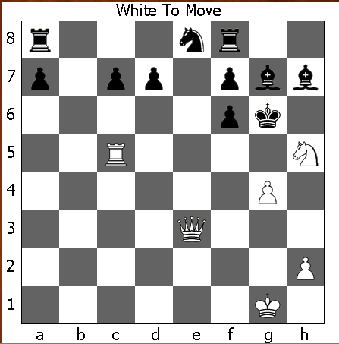

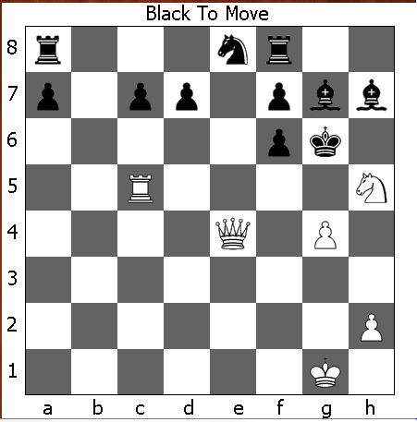 And now we can fork the king and the rook:

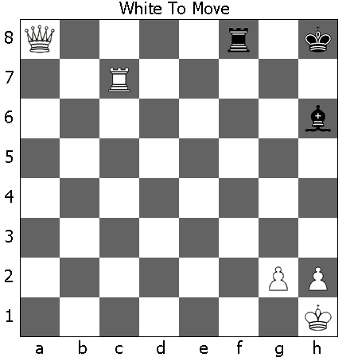

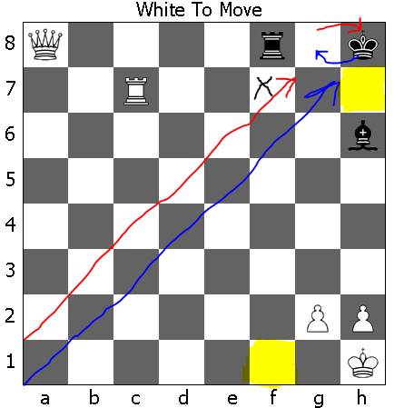Here is another example with the queen. Can you spot how we might gain time on black’s king? Are there any hanging pieces that we might be able to take? Can we force a checkmate? Do we have much room for error?

Mate in 12 or less

We see that the king is stuck between two squares because of our rook. We can alternate on the a1-h8 (red) and a2-g8 (blue) diagonals to continuously check the king.

Now, in this example, black could block a check on the blue diagonal with his bishop  
 (.. Bg7), however, this would immediately lose (Qxg7#) when we recapture with the queen. Similarly, the Rook could block the checks on the red diagonal (Rf7), but then the Queen could recapture (Qxf7+) and then checkmate (… Kh8; Qh7#). So, it turns out that blocking is not really a possibility.   
  
I have highlighted the 2 most important squares for both sides. If black can get his rook to f1, It will be checkmate (Rf1#). While could prevent this by keeping his queen on row 1, or by staying on the a4-d1 diagonal, but we wouldn’t want to dedicate our queen to stopping the enemy rook when it is capable of more. Our rook would be able to prevent the back-rank-mate by moving to c1, if not for  
 .. Bxc1. If white gets his queen to h7 (with rook protection) it will be checkmate. Qg7+ would be checkmate if it weren’t for that pesky bishop. White can’t threaten that square or else the black rook would immediately checkmate the white king.

So, in this scenario, it would be best to either force a capture on the hanging piece (bishop on h6) or to move our queen to a spot that both threatens the checkmate square (h7) and protects the square black could checkmate us on (f1). So the best series of moves would be to gain time on the queen until our queen has made it here (Qa1+ Kg8; Qa2+ Kh8; Qb2+ Kg8;Qb3+ Kh8):  
  
  
  
  
In This position, white has a choice of 2 winning moves: he could continue gaining time on the king until he reaches e6+ and forcibly wins  
(Qxh6+ K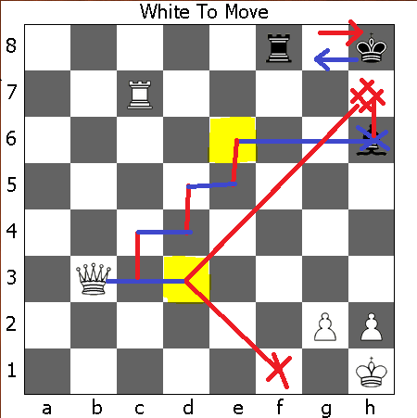g8; Qh7#), or he could go straight to d3, and black has no answers to the checkmate threat (Qd3 Rf1+; Qxf1 .. and white easily checkmates soon) or (Qd3 .. ; Qh7#).

Check Abuse very clearly demonstrates how much of a liability an exposed king can be, especially when there is still a queen on the board. It also shows how strong rooks are at confining a king to a small space, and how this can be taken advantage of.

**Tactic 6:** *The Kick*

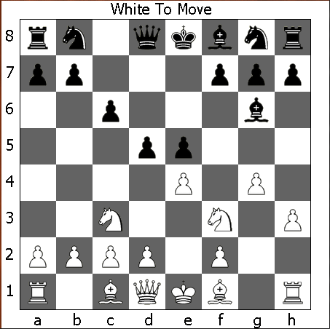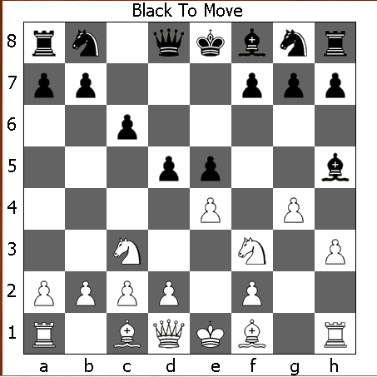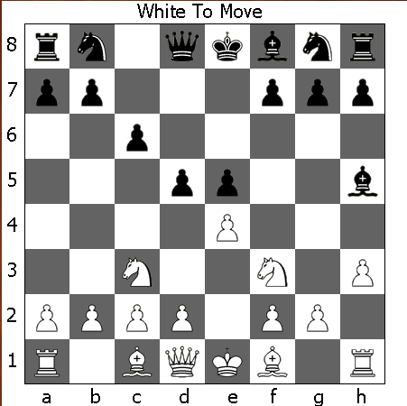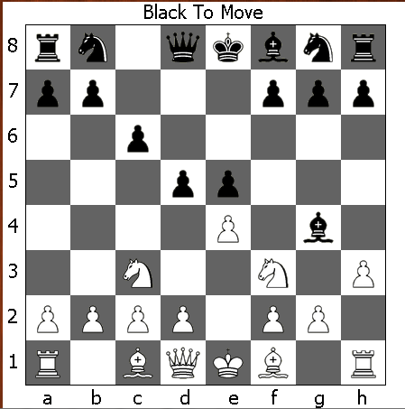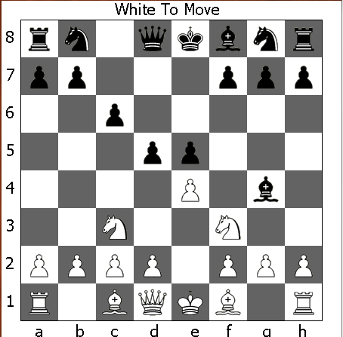This tactic is the use of the fact that people don’t want to trade down in most situations. Because a queen is worth more than a pawn, when a conflict between a protected pawn and a queen arises, the queen will be the one to run. You can use lesser pieces to bully the more important pieces around by pushing them with threats. This is frequently done with pawns – because they are the least valuable individual pieces. When a pawn pushes a more important piece around like so, it is called a kick. I’m not going to spend much time discussing this one, because it is an easy concept to understand. Here is an example:

As you can see – this is great for pushing a piece out of a powerful square. We were able to unpin our knight to our queen by pushing the bishop away, while grabbing some space for ourselves. White can now Nxe5 without the bishop killing the queen (although he might want to put an extra piece of protection on his e4 pawn first). He also has opened a good spot for his bishop on g2.