Exploring Predictive Maintenance and Signal Processing Techniques for Automotive Health Monitoring

Amruta Amune   
Department of Multidisciplinary Engineering  
Vishwakarma Institute of TechnologyPune, India  
amruta.amune@vit.edu

Soham Nimale  
Department of Multidisciplinary Engineering  
Vishwakarma Institute of TechnologyPune, India  
soham.nimale22@vit.edu Sagar Shahari  
Department of Multidisciplinary Engineering  
Vishwakarma Institute of TechnologyPune, India  
sagar.shahari221@vit.edu

Soham Surdas  
Department of Multidisciplinary Engineering  
Vishwakarma Institute of TechnologyPune, India  
soham.surdas22@vit.edu Soham Kasurde  
Department of Multidisciplinary Engineering  
Vishwakarma Institute of TechnologyPune, India  
soham.kasurde221@vit.edu

Shubham Tayde  
Department of Multidisciplinary Engineering  
Vishwakarma Institute of TechnologyPune, India  
shubham.tayde22@vit.edu

*Abstract*— Predictive maintenance is one of the most crucial technologies in today's world, having applications in various domains like automotive, aerospace, manufacturing, and so forth. It is a data-oriented approach that helps predict if any machine or associated component with the machine needs maintenance or not. It also helps predict the remaining lifespan of the same. Various machine learning-based algorithms and models are being developed in this domain. Some of them include Deep-learning-based approaches like Autoencoders, ANNs, CNNs, and so forth, and Signal Processing models using factors like Mean Squared Error for superimposition of primary signals with appropriate opposite phase signals. We present a systematic study of various research work done in this field specific to the Automotive sector. We focus on the problems solved by the authors through their proposed solutions, some of the results and insights, and a brief description of their proposed solution. Approximately 30 research papers were included selectively in this study. We conclude the paper by suggesting a future direction in the predictive maintenance field based on periodic monitoring, in contrast with the trend of continuous monitoring for early diagnosis.

Keywords—Automotive Technology, Deep Learning, Machine Learning, Predictive Analysis, Signal Processing.

# **Introduction**

Predictive maintenance is a necessity. The wear and tear of various components and their parts in a car or heavy vehicle, especially the engine, can lead to risks of malfunctioning or even complete failure. Sometimes, this leads to consequential outcomes like the loss of lives. Even the cost and time required for maintenance after such malfunctions or failures is very high. Fatal issues like brake failure, wear and tear of brake pads and tyres, fuel leaks, component failing, fluid leakage, battery failure, and overheating are common occurrences if the maintenance is unfinished. The prediction of the exact time when some of these components might need maintenance is the major problem associated with the existing systems. The components also become less repairable over time, making it necessary to get an accurate estimate of this time.

Thus, Predictive maintenance, as the name suggests, helps predict the need and time for maintenance of these components in advance, helping solve most of the discussed problems. Early diagnosis using predictive maintenance can help reduce downtime and even extend the lifespan of the components when compared with the typical diagnosis methods. It eventually leads to the reduction of the overall cost of the maintenance. The presented advantages hold since an early diagnosis leads to appropriate actions being taken through maintenance before the components under consideration become less repairable.

Most of the predictive maintenance systems in the automotive sector use continuous monitoring systems. It helps make an early diagnosis and also proves to be a great source of data for analysis and feature extraction. The data and the extracted features could then be used to solve problems related to the associated components like engine health prediction, engine vibration analysis, and so forth. The same collected data is also used for an early diagnosis of these vehicles.

Sensor technologies, including wired and wireless sensors are being used to collect this data. For example, the rotational speed of an engine could be monitored by a wireless rotation sensor and the information could be passed to the control system present in the vehicle for further processing and analysis. Multiple such sensors are attached to such vehicles, making them rich data sources. Such quantities of data could be stored using the Cloud technology, also enabling remote analysis and computing power, further reducing the overall cost of the system. This paper presents a comprehensive survey of predictive analysis and signal processing systems that aims to

* Present existing solutions for the predictive maintenance of vehicles and their components.
* Present various existing Signal Processing techniques used for vibration and sound analysis, focusing more on the engine.
* Present various problems in the existing systems implemented in these vehicles and their high-level diagnosis and solutions to these problems.
* Summarize the results of the research work presented by authors and highlight their novelty. Results are also included from the research works where experiments like the use of biodiesel are conducted on these vehicles.
* Search for new approaches and present potential recommendations and directions for future research in this field.

In this paper, the Section I focus on the survey, the problems faced by existing systems and the need of predictive maintenance. The section II discusses about the methodology used for the survey, along with the description of the papers used for the same. Section III comprises of the detailed description of each research category and the problems, solutions, insights, and results from each of the shortlisted papers. The section IV presents the challenges yet to be solved in this field along with an appropriate future direction based on periodic predictive maintenance approach. Finally, we conclude and summarize our study in the section V.

# **Literature Review**

For better presentation of the literature survey, we have divided it into four categories using the categories represented in the following figure 1. The categories include Informative, Fuel Experimentation, Sound/Vibration Analysis, and Predictive Maintenance. Informative papers explain the working, faults, innovations, regulations, and technical terminologies associated with the automotive and predictive maintenance field. There are about eight papers in this category, depicted in Fig. 1.

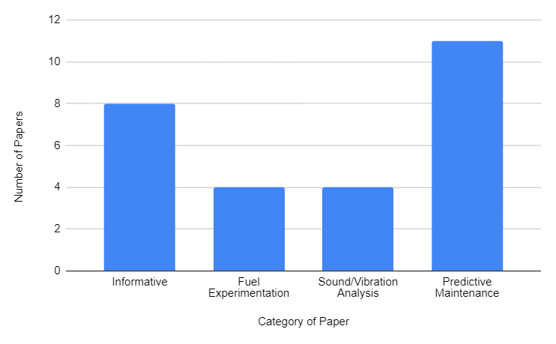

Fig. 1. Category-wise frequency of the shortlisted papers

## **Informative**

The authors, Hani Ali Almubarak, et al. [1] discussed the basic tests to be performed for manual fault diagnosis of engine-related issues. They present four major tests including Compression tests, Ignition tests, and fuel pressure tests. They also provide systematic representations of the possible causes and the solutions to various problems that could be diagnosed from these tests. One of the major features of their methodology is the prediction of internal engine faults from external tests of the vehicle.

T. Selvakumar, et al. [2] presented a hybrid solution to the problem of dependence of vehicles on non-renewable fuels. They suggest a novel hybrid engine that works in two modes, electric and internal combustion mode. They also provide a detailed description of various technical terminologies and processes involved in both types of engines.

In [3], L. Plotnikov, et al. presented a novel computer-based numerically modelled approach for fuel testing for piston-based engines. They use the computer model to simulate the engine upon the different types of fuels and produce valuable results. Some of their results and insights include the identification of fuels like propane and methane for more cost-effective and efficient results. They also showed that a switch of fuel caused a 5-12% loss in the power, but and 4-13% increment in the fuel usage efficiency.

T. Haus, et al. [4] provided a very detailed explanation of various factors affecting the engine and how each factor is measured. They also design a controller for rotational speed using these factors to create a setpoint for the rotational speed. The novelty of their work lies in the detailed work of understanding the engine’s behaviour under the influence of the given factors and how they control these factors to achieve the desired goal.

J. S. Potdar, et al. [5] explained the design methodology of an electronic control unit for the optimization of fuel injection and spark ignition timings. The system was designed for a four-cylinder engine. They used various sensors for obtaining data like the engine coolant temperature, the fuel pressure, and so forth. The controller itself uses the obtained data to control the actuators and produce the desired results for the given input. Their proposed system was also able to reduce the exhaust gas emissions.

In [6], A. X. A. Sim and B. Sitohang presented a detailed development process of an end-to-end system for on-board diagnostics. The authors explain various standards and regulations to be followed while developing such systems. They also give an overview of the software and hardware requirements and the communication model along with the problems associated with it.

O. S. Kuzema and P. O. Kuzema helped to find a relation between the car engine operation time and the mechanical contaminants in the engine’s lubricant in the paper [7]. They perform this experiment with the help of electron microscopy. With the help of the impurities found in the engine oil, the authors could conclude the approximate car technical conditions, the engine operation time, and the quality of the oil filter used to use their novel experimentation.

In [8], T. Shen and J. Zhang described the standard problems associated with control systems for internal combustion engines. They provide a solution using two control loops one for fuel injection and spark ignition each. Using their novel solution, they were also able to overcome the problems of the cold-starting phase of the automotive.

## **Fuel Experimentation**

In [9], P. V. Sagar et al. experimented with the Jatropha biodiesel blends by tracking the emissions and the impact of the fuels on the performance. They observed a 30-10% reduction in the emission of NOx gases. The best results were seen with 20% of biodiesel by volume in diesel, integrated with 10% of Exhaust Gas Recirculation (EGR).

R. Schmied, et al. in [10] presented a solution to control the NOx emissions under various abnormal conditions. They use the input shaping technique to produce a response to the transient emission profile. The injection parameters are changed to dynamically reduce the NOx emissions, resulting in an almost 15% reduction of NOx emissions without any considerable change in the combustion noise level.

In [11] V. A. Markov, et al. experimented with various combinations of vegetable oil additives with diesel fuel for obtaining an optimal performance and minimizing the emissions of NOx, HCs, and CO. They observed that the emissions decreased at a much higher rate compared to the decrease rate of the torque produced due to the oxygen-rich nature of these additives. They obtained the maximal results with the combination of 10% soybean oil and 90% diesel fuel by volume.

In [12], D. Kurczyński experimented with the different concentrations of rapeseed oil methyl esters and diesel fuel to test the emission reduction concerning NOx gases. The presence of oxygen in the esters helped reduce the quantity of HCs and NOx through the exhaust. They also observed the reduction of CO levels in the emissions as well.

## **Signal/Vibration Processing**

Y. Karunakar, et al. [13] try to solve the problem of fault diagnosis of car engines using signal analysis of the recorded engine sound signals. They use the technique of discrete and continuous wavelet transformation to diagnose the underlying fault in the system. The diagnosed problems include battery-related issues, fuel problems, starter problems, and other engine-related problems. Their proposed solution does not work in real time.

N. Xiangju, et al. [14] present a noise pollution reduction system based on superimposing of sound waves of opposite phases. Their novel approach includes the use of an Adaptive controller to generate this secondary signal. An adaptive controller was needed to make sure the system was robust against various environmental factors and noises. Finally, they present results where they compare the original vibrations and the superimposed vibrations to depict the reduction of amplitude due to the superimposing waves.

In [15], A. Yar, et al. discussed a novel system based on sound and vibrational analysis for dynamic control of engine cylinder usage for better performance. Their novel ideas include the adjustment of the power of individual cylinders to reduce fuel consumption at times when one or two cylinders are not needed for power generation. Their proposed system reduced the fuel utilization by 10%. They were also able to extend their model to create an early fault detection system based on the data generated during the adjustments of the cylinder. The authors further plan to divide the cylinder into various processes and parts and create an end-to-end system that can control each process and part individually to optimize the performance of the engine and at the same time save as much fuel as possible.

H. Zhao, et al. [16] make use of a deep Convolutional Neural Network (CNN) for the classification of valve clearance fault diagnosis. They reduce the complexity of this task by using techniques like Wavelet packet transform and Mel Frequency for better feature extraction. They also present the various possible causes for the valve fault which include aging, constant change in temperature and pressure, and so forth. The overall accuracy of their model was 93.34% on the intake valves and 99.97% on the exhaust valves.

## **Predictive Analysis**

A. Sarwar, et al. presented an end-to-end system for the fault diagnosis of the Lubrication system in their paper [17]. They propose a real-time system based on the closed-loop control adaption of a continuous variable displacement oil pump (cVDOP). Their solution not only isolates the faults but also presents the severity of the same along with various warning mechanisms.

In [18], Q. Ahmed, et al. developed a virtual-sensor-based solution for the fault diagnosis of sensors. They experimented with the solution and tested their proposed methodology. They obtained novel results for the fault diagnosis of the sensors present in the intake system.

In [19], H. C. Vu, et al. used temperature-based data for the prediction of the engine health status of industrial diesel engines. They use particle-filer-based technology for this prediction task. Their solution is an almost real-time system, with very high accuracies. The results presented by them represent the predicted failure and the real failure with an insignificant amount of delay, making their solution novel.

D. Mahmoud and E. A. R. Mustafa suggested the use of Artificial Neural Networks (ANN) to predict the emissions of gases like NOx and CO [20]. The predictions are then used to further improve the system design and optimization. They also provide a graphical user interface for end users to use the system with ease. Finally, they compare the ANN output with the real-time data and obtain almost overlapping results.

K. Chen, et al. [21] discussed the approaches of fault diagnosis in the valve train of an engine. They explained the reasons for faults, and their predictions and proposed their novel methodology to perform the same using stacked auto-encoders and a combination of supervised and unsupervised learning. Another novelty of their approach includes the prediction of fault directly through the raw data, without any prior preprocessing, making it much easier to deploy in real-time.

H. Wang, et al. [22] discussed a unique approach to diagnosing dual fuel engines based on not only the data while the engine runs on one of the fuels, but also on the data generated while the engine switches from one fuel mode to the other. They present a detailed description of the software and hardware used for experimentation purposes and thus provide a novel approach for engine health prediction for dual-fuel cars.

In [23], W. Qian presented a smart Dynamic Bayesian Network-based model that could not only help predict the reliability of an engine but also understand the underlying relation between various extracted features and how they relate to the engine. A time series-based approach is used by the authors for a comprehensive analysis and accurate prediction.

S. A. Mostafa, et al. [24] discussed the application of an agent-based inference engine to determine any car failure beforehand i.e. to give an early diagnosis of car failure. They depict the entire system diagram for their proposed model along with various layers involved in the same. Their proposed solution provides a higher accuracy rate when compared to traditional solutions that use logical flows.

In [25], Campean, et al. explained the various challenges in the development of an Integrated Vehicle Health Management System (IVHMS) for automobiles. They include both the health monitoring and the performance monitoring of the automotive. They suggest that the use of IVHMS would lead to a simplified representation of complex early diagnosis and monitoring systems. Finally, they present the framework for the detection, diagnosis, prediction, and prevention of failures and provide methods to improve the efficiency and performance of this framework.

Y. Li, et al. [26] proposed a predictive maintenance system based on oil sensors. They not only predict the faults in the engine but also present a health evaluation with appropriate scoring to know the continuous status of the engine. The oil sensor monitors both, physical and chemical indicators. To test their system, the authors deployed their solution on tracked armoured vehicles in actual working conditions of the engine.

In [27], S. M. Namburu, et al. discussed a real-time fault detection system for automotive engines. The authors focused on a data-driven approach to improve efficiency and reduce the costs of engine failure. Their novelty lies in the integrated solution that made use of both statistical and signal/vibration-based data. They were able to achieve an accuracy of 82.22% even on sparse training data.

# **Methodology**

To conduct a comprehensive survey, we divided the papers into various components. Some of the components are presented in the Fig. 2. Initially, we pooled an approximate of 50 papers related to the field of interest i.e. predictive analysis, and signal processing. Papers were also included from some fields like automotive technologies to better understand the problems and existing solutions in the same. Search keywords included: Automotive Engine Health, Engine Health, Car Engine, Predictive Analysis, Signal Processing, and Machine Learning in vehicles maintenance, Experiments in automotive sectors.

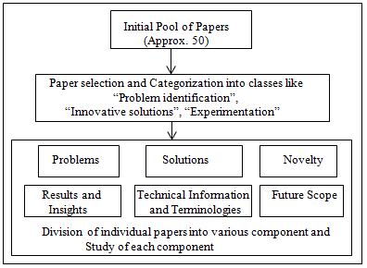

Fig. 2. Methodology used for paper selection and shortlisting for the literature survey, including the division of individual papers into various components for easy of analysis and study.

The specific papers were then shortlisted from the pooled set of papers based on the quality of publication. We also excluded the papers that were published before the year 2003. So, the overall range of papers under consideration included papers published from 2003 to 2024 (till date).

The following figure 3 depicts the split between various sources of the shortlisted papers for the review.

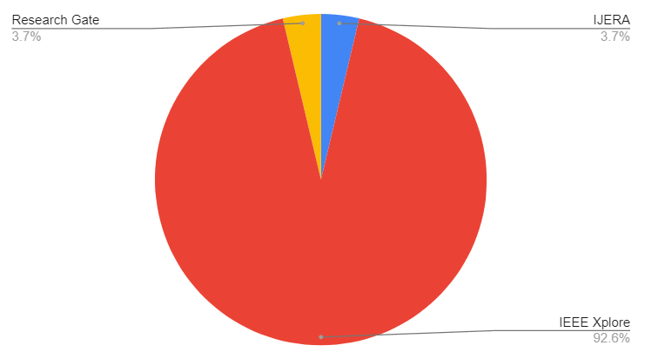

Fig. 3. Split between the types of publication

As shown in above figure, the red slice depicts the conference proceedings and the blue slice presents the journal publications. IEEE Xplore digital library accounted for 92.6% of the shortlisted papers, while 3.7% were from the Research Gate, and the remaining 3.7% were selected from the International Journal of Engineering Research and Applications (IJERA). This percentage corresponds to 25, 1, and 1 paper respectively. 3 out of 27 of the shortlisted papers were from journal publications and 24 were from conference proceedings. It accounts for 11.11% of papers and 88.88% of papers respectively, as depicted in Fig. 4.

As shown in fig. 4, the red slice depicts the papers published in the IEEE Xplore, the blue slice depicts the papers published in the IJERA journal, and the yellow slice depicts the papers published in the Research Gate.

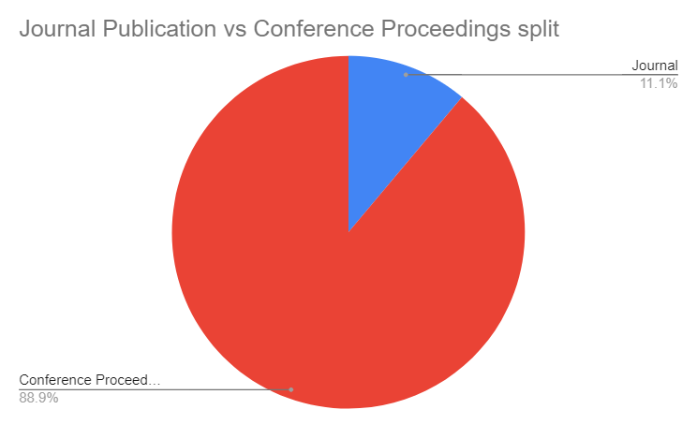

Fig. 4. Split between the sources of the shortlisted papers.

They correspond to 29.62% of the total shortlisted papers. Four papers belong to the Fuel Experimentation category, where authors have tested various fuel alternatives on diesel-based Internal Combustion engines. They account for 14.8% of the shortlisted papers. The four papers in the category Sound/Vibration Analysis, accounting for 14.8% of the shortlisted papers, discussed the appropriate procedures and techniques for fault diagnosis of engines using the sound and vibration produced by the engine. Finally, about eleven papers from the category of Predictive Maintenance provide a detailed explanation of early fault diagnosis using approaches like machine learning. They account for 40.74% of the total shortlisted papers. Fig. 5. Depict the year-wise frequency distribution of the shortlisted papers.

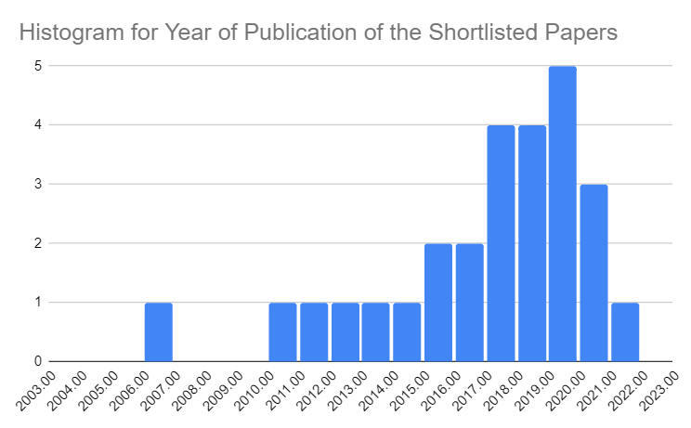

Fig. 5. Frequency distribution of the shortlisted papers based on the year of publication in the journal or the conference proceedings

The maximum and minimum year for the shortlisted papers corresponds to 2022 and 2006 respectively. Most of the shortlisted papers were from 2019. Thus, once the shortlisted papers were gathered, a thorough review was done and the insights gained from each individual paper are presented.

# **Comparative Analysis**

In this section, we provide a comparative analysis of various approaches used for the purpose of vehicle predictive maintenance and sound/vibrational analysis. The accuracy of 98%, using an AI model for an overall “vehicle level” predictive maintenance was observed by S. Bundasak, et al. in [28]. They applied K-Nearest-Neighbours, Naïve Bayes, and Logistic Regression algorithms for this purpose, and got the highest accuracy of using the Logistic Regression model. Meanwhile, H. Zhao in [16] achieved an 99.79% and 93.34% accuracy in valve fault detection, corresponding to the exhaust and the intake valve fault diagnosis respectively. Authors of [27] were able to achieve 82.22% accuracy while classifying various types of faults, where some of the faults had an 100% of classification rate. K. Chen, et al. achieved 98.6% accuracy in [21]. They perform valve fault diagnosis for internal combustion engines using stacked autoencoders.

The summary of the comparative analysis of shortlisted papers is presented in following Table I.

Table 1. Summary of comparative analysis of the shortlisted papers.

| Paper Reference No. | Year | Model/ Approach | Accuracy |
| --- | --- | --- | --- |
| 16 | 2019 | Convolutional Neural Network and Signal Processing | 99.79% - Exhaust Valve  93.34% - Intake Valve |
| 21 | 2019 | Stacked Autoencoders | 98.6% |
| 28 | 2022 | Logistic Regression | 98% |
| 27 | 2006 | Generalized Likelihood Ratio Test (GLRT) | 82.22% |

# **Challenges and Future Directions**

The major challenge we uncovered in the predictive maintenance and the signal processing approach for early diagnosis of automotive faults is the use of Continuous Monitoring Systems. By Continuous Monitoring Systems, we refer to the paradigm of solving this early diagnosis problem by continuously obtaining the readings from the sensors while the vehicle is running and producing continuous results using them over time. Continuous monitoring of these vehicle components using various sensors is a great approach to track the component health and to identify any anomaly if it occurs. However, with this methodology, the sensor lifespan itself is reduced. This issue occurs due to the active time of these sensors. Sometimes, the readings of these sensors deviate from the expected readings not because of an anomaly in the vehicle, but due to the wearing out of the sensor itself over time. Several issues that cause such wearing are as follows: aging, rapid changes in the readings (sometimes caused by oscillating readings), continuous heat generation, inconsistent power supplies, and others. Another issue with the employment of Continuous Monitoring Systems for early diagnosis is the high power usage. A considerable amount of power is utilized to run these sensors and the processing unit. This power consumption falls under the non-functional category. By non-functional category, we refer to the use of power for tasks performed for a purpose that is not necessary for the normal functioning of the vehicle.

To solve these issues, we propose a new direction of research in the predictive maintenance and signal processing field for the automotive sector. The proposed direction includes the implementation of “Periodic” Monitoring Systems for this task. Periodic monitoring refers to the usage of sensors and the processing unit for early diagnosis prediction only after certain intervals of time. The time interval itself could vary depending on the use case. Some examples include multiple times per day, once per day, once per week, multiple times a month, and once per month. This methodology of predictive maintenance would lead to a high reduction in the cost and power of performing the same task. Although there exists a trade-off between the accuracy of the system and the consumed power for the same task, this approach is pragmatic and fits perfectly in general everyday scenarios. The description of the trade-off is as follows - by reducing the accuracy of the overall system we try to save the power consumed for its functioning.

We also observed that most of the research papers that depict the results of various variations in the existing fuels to try and reduce the emissions of NOx, CO, and HCs do not include the effect of the same on the vehicle’s engine health over time. It is a significant part of such experiments and should not be forsaken. Another suggested direction for future research is to include the correlation between the various variations in the existing fuels for a particular vehicle with their engine health over time. This correlation would be a significant factor, along with other factors like emission reduction, throughput, and others, in determining whether an alternative fuel could replace the existing ones.

The final direction for future research would include research on the integration of predictive maintenance using sensor data like internal temperature, pressure, and so forth, and signal processing with vibration analysis. It could be possible to use various methods like ensemble learning or the usage of a single model that can account for both the feature vector and the vibration data to produce a single output for early diagnosis of faults.

# **Conclusion**

This paper presents a comprehensive literature survey on the predictive maintenance and signal processing approaches for early vehicle fault diagnosis. It also includes papers describing the problems in the automotive sector, focusing more on the engine of vehicles. Another category of paper included in this survey is the experiments performed by various authors in this sector and their impact on emissions, performance, and engine health. We also present the methodology for paper selection and shortlisting for better insights into the fields related to our work. After a thorough literature review, we conclude the paper by providing various novel future directions in the predictive maintenance field for the automotive sector including the use of “Periodic” Monitoring Systems.

# **References**

1. Hani Ali Almubarak, Ahmad Hussain Albloushi. Automotive engine tests "the basics". International Journal of Engineering Research and Applications. Jul 21
2. T. Selvakumar, S. Karthik and S. A. Kumar, "Modern Electric Engine for Future Cars," 2018 International Conference on Power, Energy, Control and Transmission Systems (ICPECTS), Chennai, India, 2018, pp. 289-293, doi: 10.1109/ICPECTS.2018.8521629.
3. L. Plotnikov, A. Kozubsky, A. Maksimenko and L. Osipov, "Numerical Modelling of Working Processes of Piston Engines Operating on Different Types of Fuel," 2019 60th International Scientific Conference on Information Technology and Management Science of Riga Technical University (ITMS), Riga, Latvia, 2019, pp. 1-4, doi: 10.1109/ITMS47855.2019.8940694.
4. T. Haus, M. Car, M. Orsag and S. Bogdan, "Identification results of an internal combustion engine as a quadrotor propulsion system," 2017 25th Mediterranean Conference on Control and Automation (MED), Valletta, Malta, 2017, pp. 713-718, doi: 10.1109/MED.2017.7984202.
5. J. S. Potdar and Y. B. Mane, "Hardware Design and Development of Engine Control Unit for Four Cylinder Engine," 2018 Fourth International Conference on Computing Communication Control and Automation (ICCUBEA), Pune, India, 2018, pp. 1-5, doi: 10.1109/ICCUBEA.2018.8697769.
6. A. X. A. Sim and B. Sitohang, "OBD-II standard car engine diagnostic software development," 2014 International Conference on Data and Software Engineering (ICODSE), Bandung, Indonesia, 2014, pp. 1-5, doi: 10.1109/ICODSE.2014.7062704.
7. O. S. Kuzema and P. O. Kuzema, "Effect of the duration of car engine operation on the mechanical contaminants in its lubricant," 2017 IEEE 7th International Conference Nanomaterials: Application & Properties (NAP), Odessa, UKraine, 2017, pp. 01PCSI03-1-01PCSI03-4, doi: 10.1109/NAP.2017.8190142.
8. T. Shen and J. Zhang, "SICE benchmark problem of engine control and a challenging result," Proceedings of the 10th World Congress on Intelligent Control and Automation, Beijing, China, 2012, pp. 2340-2345, doi: 10.1109/WCICA.2012.6358265.
9. P. V. Sagar, L. Agarwal, M. V. L. Sravan Kumar, K. Nanthagopal and T. Elango, "Effect of EGR on emissions from a single cylinder diesel engine using Jatropha Biodiesel blends," 2013 International Conference on Energy Efficient Technologies for Sustainability, Nagercoil, India, 2013, pp. 562-565, doi: 10.1109/ICEETS.2013.6533446.
10. R. Schmied, S. Stadlbauer, H. Waschl and L. del Re, "Improving the transient emission performance of a Diesel engine by input shaping techniques," 2015 54th Annual Conference of the Society of Instrument and Control Engineers of Japan (SICE), Hangzhou, China, 2015, pp. 1287-1292, doi: 10.1109/SICE.2015.7285459.
11. V. A. Markov, S. N. Devyanin and S. Bowen, "Emission Performance of a Diesel Engine Running on Petroleum Diesel Fuel with Different Vegetable Oil Additives," 2020 International Multi-Conference on Industrial Engineering and Modern Technologies (FarEastCon), Vladivostok, Russia, 2020, pp. 1-5, doi: 10.1109/FarEastCon50210.2020.9271091.
12. D. Kurczyński, "Impact of RME biodiesel on the concentration of particulates and nitrogen oxides in compression ignition engine exhaust fumes," 2020 XII International Science-Technical Conference AUTOMOTIVE SAFETY, Kielce, Poland, 2020, pp. 1-7, doi: 10.1109/AUTOMOTIVESAFETY47494.2020.9293517.
13. Y. Karunakar, A. Kuwadekar and K. Al Begain, "A Mobile Based Application for Detecting Fault by Sound Analysis in Car Engines Using Triangular Window and Wavelet Transform," 2010 International Conference on Computational Intelligence and Communication Networks, Bhopal, India, 2010, pp. 523-528, doi: 10.1109/CICN.2010.103.
14. N. Xiangju, M. Xinglei, Q. Shuang and G. Hongjun, "The research of car engine rotating speed adaptive active control system," 2017 First International Conference on Electronics Instrumentation & Information Systems (EIIS), Harbin, China, 2017, pp. 1-4, doi: 10.1109/EIIS.2017.8298725.
15. A. Yar, Q. Ahmed, C. Hall and A. I. Bhatti, "Model-based Selective Cylinder Deactivation Strategies in an Inline Four Cylinder Gasoline Engine," 2018 Annual American Control Conference (ACC), Milwaukee, WI, USA, 2018, pp. 2443-2448, doi: 10.23919/ACC.2018.8431794.
16. H. Zhao, Z. Mao, K. Chen and Z. Jiang, "An intelligent fault diagnosis method for a diesel engine valve based on improved wavelet packet-Mel frequency and convolutional neural network," 2019 International Conference on Sensing, Diagnostics, Prognostics, and Control (SDPC), Beijing, China, 2019, pp. 354-359, doi: 10.1109/SDPC.2019.00071.
17. A. Sarwar and S. B. Mehdi, "Fault Diagnosis of Lubrication System in Internal Combustion Engine," 2019 IEEE International Conference on Prognostics and Health Management (ICPHM), San Francisco, CA, USA, 2019, pp. 1-8, doi: 10.1109/ICPHM.2019.8819395.
18. Q. Ahmed, A. I. Bhatti and M. Iqbal, "Virtual Sensors for Automotive Engine Sensors Fault Diagnosis in Second-Order Sliding Modes," in IEEE Sensors Journal, vol. 11, no. 9, pp. 1832-1840, Sept. 2011, doi: 10.1109/JSEN.2011.2105471.
19. H. C. Vu, P. Do, B. Iung and F. Peysson, "A case study on health prediction of an industrial diesel motor using particle filtering," 2017 Prognostics and System Health Management Conference (PHM-Harbin), Harbin, China, 2017, pp. 1-7, doi: 10.1109/PHM.2017.8079245.
20. D. Mahmoud and E. A. R. Mustafa, "Modelling and gasses emissions prediction for a turbo-charged diesel engine using artificial neural networks," 2015 International Conference on Computing, Control, Networking, Electronics and Embedded Systems Engineering (ICCNEEE), Khartoum, Sudan, 2015, pp. 368-373, doi: 10.1109/ICCNEEE.2015.7381393.
21. K. Chen, Z. Mao, H. Zhao and J. Zhang, "Valve fault diagnosis of internal combustion engine based on an improved stacked autoencoder," 2019 International Conference on Sensing, Diagnostics, Prognostics, and Control (SDPC), Beijing, China, 2019, pp. 295-300, doi: 10.1109/SDPC.2019.00060.
22. H. Wang, I. Kolmanovsky and J. Sun, "Set-membership condition monitoring framework for dual fuel engines," 2016 American Control Conference (ACC), Boston, MA, USA, 2016, pp. 3298-3303, doi: 10.1109/ACC.2016.7525426.
23. W. Qian, J. Liu, Q. Cao, X. Yin and L. Xie, "Reliability assessment of car engine based on dynamic Bayesian network," 2016 11th International Conference on Reliability, Maintainability and Safety (ICRMS), Hangzhou, China, 2016, pp. 1-4, doi: 10.1109/ICRMS.2016.8050144.
24. S. A. Mostafa, A. Mustapha, A. A. Hazeem, S. H. Khaleefah and M. A. Mohammed, "An Agent-Based Inference Engine for Efficient and Reliable Automated Car Failure Diagnosis Assistance," in IEEE Access, vol. 6, pp. 8322-8331, 2018, doi: 10.1109/ACCESS.2018.2803051.
25. Campean, Felician & Neagu, Daniel & Doikin, Aleksandr & Soleimani, Morteza & Byrne, Thomas & Sherratt, Andrew. (2019). Automotive IVHM: Towards Intelligent Personalised Systems Healthcare. Proceedings of the Design Society: International Conference on Engineering Design. 1. 857-866. 10.1017/dsi.2019.90.
26. Y. Li, W. Dong, X. Yi and Y. Zhang, "Engine Fault Prediction and Health Evaluation Based on Oil Sensor," 2020 Prognostics and Health Management Conference (PHM-Besançon), Besancon, France, 2020, pp. 223-228, doi: 10.1109/PHM-Besancon49106.2020.00044.
27. S. M. Namburu, M. Wilcutts, S. Chigusa, L. Qiao, K. Choi and K. Pattipati, "Systematic Data-Driven Approach to Real-Time Fault Detection and Diagnosis in Automotive Engines," 2006 IEEE Autotestcon, Anaheim, CA, USA, 2006, pp. 59-65, doi: 10.1109/AUTEST.2006.283654.
28. S. Bundasak and P. Wittayasirikul, "Predictive maintenance using AI for Motor health prediction system," 2022 International Electrical Engineering Congress (iEECON), Khon Kaen, Thailand, 2022, pp. 1-4, doi: 10.1109/iEECON53204.2022.9741620.
29. M. Rane, M. Patil, N. Rane and A. Amune, "Random Forest Regressor Approach for Predicting Resale Value of used Vehicles (RFRVP)," 2023 Third International Conference on Advances in Electrical, Computing, Communication and Sustainable Technologies (ICAECT), Bhilai, India, 2023, pp. 1-6, doi: 10.1109/ICAECT57570.2023.10118285.
30. P. Kharade, K. Kodag, S. Khade, O. Kasabekar and A. Amune, "Smart Vehicle with Cognitive Abilities," 2023 7th International Conference On Computing, Communication, Control And Automation (ICCUBEA), Pune, India, 2023, pp. 1-6, doi: 10.1109/ICCUBEA58933.2023.10391965.
31. Musale, V., & Chaudhari, D. (2016). Novel approach towards securing wireless sensor network systems for health care. 2016 International Conference on Global Trends in Signal Processing, Information Computing and Communication (ICGTSPICC), 164-168.
32. T. Parbat, R. Benhal, H. Jain, V. Musale, “Emerging Strategies to Big Data Analytics in Healthcare”, International Journal of Scientific Research in Computer Science, Engineering and Information Technology, ISSN: 2456-3307, Volume 7, issue 6, pp. 254-260, 2021, doi : https://doi.org/10.32628/IJSRCSEIT