**Capstone Project Ideas**

[in order of preference]

1. **Price and Promotion Analytics**

Derive optimal pricing for products based on past transaction history and price sensitivity analysis.

Data availability: Sales transactions data set available

* 1. Profit Optimization – [WA_Retail-SalesMarketing_-ProfitCost]

1. **Market Basket Analysis**

Analysis of transaction data to uncover patterns in purchases – which items are bought together frequently.

Data availability: Grocery data set available

* 1. Belgian Retailer
  2. Groceries data set

1. **Targeted Marketing**

Customer analytics to determine high-value customers to be targeted through direct marketing campaigns

Data availability: Charity/ Donor data set available

* 1. Kaggle competition – Raising money to fund an organizational mission
     1. [https://www.kaggle.com/c/Raising-Money-to-Fund-an-Organizational-Mission]
  2. US Superstore data
     1. Tableau trial version sample dataset
  3. Kaggle competition - Determine whether to send a direct mail piece to a customer
     1. https://www.kaggle.com/c/springleaf-marketing-response

Data Sources:

1. BestBuy – <http://developer.bestbuy.com/apis>
2. Kaggle.com competitions
3. KDD Cup competitions
4. Tableau trial version – sample data sets
5. IBM Watson - <https://community.watsonanalytics.com/guide-to-sample-datasets/>

Exploratory Data Analysis [WA_Retail-SalesMarketing_-ProfitCost]

* Data source:

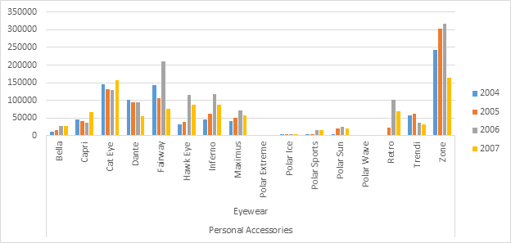

Assumptions:

1. The data analysis is performed for United States; it is assumed that, due to practically constant inflation rates, the prices across the years from 2004 to 2007 do not require any inflation adjustment.
2. This project is an effort to demonstrate an adequate understanding of the subject matter, and therefore does not claim to be useful in real life given the particular data set in question (2004 – 2007). However, the methodology used is very relevant for contemporary real-time effort in any price optimization endeavor.