

INTRA UNIVERSITY PROJECT SHOWCASING

Organized By : Kambaii Innovation and Education & Department of ECE

Team Name : Day Dreamer

Project Name : CCTV Footage Based Intelligent Car Parking System.

Team Members :

1. Animesh Sarkar Tusher  
   Roll – 1801077  
   Dept. of EEE
2. Mehnaj Islam Maliha  
   Roll – 1801070  
   Dept. of EEE
3. Mushfique Promel  
   Roll – 1801101  
   Dept. of EEE

**Project Name :**

CCTV Footage Based Intelligent Car Parking System.

**Objectives :**

1. This project specifically aims to stop the use of "IR Sensor" to automate parking garages. No IR sensors are used in our project.
2. Making an Intelligent Car Parking System.

**Functionality** :

1. In the modern day, CCTV is now required in every parking space. The "Image Processing" technique was used in our project, which used CCTV video as its foundation. Using CCTV footage analysis, we will be able to distinguish between parking spots that are empty and those that are not. Depending on the result, it will permit a car to park in a space. Before approaching the parking place, the driver of a car can check the number of slots available on an LCD display that has been installed there.
2. When every parking space is occupied by cars and a car tries to enter, the parking gate won't open and a buzzer will ring.
3. The gate will open and the free slot numbers will be shown on the LCD screen if there are any available spots.
4. The parking gate must be opened for a car to leave.
5. The RGB will produce green light when a parking place has a vacancy. RGB will produce a red light if there are no available slots, and a blue light if a car wishes to exit a parking place.
6. A phone camera is used as CCTV and it is connected via a USB cable to the computer.

**Application of the project :**

Bangladesh is one of the nations having a highly populated area. The Peoples' main problem is transportation and vehicle parking as a result of the enormous population. The goal of this project is to use image processing to create an intelligent parking system. The Image Processing Technique may be applied in this Systematic Approach to Locate the Free Empty Parking space to Park Our Vehicles. The parking area might be designated with a lot of numbers in the proposed approach, making it possible to locate an empty spot to park a car without the use of any kind of sensors.

In order to easily park the car in a vacant spot, precise numbers can be shown. Finding open parking spaces in parking lots is a common challenge for drivers. This project shows an image-processing-based smart parking lot management system.

**Drawbacks:**

One major drawback of this project is, if we change the camera angle we need to specify the parking slot’s position and height weight again.

**References:**

1. <https://www.researchgate.net/publication/321816743_Image_processing_based_intelligent_parking_system>
2. <https://www.researchgate.net/publication/326439400_A_Smart_Image_Processing-based_System_for_Parking_Space_Vacancy_Management>

**Project Gallery :**

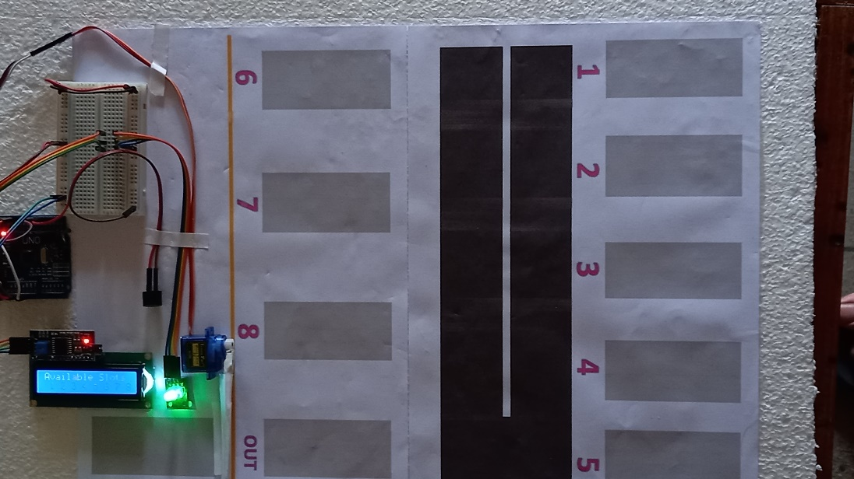

**Fig 01**: Every Slots are Available

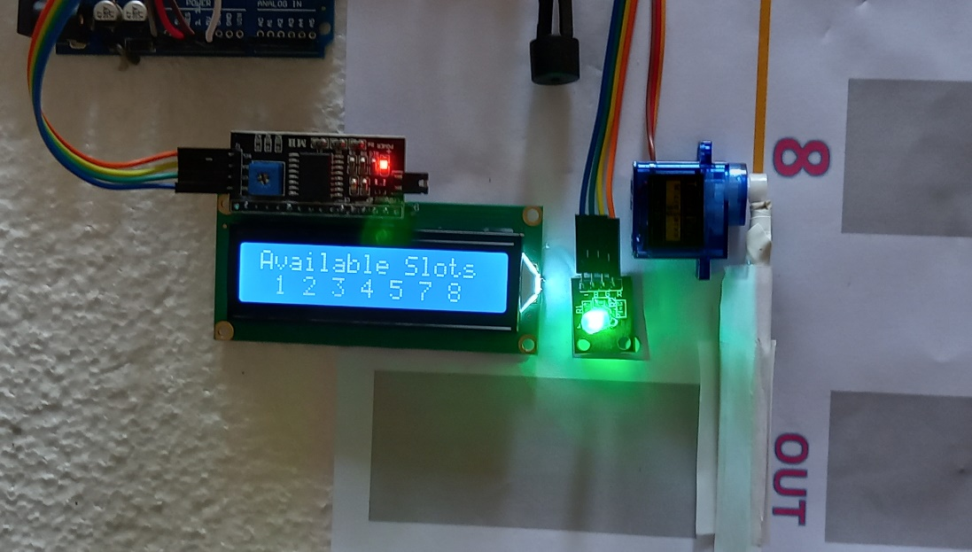

**Fig 02**: LED display showing “Available Slots 1 2 3 4 5 7 8”

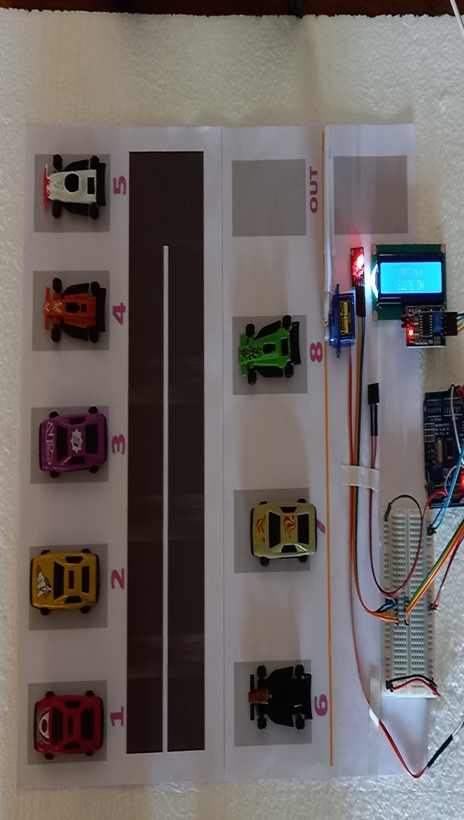

**Fig 03**: Every slot is occupied

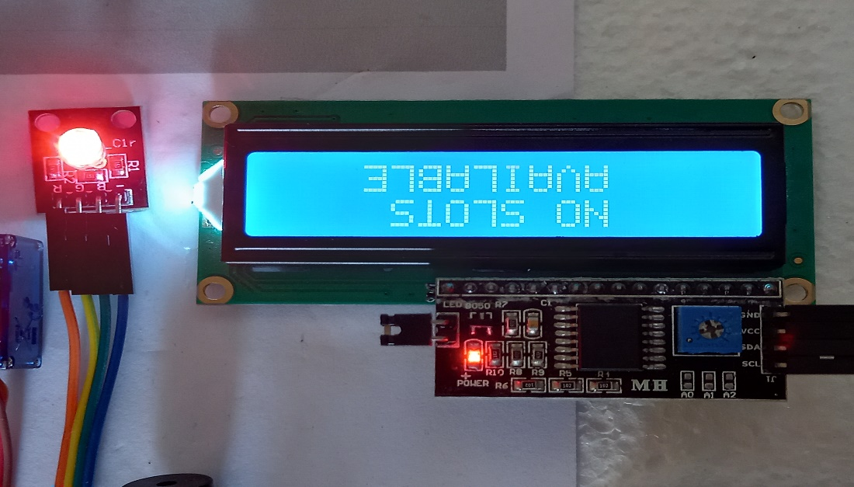

**Fig 04**: LED display showing “NO SLOTS AVAILABLE”