**RPi Based Intelligent Car Parking System**

**Objectives:**

1. Stopping the usage of "**IR Sensor**" to automate parking garages is a particular aim of this initiative. In our project, no **IR sensors** are utilized.
2. The goal of this project is to use image processing to create an intelligent parking system.

**Block diagram:**

Image

Acquisition

and Processing

Data

Interpretation

System

Initialization

Display

Update

**Fig.1: Block diagram of car parking system**

**Methodology**

* **System Operation**

The operation of the system involves four major sub-operations. These modules are system initialization, image acquisition and processing, data interpretation, and display update. The last three processes are then repeated as long as the system is active. The initialization of the parking guidance system takes place once, when the system is being set up for the first time or after a replacement of any of the systems module. During initialization, a refresh signal is sent from the node’s controller to the image sensors in order to activate the process. Then image acquisition and processing takes place and starts working. Image processing can be discussed step by step:

1. First of all we need to define all parking slots, entry & exist slots by detecting all of its height and weight.

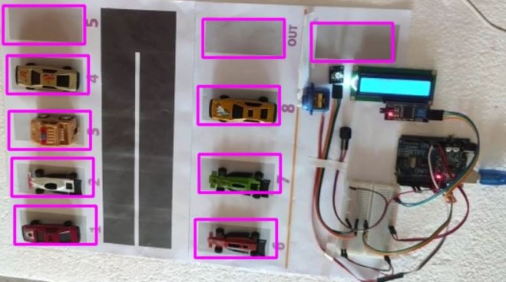

1. CCTV detects the slots pixel and then give a footage that is in BGR format. The empty slot’s pixel and the pixel of the slots with cars are different. By image processing this difference is detected and the system working.

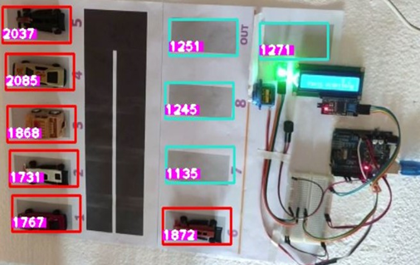

1. This BGR format is then converted into Gray scale image.

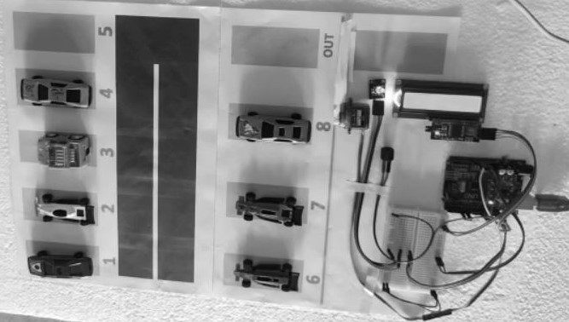

1. The Gray scale image is then converted into GaussianBlur format. This process is done with convolution theory and a 3*3 matrix is used here which all element’s value is 1.

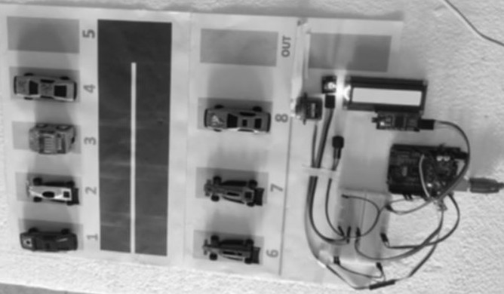

1. The image that is received from GaussianBlur is then transformed into Threshold image. Here Threshold value 15 & 3 are used by using trackbar. Adaptive Threshold Gaussian method is used for taking this Threshold image.

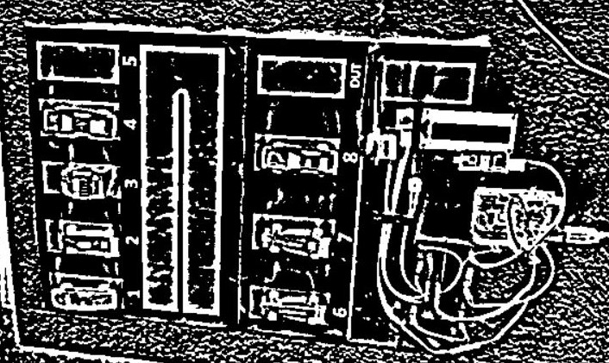

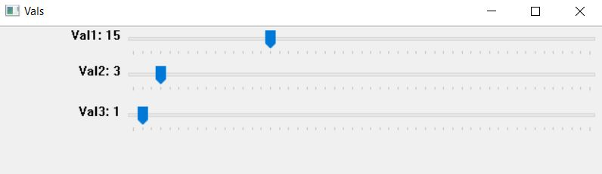

1. Threshold image is then converted into Median image.

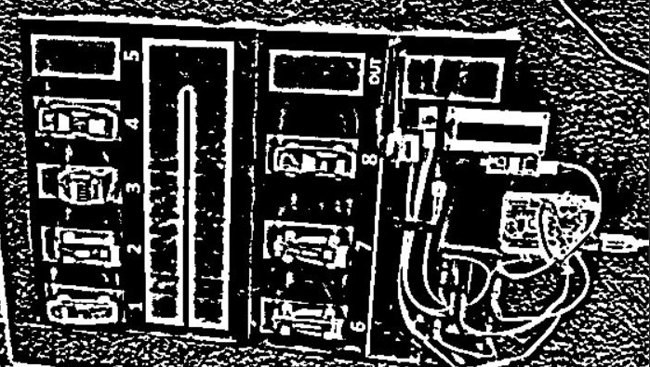

1. The Median image is then dialted and for this purpose the Kernel Matrix (3*3) (with all elements are 1 ) is used.

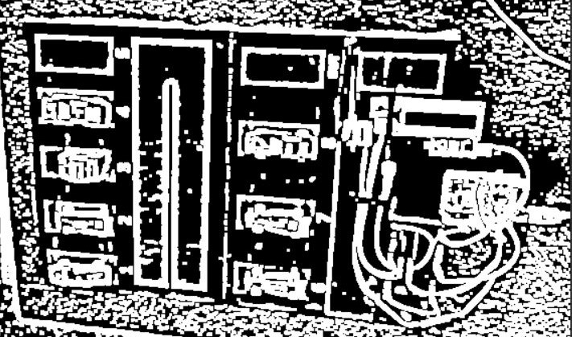

The pixel of image is counted from this dialted image.

* **Description:**

1. Every parking place must now have a **CCTV** in the current day. This **CCTV** footage served as the basis for our project, which employed the "**Image Processing**" method. We will identify vacant parking spaces and spaces that are not empty using **CCTV** footage analysis. Depending on the outcome, it will let a car to enter a parking spot. The driver of a car may check the number of available slots via an LCD display that has been installed at the parking space's entrance before entering.
2. When every parking space is occupied by cars and a car tries to enter, the parking gate won't open and a buzzer will ring.
3. If there are any available slots, the gate will be opened and the LCD display will indicate the free slot numbers.
4. If a vehicle wishes to depart, the parking gate must be opened.
5. When there is available slots in parking space, the RGB will emit green light. If there is no slots available RGB will emit red light and if any vehicle wants to go out from parking space then RGB will emit blue light.

**Insights:**

* **What is an IR Sensor?**

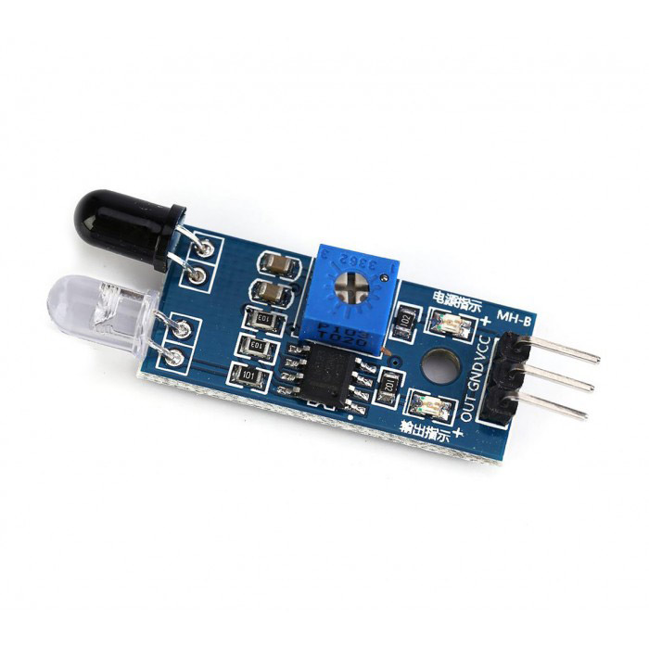An IR obstacle sensor is a type of sensor that uses infrared light to identify barriers or objects in its range of vision. Infrared light is emitted by these sensors, which bounces off of things and returns to the sensor.

The sensor can gauge the distance to the item by timing how long it takes for the light to return. In robotics and automation, where precise obstacle detection is essential to preventing collisions and guaranteeing safe operation, this technique is frequently utilized. IR obstacle sensors are a common option for many applications since they are reasonably priced and simple to use.

* 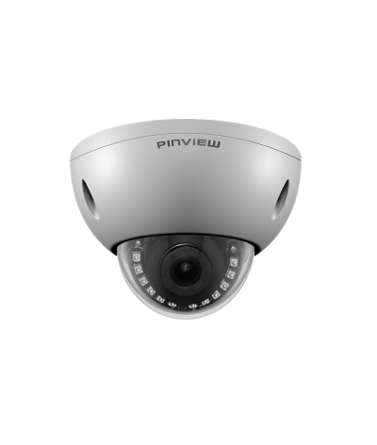**What is CCTV Camera?**

CCTV (closed-circuit television) cameras are surveillance devices that are used to keep an eye on a particular space or place. These cameras may record video in real time and transfer it to a display or recording device for live viewing or replay of previously recorded video.

For security purposes, CCTV cameras are frequently utilized in public areas, banks, houses, and companies. They come in a variety of sizes, forms, and features and may be used both indoors and outdoors. CCTV cameras have developed into a crucial tool for deterring crime and offering proof in criminal cases.

* **Advantages of Using CCTV Camera Instead of Using IR Sensor In Terms of Cost Effectiveness:**

It costs about **93.8 taka** per piece to purchase a standard IR Obstacle sensor.

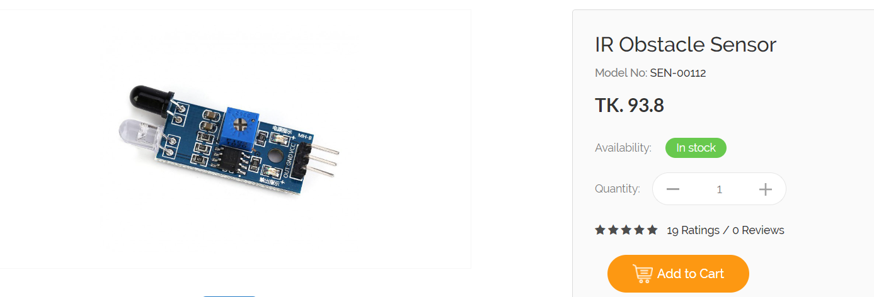

There are many parking spaces if we look at the parking lot of any busy apartment or workplace.

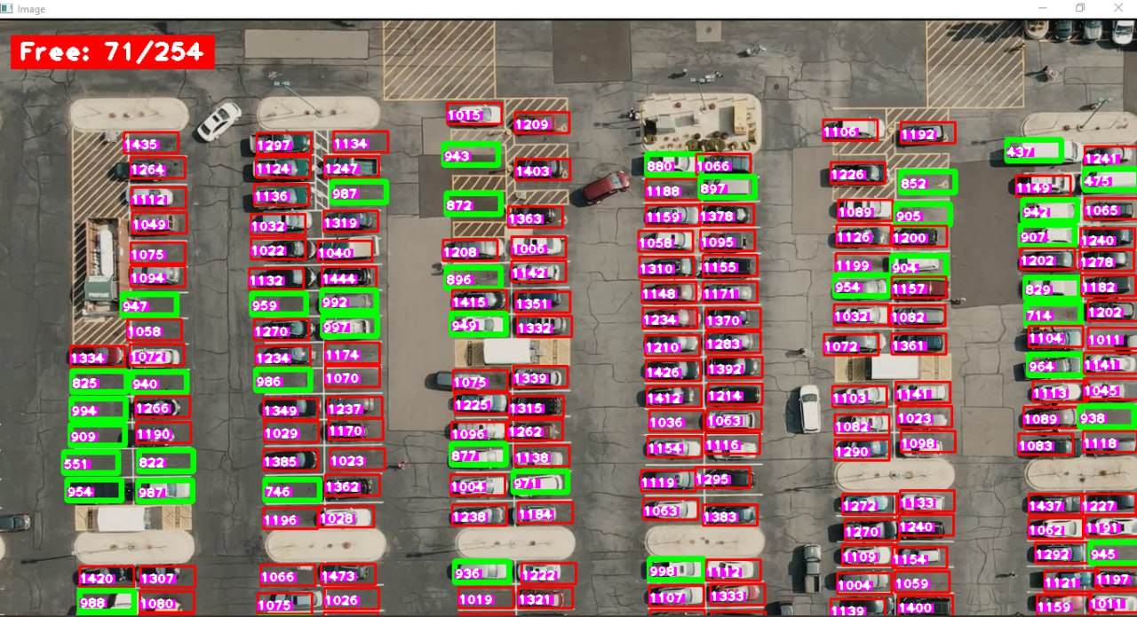

We have used this parking space of 254 slots to determine the cost effectiveness of our project. One parking space can only be served by one IR sensor. Hence, we will require 254 IR sensors to cover 254 parking spaces.

Cost of 1 IR sensor is **93.8 Taka.**

Hence, the price of **254 IR sensors is (254*93.8) = 23,825.2 TAKA**.

Hence, utilizing an IR sensor is quite expensive for a large parking space. Also, this is the price for installing the IR sensors. The longevity of these sensors is not guaranteed to be very long. The price will rise much further in such scenario.

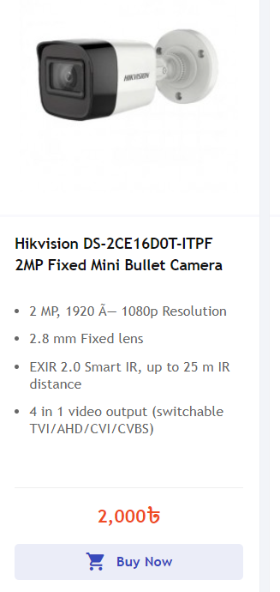

But in case of a CCTV camera, we can monitor a large parking space with a few cameras which will cost too much less than using IR sensors. The cost of a good CCTV camera can be 2000 taka. To cover a large parking slot, we will need 3-4 CCTV cameras which will cost 6000-8000 TK which is much less than the total cost of IR sensors.

Moreover, IR sensors are primarily used for vehicle detection and may not offer the versatility and additional features that CCTV cameras provide. IR sensors do not provide visual confirmation of parked vehicles, which may be a drawback if visual verification is required.

* **In Terms of Visual Verification**

CCTV cameras provide visual evidence of events, allowing for real-time monitoring and post-event analysis. This visual verification can be crucial in identifying and understanding situations, especially in security and surveillance applications.

* **In Terms of Detailed Information**

CCTV cameras capture detailed images and videos, which can include faces, license plates, and other identifying details. This information can be invaluable for investigations and legal purposes.

* **In Terms of Continuous Monitoring**

CCTV cameras can provide continuous monitoring of an area, recording events around the clock. In contrast, IR sensors typically detect motion or the presence of an object but do not provide continuous surveillance.

* **In Terms of Remote Access**

Modern CCTV systems often offer remote access through smartphones and computers, allowing users to check live feeds and review recorded footage from anywhere with an internet connection.

* **In Terms of Versatility**

CCTV cameras come in various types, such as dome cameras, bullet cameras, and PTZ (pan-tilt-zoom) cameras, making them adaptable to different surveillance needs and environments.

* **In Terms of Multiple Applications**

CCTV cameras can be used for various purposes, including security, traffic management, industrial monitoring, and even home surveillance, making them versatile tools.

It's important to remember that CCTV cameras have certain drawbacks as well, including privacy issues, the requirement for proper illumination, and the possibility for technological difficulties. However, if we are considering a large apartment garage or market, we must choose the most practical, secure, and long-lasting approach. Considering that, CCTV will be a much better option than IR sensors.