**CSE 316**

**MICROPROCESSOR & MICROCONTROLLER SESSIONAL**

**PROJECT UPDATE-1**

**SURVEILLANCE DRONE**

**SUBMITTED BY:**

**FAHIM AHMED (1305053)**

**MIRZA MASFIQUR RAHMAN (1305035)**

**Quadcopter Necessary components:**

1. **Brushless Motor(XA2212) :**

**Specification**

* KV Values: 1400KV
* Voltage: DC 8~12V
* Current: 11.9~20.6A
* Trust: 520~940G
* Power: 95.2~247.2W
* Efficiency: 5.5~3.8G/W
* Rotation Speed: 8250~12020RPM

Will be used to lift the quadcopter. The speed of the motor will be controlled by a ESC(electronic speed controller).

# Sonar Sensor(HC-SR04) :

This is the HC-SR04 ultrasonic ranging sensor. This economical sensor provides 2cm to 400cm of non-contact measurement functionality with a ranging accuracy that can reach up to 3mm. Each HC-SR04 module includes an ultrasonic transmitter, a receiver and a control circuit.

There are only four pins on the HC-SR04: VCC (Power), Trig (Trigger), Echo (Receive), and GND (Ground).

We will use 6 sonars in our project.

**Features:**

* Operating Voltage: 5V DC
* Operating Current: 15mA
* Measure Angle: 15°
* Ranging Distance: 2cm - 4m

1. **Electronic Speed Controller:**

This device is used to control the speed of the motor. It takes 11v input from a battery and supplies to a three phase motor connected to it. The variation in the voltage will help to change the speed of the motor.

**Specification:**

Model: RS30A V2  
Input Voltage: 2-4S  
Con.Current:30A  
Peak Current(10s):35A  
BEC:NO  
Programming :YES  
Net Weight: 6.26g  
Size:28*13mm

1. **8 to 1 MUX:**

As interrupts will be used for sonar control so we will use only one sonar reading at a time, and for this purpose we are using a 8 to 1 mux to select the specific sonar at a time.

1. **RC Flight Controller:**

This device will be used to control the quadcopter. It has a receiver that will be connected with the microcontroller atmega32. The quadcopter will move to the direction given by the controller.

**BLOCK DIAGRAM:**

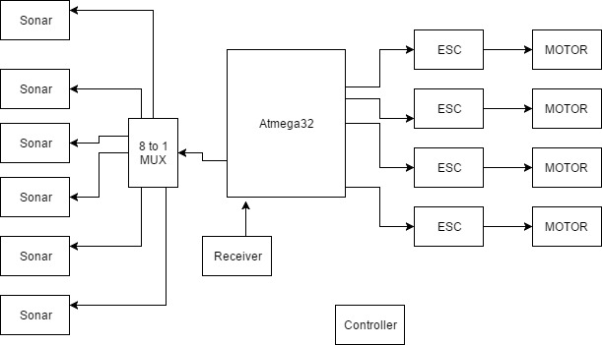

**CIRCUIT DIAGRAM:**

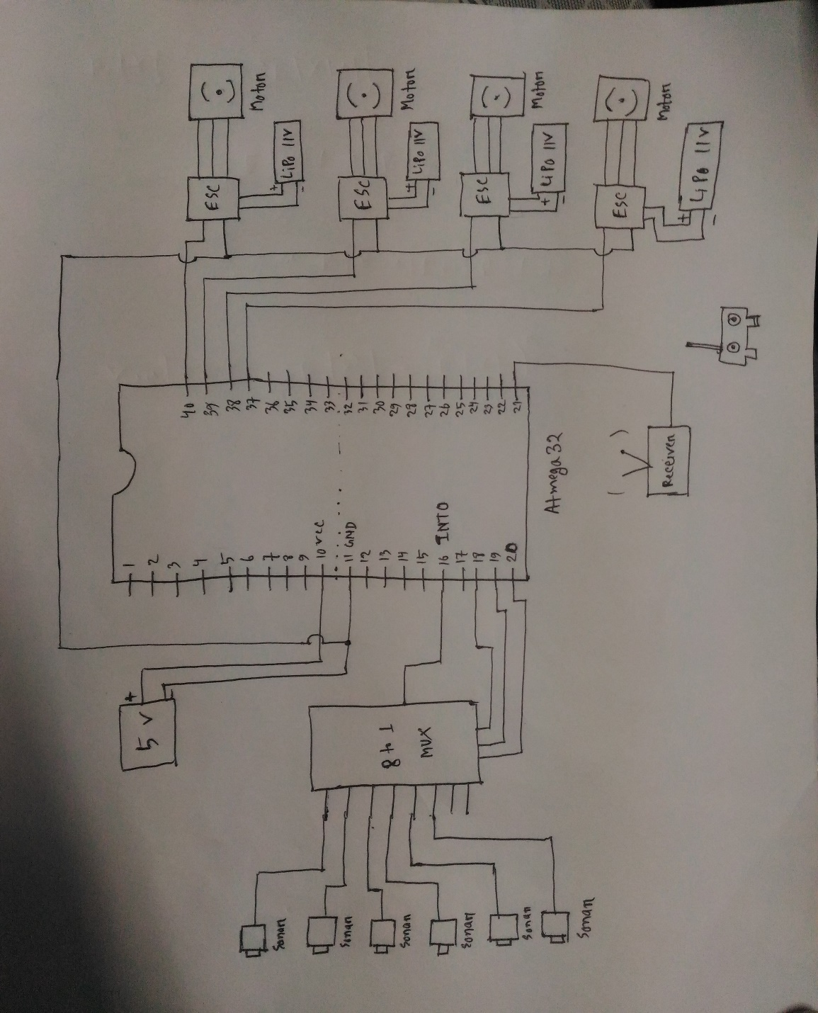

**FLOW CHART:**

