Hoàng Minh Thuận – 207CT28580

Bài thực hành LAB 7

1 MERN stack

1.1 Functionals

1.1.1 Customer - add2cart

1.1.1.1 Client-customer

- Update ’client-customer/src/contexts/MyProvider.js’ file

- Update ’client-customer/src/components/ProductDetailComponent.js’ file

- Update ’client-customer/src/components/InformComponent.js’ file

- Browser: http://localhost:3001/product/<id>

1.1.1.2 Screenshots

1.1.2 Customer - mycart

1.1.2.1 Client-customer

- Create ’client-customer/src/utils/CartUtil.js’ file

- Create ’client-customer/src/components/MycartComponent.js’ file

- Update ’client-customer/src/components/InformComponent.js’ file

- Update ’client-customer/src/components/MainComponent.js’ file

- Browser: http://localhost:3001/mycart

1.1.2.2 Screenshots

1.1.3 Customer - remove2cart

1.1.3.1 Client-customer

- Update ’client-customer/src/components/MycartComponent.js’ file

- Browser: <http://localhost:3001/mycart>

1.1.4 Customer - checkout

1.1.4.1 Server

- Create ’server/models/OrderDAO.js’ file

- Update ’server/api/customer.js’ file

- Postman: (POST) http://localhost:3000/api/customer/checkout

• Headers: ”x-access-token”: <token>

• Body(raw+JSON): { ... }

1.1.4.2 Client-customer

- Update ’client-customer/src/components/MycartComponent.js’ file

- Browser: http://localhost:3001/mycart

1.1.5 Customer - myorders

1.1.5.1 Server

- Update ’server/models/OrderDAO.js’ file

- Update ’server/api/customer.js’ file

- Postman: (GET) http://localhost:3000/api/customer/orders/customer/<cid>

• Headers: ”x-access-token”: <token>

1.1.5.2 Client-customer

- Create ’client-customer/src/components/MyordersComponent.js’ file

- Update ’client-customer/src/components/InformComponent.js’ file

- Update ’client-customer/src/components/MainComponent.js’ file

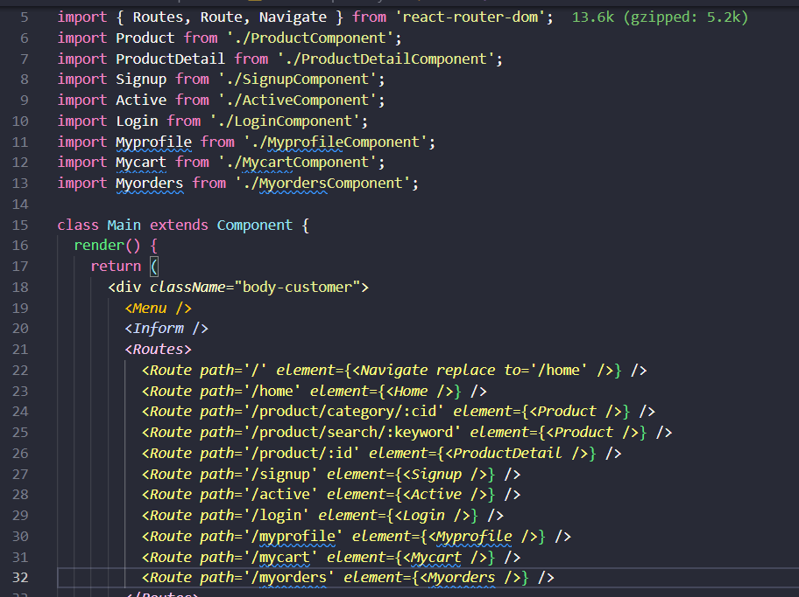

- Browser: http://localhost:3001/myorders

