|  |  |
| --- | --- |
|  | **Moch. Adam Gifari H.** | Social Media Specialist  I’m a creative and have a high curiosity abput trends on socia media. I, interested in the idea of content creation, and how the content can influence audiences behavior.  I experienced in media relations and social media specialist for more than 1 year, and 3 years experiences in Graphic Design. I experienced in copywriting, editing, and content creations and campaigns on Instagram with research and audiences.  Adress: Sukahaji, Majalengka City, West Java  Email: aghifar318@gmail.com |

|  |  |
| --- | --- |
| Work Experiences | |
| Jan 2022 – now | **Media Relations** DPD PKS Majalengka  1. Making content plan with team 2. Inventing BERRSIH concept (Berita, Edukasi, Reaksi Internal, Reaksi eksternal, Story, Interaksi, Hiburan) for content 3. Maintaining social media traffic 4. Create and maintaining party’s image 5. Create an interesting copywriting |
| May 2022 – Dec 2022 | **Personal Branding**  **Nurhasan Zaidi, S.Sos. & Dhora Darojatin, M.Kes.**   1. Making and maintaining Nurhasan Zaidi’s image as a member of Commision VII of the Representative Council 2. Making and maintaining Dhora Darojatin’s image as a Vice Chairman of Representative Council Region Majalengka |
| jan 2022 – now | **Social Media Specialist**  **Katakan Saja**   1. Managing DPD PKS Majalengka’s Instagram account 2. Maintaining social media traffic 3. Sorting content 4. Making content with team 5. Instagram live scheduling 6. Keeping account’s exposure from public 7. Keeping interaction with public |
| Jan 2022 – now | **Content Creator**  **DPD PKS Majalengka & Fraksi PKS Majalengka**   1. Editing videos for Instagram reels 2. Editing posters for Instagram feeds 3. Designing campaign |
| Aug 2019 – now | **Graphic Designer**  **Miraicom**   1. Making logo 2. Making ilustration 3. Making another design for Miraicom’s Instagram account |
| Apr 2020 – Okt 2020 | **Front-end Programmer**  **PT Chronoz Global Media**   1. Developing front-end Miraipro project 2. Developing front-end Pustaka project |

|  |
| --- |
| Educations |
| 2021-2024 Majalengka University Communication Science | GPA 3.78 scale 4.00 |
| 2018-2021 SMKN 1 Majalengka Software Engineering | GPA 86.50 scale 100 |

|  |  |
| --- | --- |
| Achievements | |
| Mar 2022 | **3rd Place in FISIP Debate Competition**  Jilly Ortega, Ketua Senat Mahasiswa FISIP UNMA |
| Oct 2020 | TOEIC English Test Educational Testing Service (ETS)  Total score 605 (reading 240 & listening 365) |
| Oct 2020 | VIERRA English Test English Test Center (ETC) Majalengka  Level Intermediate |
| Oct 2020 | KKSI (Kamp Kreatif SMK Indonesia) Gakushudo, Japanese Language N5 Test  Tchin Thian Shiang, Gakushudo  Total score 141/180 (bunpou 53/82, moji 33/38, choukai 141/180) |

|  |  |
| --- | --- |
| Skills | Languages |
| * Critist * Copywriting * Work in team * Communicative * Creative * Idealist * Quick learning | * Bahasa Indonesia – Native * English – Intermediate * Japanese – Basic |

**Portofolio**

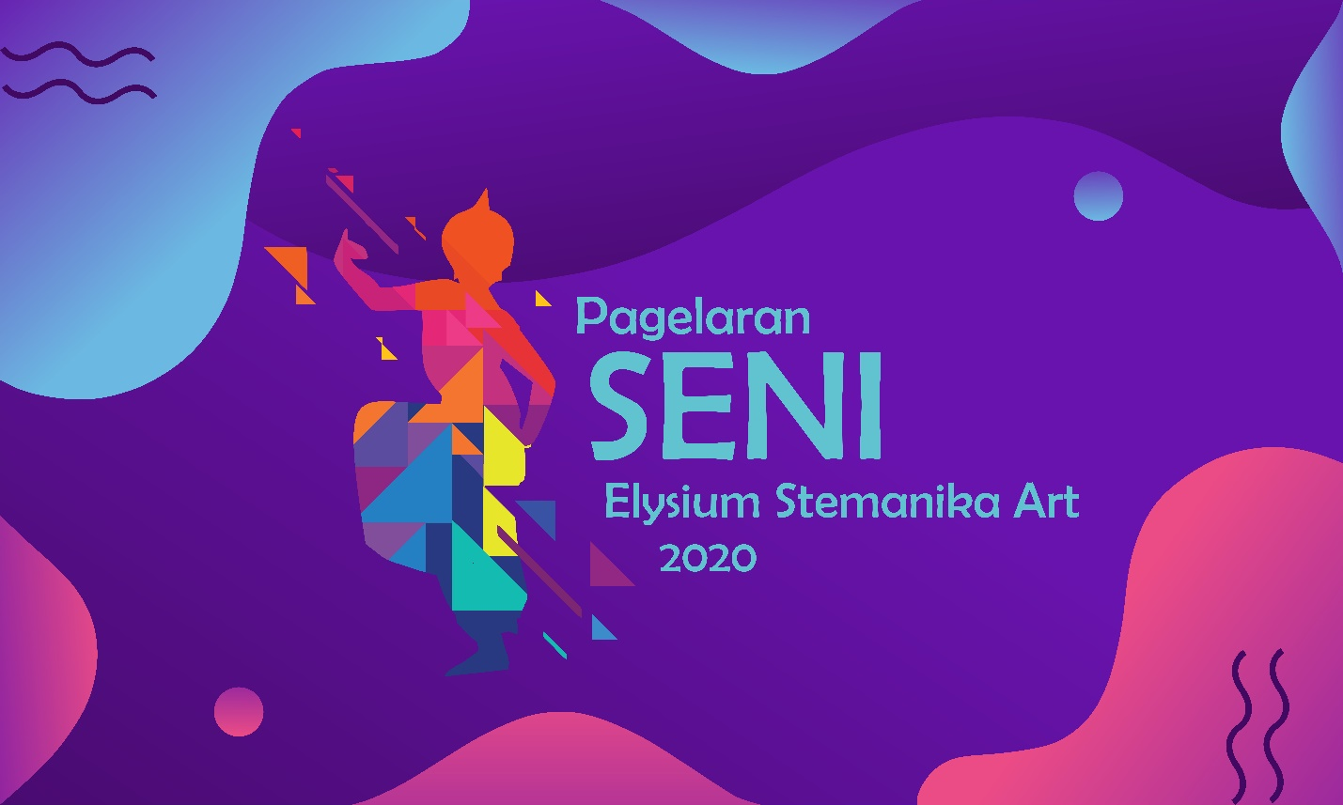

**2020, Elysium Stemanika Art performance banner design**

|  |  |
| --- | --- |
|  |  |
| **2021, Adhimukti Ananta logo design for the Majalengka University communication science student association** | |
|  | |
| **2020, poster design** | |
|  |  |
| **2020, corona virus poster design** | |
|  | |
| **2022, charity concert banner design** | |
|  | |
| **2022, beauty class banner design** | |
|  | |
| **2021, redesign Majalengka University logo** | |
|  | |
| **2022, Gebyar Fisip logo branding design** | |
|  | |
| **2022, Ghifari logo branding design** | |
|  | |
| **2022, Calon Korporat logo design** | |
|  | |
| **2021, Halo Production logo design** | |
|  | |
| **2022, Faculty of Social and Political Science logo** | |