**FEN Chess Position Classification Using CNN**

|  |  |  |
| --- | --- | --- |
| Snir Lugassy  206312506 | Gal Oshri  311363873 | Eilon Amram  205679780 |

**Abstract**

Forsyth-Edwards Notation (FEN) is a common notation for chess board state representation. In FEN each piece is represented using a unique letter, The white pieces are denoted using upper-case letters and the black pieces using lower-case letters.

We will train a Convolutional Neural Network to classify the unique state of a Chess board in FEN notation given images taken from online Chess website.

**Forsyth-Edwards Notation Definition**

The full FEN will describe many details about a certain game, we will consider only notation used to describe the piece placement in the board.

The piece placement is defined from the white player perspective, using 6 groups of characters separated by a delimiter. We will use ‘-’ as a delimiter (adopted from the dataset) although the original definition suggests the usage of ‘/’ as a delimiter.

Each group of characters corresponds to a row in the board from top to bottom, each character corresponds to a piece or space in the row from left to right according to the following dictionary:

“p” = Pawn

“n” = Knight

“b” = Bishop

“r” = Rook

“q” = Queen

“k” = King

1-8 = Number of empty squares

White pieces are represented using upper-case letters and the black pieces using lower-case letters.

The state of the board in Figure 1 using FEN is:

**Chess Position Dataset**

Our dataset consists of 100,000 images of chess boards taken from the online website “Chess.com”, with a size of 400×400 pixels. The boards have variety of colors, and the pieces has a variety of both shape and color.

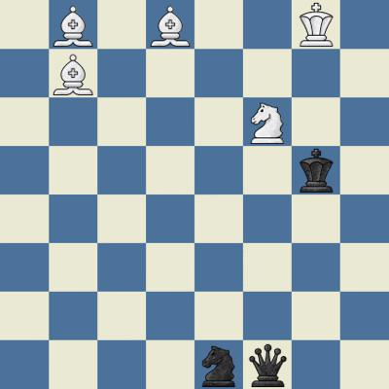

Figure 1: Example board image

The state of each board in FEN is stored in the file name of the image file.

**Data Processing and Transformations**

**Model**

**Inference**

**Results**

**Discussion**