Means-Ends Analysis

Means-Ends Analysis is used in many human planning activities.

Means-ends analysis is a problem solving strategy that arose from the work on problem solving of Newell and Simon (1972). In means-ends analysis, one solves a problem by considering the obstacles that stand between the initial problem state and the goal state. The elimination of these obstacles (and, recursively, the obstacles in the way of eliminating these obstacles) are then defined as (simpler) subgoals to be achieved. When all of the subgoals have been achieved – when all of the obstacles are out of the way – then the main goal of interest has been achieved. Because the subgoals have been called up by the need to solve this main goal, means-ends analysis can be viewed as a search strategy in which the long-range goal is always kept in mind to guide problem solving. It is not as near-sighted as other search techniques, like hill climbing.
Means-ends analysis is a version of divide-and-conquer. The difference between the two is that divide-and-conquer is purely recursive: the subproblems that are solved are always of the same type. Means-ends analysis is more flexible, and less obviously recursive, because the subproblems that are defined for it need not all be of the same type.
To solve Time-Tabling Problem we have used Means-Ends Analysis Strategy.

Time-Tabling Problem

We are given with Rooms available at different time and Demands of the Teacher that is at what particular time they want their classes to be scheduled.
We are supposed to fulfill their demands and allot them rooms accordingly. The demands are prioritized on First Come First Serve Basis.
Finally we have to create a TimeTable according to the requirements of teachers and the rooms available.

Solving Approach :
We take the first demand, fulfill it accordingly and schedule the remaining demands .
In case we can’t fulfill the demand that is Room is not available at requested time, we hold the particular demand and schedule the remaining demands
After scheduling possible demands we randomly allot rooms to the demands that were previously on hold.
The process continues till either all the demands are fulfilled or all the rooms are occupied.

Predicates Used :
In-Built:
- dynamic : dynamic(Pred) specifies that the procedure whose predicate indicator is Pred is a dynamic procedure. This directive makes it possible to alter the definition of Pred by adding or removing clauses.
- write : write on Screen.
- read : Read Input from User.
- assertz : asserta(Clause)first converts the term Clause to a clause and then adds it to the current internal database.
- retract : retract(Clause)erases the first clause of the database that unifies with Clause.
- append : append(List1, List2, List12) succeeds if the concatenation of the list List1 and the list List2 is the list List12.
- findall : findall(Template, Goal, Instances) succeeds if Instances unifies with the list of values to which a variable X not occurring in Template or Goal would be instantiated by successive re-executions of call(Goal), X = Template after systematic replacement of all variables in X by new variables.
- format : format(SorA, Format, Arguments) writes the Format string replacing each format control sequence F by the corresponding element of Arguments (formatted according to F) to the stream associated with the stream-term or alias SorA.
- initialization : initialization(Goal) adds Goal to the set of goal which shall be executed at run-time. A user directive is generated to execute Goal at run-time.
User-Defined:
- roomAvailable : represents room available at a particular time
- roomAlloted : represents name, time and room alloted to a teacher
- inputloop : takes the input i.e the name of the teacher and the time
- allot : allots the rooms corresponding to the demands
- demand : represents teacher and the time
- demands : makes list of the demand
- output : shows the final timetable on screen
- schedule : calls all the predicates in order to generate timetable.

Code

:-dynamic(roomAvailable/2).
:-dynamic(roomAlloted/3).
:-dynamic(demand/2).

roomAvailable(401,9).
roomAvailable(401,11).

roomAvailable(402,9).
roomAvailable(402,11).

inputloop(0).
inputloop(I) :- I>0,
write('Name of the teacher: '), read(Name),
write(' Time: '), read(Time), nl,
assertz(demand(Name,Time)),
N is I-1, inputloop(N).

allot([], CRemain, CRemain).
allot([[Name,Time]|Tail], CRemain, FRemain) :- roomAvailable(Room,Time), retract(roomAvailable(Room,Time)), assertz(roomAlloted(Name,Room,Time)), allot(Tail, CRemain, FRemain).
allot([[Name,_]|Tail], CRemain, FRemain) :- append(CRemain, [[Name, _]], NCRemain), allot(Tail, NCRemain, FRemain).

demands(Demands) :- findall([Name,Time], demand(Name,Time), Demands).

output([]).
output([[Name,Time,Room]|Tail]) :- format('Teacher: ~w Time: ~w Room: ~w', [Name,Time,Room]), nl, output(Tail).

schedule :- write('Enter the number of demands: '), read(D), inputloop(D),
demands(L),
allot(L, [], Remaining),
allot(Remaining, [], []),
findall([X,Y,Z], roomAlloted(X,Y,Z), S),
output(S), retractall(roomAlloted/3), !; write('Can\'t be Scheduled.'), nl, !.

:- initialization(schedule).

Test Case

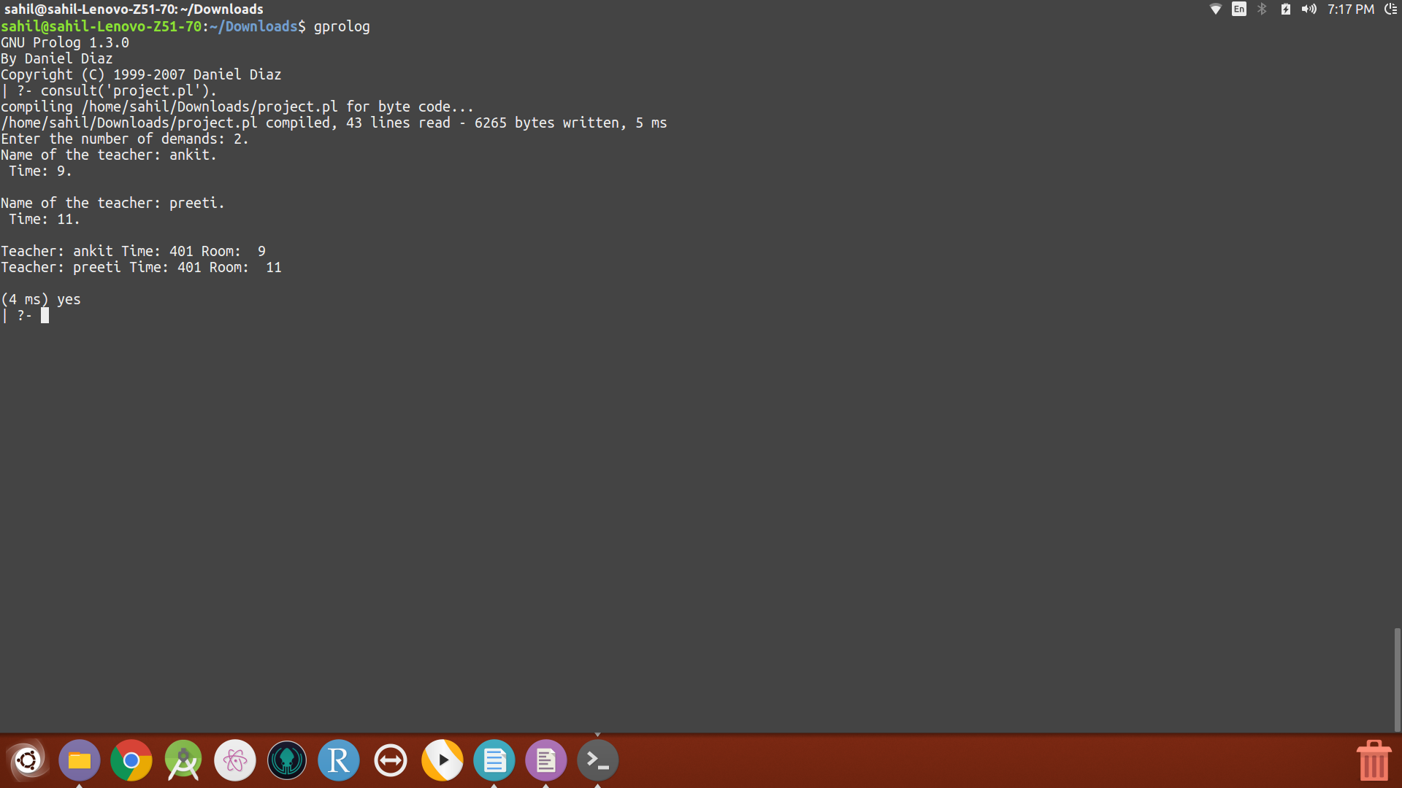
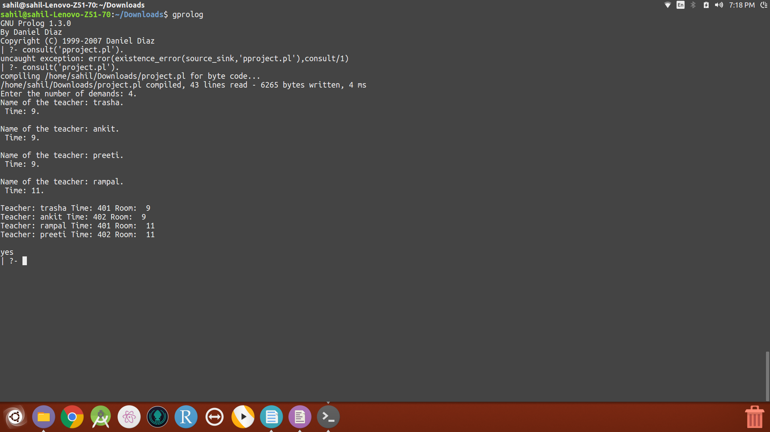
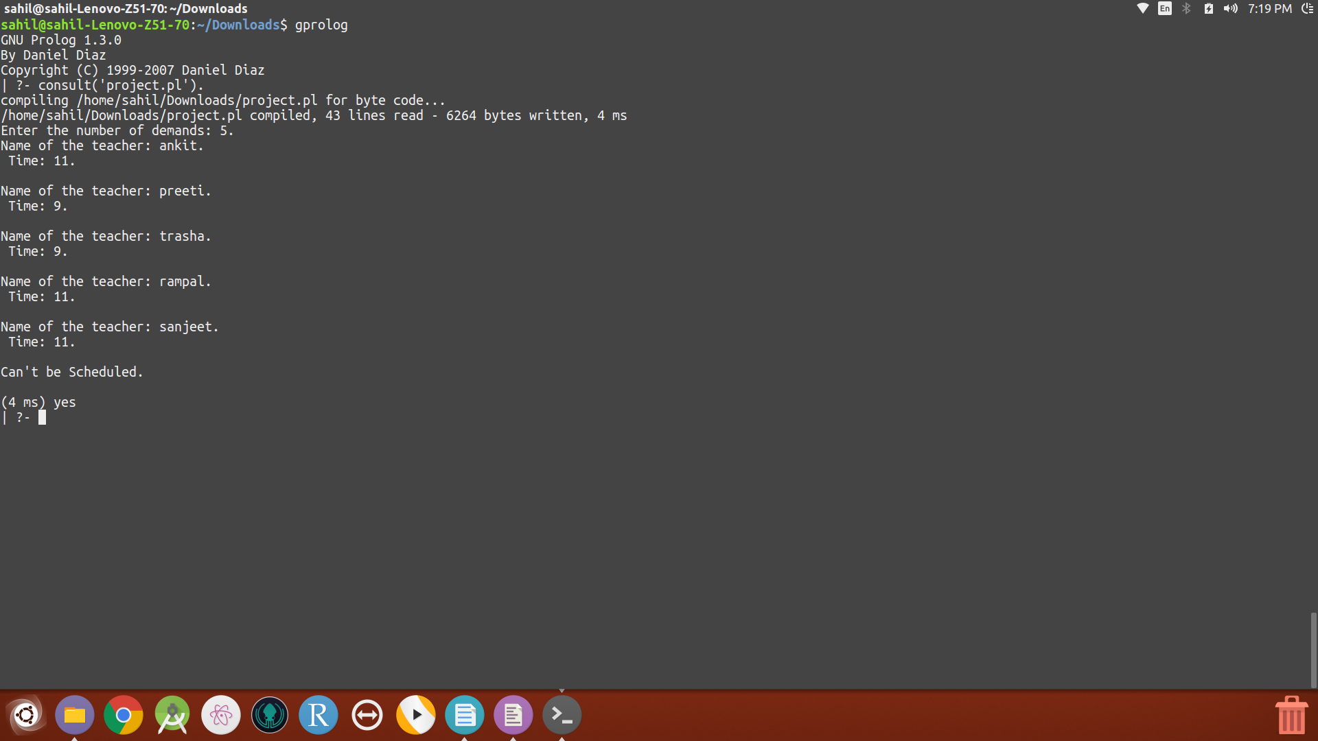

References:
- Newell, A., & Simon, H. A. (1972). Human Problem Solving. Englewood Cliffs, NJ: Prentice-Hall.
2.http://www.gprolog.org/manual/gprolog.html

