Innovation Crew

Vision (Information Technology)

Version <1.4>

Revision History

|  |  |  |  |
| --- | --- | --- | --- |
| **Date** | **Version** | **Description** | **Author** |
| 05, September, 17 | 1.0 | Adjusted the headings,footer, and titles; Added information to the problem statement | Nathan Bearden & Savannah James |
| 13, September, 17 | 1.1 | Positioning, Stakeholder and User Descriptions, Assumptions and Dependencies, and Product Features | Nathan Bearden & Savannah James |
| 18, September, 17 | 1.2 | References, Product Perspective, Other Product Requirements, Cleaning up Formatting, and Printing | Nathan Bearden & Jonathan Tran |
| 27, September, 17 | 1.3 | Added Feasibility Considerations to the Appendix | Nathan Bearden |

Table of Contents

1. Introduction 4

1.1 References

2. Positioning 4-5

2.1 Problem Statement 4

2.2 Product Position Statement 5

3. Stakeholder and User Descriptions 5-7

3.1 Stakeholder Summary 5

3.2 User Summary 6

3.3 User Environment 6

3.4 Summary of Key Stakeholder or User Needs 7

3.5 Alternatives and Competition 7

4. Product Overview 7-8

4.1 Product Perspective 7-8

4.2 Assumptions and Dependencies 8

5. Product Features 8

6. Other Product Requirements 8

7. Appendix 9-12

7.1 Feasibility Considerations 9-12

Vision (Small Project)

# Introduction

The purpose of this document to collect, analyze, and define high-level needs and features of the Surgery on Sunday website. It focuses on the capabilities needed by the stakeholders and the target users, and why these needs exist. The details of how the Surgery on Sunday website fulfills these needs are detailed in the use-case and supplementary specifications.

## References

1. Surgery on Sunday reports by upper level University of Louisville CIS students.
2. Information gathered from Barbara and Jordan via presentation and email

# Positioning

## Problem Statement

|  |  |
| --- | --- |
| The problem of | Surgery on Sunday’s current system could be improved because it is creating more work and not allowing the organization to recognize their full potential in securing donations. |
| affects | There are several stakeholders that are affected by this problem. The issues plaguing the system greatly affect personnel in the upper positions of the company. In turn, these issues affect potential patients, volunteers, and donors who come in contact with the organization through the website. |
| the impact of which is | The impact of the problem is that several of their business processes are far more time-consuming than necessary. Additionally, the organization’s ability to secure donations is Another impact is that the organization’s ability to secure donations is not at full capacity which leads to an inability to serve every patient. |
| a successful solution would be | A successful solution would be to optimize their database systems, change the way donations are secured, and raise awareness of the organization. Some key benefits of this specific solution would be that the organization will secure more donations, will spend less time on important business processes, and in all be able to receive and treat more patients. |

## 

## Product Position Statement

|  |  |
| --- | --- |
| For | Surgery on Sunday |
| Who | They need an information technology system that saves them time and generates an increase in cash flows from donations so that they can treat more patients. |
| The Surgery on Sunday Information System | Is an information technology system and relational database. |
| That | They should use this system because it is going to generate more cash flows for them through donations and save time that they can instead utilize to write grants. This increase in their cash flows will allow them to serve more patients, achieving the goal of the organization. |
| Unlike | The alternatives which would be to keep the outsource for their website design to an organization that specializes in website design or to simply keep everything the way that it is. |
| Our product | This product will be different than alternatives because it is the best option Surgery on Sunday when one weighs the costs of this particular endeavor compared to the potential benefits. |

# Stakeholder and User Descriptions

## Stakeholder Summary

|  |  |  |
| --- | --- | --- |
| **Name** | **Description** | **Responsibilities** |
| Patients | This is the group that will be receiving the surgeries that the organization provides. | Will use the new system to apply to receive care. |
| Donors | This is the group that will be using the website to donate to the organization. | Will use the new system to donate to the organization. |
| Volunteers | This is the group that will be using the website to apply to volunteer. | Will use the new system to apply to help at certain events and fundraisers. |
| Doctor Sutton | She is the head decision-maker of Surgery on Sunday. | Will benefit from a new system because it will allow SOS to treat more patients. |
| Board of Directors | They make the ultimate decisions about the long term strategies of Surgery on Sunday. | Will benefit from a new system because it will allow SOS to treat more patients. |

## User Summary

|  |  |  |  |
| --- | --- | --- | --- |
| **Name** | **Description** | **Responsibilities** | **Stakeholder** |
| Barbara | She represents the person who creates the events and navigates the data for whatever objective she needs to accomplish. | Create events.  Navigate through the database to find information.  Create patient testimonials. |  |
| Jordan | He is the head of IT and represents the user who will be in charge of the system that we create after completion. | Maintain the website.  Maintain the database. |  |

## User Environment

Currently, Barbara, Jordan, and a few others are the ones in charge of maintaining the website, organizing events, sorting through volunteer data and patient referrals, and ensuring all information is transferred into an excel spreadsheet. The number of people completing these tasks will not be changing, however, each employee will spend less time on each task.

After hearing Barbara speak to the class, it seems like the most time consuming activity is organizing the surgical events. This is because each hospital likes to have its own employees in their facilities. This takes a lot of time trying to organize which volunteers are able on the date that the surgery is scheduled, if there needs to be an interpreter, which medical staff is needed based on the surgical need, etc. Say Barbara spend an hour organizing each surgical event. A database that can generate a report of the information listed above could be done in a few minutes. This could allow Barbara to plan more events, or spend time writing grants and recruiting more volunteers. The time Jordan spends maintaining the website will decrease as well, since the forms could link directly to the database. This will ensure that there is no data redundancy and that there would be no mistakes with someone typing in information into an excel spreadsheet.

The constraints are that Surgery on Sunday relies solely on donations to keep their organization going. This means that the organization is on a very limited budget. There is also a unique constraint with remaining compliant to HIPAA requirements and keeping personal information secure for all volunteers.

Currently, Surgery on Sunday uses G Suite. They use Google business for email, cloud services, word processing, and Google Forms for volunteer information. The forms put volunteer information to an Excel spreadsheet. The organization also uses RedCap to keep information about their patients, and remain HIPAA compliant. Finally, they use WordPress to host their website. In the future, Surgery on Sunday would like to switch from RedCap to EPIC, which is what most hospitals use today. Surgery on Sunday stated that they would like to continue to use WordPress to host their website, since it is a free service. We would like to see SOS step away from Google business, and instead, use relational databases in order to store information. Our application does not need to integrate with the website besides capturing data from forms filled out.

## Summary of Key Stakeholder or User Needs

Key Problems with the existing system:

1. The current system makes it very labor intensive for Barbara to create events.
   1. The reason for this problem is that they currently send data that is input to the website to several Excel Spreadsheets.
   2. This problem is solved now by an employee (Barbara) painstakingly sifting through all of the data and creating an event based on doctor, site, volunteer, and patient information.
   3. They would like a system that automatically generates events, and that is what we intend to build for them.
2. The current system could secure more potential donations.
   1. The reason for this problem is that the website does not have a lot of features that are prominent on other websites that work to increase donors and potential donations.
   2. This problem is solved now by sending the potential donor to PayPal.
   3. They would like a system that generates more revenue so that they can extend into new markets and treat more patients.
3. The current system could attract more potential patients.
   1. The reasons for this problem is that the website could raise more awareness about the organization, could consider language barriers, and could make the patient referral process accessible to everyone and not just select medical personnel.
   2. The current problem is solved by making the patient referral process available to only select medical personnel.
   3. They would like to increase market share which we can accomplish through generating awareness and treating more patients.

## Alternatives and Competition

They could choose to maintain the system that they have implemented now. The strengths of keeping this system would be that they are used to this system and know how it operates. However, there are many weaknesses. Their data would remain spread out across many Excel spreadsheets. These spreadsheets do not communicate with each other which means that Barbara would continue spending hours scheduling events and looking for information that volunteers input through the website.

Surgery on Sunday is limited to alternatives available because of their little budget in regards to IT. However, Surgery on Sunday could seek the help of an organization that specializes in designing websites. One strength of this plan would be that this organization has a high level of familiarity with this particular endeavor, so this organization will likely accomplish everything that Surgery on Sunday asks them to do. The obvious weakness is that this alternative will be very costly so much to the point that the costs may actually outweigh the possible benefits.

# 

# Product Overview

## Product Perspective

Our product will and is designed to affect the entire organization and how the organization operates as a whole. Our product should lead to an increase in market share for the organization and will be designed to streamline the event creation process. While the changes will be designed to make things easier, we will be changing the way that volunteer, donor, and patient is gathered and stored when input at the website. We will also be changing the process of receiving donations online.

## Assumptions and Dependencies

Our current vision assumes that:

1. The software that we use must comply with HIPAA regulations.
2. The organization wants to use a WordPress site.
3. Our solution will be budget friendly and easy to use.

# Product Features

We have several system features that we would like to implement. We will list them here:

1. We would like to overhaul the system that Surgery on Sunday has in place for gathering and storing patient, volunteer, and donor information. We would like to create a system that automatically creates events as information is added to the system. We need this system to remain HIPAA compliant. This will benefit the organization because it will save Barbara time which she can spend writing grants.
2. We would also like to make the patient referral process simpler and accessible to everyone. This will benefit the organization because it should raise the amount of patient referrals that the organization receives through the website.
3. We would like to add a patient testimonials section to the website. This will benefit the organization because it will keep users on the website and raise awareness of the organization. This could lead to an increase of donors, volunteers, and potential patients.
4. We would like to improve the social media presence of the website. This will benefit the organization because it will raise awareness about the organization. This could lead to an increase of donors, volunteers, and potential patients.
5. We would like to add the option to translate the website into Spanish for users of the website. This will benefit the organization because it will open up the possibility of interacting with more individuals who do not speak English.

# Other Product Requirements

The only requirements for the system that we build will be that:

1. The system must be easy to maintain as the only dedicated IT personnel has admitted that he is a beginner in the IT field.
2. The website must be easy to use as we would like to make it the hub for anyone who is interested in Surgery on Sunday
3. Events should be created automatically or at worst at a much quicker pace than the current length of approximately 30-45 days.
4. The system must consider current HIPAA regulations.
5. The system must be flexible enough that the organization will be able to change if any future problems arise.
6. The system complies with the restraint that Surgery on Sunday has limited funds to use on IT.
7. The system may require that we provide Jordan with a manual on what exactly we have changed, possible issues that may come up and how to fix them, and the tasks that he will be assigned in the IT department.
8. The system must be valuable to Surgery on Sunday.

# Appendix

* 1. Feasibility Considerations

The feasibility considerations outline whether or not we believe that it will be feasible to complete the proposed project for the organization from a technological, organizational, and economical viewpoint.

*Technological*: as University of Louisville CIS students, we feel that we have enough familiarity with both business and technology to improve Surgery on Sunday’s current system.

*Organizational:* Users of the database system will obviously use the new system because the purpose of it is to make their lives much easier. The features that we will be adding to the website are all also designed to keep prospective donors and patients on the page or coming back, so we believe all of these are organizationally feasible as well.

*Economical:*

*Moderate Forecast*

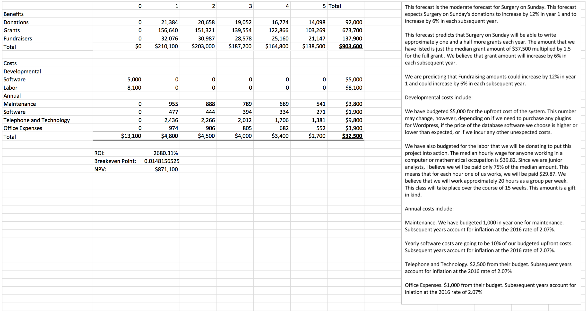

*Conservative Forecast*

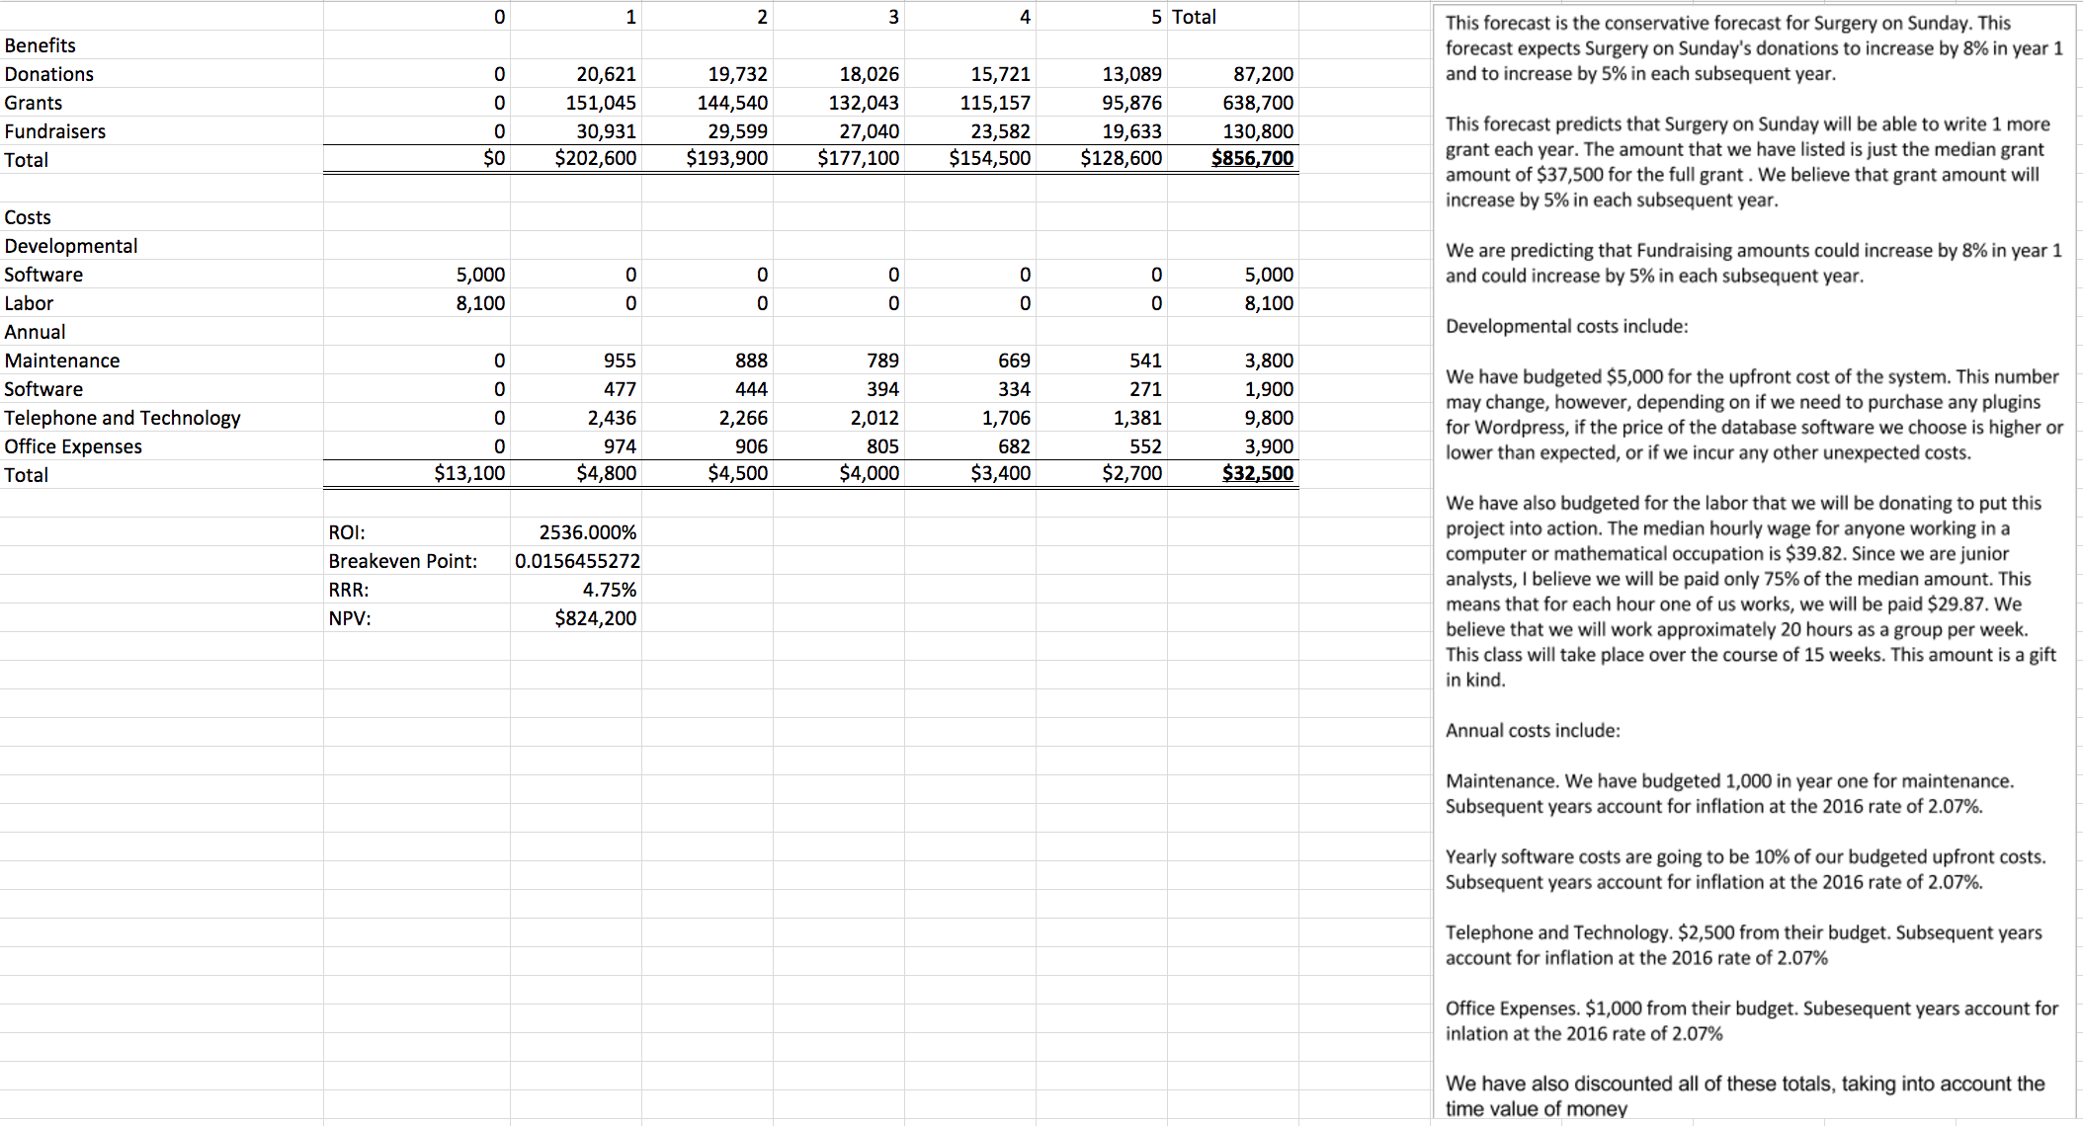

*Liberal Forecast*

