**Full Stack Development Java**

**Front End**

**Back End**

Core Java

Basics of Java

Java intro, Installation and Setup for Java, Writing and executing first java program, Data Type, Control flow statements, Operators, Array, Class, Objects, methods, Java Build-class, String classes.

Object Oriented Programing in Java

Encapsulation, Inheritance, Polymorphism, Abstraction, constructor, Java keyword, final, static, super, this, access modifier, package

Advance of Core Java

Exception Handling, Threading, Collection, JDBC.

Spring Boot Framework

**Database**

SQL, MYSQL Database

Tools (**Dev and DevOps Tool**)

**Git**

**GitHub**

**Maven**

Postman

Swagger

Software

JDK (JDK-11)

Eclipse IDE

MySql Database

Git

Maven

Postman

Download JDK (1.8 and above).

<https://www.oracle.com/in/java/technologies/downloads/>

**Note: Download Installer instead of zip file**

**Java Documentation**

<https://docs.oracle.com/en/java/javase/11/docs/api/>

**Logical Program Solving:**  
<https://www.hackerearth.com/>

<https://www.hackerrank.com/>

**Java Setup**

1. Download JDK

<https://www.oracle.com/java/technologies/downloads/>

Download the Installer for you operating System.

1. Install JDK
2. Verify the Installation
   1. You can verify the installation file into C:\Program File\java\<jdk-version-folder>

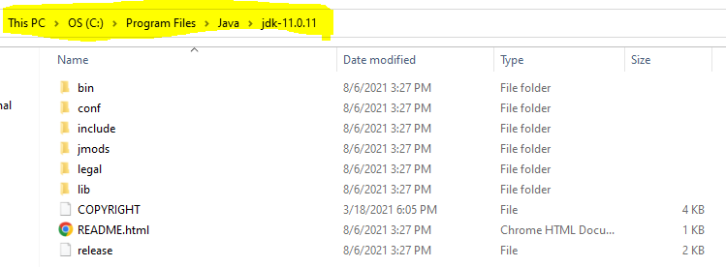

1. Setup Environment Variable
   1. **Set JAVA_HOME**
      1. Go to Start and Search for “Environment” word and select the “Edit System Environment Variable” option.
      2. Click on the “Environment Variable” button on the new window.
      3. Select “New” Button from the ‘System Variables’ section
      4. Provide the following details into text box
         1. Variable Name: **JAVA_HOME**
         2. **Variable Value: <JDK-Path>**

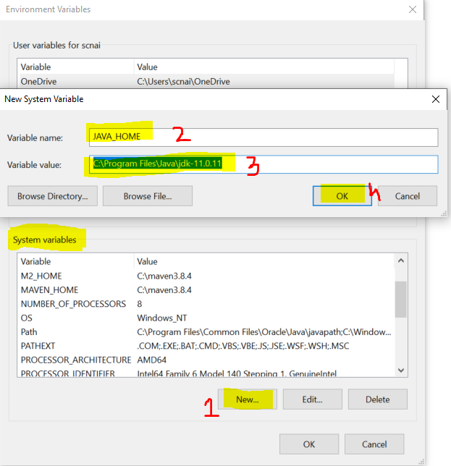

* 1. **Set Path**
     1. Check for “path” variable inside ‘system variables’ section
     2. Select “Path” variable and click on “Edit” Button
     3. Click the “New” button on the new window
     4. And set the variable value as follows

**%JAVA_HOME%\bin**

* + 1. Click on “OK”

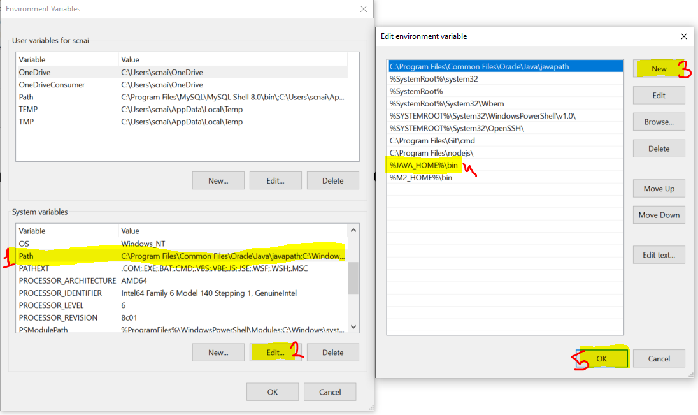

1. Verify the Environment Variable Setup
   1. Open CMD
   2. Try the following commands
      1. **java -version**
      2. **javac**

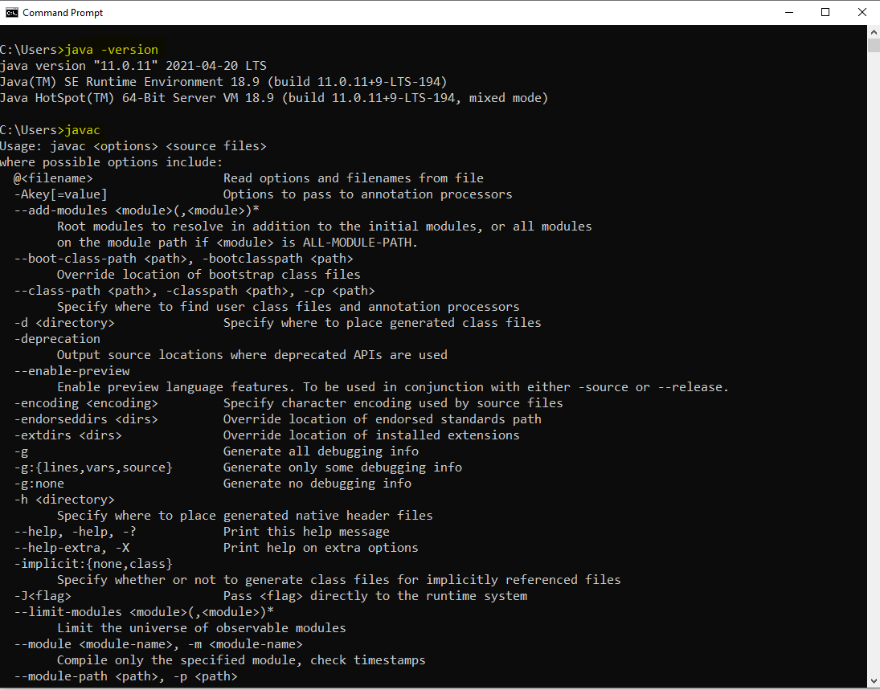

**Type of Application**

1. Desktop Application
2. Web Application
3. Mobile Application
4. Embedded Application
5. Console Application

**Java Introduction**

1. Java Editions
   1. JSE
      1. Java Standard Edition
      2. Also known as Core Java
      3. It is use to develop the console based app and desktop application
   2. JEE
      1. Java Enterprise Edition
      2. Also known as Advance Java
      3. It is use to create Web Application
   3. JME
      1. Java Micro Edition
      2. It is use to create Mobile and embedded application

**Writing First Java Program and Execution of the program**

1. Open Notepad
2. Write a Java Program
   1. Create a Class
      1. Everything in java must be in a class except import and package statement.
      2. Syntax for Class

**public class <className>**

**{**

**}**

* 1. Create a main method
     1. At the time of execution of the program java search for main method internally.
     2. This method is a start point of all java program.
     3. The main purpose of method is use to write a logic and execute it to produce an output
     4. Syntax:

**public static void main(String args[])**

**{**

**}**

* 1. Write an executable statement
     1. These statement executes and produce an output
     2. To print the output you can use following line of code

**System.out.println(“Message”);**

1. Save the file
   1. File Name must be same as public class Name
   2. File extension must be .java.
2. Open a CMD to compile and execute the java program
   1. Open a command prompt from a location where you save your java file.
      1. Go to a location where you save your java file.
      2. Type ‘CMD’ in the address bar
      3. Hit Enter.
3. Compile the Java code
   1. To Compile A java code use following command

**javac <filename with extension>**

* 1. As a outcome of the compilation you will get a .class file.

1. Execute The Java Code
   1. To Execute use following command

**java <ClassName>**

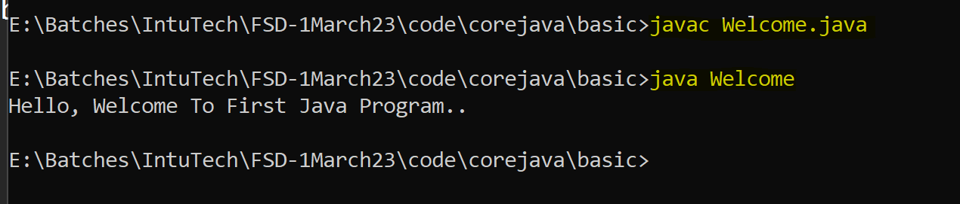

**Rules**

1. You can create multiple java classes in a file but only one class must be public and you java file name must be save as a public class name.
2. The .class file will be generated after compilation of the java file. The .class file is generated for the java classes created inside the file. Every java class will have a separate .class file.
3. It is not mandatory to provide the main method inside java class. but if you are trying to execute the java class from JVM then you class must have a main method.
4. The main method internally called by the JVM at the time of your class execution.

**Important components**

1. JVM
   1. Java Virtual Machine
   2. It is use to execute the java program.
   3. The memory required from the program execution will be provided by JVM.
   4. Heap and Stack is the main memories which is allocated by JVM.
2. JRE
   1. Java Runtime Environment.
   2. JRE is a combination of the JVM and the APIs.
   3. It help you to create a runtime environment for the application.
   4. This has be present on the client system.
3. APIs
   1. Application Programming Interface.
   2. APIs are the predefine class, interfaces or functionalities by the programming language.
   3. These functionalities you can use to achieve you purpose.
4. JDK
   1. Java Development Kit
   2. It help us to develop and execute the java program, It is combination of Dev. Tools, JRE, JVM, APIs.
   3. It has to be install on developers system.

**Keyword, Identifier, Literals**

**Keyword**

1. Are the words which are reserve by the java programing language.
2. These words cannot used for you own purpose.
3. There are total 52 words are serve by java.
4. All keyword are in small case only.
5. Example:

public, class, static void, if, else, do, for, int, byte, short, long, char, float, double, boolean, case, break, continue etc.

**Identifier**

1. The words which are used by the developer, these words are use to identify the java components.
2. The words which are used to create class, method, object, variable name are called keywords.
3. Using Identifier, you can provide the name which can be further use for the reference.
4. Rules to create identifier
   1. Identifier must not be a keyword.
   2. Identifier can contains alphabets, symbol, number.
   3. There are only 2 symbols are allowed _ and $
   4. The identifier must start with alphabets or symbol and it must not start with number.
   5. Identifier cannot contain spaces.
   6. There is no character limit to create identifier.
   7. Java is Case sensitive and hance you have to use it in a same way in which you declare.
5. Conventions to use Identifier
   1. Identifier for class
      1. The name should be start with capital case.
      2. If there is a combination of multiple words then every word should be start with capital.
      3. Example: Welcome, System, String, EmployeeDetails
   2. Convention to create Method, variable and object
      1. The name should be start with small case.
      2. If there is more than one word then 2nd word onward it should start with capital case.
      3. Example: main, println, args, out, printDetails
   3. Convention for Constants
      1. The name of the constants should in capital case.
      2. If it is a combination of multiple words then it should be separated by ‘_’
      3. Example: PI, GRAVITY, COMPANY_NAME

**Literal**

1. Literals are the values, mostly string values are also consider as a literal.
2. The values which is reserve by java is also known are literals. These values are also consider as keyword.
3. Example: null, true, false.

**Comments in Java**

1. Comments are use to add code level documentation, to skip the specific line of code from the execution.
2. There are 3 types of comments in java
   1. Single Line Comment
      1. Syntax

// line to comment.

* 1. Multi-line comment
     1. Syntax

/*

Lines to comment

*/

* 1. Documentation comment
     1. This comment is use to write a code level documentation.
     2. The commented lines will be included inside the .class file after compilation.
     3. Syntax:

/**

Comments

*/

**Data Type and variable**

**Operator**

1. Arithmetic Operator

+, -, *, /, %

1. Assignment Operator

=, +=, -=, /=, *=

1. Increment and Decrement Operator

++, --

1. Relational Operator
   1. returns only Boolean values
   2. It use to create a conditional/logical expression (decision making statement)

>, >=, <, <=, ==, !=

1. Logical Operator
   1. Logical operator can return numeric value or Boolean values.
   2. It can be use with the numeric value or to combine the 2 or more conditional expression.
   3. It can be use to perform operation on Bit level.

& , |, !

1. Short Circuit Operator
   1. Is use to combine the 2 or more conditional expression.
   2. It cannot be use for a numeric value bit level operations.

&&, ||

1. Ternary Operator
   1. It is use to execute the operations based on the conditional expression
   2. Here ‘?’ is consider as If and ‘:’ is consider as else.
   3. Example :

(salary<25000) ? 200*10 : 200*5 ;

If _____ else _____

?, :

**Control Flow Statement**

1. It is use to control the execution flow of the program.
2. By default the program executes sequentially.
3. Using control flow statement you can decide when how many time the statement should gets executes.
4. This can achieve by using 2 ways
   1. Conditional Statement
      1. This is use to execute a statement or block of statement base on some scenario or condition.
      2. There are different options to execute statement based on condition

**If condition** and its variation and **switch case**.

* 1. Loop Statement
     1. This is use to execute the statement or block of statement multiple time.
     2. Different options to execute statement multiple times

**While, do-while, For loop, nested loop and enhance for(for-each)**

**If Conditional Statement**

1. Using this you can execute the statement based on the condition.
2. There are different variations to achieve this statement
3. **If Condition**

Syntax:

if(conditional Expression)

{

Statement(s)

}

1. **If-else**

Syntax:

if(conditional Expression)

{

Statement(s)

}

else

{

Statement(s)

}

1. **Else-if ladder**

Syntax:

if(conditional Expression)

{

Statement(s)

}

else if(conditional Expression)

{

Statement(s)

}

else if(conditional Expression)

{

Statement(s)

}

else

{

Statement(s)

}  
**Note: In this case only one condition gets executes. It there are multiple conditions satisfies but it will execute only the first condition block.**

1. **Nested if**

You can create one if structure into another structure which is called nesting.

Syntax:

if(condition) {

if(condition) {

}

}

Task:

1. Create a two int variable and print the grater number from them.

Example: int a =20, int b = 30

O/P : **The Grater Number is 30**

1. WAP to print the vaccination slot based on age

If age is between 60-120 “You are in Slot-1”

If age is between 30-60 “You are in Slot-2”

If age is between 18-30 “You are in Slot-3”

If age is between 1-18 “You are in Slot-4”

Any other age values than this print “Invalid Age…”

1. WAP to print the Age Group

If age is between 60-120 “Old Age”

If age is between 22-60 “Adult Age”

If age is between 12-22 “Teen Age”

If age is between 0.1-12 “Kids Age”

Any other value “Invalid Age”

Task for 22-March

1. WAP to print a day type

If value of day is 1,2,3,4,5 then print “Working Days”

6, 7 then print “This is Weekend”

**While and Do-While**

1. WAP to print the table of the given number using while loop

Example : number = 5

O/P 5

10

15

20

.

.

.

50

1. Print all the odd numbers from the 1 – 50 using a do-while loop.

Hint : if number%2 != 0 then the number is Odd

O/P

1

3

5

.

.

.

49

**Nested Looping**

1. You can create one loop inside another loop.
2. It is mostly used for a scenario where you wanted handle the table structure data.
3. That is you can perform the operation on row and columns using nested loop.
4. Syntax

for( ; ; ) // Row

{

for( ; ; ) // column

{

}

}

Task 24-March: WAP to print following pattern

*

* * *

* * * * *

* * * * * * *

1

12

123

1234

12345

**Enhance For Loop**

1. It is mainly used to get the values one by one from the collection/group of values which is also known as iterating collection.
2. Syntax:

for(datatype identifier : collection )

{

Statement(s)

}

**Array**

**Class, Object and Method**

**Class**

1. Class is a collection of **state**/variables/data member and **behavior**/methods/member function.
2. Along with variables and methods you can also create a constructure or another class(Nested class) in a class.
3. The data member and member function of class can be used outside class using the Object.
4. Syntax to create class

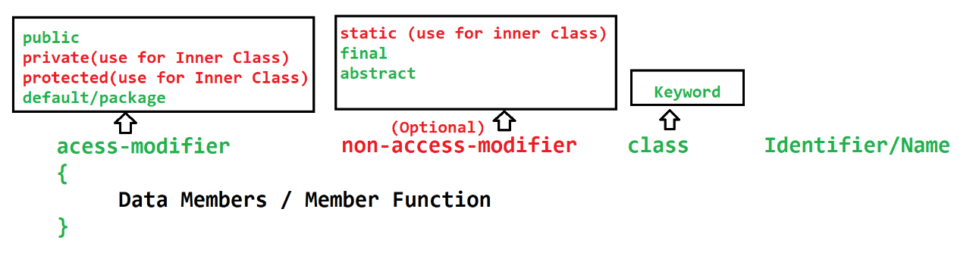

**Method**

1. Method is a collection of variables and the executable statement.
2. Methods are used to write a logical code. The code written inside methods can be reuse from the different location of the program/project.
3. Method is also help to reduce the complexity of the program by dividing a logic into a smaller chunk or code.
4. To execute the logic from the method, methods has to execute manually by calling them directly or by using Object.
5. Methods can accept the values which is known as **input parameter**. There can be more than one parameter. The values which is passed to parameters are called **arguments**.
6. Method can return the output of the execution as a **return type**. There can be only single return type.
7. Types of methods
   1. Build-In Method (Predefine) Method
      1. The methods which are provided by language/framework.
   2. Custom method (User define) Method
      1. The methods created programmatically.
8. Syntax:

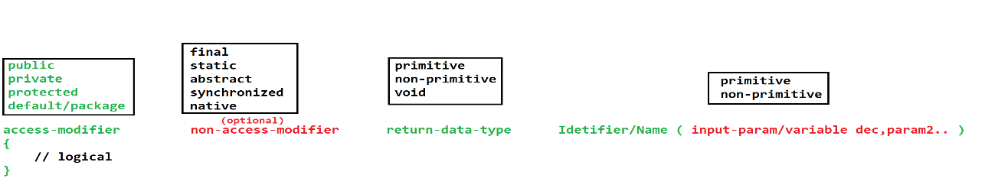

**Object**

1. Object is a representation of the class.
2. Using an object you can access the properties of the class (variables and methods).
3. To access the properties of the class you have to use dot(.) operator.
4. In Java you can create Object using **new** operator
5. Syntax

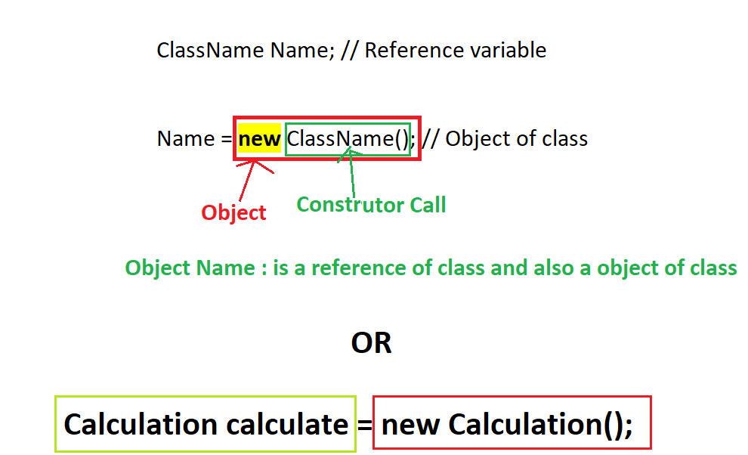

**Java Memory**

1. Stack:
   1. This memory is allocated for the method execution.
   2. The data created inside method will be allocated in this memory.
   3. This is based in LIFO (Last In First Out) structure.
   4. This memory keep on clearing as an when the method execution is completed.
2. Heap:
   1. This memory is allocated for a objects.
   2. The object creation happens inside this memory.
   3. To clear this memory java perform the Garbage Collection (GC) process.
   4. The GC process will be happen after a specific interval.

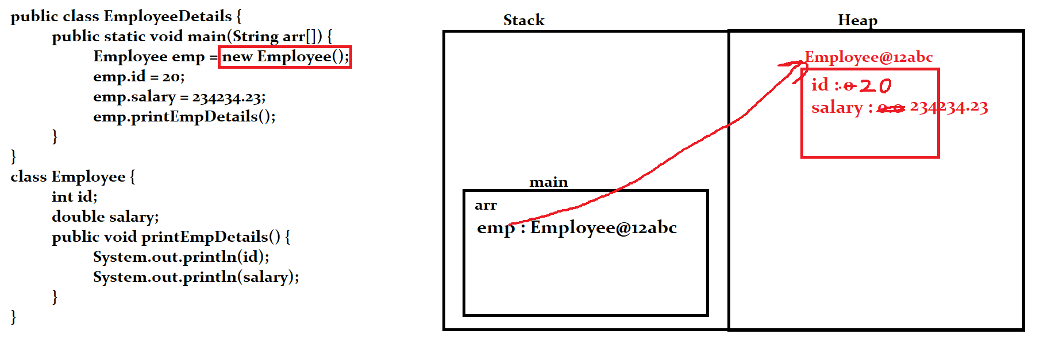

**String In Java**

**User Input in Java**

1. Command Line Argument
   1. This technique is use to get the input from the user.
   2. The user input will be provided at the start of the application from the execution command.
   3. The user inputs will be received inside the main method parameter inside the string array.
   4. In this case the values has to convert into a specific data type once it received in the java program.
   5. The Sequence of the value and the total number of user input has to follow else you may get an exception in the java program.
2. Scanner Class
   1. Scanner class is **build-in class**.
   2. This class is present inside **java.util package.**
   3. This class is use to accept the input from the user at the runtime of the program.
   4. Scanner class has a multiple functions using which you can accept the specific data type of values from the user.
   5. Scanner class is use to get the value from the console, file, string.
3. Console Class
4. Buffer Class

**Eclipse Installation and Setup**

<https://www.eclipse.org/downloads/download.php?file=/technology/epp/downloads/release/2023-03/R/eclipse-jee-2023-03-R-win32-x86_64.zip>

Set the Eclipse perspective to “Java”

Create Java Project into eclipse

1. Go To “File” menu -> “New” Option -> Click on “Java Project” option.
2. Set the Name of the project
3. Unchecked the Module checkbox.
4. Click on Next -> click on Finish

Creating Java File

1. Right click on the “src” folder -> Go To “New” option -> Click on “Class” option
2. Set the java class name
3. Select the main method option if you wanted to create main method.
4. Click on Finish

**Object Oriented Programming (OOPs)**

1. Encapsulation
   1. It is use to achieve the Data hiding and wrapping of data member and member function into single unit.
2. Inheritance
   1. Is use to access/inherit the properties of parent into child.
3. Polymorphism
   1. One Object having multiple forms (Same thing can be use in a multiple ways or for multiple purpose)
4. Abstraction
   1. Is use to hide the complex implementation/functionality and display only the important one to the user.

**Inheritance Advantage**

1. You can achieve a Reusability.
2. Can Achieve extensibility.
3. To perform runtime polymorphism the Inheritance is required.

**Polymorphic object**

1. You can create an object with parent class reference and child class Object.
2. Example:

ParentClass Object = new ChildClass();

1. By using this object you can achieve runtime polymorphism.

**Object class**

1. Object class is a build-in class in java.
2. Object class is a parent of all java classes.
3. In this class the common properties are declare which is used in all the java classes.
4. If there is no direct parent of any class then java will add Object class as a parent for those classes.
5. Some of the common properties (methods)
   1. equals(Object)
   2. toString()
   3. hashCode()
   4. getClass()
   5. wait(), wait(int), wait(int, long)
   6. notify()
   7. notifyAll()

**Constructor**

1. Constructor is used to initialize the instance variables at the time of object creation.
2. By default every class has a Constructor.
3. If you do not create any Constructor inside class then java will provide a default Constructor.
4. If you manually created any constructor inside class then java will not provide any constructor.
5. Rules to create constructor
   1. Constructor must have a same name as class name.
   2. Constructor do not have a return data type.
   3. Constructor can be created with any access modifier.
   4. There can be multiple constructor in a class which must be created with different parameter list this is also known as constructor overloading.
   5. Constructor always calls at the time of object creation and it can’t be called using class object and dot operator.
6. Every sub class constructor classes super class default or no-param constructor.
7. Every constructor has by default **super()** statement added as a first line.

**Java Keywords (super, this, static, final)**

super Keyword

1. Super keyword is use to access the properties of the super class.
2. You can access the super class Constructor, variable, methods.
3. Access Constructor using super keyword.
   1. Sub class Constructor can access super class Constructor.
   2. By default super keyword will be added as a first line of every sub class Constructor.
   3. One Constructor can only call another Constructor and that line must be a first line in a Constructor.
4. You can access the variable and methods of super class from any location of the program.

this keyword

1. this keyword is use to access the properties of same class.
2. it is a current object of same class.
3. Using this keyword you can access the constructor, variable and method of same class.
4. Access Constructor from same class.
   1. You can access the constructor of same class using this keyword.
   2. It must be a first line in a constructor.
   3. One Constructor can only call another Constructor

**Static Keyword**

1. Using static keyword you can create a class level properties
2. You can create static variable, method and static class (inner/nested class).
3. static properties can be access without creating object and only using class name.
4. Static variable
   1. Static variables has to create inside class and outside any method.
   2. Static variables are the sharable between all the objects of the class.
5. Static Method
   1. Static methods can be access by class name only.
   2. Static methos can access the static properties of the class only.
   3. You cannot use super and this keyword inside static method.

**Final Keyword**

1. Final keyword is use to create constants.
2. You can create static variable, method, class.
3. Final variable
   1. Final values will be unchanged once it is created.
   2. You cannot reassign the final variable value.
4. Final Methods
   1. The implementation of the final method is fixed.
   2. The final methods cannot be override.
5. Final class
   1. You cannot use final class as a super class for any other class.
   2. The final class properties are not final implicitly.

**Package, Import and access modifier**

**Package**

1. To create a group of java classes having similar functionality.
2. Packages are the folder in the file system.
3. Rules to create package
   1. Package statement must be a first statement in a file.
   2. It must be outside any class.
   3. Package statement is applicable for all the classes of the file.
   4. It must be creates using package keyword.
   5. There can be only one package statement present for a java file.

**Import**

1. Import statements are used access the classes from one package to another.
2. Rules to use import statement
   1. Import statement must be after package statement (if present)
   2. Import statement must be outside any class.
   3. It must be created with import keyword.
   4. Import statement can be write multiple time.
   5. It can be use to import all the classes from the package to access only single class.

Example:

import pack1.pack2.*; 🡪 Import all the classes from the package.

import pack1.pack2.ClassName; 🡪 Import a specific class from the package.

* 1. In all the java files by default java.lang package is imported.

**Access Modifier**

1. Access modifier are used to manage the access of the classes and its properties into another class.
2. There are 4 access modifier. Out of which default is the access modifier which is added by default of you not explicitly define.

|  |  |  |  |  |  |
| --- | --- | --- | --- | --- | --- |
| **Access Modifier** | **Access in same class** | **Access in different class of same package using object** | **Access in different class of same package using Inheritance** | **Access in different class of different package using Inheritance** | **Access in different class of different package using Object** |
| public | **YES** | **YES** | **YES** | **YES** | **YES** |
| protected | **YES** | **YES** | **YES** | **YES** | **NO** |
| default/package | **YES** | **YES** | **YES** | **NO** | **NO** |
| private | **YES** | **NO** | **NO** | **NO** | **NO** |

Arrang Access modifier by restriction level from high to Low

private 🡪 default 🡪 protected 🡪 public

**Polymorphism**

1. One object can have different form (one thing can be achieve in multiple ways)
2. There are 2 types of polymorphism
   1. Compile time polymorphism
      1. The method call resolves at the time of compilation and same will be followed at execution.
      2. To achieve this you have to use **overloading**
   2. Runtime polymorphism
      1. The method call is decided at the time of execution (compilation linking will not be followed at execution time).
      2. To achieve this you have to use **overriding**

**Overloading**

1. Method name must be same with different parameter list.
2. Overloading can be done in same class or sub class.
3. In Overloading parameter list must be different by following ways
   1. You can change the data type of the parameter.
   2. You can change the number of parameters.
   3. Sequence of parameter can be change.
4. Return data type may or many not be same.
5. Access modifier may or many not be same.
6. Can overload static methods. (you can overload main method)
7. Can overload final methods.
8. Can throw new and broader checked exception.
9. Advantage of overlading
   1. To improve the readability of the program.
   2. Provide easy interface to the user to use the functionality.

**Overriding**

1. Method name must be same and input parameter must be same.
2. Overriding must have to do in the sub class.
3. Return data type must be same if it is primitive or void else it can be change to sub type.
4. Access modifier can be change but must be less restrictive.
5. You cannot override the final methods.
6. You cannot override the static methods.
7. Cannot throw new and broader checked exception.
8. Advantage
   1. You can change the default implementation of parent class methods into sub class.

**Runtime Polymorphism**

1. There must be an inheritance between the classes.
2. The method must be override.
3. Method call happened using a polymorphic object.

**Abstraction**

1. Is use to hide the complex implementation/functionality and display only the important one to the user.
2. Abstraction can be achieved by 2 ways.
   1. Abstract Class
      1. Is use to achieve 0 to 100% abstraction. You can achieve the partial abstraction using abstract class.
   2. Interface
      1. You can achieve 100% abstraction.

**Abstraction Class**

1. Abstract class is use to achieve 0-100 abstraction which is also known as partial abstraction.
2. Abstract classes are mark with word abstract. Which contains abstract or non-methods.
3. Abstract method which do not have any implementation and it is just declare. Abstract method will be created using abstract keyword.
4. If any class has any abstract method created then the class must have to mark as abstract.
5. Abstract will be used as a parent class in the hierarchy.
6. You cannot create an object of abstract class. but you can use it as a reference.
7. Every sub class of the abstract class, has to provide the implementation (override) of all the abstract methods.
8. Abstract class can have a constructure. These constructure gets called whenever you create object of sub class of abstract class.
9. Abstract method cannot be static or final.
10. You can create a static and final method inside abstract class but it must be non-abstract method.
11. You cannot mark your abstract class as static or final.

**Interface**

1. Using Interface you can achieve 100% abstraction (till Jdk 1.7).
2. It is not a class, but every interface will get a .class file after compilation.
3. Interface will be created using interface keyword.
4. The methods created inside interface are by default public and abstract.
5. The variables created inside interface are by default public static and final.
6. Interfaces are implements by the class (abstract or non-abstract class).
7. Every sub(non-abstract) class of the interface has to provide the implementation for all abstract method.
8. Cannot create Object of interface but can be used as a reference.
9. Cannot create constructor inside interface.
10. Can create only public properties inside interface, no other access modifier is allowed inside interface.
11. You cannot create final method inside interface.
12. Cannot create static methods inside interface till JDK 1.7.
13. One interface can extends another interface, you can also extends more than one interface on single interface. Which is also known as multiple inheritance.
14. One class can implements more than one interface.
15. One class can extends another class and also implements the interfaces.

**Interface in JDK 1.8 and above**

1. You can create an implemented methods inside interface which is known as default method. (Can create default methods)
2. Can create static method inside interface.
3. Functional interface is introduce to achieve the functional programing in java.
   1. Functional interface is an interface which has only one abstract method.
   2. To ensure the interface is functional interface you can use an annotation as @FuntionalInterface.
   3. There can be any number of default or static methods inside functional interface, but there must be a single abstract method.

**Exception Handling**