Full Stack Development Using Java

Backend
Core Java
Basics Concepts of Programing using Java
Intro to Java, Installation and env setup, Writing, Compiling and executing first java program, Data Type, Control Flow statements, Array, class, Object, method, String classes, User inputs.
Object Oriented Programing Concepts
Encapsulation, Inheritance, Polymorphism, Abstraction, constructor, Keyword in Java, Package, imports, access modifiers
Advance concepts for Core Java
Exception Handling, Collection, threading, JDBC
Advance Java
Jsp, Servlet
Spring Boot Framework

Database
SQL

DevOps
- Git
- GitHub
- Maven
Software
- Jdk
- Eclipse
- MySql Database
- Git
- Postman
- Maven

Java Setup
- Download JDK
https://www.oracle.com/java/technologies/downloads/
Download the Installer for you operating System.
- Install JDK
- Verify the Installation
  - You can verify the installation file into C:\Program File\java\<jdk-version-folder>
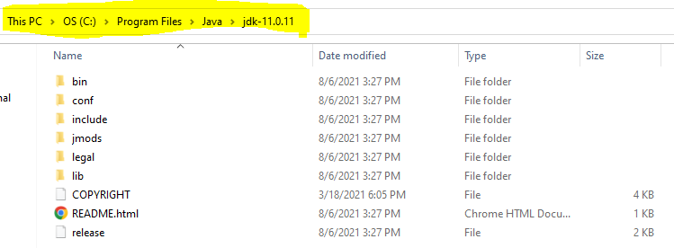
- Setup Environment Variable
  - Set JAVA_HOME
    - Go to Start and Search for “Environment” word and select the “Edit System Environment Variable” option.
    - Click on the “Environment Variable” button
    - Select “New” Button from the System Variable section
    - Provide the following details into text box
      - Variable Name: JAVA_HOME
      - Variable Value: <JDK-Path>
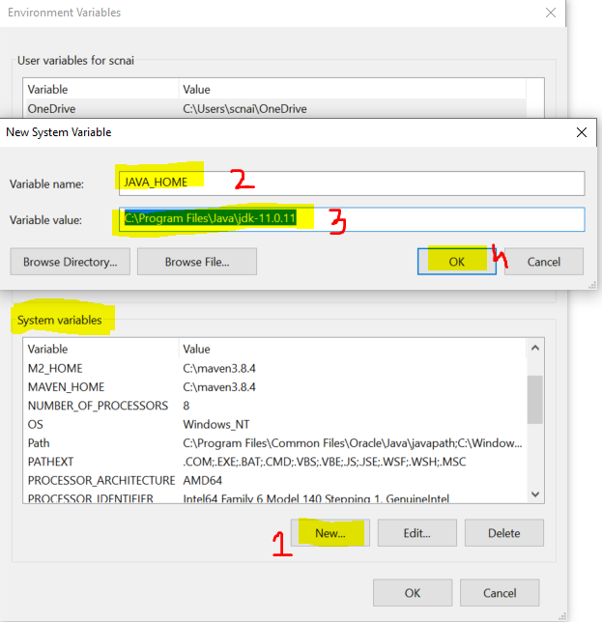
  - Set Path
    - Check for “path” variable inside system variable section
    - Select “Path” variable and click on “Edit” Button
    - Click the “New” button on the new window
    - And set the variable value as follows
%JAVA_HOME%\bin
    - Click on “OK”
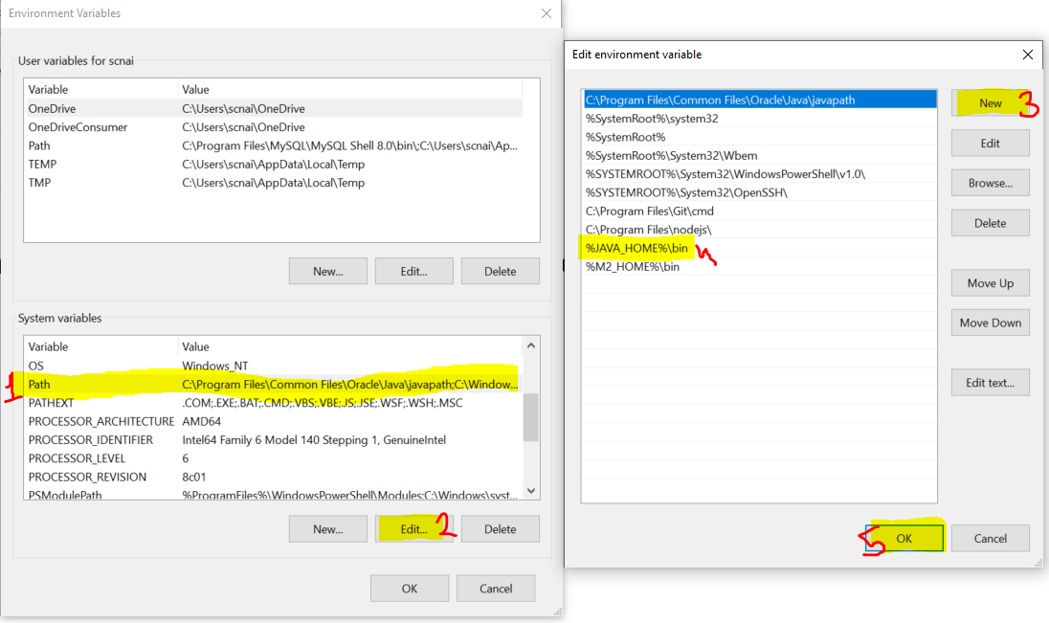
- Verify the Environment Variable Setup
  - Open CMD
  - Try the following commands
    - “java -version”
    - “javac”
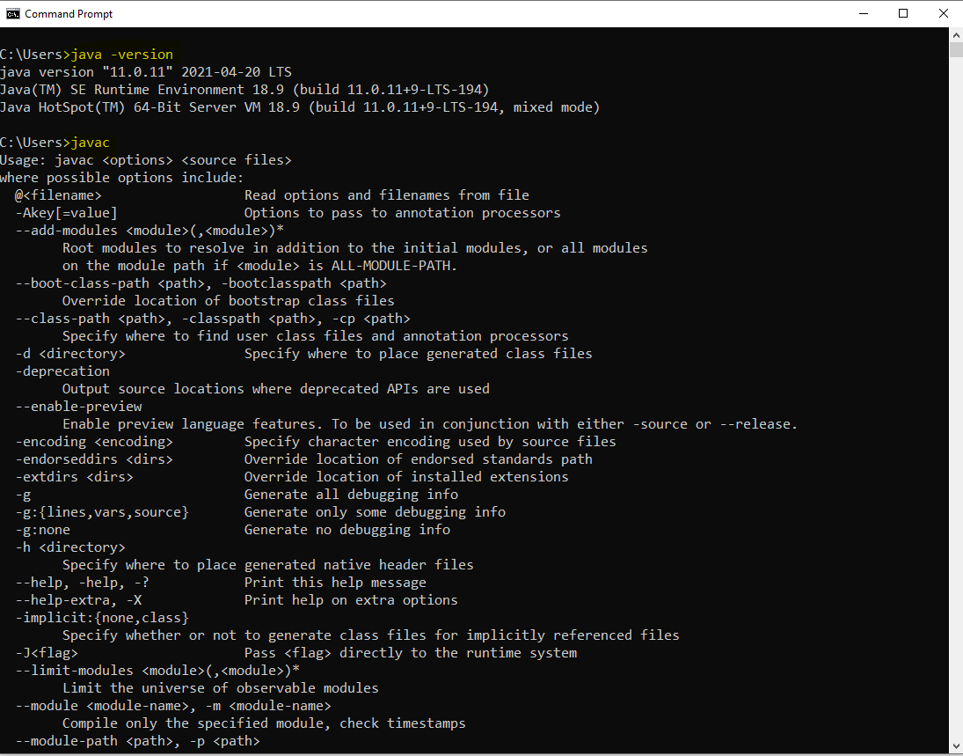

Important Components of Java
- JVM
  - JVM stands for Java Virtual Machine.
  - Using JVM you can execute your java code. This will help us to allocate the memory while execution of the java code.
- JRE
  - JRE stands for Java Runtime Environment
  - JRE help us to execute the java code by using JVM and APIs.
  - JRE must be present inside the client machine.
- JDK
  - JDK stands for Java Development Kit
  - JDK will help us to develop, compile and execute the java code.
  - JDK has a JRE, APIs and development tools like javac, javap etc.
  - JDK must be available on developer’s machine.
- APIs
  - APIs are the set of pre define functionalities provided by programing language.
  - This APIs are provided in the form of .jar file in java

Writing and Executing First Java Program
- Writing a java code
  - You can write a using IDE or Notepad or any editor tool.
- Java Program Syntax
  - Create Java class
    - In java everything must be write inside class except import and package statement.
    - Syntax:
public class <Class_Name>
{

}
  - Cerate Main Method inside java class
    - Main method is the first method which gets executed.
    - This method is a start point of java program.
    - This method will be called internally by java (JVM) when you execute your program.
    - Syntax:
public static void main(String args[])
{

}
  - Write an executable code into method.
System.out.println(“Hello, Welcome to first java program”);
- Save File
  - File Name must be same as public class name.
  - File extension must be .java.
- Compile the java code
  - In this sept the java code will be converted into a byte code and the binary file will be created.
  - As an outcome of the compilation step the .class file will be created.
  - In this step all the syntax validation will also happens.
  - To compile a code first Open a CMD
    - The path of the CMD must be pointing to a location where you save your java class. (to do this you can go to a folder where you save your java class, click on the address bar and type “cmd” and hit enter)
    - Execute a command to compile
javac FileName.java
- Execute Java code
  - Use same CMD
  - Execute a command to run java program
java className

Rules In the Java File (Source file)
- Java File is also known as Source file and the java code is also known as Source code.
- You can create multiple java classes in a source file, but only one public class is allowed.
- All the classes from the source file can have a main method.
- Source File name must be same as the public class name.
- For every class from the source file will get a different .class file after compilation.

Keyword, literal and Identifier
Keyword
- Keyword is a reserve word in the java programing language.
- There is total 52 keyword in java.
- Keywords are always in small cases.
- Examples are,
public, class, static, void, protected, private, default, if, else, for, while, do, int, short, long, byte, boolean, float, double, char, true, false, null etc…

Literal
- Literal are considered as a value and also a values from the keyword.
- String values are also considered as a literal.
- Example: true, false, null

Identifier
- Identifiers are the words which is used by developer of identifying the things from the programs.
- The words used to define/create variables, methods, class, Objects are called as an identifier.
- Rules to create Identifier
  - Identifier must not be a keyword.
  - Identifier Can contains alphabets, numbers or symbols.
  - Only $ and _ symbols are allowed, No other symbol is allowed.
  - Identifier must be start with alphabets or symbols, identifier must not be start with number.
  - There is no limit in the number of char, but it must be a meaningful.
  - Identifier are case sensitive.
  - Spaces are not allowed in the identifier.
- Example:
First, Second, Third, main, String, System, out, println, args
- Conventions to create Java Class
  - The class name should be start with Capital case and if class name is more than one word then every word should be start with capital.
- Convention to create method, variable and object
  - The name should be start with small case if name is combination of multiple words then every word starts with capital from the seconds word onwards.
- Convention for Constant
  - The name should be in capital case.

Data Type and Variable

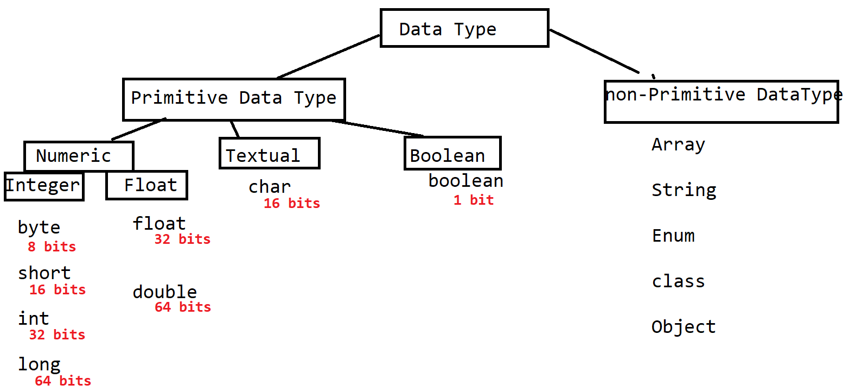

Integer
- Can store a numeric value without any decimal point.
- Example:
23,123, 45, -54, -44

Float
- Can Store the numeric value with decimal point.
- Example
2.3.12.3, -55.44, -2.2

Char
- Can store single character. Character can be a alphabets, symbol, numeric values (Without decimal point and negative)
- Char values must be created inside single quotes. (‘value’)
- In char you can store the ASCII value or number.
https://www.cs.cmu.edu/~pattis/15-1XX/common/handouts/ascii.html
- Example
‘A’, 65, ‘@’

Boolean
- In the Boolean true or false values are allowed. No other values can be store inside Boolean.
- In Java 0 and 1 is not consider as true and false, it will consider as a numeric value.

Variables
- Variables are used to store a values.
- Variables are used in a math expression.
- Variables are used to display values to the user.
- Variables are used to assign value to another variable.
- Variables has to use with a data type.
- Syntax for variable

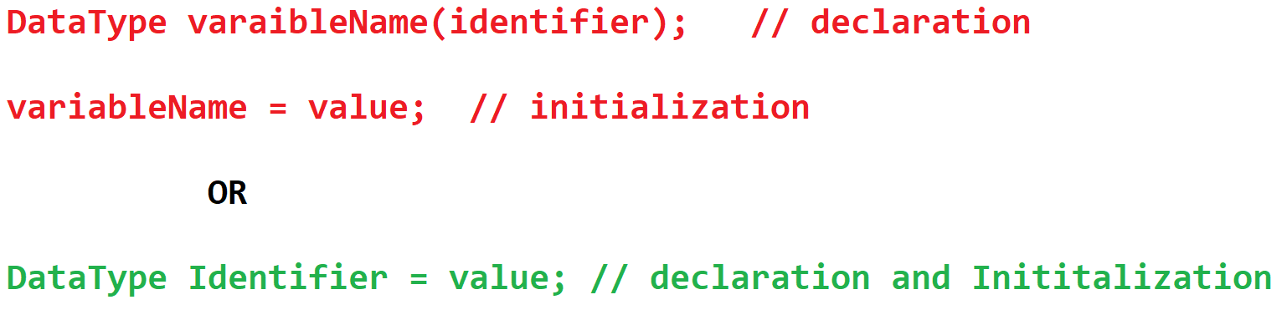

Memory Representation

To Find the Range of numeric values

-2^{n-1} to 2^{n-1} – 1

Here, n is the number of bits

Rules to create Variable

Long variable
The value must be ends with ‘l’ or ‘L’

Float Variable
Float variable values must has a suffix as ‘f’ or ‘F’

Char variable
Char can store a single character or numeric values(positive number only)
Or a symbol.

Casting in the Primitive Data Type
- Casting a process to convert data from one data type to another data type.
- There are two types of casting
  - Implicit Casting
    - In this the value of one data type can be converted into another data type automatically/internally.
    - This casting done by java internally and no extra code has to provide of this.
    - Example:
byte x = 10;
int y = x;
  - Explicit Casting
    - In this casting value of one data type cannot be directly converted into another data type.
    - To achieve this conversion you have to add extra code manually.
    - Example
int x = 10;
byte y = (byte) x;

Type of Variables.
- The type of variables decided on the bases of the position of the variable in the program.
- There are 3 types of variable
  - Local Variable
    - The variables which created inside method are called local variable.
    - The local variable is only accessible inside a method and you cannot use these variables outside the method.
    - All the local variables must be initialized before use. Else you will get a compile time error.
  - Instance Variable
    - The variables which is created inside class and outside any method are called instance variable.
    - The instance variables are accessible inside a class and in all the non-static methods of the class.
    - All the instance variable copy will be assign to an object (instance)
    - All instance variable will get a default value if you do not provide value manually
  - Class/Static Variable
    - The variable which is created inside class and outside method with static keyword is called class or static variable.
    - Static Variables can be access from static and non-static methods.
    - Static variables are initialized by java if you don’t provide any value.
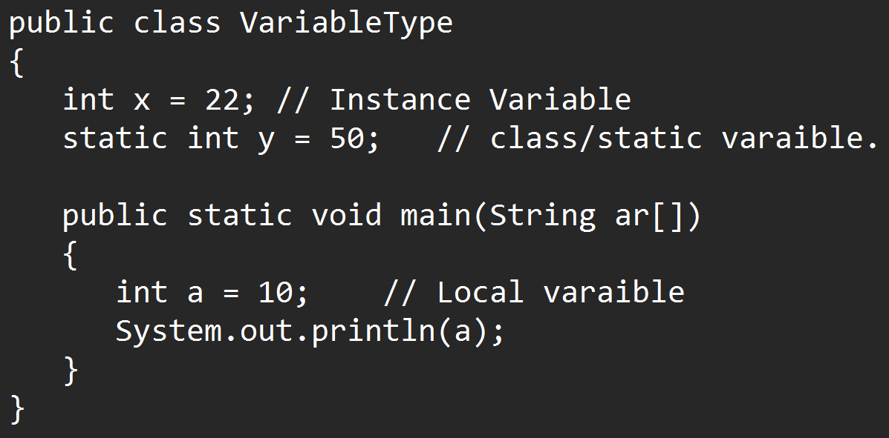

Default Values

Data Type | Value
byte  short  int  long | 0
float  double | 0.0
char | 0 or \u0000
boolean | false
Non-primitive | null

Note: The default values are only applicable for the instance and the Static/class variables.

Operators
- Arithmetic Operator (non-boolean values)
+, -, *, /, %
- Assignment Operator (non-boolean values)
=, +=, -=, *=, /=
- Relational Operator (Boolean value)
==, !=, >, >=, <, <=
- Increment Decrement Operator (non-boolean values)
++, -- (Per and Post operations)
- Logical Operator (for both boolean and non-boolean values)
&, |, !
- Short circuit operator (Boolean value)
&&, ||
- Ternary Operator (Decision Making Operator)
?, :

Comments
- To skip the line or block of line form the execution then you can use comments in java.
- Using comments, you can also write a documentation for your program.
- In Java there are 3 types of comments
  - Single Line Comment
To Comment out the single line of code. Commented line of code will not be included into a .class file.
Syntax:
// line to comment

  - Multi line comment
To comment out the more than one line at a time. Commented line of code will not be included into a .class file.
Syntax:
/*
Lines to comment
*/

  - Documentation Comment
To provide a documentation for the code. These commented lines are also added into a .class file.
Syntax:
/**
Links to Comment
*/
Control Flow Statement
- Every Program Executes in a sequence by default.
- There are 3 types of control flow statement
  - Sequential execution
    - This is the default behavior of any program.
  - Conditional Statement
    - This is used to execute a statement or block of statements based on the condition/criteria or scenario.
    - Using if conditional statement and switch cases can write a conditional statement.
  - Looping Statement
    - This is used to execute the statement or a block of statement multiple time.
    - This can be achieved using for, while, do-while loop

If conditional Statement
- This is use to execute a statement or block of statements based on condition.
- There is different structure of the if condition.
- if structure
Syntax:
if(Boolean Expression/Condition)
{
Statement(s)
}

Note: The statement written inside curly braces executes only if condition is true

- if-else structure
Syntax:
if(Boolean Expression/Condition)
{
Statement(s)
}
else
{
Statement(s)
}

Note: else block always comes with a if block only and it gets executed when the condition is false.

- Nested If
Syntax:
if(Boolean Expression/Condition)
{
if(Boolean Expression/Condition)
{
Statement(s)
}
}
Note: One structure can be created into another structure.

- else-if structure/ladder
Syntax:
if(Boolean Expression/Condition)
{
Statement(s)
}
else if(Boolean Expression/Condition)
{
Statement(s)
}
else if(Boolean Expression/Condition)
{
Statement(s)
}
else
{
Statement(s)
}
Note:
- In this structure you can execute the else based on the condition, there can be any number of else-if present in this structure.
- Else block is optional here and it will gets executed only if none of the condition satisfy.
- In this structure if any of the condition becomes true then it will not execute rest of the conditions and will come outside the structure by executing the statements.

Task :
WAP to get the Age category.
Given : int age = 20;
Output:
Print one of the following result.
“Child Age” if age between 0-17
“Teen Age” if age between 18-22
“Adult Age” if age between 23-60
“Old Age” if age between 60-110
If not between 0-110 then print “Invalid Age”

Switch Case
- Switch structure is used to execute a cases in the different scenarios.
- Switch is a keyword. Which can be used with value and the cases.
- Switch cases are used in a scenarios where you wanted to compare the equality check between value.
- Syntax :
switch(value)
{
case label:
Statement(s)
break;
case label:
Statement(s)
break;
case label:
Statement(s)
break;
default:
Statement(s)
break;
}
- Inside switch case there is no condition check happens, hence cases are executed without checking condition and hence to break the case you can use break statement
- Rules to use switch case
  - The data type of switch values must be matches with the case label data type.
  - Break statement is not mandatory, but if you dont provided break statement it will execute all the cases till end case or until come outside of the switch case.
  - Case lable must be always unique, No Duplicate case label is allowed.
  - If multiple cases having a same line of execution then you can combine a cases.

Task:
Print the Day using day number using switch case
Day = 1,2,3,4,5 : Working Day
Day = 6,7 : Weekend
Any other value = Invalid Day

Looping Statement
- Looping statement is used to execute a statement or block of statement multiple times.
- There are multiple options to achieve this
  - While
  - Do-while
  - for
While loop
- while loop is also known as pre condition checked.
- You can use this loop when the number of iterations are not fixed.
- Syntax:
Variable = value // variable declaration
while(Boolean Expression/Condition)
{
Statement(s)
Increment/Decrement
}

do-while
- This structure is also known as post condition check.
- Do while loop executes the statement at least once even if condition is false.
- Syntax:
Variable = value // variable declaration
do
{
Statement(s)
Increment/Decrement
}
while(Boolean Expression/Condition);
for loop
- For loop is used for same purpose like while and do-while
- You can use for loop in the case where you know how many time you wanted to execute loop.
- Syntax
for(declaration/Initialization ; Condition check ; increment/decrement/statement )
{
Statement(s)
}

Nested Loop
- One Loop inside another loop is called nested Looping
- This is mostly useful where you wants to handle the data which is table format or to handle row and column.
- Syntax:
for() { // row
for() { // column
}
}

Enhance For Loop (for-each)

- This loop is used to iterate collection and get the values from the collection one by one.
- In the enhance for loop you can get all the values from the collection. In this indexes are maintain internally.
- Syntax:
for (x var : collection_obj)
{

}

Array
- Array is a non-primitive data type.
- Non-primitive data types are always in object format and they do not have any fixed memory.
- Array is use to group the multiple values/Object into a single location.
- Array is of fixed size/length and it can store only a same type of data.
- Array is indexed based. In array you can set or get the values using index.
- Index is managed by java internally, Index always start with 0, index is always positive number.
- If you handle the index inappropriately then you will get an java.lang.ArrayIndexOutOfBoundsException
- Types of Arrays
  - 1-D Array
  - 2-D Array
  - Jagged Array (Multi-D Array)
1-D Array
- In 1-D array you can store values into row format.
- To get the total number of values inside array you can use array.length function
- To create 1-D array you have follow following steps.
  - Declaration of Array.
    - Using this step you can notify java about the usage of array.
    - Syntax:
DataType identifier[];
Example:
double precent[];
  - Instance/Object Creation (Instantiation) of Array.
    - In this step the object will be created for array using new operator.
    - Memory will be allocated for an array after object creation.
    - The index and the values are created.
    - In this step you have to provide the size/length of an array.
    - Syntax:
identifier = new DataType[size];
Example
percent = new double[5];
  - Initialization of Array.
    - In this step you can assign a values to every block of an array.
    - To set and get the values you have to user the indexes.
    - Syntax:
identifier[index] = value;

Different approaches to create an Array

1.
double percent[]; // Declaration of array.
percent = new double[5]; // instance/Object creation
percent[0] = 77.8;
percent[2] = 87.65;

2.
double percent[] = new double[5]; // Declaration and instance/Object creation
percent[0] = 77.8;
percent[2] = 87.65;

3.
double percent[] = new double [] {77.8, 0.0, 87.65, 0.0, .0.0};

4.
double percent[] = {77.8, 0.0, 87.65, 0.0, .0.0};

2-D Array
- To store a data in the form of table you can use 2-D array.
- In this array the number of rows must be fixed but columns can he dynamically decided.
- To get the total number of row in array you can use array.length
- To Get the total number of column you can use array[row_index].length
- To create 2-D array you have follow following steps.
  - Declaration of Array.
    - Using this step you can notify java about the usage of array.
    - Syntax:
DataType identifier[][];
Example:
double precent[][];
  - Instance/Object Creation (Instantiation) of Array.
    - In this step the object will be created for array using new operator.
    - Memory will be allocated for an array after object creation.
    - The index and the values are created.
    - In this step you have to provide the size/length of an array.
    - Syntax:
identifier = new DataType[row_size][column_size];
Example
percent = new double[5][3];
  - Initialization of Array.
    - In this step you can assign a values to every block of an array.
    - To set and get the values you have to user the indexes.
    - Syntax:
identifier[row_index][column_index] = value

Different Approaches for 2-D Array

1.
double marks[][];
marks = new double[3][5];
marks[0][3] = 77;
marks[1][2] = 66;
marks[2][0] = 68;
marks[2][4] = 65;

2.
double marks[][] = new double[3][5];
marks[0][3] = 77;
marks[1][2] = 66;
marks[2][0] = 68;
marks[2][4] = 65;

3.
double marks[][] = new double[][] { {77,88,99,66,67}
, {76,67,87,68,61}
, {71,81,91,61,51} };

4.
double marks[][] = {{77,88,99,66,67}
, {76,67,87,68,61}
, {71,81,91,61,51}};

Jagged Array
- The rows will be fixed and there will be a different number of columns for a row in same array.
- This is also known as multi-dimensional array.
- Example:
int arr[][] = {
{45,67}, {43,65,87,23}, {3,5,8}
}

Class Object and Method
Class
- Class is a collection of state(data/variable) and behavior(function/method)
- Along with variables and methods you can also create constructor and another class (Nested class) inside one class.
- There are 2 types of classes
  - Build-in class: The class which is written and provided by java.
  - Custom Class: The class which is create programmatically.
- Syntax:

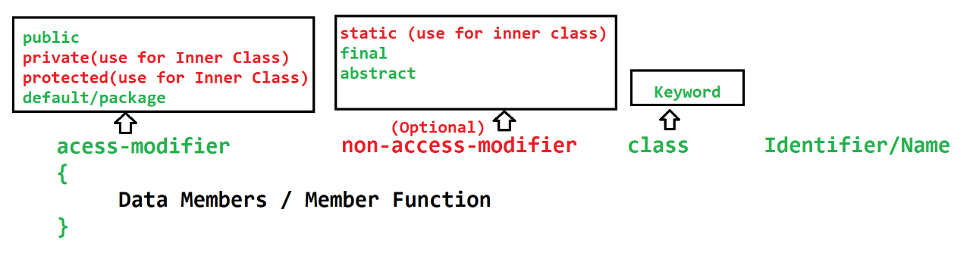

Method
- Methods are used to execute the business logic or statements.
- Methods are use to distribute the large code into a smaller chunk. It will reduce the code complexity and increase the code readability.
- Methods contains the input parameter which is used to accept the values inside method at the time of calling it.
- Method can have a return type using which output can be return back to a caller. From the method you can return one values at a time.
- Parameter: Are used to accept values as an input inside method. It is in the method signature.
- Arguments: Is a values passed to a input parameter while calling a method.
- Syntax: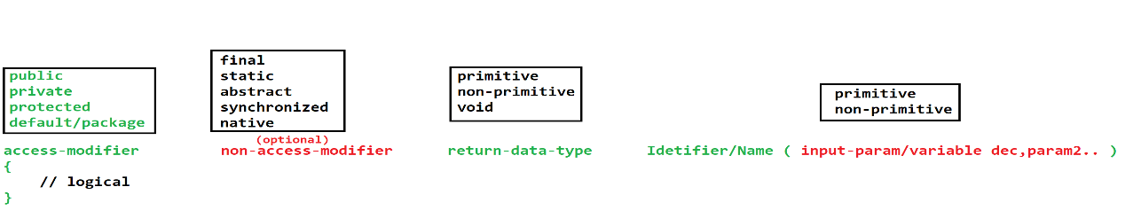

Object
- Object is a representation of the class.
- Using object you can access the properties (Variables, Methods) for one class from another class.
- Every Object of the class will get the new memory allocation inside Heap memory.
- new operator is used to create object of the class
- Syntax:
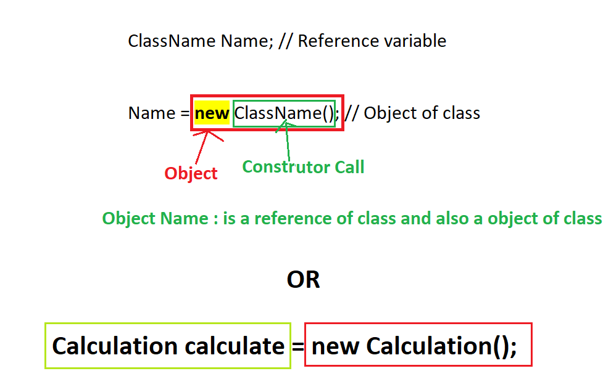

String in Java
- String is a non-primitive data type.
- String is an array of multiple characters.
- In a string every character stores into a separate index.
- String value must be created inside double quotes (“ value ”)
- String can be used in java using following build-in classes.
  - String
  - StringBuilder
  - StringBuffer
  - StringTokenizer

String class
- String is a build-in class of java
- String class is present inside java.lang package.
- String class is used to store a string value.
- String class is a final class
- String class objects are immutable. That means one you assign values to a string it will never change even after applying a method of string class.
- String class has multiple methods using which you can perform operation on existing string.
- To use string class you have to create object of String class.
- Object creation can be achieved by 2 ways.
  - With New operator
String str = new String(“value”);
  - Without new operator
String str = “value”;
- String Constant Pool (SCP)
  - SCP is one of the memory allocation inside Heap, in which the string object will be store, which is created using without new operator.
  - While creating any object inside SCP it will first check if already same value is present or not, if same value is present then it will not create new object instead it will return the same object, else it will create new object.

- If you used == operator to compare two objects then their memory allocations will be compare instead of their values. To compare the valued from the objects you have to used .equals() method.

Task-1
WAP to store you full name (FN MN LN) and print it in the name as per the 10th marksheet (LN FN MN). Output must be in a capital case.
Hint: Use Split method and get the array of words and print required output using array.
Task-2
WAP to print the string value in reverse.
In -> Hello
Out -> olleH
Hint: use toCharArray method to convert string into array and print array into reverse order.

StringBuilder
- StringBuilder is a java build-in class.
- This is the final class.
- This class is present inside java.lang package.
- Using this class you can store and manage the string values.
- StringBuilder object is mutable. That’s is original value keep on changing when you apply the method of class.
- To use this class you have to create a object of this class.
- Syntax:
StringBuilder obj = new StringBuilder(“<value>”);

StringBuffer
- StringBuffer is a java build-in class.
- This is the final class.
- This class is present inside java.lang package.
- Using this class you can store and manage the string values.
- StringBuffer object is mutable. That’s is original value keep on changing when you apply the method of class.
- To use this class you have to create an object of this class.
- Syntax:
StringBuffer obj = new StringBuffer(“<value>”);
- StringBuffer methods are synchronized.
- It is a thread safe class, that is only one thread can access the object of this class.
- It is slower in the performance than StringBuilder.
Accept User Input
- Command Line Argument
  - You can accept values from the user before execution startup of the application.
  - The Entered values are pass to a String[] of the main method.
  - Hence, all the entered values are in string only. If you pass any numeric value then it will be consider as a string only.
  - Command Line Argument will be used to pass a values from the execution command of the program.
  - There are some issues in this approach.
    - All values which you received in to java program will be in string only. You have to manually convert this value into appropriate Data type once it is received.
    - All values must be provided and it must be in a same sequence in which it is expected in the java program.

- Scanner Class
  - This is the predefine class in java using which you can accept the input from the user using CMD or form the file or from the string.
  - This class inside present inside java.util package.
  - This class is use to accept the values form the user at the time of execution of the program (at program runtime).
  - There are multiple methods provided, to accept the different data type values such as next() to accept string value, nextInt() to accept int value like wise nextXXX() is for different data types.

Eclipse IDE

Download
https://www.eclipse.org/downloads/download.php?file=/oomph/epp/2022-06/R/eclipse-inst-jre-win64.exe

Install
https://www.eclipse.org/downloads/packages/installer

Note: While installation select “Eclipse IDE for Java EE Developers” option (2nd option from the list)

Object Oriented Programming (OOPs)
- The base of OOPs concept is class and object.
- There are 4 main oops concepts
  - Encapsulation: Wrapping of data member and member function into single unit.
  - Inheritance: it is way using which you can inherit the properties of parent class access by child class.
  - Polymorphism: Achieve a multiple thing using single object.
  - Abstraction : Hiding the complexity and showing only the required details.

Encapsulation
- Wrapping of data member (variables) and member function (method) into single unit.
- Class is also consider as a encapsulation.
- As per recommendation create all instance variable as private and provide access to these variables using getters and setters methods.
- These type of java classes as wildly used in a application development, in the different technologies it has different names such as bean, dto, entity, pojo class.
- Getter Methods
  - Getter methods are use to return the instance variable value.
  - Getter method not accepts any value but it will return the value.
  - The prefix of getter method should be “get” followed with variable name
- Setter method
  - Setter methods are use to set the values for the instance variable.
  - Setter methods will accept the value from input parameter and also not return anything.
  - The prefix of the setter method should be “set” followed with the variable name.
- Advantage of Encapsulation
  - Can achieve Data hiding (By making variable as a private).
  - Is a way to achieve loose coupling (if you change one part of code it will not effect on another code).
  - It will increase the flexibility of the code.

Inheritance
- Using inheritance, you can access the properties (data member and member function) of parent class into child class.
- Advantage of inheritance
  - Reusability
  - Extensibility
  - It is an import concept to achieve overriding and run time polymorphism.
- To Achieve inheritance you can use “extends” keyword. It is creating an IS-A relation between 2 classes.
- There are total 5 types of inheritance available inside OOP’s concepts but only 3 are directly supported by java and other 2 can be achieve using interface.
- In Java One class can extends one class at a time. One class cannot have more than one parent.
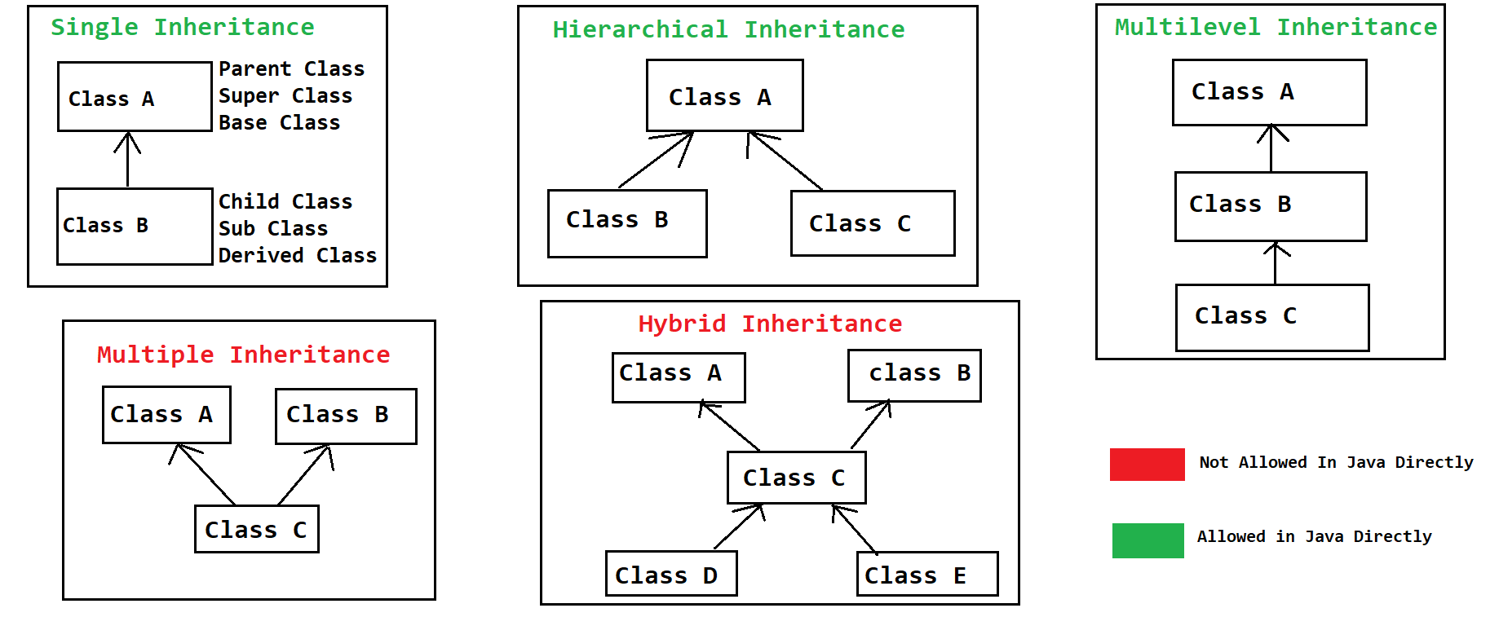
- You cannot access the private properties of parent class inside child class.
- In multilevel inheritance properties of the grant parent class will be accessible in the child class through its parent class.
- Every Super class reference variable can hold the object of its child class. this type of object is known as polymorphic object.
Syntax: ParentClass obj = new ChildClass();

Object Class
- It is a super/parent class of all the java class.
- Every java class directly or indirectly inherits the property of Object class.
- If you do not added any parent class then by default its super class will be a Object class.
- All the common and mostly used methods are provided into this class, so that its methods can be accessible to all the classes.
- Some of the mostly used common methods are
  - toString()
  - hashCode()
  - getClass()
  - finalized()
  - equals()
  - wait()
  - notify()
  - notifyAll()

this, super, static, final Keywords

this:
- this is also known as same class current object. This points to a current class Object.
- This is used to access the same class instance variable, method and constructor.

super:
- User keyword is used to access the properties of super/parent class. properties such as variable, method and constructor.
- Super is not an object of parent class. It is just an provision using which you can access the properties of super class.

static:
- Static keyword is use for a variable, method, class (must be an inner class) or can create static block also.
- Static properties will load into memory at the time of class loading (before program execution start).
- Static properties can be access without object and just by using a class name
- In the static method or inside static block you cannot access the non static propertied. That is, Static methods and block can access only static properties of the class.
- this and super keyword cannot be use inside static method or block.
- static block is used to initialized the static variable. This block called at the start of the class execution, and it gets called only once.

final
- Final keywork is used to create a constant. Constants are the properties which does not changed once it is created.
- In java you can make variable, method and class as a final.
- Final Variable: The variable whose value is fixed once it is declare. Final Variables can be local or instance variable.
- Final Method: the method implementation will be fixed and it will never changed. Final methods cannot be override but it can be overload.
- Final class: final classes cannot be use as a super class (can’t be parent). Final class can extend another class. String, StringBuffer, StringBuilder are the examples of build-in final class.

Package and Import
- Package Statement:
  - Is a group of java files/classes which has a similar type of execution.
  - In the file system packages are nothing but the folder which has a java classes.
  - There can be only one package statement in a source file.
  - The package statement must be a first statement in a file.
  - package keyword is used to create package in java.
  - There can be only one package statement a file. And it will be applicable for all the classes in a source file
  - Syntax:
package packageName;
package package1.package2.package3;
- Import statement:
  - Import statement is use to access the properties of the class from one package to another package.
  - Using import statement you gives the access of the java class which is present inside another package.
  - Import statement must be write after package statement.
  - There can be multiple import statement present inside class.
  - Syntax:
import packagename.ClassName;
To import a single class from a package
import packagename.*;
To import all the classes from the package
Access Modifier
- Access Modifiers are use to control the access of the properties of class.
- You can decide which property can be access outside the class.
- There are 4 access modifiers in java
  - public
  - protected
  - default/package (this is the default access modifier if you not provided explicitly)
  - private
Access Modifier | In Same class | Different class in same package by Object | Different class in same package by Inheritance | Different class in different package by Inheritance | Different class in different package by Object
public | YES | YES | YES | YES | YES
protected | YES | YES | YES | YES | NO
default | YES | YES | YES | NO | NO
private | YES | NO | NO | NO | NO

Restriction Level from Highest to Lowest
private default protected public
Polymorphism
- Single Object can be use in a multiple ways.
- Polymorphism is more than one form.
- There are 2 types of polymorphism
  - Compile time polymorphism
    - The method call is resolve at the time of compilation and the same will be followed at the time of execution.
    - The Example of compile time polymorphism is Overloading
  - Runtime polymorphism
    - The method calls resolve at the time of execution/runtime.
    - The example of runtime polymorphism is Overriding

Overloading
- In the overloading the method with same name can be implemented multiple times using different parameter list is known as overloading.
- In the overloading method name must same with different parameters.
  - Can have same number of parameters with different data type.
  - Can have different number of parameters.
  - Can changes the sequence of the parameter.
- Overloading can be done in the same class or a sub class.
- In the overloading return data type can be same or it can be change.
- In the overloading access modifier can be same or it can be change.
- Can throw new and broader checked exception.
- Can overload static method (main method also).
- Can overloading final method.
- StringBuffer and StringBuilder is an example of overloading.
- Advantage of Overloading
  - You can improve the code readability
  - Can provide easy way to access the functionalities to the user.

Overriding
- Overriding must have to do in Sub-class.
- In the Overriding method name must be same with same parameter list.
- Return data type must be same if it is primitive or void or it can be sub type.
- Access modifier can be same or it can be change but it must be less restrictive.
- Cannot throw new and broader checked exception.
- You cannot override the final methods.
- Static method cannot be override.
- Advantage of overriding
  - You can change the implementation provided inside super class inside sub class.

Runtime Polymorphism
- It is a process in which method call is resolve at the time of execution, so different method can be called at runtime.
- Following steps has to follow to achieve runtime polymorphism
  - There must be an inheritance and overriding present inside a code.
  - There must a Polymorphic Object created.
  - Call the overridden method using a polymorphic object.

Polymorphic Object
- It an object in which the reference will of parent and the object is of child.
- The Object which has parent reference and child object is called polymorphic object.
- Every parent reference in java can hold objects of its child class.
- Syntax:
Parent obj = new Child();

FAQ:
- What is Polymorphism
- What is overloading with and programmatic example.
- What is overriding with and programmatic example.
- Difference between Overloading and Overriding
- Difference in Runtime and Compile time polymorphism
- What is runtime polymorphism with an example.

Abstraction
- Abstraction is a way using which you can hide the complexity and display only the required detail or functionality to the user.
- Abstraction is also known as Implementation hiding.
- Abstraction can be achieve in java by 2 ways.
  - Abstract class
    - By using abstraction you can achieve 0-100% abstraction.
  - Interface
    - By using interface you can achieve 100% abstraction.

Abstract Class
- Can achieve 0-100% abstraction.
- It is a class which can have an abstract or non-abstract method.
- These classes are declared using an abstract keyword.
- Abstract class has abstract method, the methods which do not have any implementation and just have a declaration these methods are called as abstract method.
- If you have any abstract method in class then that class must be mark as abstract.
- Abstract classes are mostly used as a top level class in the hierarchy.
- You cannot create an object of abstract class, but it can be used as a reference to use as a polymorphic object.
- Abstract class can extends by another non abstract class, in this case you have to provide the implementation (override) for all abstract methods from the abstract class.
- Abstract class can extends by another abstract class, in this case it is not necessary to provide the implementation for the abstract method. It can be inherited as abstract in sub class.
- Abstract methods must not be private, final or static.
- You can create private, static or final in abstract class but those methods must be non-abstract.
- Can have a variable inside abstract class.
- You can create a constructor inside abstract class, and it will call whenever you crate and object of sub class of abstract.

Interface
- Interfaces are not a classes but it will get a .class file after compilation.
- Interfaces are used to achieve 100% abstraction.
- Inside interface all methods are by default public and abstract.
- Interfaces are used as a top level in a hierarchy.
- Interfaces are created with interface keyword.
- Interfaces are always implements on class (abstract class/concrete(non-abstract) class).
- If you are implementing interface on class then, you have to provide the implementation of all the abstract methods in-side a sub class.
- If you implements the interface on abstract class then, it is no necessary to implements abstract methods from the interface, abstract methods can be inherited as it is.
- We cannot create object of interface, but it can be used as a reference.
- Every variable inside interface is public, status and final.
- In Interface you can use only public access modifier no other access modifier is allowed.
- You cannot create constructor inside interface.
- You cannot create a static and final methods inside interface. (till jdk-1.7).
- One interface can extends another interface or more than one interface also. Using this you can achieve the multiple inheritance.
  - One interface can extends more than one interface.
  - One class can implements more than one interface.
  - One class can at a time extends another class and implements the interfaces.

