Full Stack Development Java
Front End

Back End
Core Java
Basics of Java
Java intro, Installation and Setup for Java, Writing and executing first java program, Data Type, Control flow statements, Operators, Array, Class, Objects, methods, Java Build-class, String classes.
Object Oriented Programing in Java
Encapsulation, Inheritance, Polymorphism, Abstraction, constructor, Java keyword, final, static, super, this, access modifier, package
Advance of Core Java
Exception Handling, Threading, Collection, JDBC.

Spring Boot Framework

Database
SQL, MYSQL Database

Tools (DevTool)
Git
GitHub
Maven
Postman
Swagger

Software
JDK (JDK-11)
Eclipse IDE
MySql Database
Git
Maven
Postman

Download JDK (1.8 and above).
https://www.oracle.com/in/java/technologies/downloads/
Note: Download Installer instead of zip file

Java Documentation
https://docs.oracle.com/en/java/javase/11/docs/api/

Logical Program Solving:
https://www.hackerearth.com/
https://www.hackerrank.com/

Java Setup
- Download JDK
https://www.oracle.com/java/technologies/downloads/
Download the Installer for you operating System.
- Install JDK
- Verify the Installation
  - You can verify the installation file into C:\Program File\java\<jdk-version-folder>
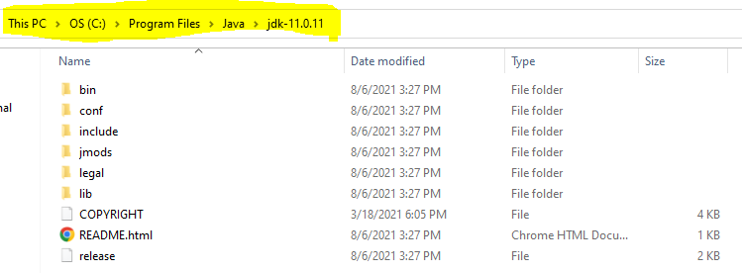
- Setup Environment Variable
  - Set JAVA_HOME
    - Go to Start and Search for “Environment” word and select the “Edit System Environment Variable” option.
    - Click on the “Environment Variable” button on the new window.
    - Select “New” Button from the ‘System Variables’ section
    - Provide the following details into text box
      - Variable Name: JAVA_HOME
      - Variable Value: <JDK-Path>
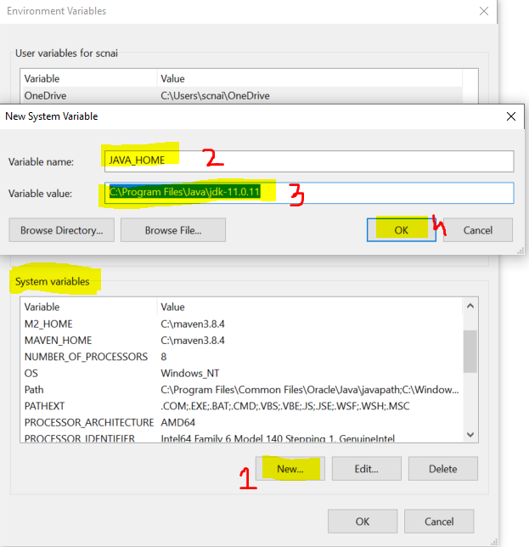
  - Set Path
    - Check for “path” variable inside ‘system variables’ section
    - Select “Path” variable and click on “Edit” Button
    - Click the “New” button on the new window
    - And set the variable value as follows
%JAVA_HOME%\bin
    - Click on “OK”
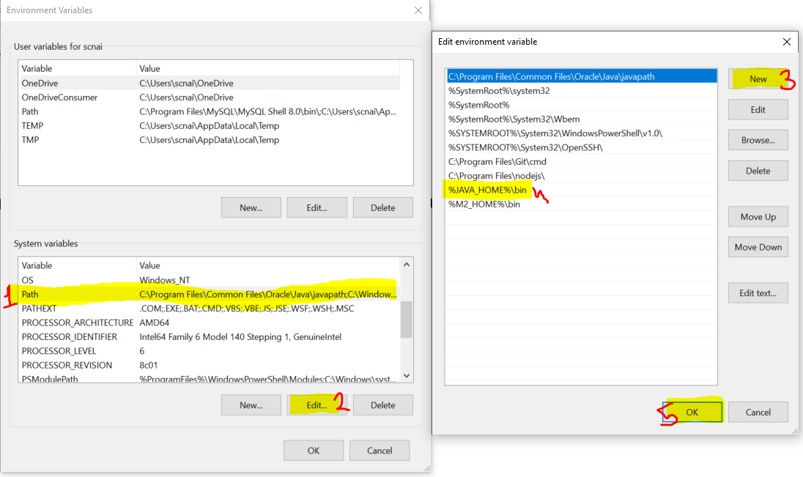
- Verify the Environment Variable Setup
  - Open CMD
  - Try the following commands
    - java -version
    - javac
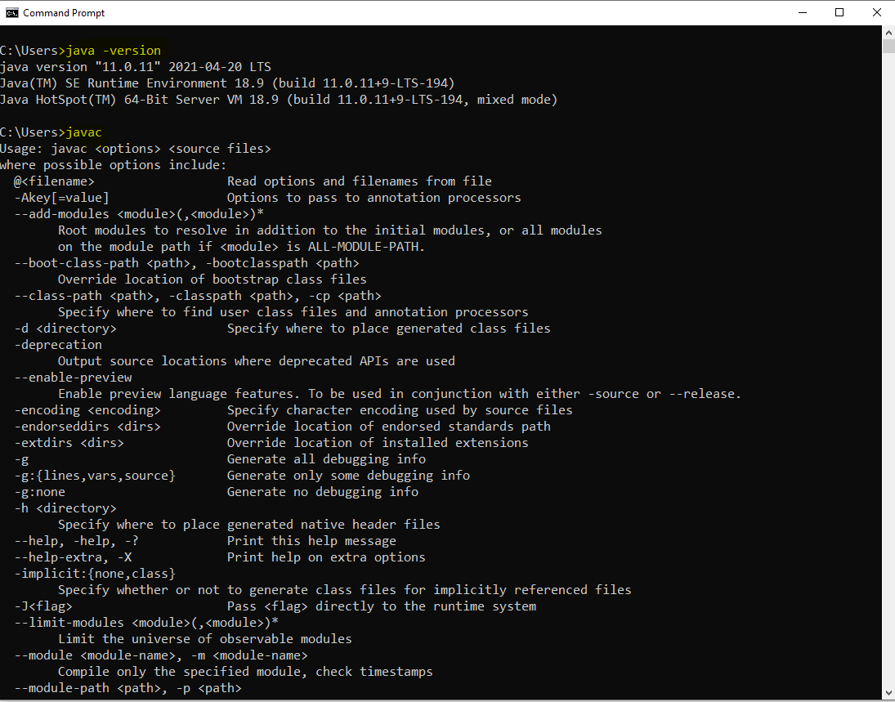

Type Of Application
- Desktop application
- Web application
- Mobile Application
- Embedded Application
- Console application

Java Intro
- Introduce in the 90’s
- First know as an Oak language
- Purpose of Java language was create a Browser, TV.
- First official version of the java is JDK 1.0
- JDK 2.0 has introduce with a multiple edition of java.

Java Editions
- JSE
  - It also known as a core Java
  - It stands for Java Standard Edition
  - Use to implement the basic concepts of java.
  - Can develop the desktop and console based application.
  - Examples: Eclipse, IntelliJ, NetBean IDEs.
- JEE
  - It is also known as Advance Java
  - It stands for Java Enterprise Edition
  - Use to develop the Dynamic Web Application.
  - Example: IRCTC, SBI, ICICI etc.
- JME
  - It stands for Java Micro Edition
  - It is use to develop the Mobile and the Embedded Application
  - Example: Android application

Key Component of Java
- JVM
  - JVM stands for Java Virtual Machine
  - It is used to execute the java program and allocate the memory which is required for program execution, it also communicate with OS for thread execution.
  - To execute the java program you must required JVM on your system.
- JRE
  - JRE stands for Java Runtime Environment.
  - It as a combination of JVM and APIs. It will provide an runtime environment for the java applications.
  - You can just execute the java program using JRE.
  - JRE has to be present on Users/client system.
- APIs
  - APIs stands for Application Programming interface.
  - It is a set of predefine (Build-in) classes, interface, function provided by java language.
  - APIs are provided in the form of .jar file
- JDK
  - JDK stands for Java Development Kit.
  - JDK has to present on Developer system to develop, compile and execute the java program.
  - JDK is a combination of JRE, JVM and APIs components.

Writing and Executing First Java Program
- Writing a java code
  - You can write a using IDE or Notepad or any editor tool.
- Java Program Syntax
  - Create Java class
    - In java everything must be write inside class except import and package statement.
    - Syntax:
public class <Class_Name>
{

}
  - Cerate Main Method inside java class
    - Main method is the first method which gets executed.
    - This method is a start point of java program.
    - This method will be called internally by java (JVM) when you execute your program.
    - Syntax:
public static void main(String args[])
{

}
  - Write an executable code into method.
System.out.println(“Hello, Welcome to first java program”);
- Save File
  - File Name must be same as public class name.
  - File extension must be .java.
- Compile the java code
  - In this sept the java code will be converted into a byte code and the binary file will be created.
  - As an outcome of the compilation step the .class file will be created.
  - In this step all the syntax validation will also happens.
  - To compile a code first Open a CMD
    - The path of the CMD must be pointing to a location where you save your java class. (to do this you can go to a folder where you save your java class, click on the address bar and type “cmd” and hit enter)
    - Execute a command to compile
javac FileName.java
- Execute Java code
  - Use same CMD
  - Execute a command to run java program
java className

Rules
- One source file can have more than one class.
- But only one class must be public
- The file name must be same as a public class name.
- After compilation .class file will be generated for the classes present inside a source file not for a complete file.

Keyword, Literal and Identifier
Keyword
- Keyword is the reserve words by programming language.
- These words will be use by programming for their internal implementation.
- There are 52 keywords in java.
- All keywords are in the small case.
- Example:
public, class, void, static, final, private, default, protected, float, double, byte, short, int, long, char, boolean, if, else, while, do, continue, break, case, switch, null, true, false etc.
Literal
- Literal is the values, mostly String values are also considered as literal.
- Specially, the values which is reserve by java as known as literal.
- These values are also a keyword.
- Example: null, true, false
Identifier
- Identifier are the words which are used for a coding perspective.
- These words are use by developer for the class, method, variable, object name.
- Using Identifier, you can provide the name of the components which can be further use for the reference.
- There are rules to create identifier
  - Identifier must not be a keyword.
  - Identifier must be start with alphabet or symbol ($ and _).
  - In the Identifier you can use an alphabet, number or symbol. It must not be start with number.
  - The allowed symbols are $ and _
  - Identifier must not contains the spaces.
  - There is no character limit for the Identifier (it should be start and meaningful).

Convention to create Identifier
- Convention for creating class
  - The class name should start with capital.
  - If the class name is combination of multiple words then every word should be start with capital.
  - Example: Welcome, String, System, PersonDetails, EmployeePersonalDetails.
- Convention for creating method, variables or Object
  - The name of variable, method and object should be start with small case.
  - If the name is a combination of multiple words, then 2nd word onwards it should start with capital.
  - Example: main, println, printDetails, studentMarks, printEmployeeDetails
- Convention for creating constants
  - The name of the constant should be in capital case.
  - If it is combination of multiple words then, use _ as a word separator.
  - Example: PI, GRAVITY, FOUNDING_YEAR

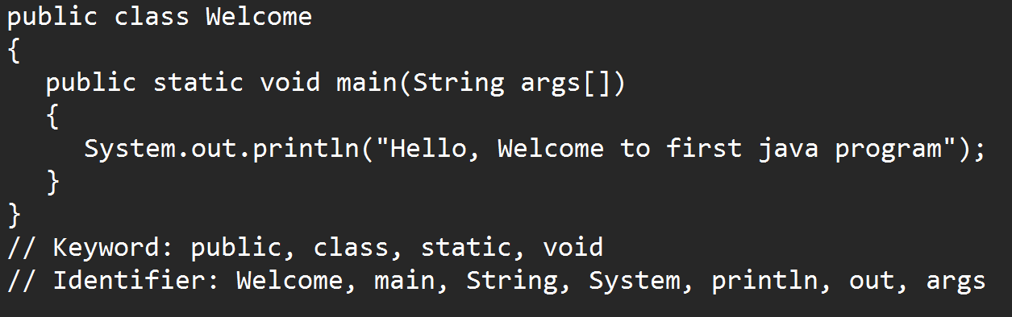

Comments in Java
- Comments are use in the program to skip the lines from the execution or it can be use for a future reference.
- The commented code will not be eligible for the execution.
- There are 3 types of comments
  - Single line comment
    - Syntax:
// line to comment
  - Multi line comment
    - Syntax
/*
Lines to comment
*/
  - Documentation Comment
    - This comment Is use to provide the code level documentation.
    - The comments added by this type will also be included inside .class files.
    - Syntax:
/**
Lines to Comment
*/

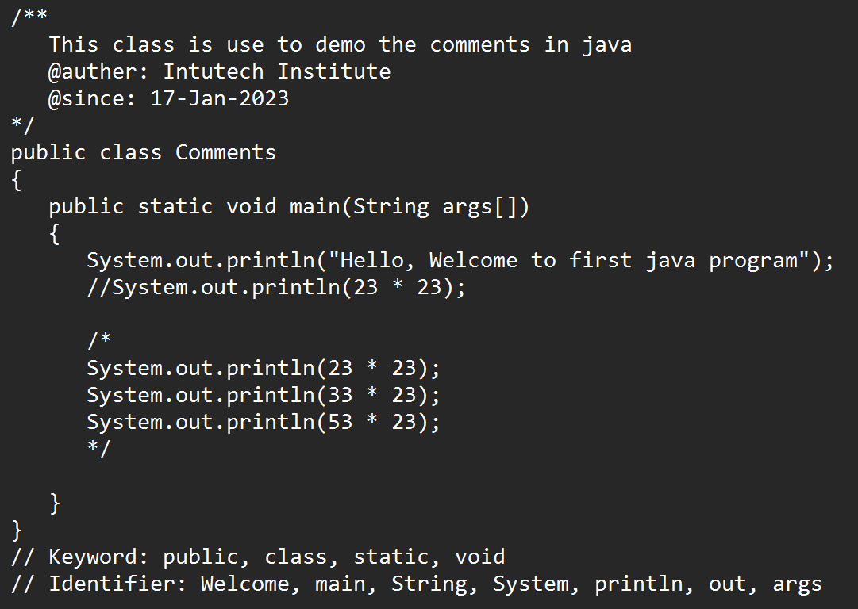

Data Type and variable
- In the program execution you will required a different type of data which has to be created inside the code.
- This different type of data is categorized using Data Type. There are 2 main categories
  - Primitive Data Type
    - It has a fixed size.
    - It is in non-Object format.
  - Non-Primitive Data Type
    - It does not have any fixed size. The Size will decide on the bases of the use.
    - It is always in the Object format

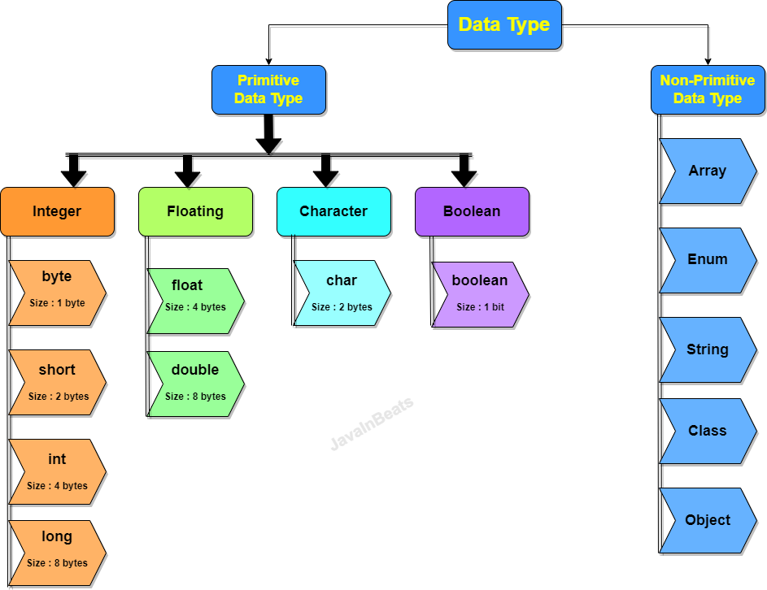

Integer
- The numeric type of data which is without any decimal number.
- The values can be negative or positive.
- Any non-decimal numeric value created without any data type is consider as int.
- Example: 121, 10, -20
Floating
- The numeric value with or without decimal number.
- The values can be negative or positive
- Any decimal numeric value created without any data type is consider as double.
- Example: 22332.12, 4.2, -121.1
Character
- Can store a alphabets, numbers or symbols.
- There can be maximum one alphabet store inside char.
- Can store numeric value which must be non-decimal and only positive value allowed.
- You can store a ASCII values inside this.
- Character value has to store in a single quotes only if it is alphabet or symbol
Boolean
- In Boolean you can store only true or false value.
- In java 0 and 1 in not consider as false and true

Variable
- Using variable, you can store the values inside program.
- Variables are use to display the output the user.
- Variable is used the expressions like math, comparison expression etc.
- Variables are used to assign value to another variable.
- Syntax:
DataType identifier; // Declaration of variable
identifier = value; // Initialization of variable

Range Of the Primitive Data Type
- You can store a value of specific range only into specific data type.
- There id a n formula to find the range of variable. (applicable of integer type)
-2^{n-1} to -2^{n- 1} – 1
Here, n is the number of bits
Example: Byte = 8 bits
-2⁸⁻¹ to -2⁸⁻ ¹ – 1
-128 to 127

Primitive variable casting
- Casting is a process in which can convert a value from one data type to another.
- There are 2 types of casting
  - Implicit casting.
    - This casting can be done automatically by Java(JVM)
    - In this the small data type values will be store inside large data type due to which there will no loss of bits happen.
  - Explicit casting.
    - This casting has to do manually to the developer
    - Java will not by default allows this casting. Because the values of large data type will be converted into smaller data type.
    - Here the bit loss can be happen.
    - To do this casting manually then you have to write the extra code.

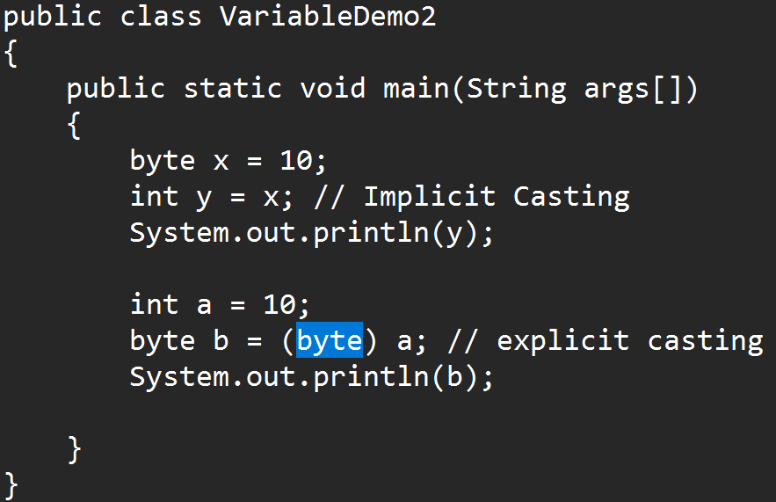

Types of Variable
- There are 3 types of variable. The variable types are decided on the bases of how and where you create a variable.
  - Instance variable
    - The variable which is create inside class and outside any method is called instance variable.
    - Instance variable are accessible inside class and in all the methods directly and out side class it can be access using Object/instance.
    - The instance variable will be initialize with default value if you do not provide any value manually.
    - Instance variables store inside Heap memory
  - Static/class variable
    - The variable which is created inside class and outside any method using static keyword.
    - static variables are accessible inside class and in all the methods directly and outside class it can be access using Class name.
    - The static variable will be initialize with default value if you do not provide any value manually.
    - Static/class variables store inside static area.
  - Local variable
    - The variable which Is created inside method.
    - These variables can use only inside method and you cannot access it into another method.
    - Local variable has to initialize before use.
    - Local variables store inside stack memory

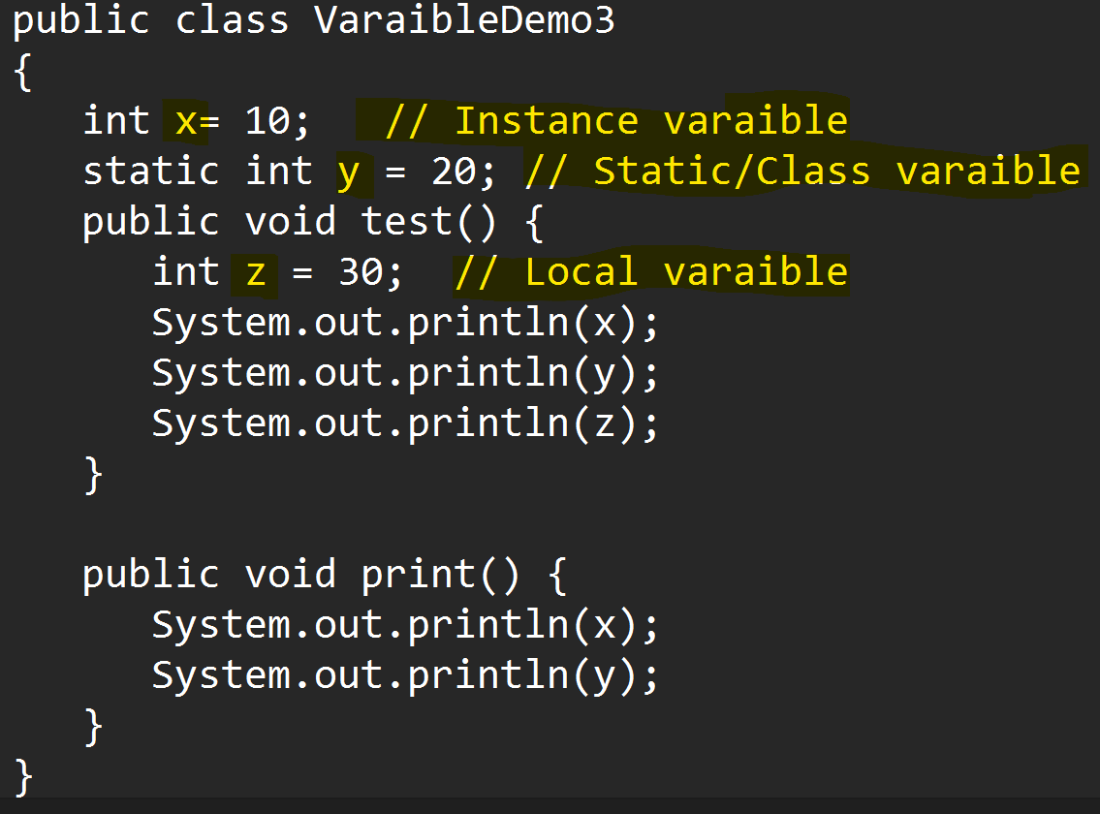

Default Values

Data Type | Default Value
byte  short  int  long | 0
float  double | 0.0
boolean | false
char | 0 or \u0000
Non-primitive | null

Note: these default values are only applicable for Instance and static variable.

Operator

- Arithmetic Operator
+, -, *, /, %
- Assignment Operator
=, +=, -=, *=, /=
- Increment decrement
++, --
This operator can use to perform the pre and post operation.
- Relational Operator
>, <, >=, <=, ==, !=
Use to compare the values. You can write a Boolean/logics/conditional expression
This operator always return true or false output only
- Logical Operator
!, &, |
Logical Operator can be use for combining 2 logical expressions or it perform numeric operation on bit level
- Short Circuit Operator
&&, ||
Using this operator you can combine 2 logical expressions
- Ternary Operator
? :
Is use to set the values based on some condition.
Where as ‘?’ consider as if condition and ‘:’ consider as else

Control Flow Statement
- Program execution flow is always in the sequence.
- To execute the program based on some scenarios or based on some conditions then you can use the control flow statement
- There are different typed of control flow statement
  - Conditional Statement
    - Using this statement you execute the statements based on condition.
    - Example: if condition and its variable or Switch case
  - Looping Statement
    - Using this statement you can execute the statements multiple time.
    - Example: while, do-while, for loop or enhance for loop

If Conditional Statement
- If you wanted to execute the statement or block of statement based on some scenario/condition.
- There are multiple variations of for If statement

If Condition
Syntax
if(condition/Boolean Expression)
{
Statement(s)
}
The statements from the if block will only executes if the condition is true.

If & else condition
Syntax
if(condition/Boolean Expression)
{
Statement(s)
}
else
{
Statement(s)
}
In this case the if statements execute when the condition is true and else statement executes when the condition is false.
Else block has to use with if block only.

Else-if condition/ladder
In this structure you can provide a condition for the else block
Syntax
if(condition)
{
Statement(s)
}
else if(condition)
{
Statement(s)
}
else if(condition)
{
Statement(s)
}
else
{
Statement(s)
}
In this structure if any of the condition becomes true then it will not check the other conditions and directly come out from the else-if structure.

Nested If
- Nested If is a way to create one if structure into another structure.
- Syntax
if(condition)
{
if(condition)
{

}
}

Switch Case
- You can improve the performance of the application using switch over a else-if.
- In Switch structure the condition checks are not happened.
- The scenarios which used for exact values matching for this you can use switch case.
- Syntax:
switch(value)
{
case label:
Statement(s)
break;
case label:
Statement(s)
break;
case label:
Statement(s)
break;
default:
Statement(s)
}
- Rules to use switch case
  - You can use byte, short, int, char, enum and String data type only for the value inside switch.
  - Case label must be match with the switch value data type.
  - Label must unique.
  - Default is not mandatory it works as else block in if statement.
  - You can combine a multiple cases having similar execution.

Looping Statement
- It is used to execute a statement or block of statement multiple time.
- There are different type of looping statement available such as while, do-while, for, enhance for loop.

While Loop
- While Loop is use to execute a statement or block of statement multiple time.
- While loop is also known as pre condition check
- Syntax
Initialization/start point of the loop
while(condition)
{
Statement(s)
Increment/decrement variable
}
- The while loop executes the statement till the file condition become false.

do-while Loop
- Do-while loop is use to execute the statement multiple times.
- Do-while loop is also known as post condition check.
- Syntax:
Initialization/start point of the loop
do
{
Statement(s)
Increment/decrement variable
}
while(condition);
- The statements executes at least once even if condition false.

For Loop
- It is use to execute a statement or block of statement multiple times.
- Syntax:
for(declaration & initialization ; Condition ; Increment/decrement/statements)
{
Statement(s)
}
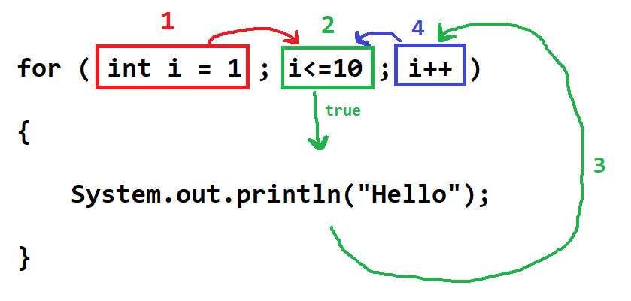

Enhance For Loop
- This loop use to execute statement multiple time. This is also known as For-Each loop
- This is used for iterating all the values one by one from the collection and array.
- Syntax:
for ( variable declaration : collection )
{
Statement(s)
}

Nested Loops
- Nested Loop is use to perform the row and column level operation
- You can create one loop inside another.
- The outer for loop is always for Row and Inner for loop is always for column.
Syntax:
for(declaration & initialization ; Condition ; Increment/decrement/statements)
{
for(declaration & initialization ; Condition ; Increment/decrement/statements)
{
Statement(s)
}
}

Array
- Array is a group of values or objects.
- Array is group of similar data type of values or object.
- Array is a fixed in size.
- For creating an Array you must know the data type and the size of the values.
- Array is a non-primitive data type.
- Array is indexed based.
- Indexes are always start from 0.
- Indexes are always managed internally by java.
- To set and get the values form array you have to use index.
- You will get an exception while handling the incorrect index. The Exception is ArrayIndexOutOfBoundsException
- There are multiple types array in java such as 1-D array, 2-D, Multi-Dimensional (Jagged Array) Array
- There are 3 steps to create array
  - Array Declaration
  - Array Instantiation (Object creation)
  - Array Initialization.

1-D Array
- Data Will be store in the form of row.
- Using length function you can get the total number of values (size) present inside array.
- You can also find the last index of the array using length function.
Last index = array.length - 1
- Syntax:
Array Declaration
DataType identifier[];
Array Instantiation (Object creation)
Identifier = new DataType[Size];
Array Initialization.
Identifier[index] = value;

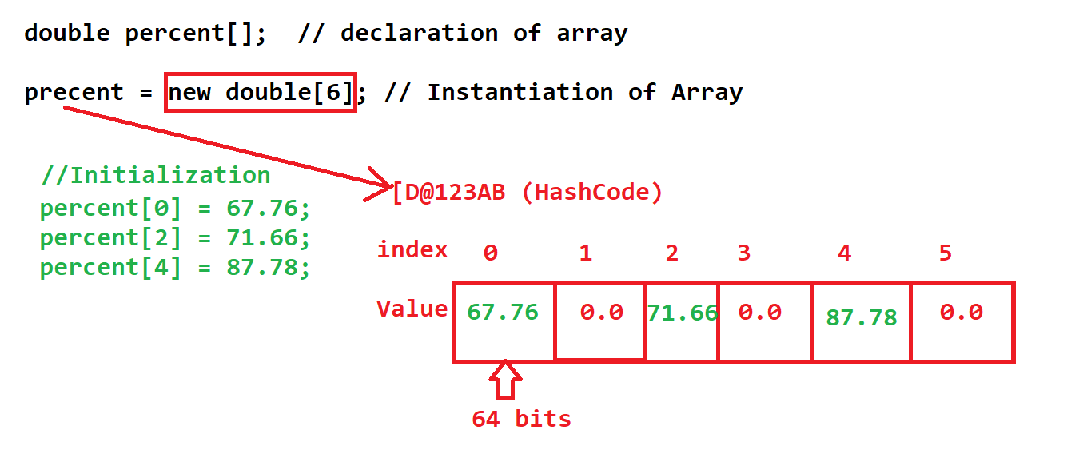

Different ways to create 1-D Array

double percent[]; // declaration of array
percent = new double[3]; // Instantiation of Array
percent[0] = 77.77; // initialization of array
percent[0] = 87.54;
percent[0] = 67.34;

double percent[] = new double[3]; // declaration and Instantiation of Array
percent[0] = 77.77; // initialization of array
percent[0] = 87.54;
percent[0] = 67.34;

// declaration, Instantiation and initialization of Array
double percent[] = new double[] {77.77, 87.54, 67.34};

// declaration and initialization of Array without manual Instantiation.
double percent[] = {77.77, 87.54, 67.34};

2-D Array
- Using this array you can store data in the form of row and column structure (table)
- In 2D array length function will return the number of rows and column
  - Array.length: it will return the total number of rows
  - Array[row-index].length: it will return the total number of columns of given row.
- It is mandatory to provide row size and column size is optional.
- Syntax:
Array Declaration
DataType identifier[][];
Array Instantiation (Object creation)
Identifier = new DataType[row-Size][column-Size];
Array Initialization.
Identifier[row-index][column-index] = value;

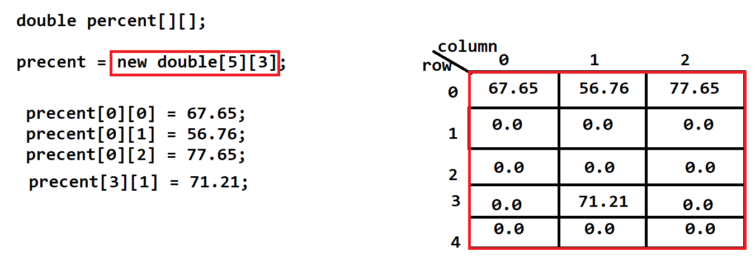
Different ways to create 2-D Array
double percent[][];
precent = new double[2][3];
percent[0][0]=66.54;
percent[0][1]=76.54;
percent[0][2]=54.14;
percent[1][0]=98.14;
percent[1][1]=89.51;
percent[1][2]=55.44;

double percent[][] = new double[2][3];
percent[0][0]=66.54;
percent[0][1]=76.54;
percent[0][2]=54.14;
percent[1][0]=98.14;
percent[1][1]=89.51;
percent[1][2]=55.44;

double percent[][] = new double[][] {{66.54, 76.54, 54.14}, {98.14,89.51, 55.44}};

double percent[][] = {{66.54, 76.54, 54.14}, {98.14, 89.51, 55.44}};
Multip-Dimensional array
- The array with different number of column.
- Example:

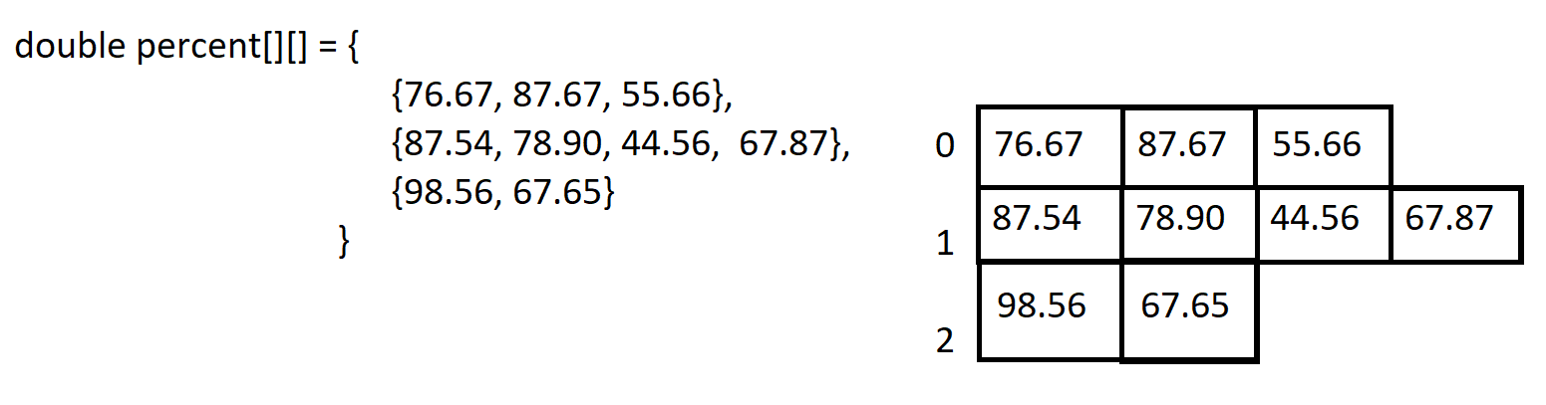

Task-1
Create a group of any number of integer values, and find the total number of even and odd values.
Example: int val[] = {45,56,67,65,35,657,86,445,568,568,346,457,34,845,6,65,8};
Output : Event Count = 8
Odd Count = 9

Task-2
Create an array with 5 student 6 subject marks.
Print the percentage of every student
Print the grade (First class , Second Class, Distinction, pass class).
Print the highest percentage.

Task-3
Create an array 5 customer and any number of product price. (Multi-Dimensional array)
Print the total amount for every customer.

Class, Object and Method

Class
- Class is a collection of state and behavior.
- Where state means the Variables/Data and behavior is also known as function or methods.
- Along with variable and method you can also create constructor.
- In Java everything has to within the class except the import and package statement.
- You can access the variables and methods of one class into another class. To do this you will required an Object of the class.
- Syntax:
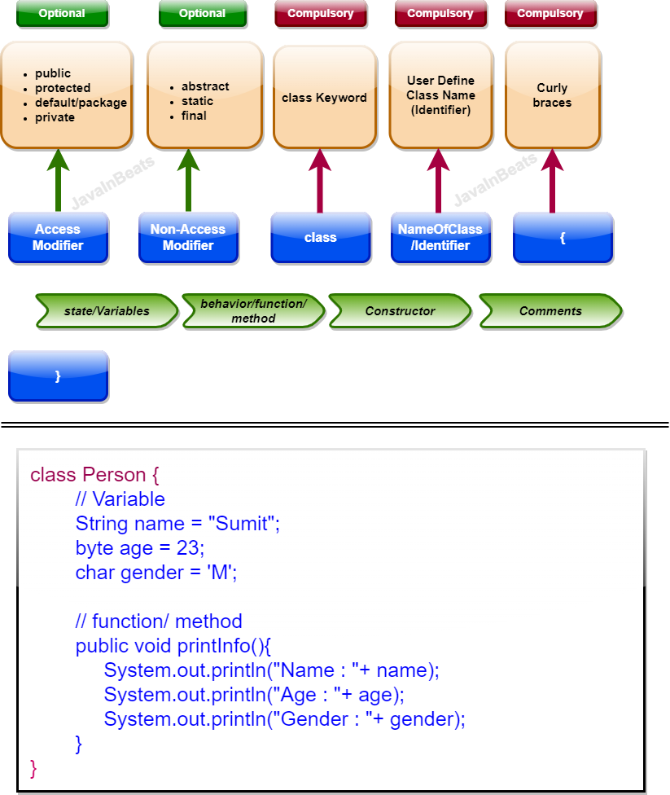

Methods
- Method is a collection of variables (local variable) and statements.
- Methods is use to write a logical code which can be execute/called from the multiple location.
- Methods is also use to divide the logic into smaller chunk of code.
- The methods has to called explicitly using an object of class to execute it.
- Types of methods
  - Custom Method
    - The method create programmatically.
  - Predefine method
    - The method which provided internally by language or framework.
- Methods will be created with or without input parameter and it can be return the output.
- The value provided for the input parameter is also known as argument.
- Syntax:
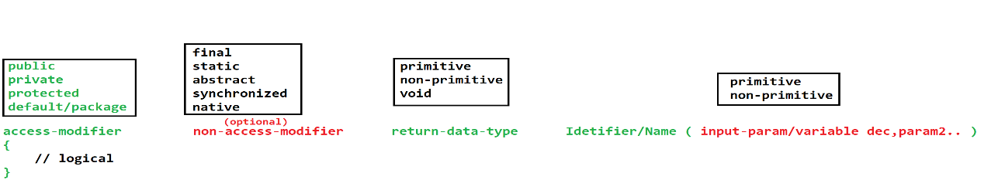

Object
- Object is a representation of the class.
- Using Object we can access the properties (variables and methods) of class.
- To use the properties of the class we have to use dot(.) operator
- You can create any number of objects of the class
- Every Object has independent memory and separate copy of the Instance variable.
- In Java you can create object using new operator.
- Syntax:
ClassName ref; // Reference variable
ref = new ClassName(); // Object of the class

OR Constructor Call
ClassName ref = new ClassName();

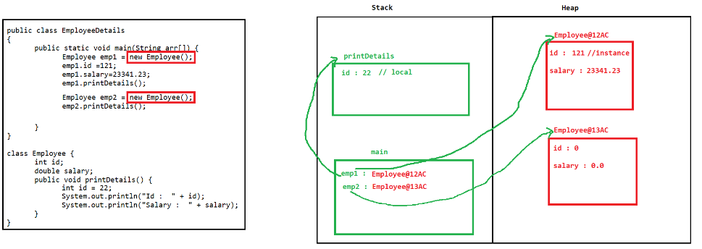

JVM Memory
Stack
- Stack memory is use to execute the methods.
- It is use to create a memory allocation for the method and method execution will happen inside stack.
- Memory gets clear after execution of the method.
- It work on the LIFO (Last In First Out)
Heap
- The objects will be created inside Heap.
- To clear this memory java have Garbage Collection (GC).
- The GC process execute internally after specific interval and it will remove all the object which are not refer by any one (no longer in use).

String in Java
- It is a non-primitive data type.
- String is use to store an array of character.
- It internally represents as an array if character.
- String values are always store in double quotes (“values”)
- In Java to store and handle the string values there are multiple classes available
  - String
  - StringBuffer
  - StringBuilder

String Class
- String class is a predefine class in Java.
- String class is a build-in class.
- String is a non-primitive data type
- String class present inside java.lang package.
- String class is a final class.
- Using this class you can store the values in array of character form.
- There are multiple methods available in this using which you can perform the operation on existing string.
- To use String class you have to create Object of It. And this can be achieved by 2 ways.
  - With new operator
String str = new String(“Value”);
  - Without new Operator
String str = “Value”;
- String class Objects are immutable. It means once you assign the value to a string it does not changes even after implementing the string methods.
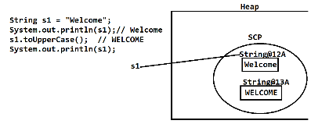
- The Object of String created with new operator will be created inside the Heap memory directly.
- The Object which is created without new Operator will be added inside String Constant Pool (SCP).
- String Constant Pool (SCP)
  - It is a String memory inside Heap.
  - Before string an object inside SCP, it will first check if the same value is present inside it or not. If present then, no new object will be created and the same object will be assign and if same value is not present the new object will be created.
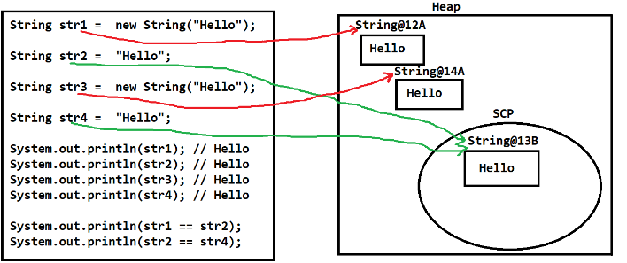

StringBuffer
- StringBuffer class is a predefine class in Java.
- StringBuffer class is a build-in class.
- StringBuffer is a non-primitive data type
- StringBuffer class present inside java.lang package.
- StringBuffer class is a final class.
- StringBuffer class objects are mutable. The Original value keep on changing by the applying the methods of the StringBuffer class.
- Syntax to create Object of StringBuffer
StringBuffer sb = new StringBuffer(“Value”);
- SCP is not application for the objects StringBuffer
- Methods of StringBuffer are synchronized.
- The object of StringBuffer is thread safe.
- StringBuffer provides slower performance than StringBuilder

StringBuilder
- StringBuilder class is a predefine class in Java.
- StringBuilder class is a build-in class.
- StringBuilder is a non-primitive data type
- StringBuilder class present inside java.lang package.
- StringBuilder class is a final class.
- StringBuilder class objects are mutable. The Original value keep on changing by the applying the methods of the StringBuilder class.
- Syntax to create Object of StringBuilder
StringBuilder sb = new StringBuilder(“Value”);
- SCP is not application for the objects StringBuilder
User Input in Java
- Using this you can accept the values from the user either at run time or at the start of the application.
- There are different classes/ways to accept he input from the user in java.
  - Command Line Argument
  - Scanner Class
  - Console Class
  - Buffer Classes
- Command Line Argument
  - Command Line argument is use to accept the user data from the command line which used at the time of program execution.
  - The values provided from the command line will be received in the main method and inside string arguments.
  - The multiple values can be provided it must be separated by space and it will be added into a separate index of the string array.
  - All the values will be only in the form of String to convert into specific data type you have to add extra code for it.

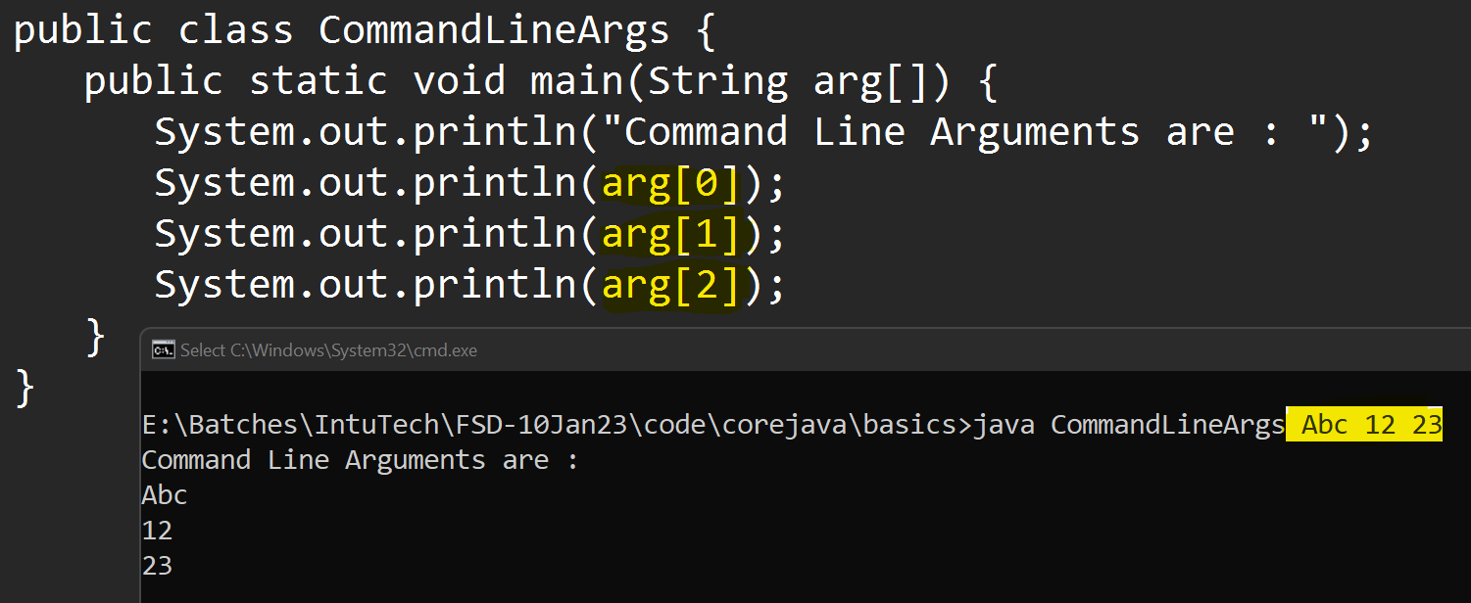

Wrapper Class

Primitive Type | Wrapper Class
byte | Byte
short | Short
int | Integer
long | Long
float | Float
double | Double
char | Character
boolean | Boolean

- Scanner Class
  - Scanner class is java build-in class.
  - It is present inside java.util package.
  - This class is use to accept the use input from console, file or string.
  - Using scanner class we can accept the use input at the runtime of the program.
  - To use scanner class you have to create object of it.
  - To accept the user input you can use next() method of the scanner class.

Integrated Development Environment IDE
- Download Eclipse
https://www.eclipse.org/downloads/download.php?file=/technology/epp/downloads/release/2022-12/R/eclipse-jee-2022-12-R-win32-x86_64.zip
- Extract zip file into appropriate location.
- Click on the eclipse application file.
- Create a workspace
- Set the perspective (Java).
- Create Project
  - File -> New Option - > Click On “Java Project”
  - Provide name of the java Project and checkout the selection of module checkbox.
  - Click on Nex and Finish button.

Object Oriented Concepts (OOPs)
- Class and Object is the base of OOPs concept.
- There are 4 main OOPs concepts
  - Encapsulation
    - It is a wrapping of data member and member function into single unit. It is use to hide the data.
  - Inheritance
    - Accessing (inheriting) the properties of parent class into child class.
  - Polymorphisms
    - Single Object can be use into a multiple form.
  - Abstraction
    - Abstraction is a process in which you can hide the complexity and display only the required details.

Encapsulation
- In this you can wrap a data member and member function into single unit.
- Class is also called as encapsulation.
- As per java recommendation it is not a good practice to use the instance variable outside class directly. You can access it using a methods.
- You can hide the access of the variables using private access modifier.
- To access the private variable you can provide a getter and setter methods.
  - Getter Method
    - Is use to get the values.
    - The getter methods always return the value and it not accept any value.
    - It is recommended to create a getter method with name ‘get’ followed with the variable name.
  - Setter method
    - Is use to set the values.
    - The setter method always accept the values which is to be set and will not return anything.
    - It is recommended to create a setter method with name ‘set’ followed with the variable name.
- Advantages
  - You can achieve the Data hiding using encapsulation
  - It one of the way to achieve loose coupling.
  - Code become flexible, that is one part of code change will not affect on another part and also code is easier for future modifications.
  - You can control who can access what.

Inheritance
- The parent class properties (data member and member function) will be inherited by child class.
- You can only inherits the non-private properties of parent class into child class.
- In Java inheritance can be achieved by extends keyword.
- In Object Oriented Programming’s there are 5 types of inheritance, but only 3 types are directly supported in java and other 2 types cannot be directly achieved but it can implement by interface.
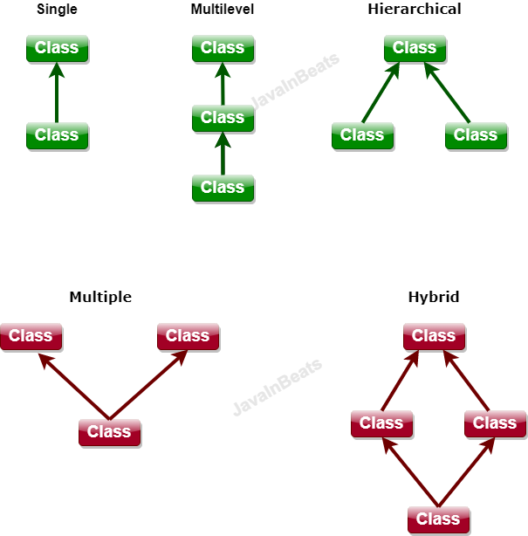
- In Java one class cannot have more than one parent class.
- In Multilevel inheritance you can get the property of super parent class into child class. and this is happened using a parent class.
- Parent class is also known as Super class or base class or parent class.
- Child class is also known as sub class or derived class or child class.
- Multiple and Hybrid is not supported in java because if both the parent class has similar property then there can be an ambiguity (confusion) to access those properties and hence it is not supported in java.
- By Inheritance you will be an IS-A relation created between class.
- Advantages
  - Can achieve the reusability (reuse variable and method)
  - Can achieve the extensibility.
  - Inheritance is required to achieve runtime polymorphism.
- Polymorphic Object
  - The object which has reference of parent class and object of child class this objects known as Polymorphic Object
  - Syntax:
ParentClass ref = new ChildClass();
  - Polymorphic objects are only use to achieved the runtime polymorphism.
Object Class
- Object is a java build-in class.
- Object class is present inside java.lang package.
- Object class is a super class of all the java classes.
- In the Object class there are common functions created which is useful in all the classes.
- Every java class directly or indirectly inherits the properties of object class.
- If any java class is not extending another class then, by default java will add Object class as a parent class.
- Commonly function of object class
  - equals(): to compare the two objects
  - toString(): it will by default returns the className@Hashcode
  - hashCode(): to return the hashcode value of the object (Proxy of memory allocation)
  - getClass(): to get the Object of Class.
  - finalized(): gets called before the garbage collection(GC) process.
  - wait(), wait(int), wait(int, long): this is use in the multithreading to pause the execution along with releasing lock.
  - notify(): is use to notify single thread which is in waiting state.
  - notifyAll(): is use to notify all thread which is in waiting state.

Constructor
- Constructor is used to construct the object values. That is, constructor is used to initialize the instance variable.
- Every class has a constructor, if you do not provide/create constructor manually inside a class then, Java will create a default constructor inside the class but if you provided/created any constructor then java will not provide the default constructor.
- Constructors get called at the time of object creation.
- There are rules to create constructor.
  - Constructor must have a name as class name.
  - Constructor must not have a return data type.
  - Constructor can create with any access modifier (public, private, protected default).
  - There can be more then one constructor in a class, but it must be with different parameter list.
  - Constructor always calls at the time of Object creation and you cannot call it using a object and dot(.) operator like methods.
  - In inheritance all the constructor of the child class call the super class default or no-parameterized constructor.

Super, this, static and final keyword..
Super Keyword
- Super keyword is use to access the properties and constructor of the super class.
- Using Super keyword you can access the parent class variable, methods and constructor.
- Access Constructor using super keyword.
  - Super class constructor can be access using super keyword.
  - Super class constructor can be access from the sub class constructor only. (One class constructor only call another class constructor)
  - Constructor calling line must be a first statement in a constructor.

This Keyword
- This Keyword is the current class Object.
- This keyword is use to access the same class variable, method and constructor.
- This Keyword is use to differentiate between the local and instance variable.
- Using this keyword you can call the constructor of same class.
  - To call constructor of same class you can use this keyword which must be the first statement in a constructor.

Final Keyword
- Final keyword is to create a constants.
- Final can be a variable, method or class.
- The value provided to the final variable is fixed. It cannot be change in an application.
- You can make method as a final, the implementation of the method is fixed and it cannot be changed. Final methods cannot be override.
- You can make class as final, the final class cannot he use as a parent class. You can create an object of class but you cannot inherit it.
- The variables and methods of the final class are not by default final. You have to make it final explicitly.

Static Keyword
- Static keyword is use to create class level properties.
- The static properties can be access with class name and without class object.
- You can mark variable, class and method as a static.
- Static class must be an inner class. You cannot create static outer class.
- Static properties are loaded inside memory at the time of class loading.
- Copy of static property is not created inside the Heap and it is not allocated for an object
- Static variable cannot be create inside method.
- Static method
  - Static method can be access outside class without object and using class name.
  - Inside Static method you cannot access the non-static properties
  - Inside static method you cannot use the super and this keyword.
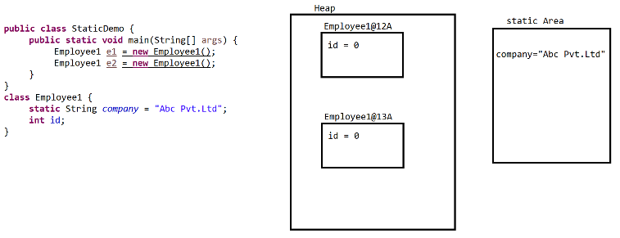

Package, Import and access modifier
Package
- Package statement must be created using a package keyword
- Package statement must be a 1st statement in a file
- Package statement is applicable for all the java classes in a file.
- Package statement can be write only once in a class.

