Full Stack Development
===============================
Front End

Back End (Java)
Core Java language
- Basics of Core Java
Intro to Java, Installation and env setup, Writing, Compiling and executing first java program, Data Type, Control Flow statements, Array, class, Object, method, String classes, User inputs.
- OOPs in Java
Encapsulation, Inheritance, Polymorphism, Abstraction, constructor, Keyword in Java, Package, imports, access modifiers.
- Advance Concepts in Core Java
Exception Handling, Collection, threading, JDBC
Advance Java
- Servlet technologies
- JSP technologies
Spring Boot Framework
- REST API

Database (MySql)
- SQL (Structure Query Language)

DevOps Tools
- Maven
- Git
- GitHub

Software
JDK
Mysql Database
Eclipse IDE
Git
Maven
Postman

Java Documentation
https://docs.oracle.com/en/java/javase/11/docs/api/java.base/module-summary.html
Java Setup
- Download JDK
https://www.oracle.com/java/technologies/downloads/
Download the Installer for you operating System.
- Install JDK
- Verify the Installation
  - You can verify the installation file into C:\Program File\java\<jdk-version-folder>
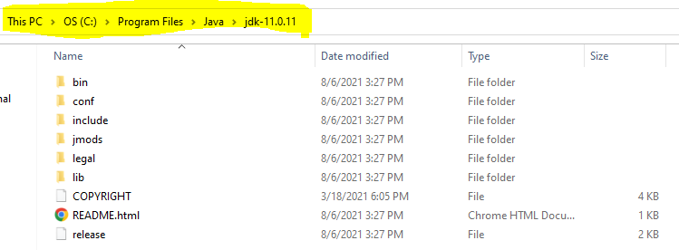
- Setup Environment Variable
  - Set JAVA_HOME
    - Go to Start and Search for “Environment” word and select the “Edit System Environment Variable” option.
    - Click on the “Environment Variable” button on the new window.
    - Select “New” Button from the ‘System Variables’ section
    - Provide the following details into text box
      - Variable Name: JAVA_HOME
      - Variable Value: <JDK-Path>
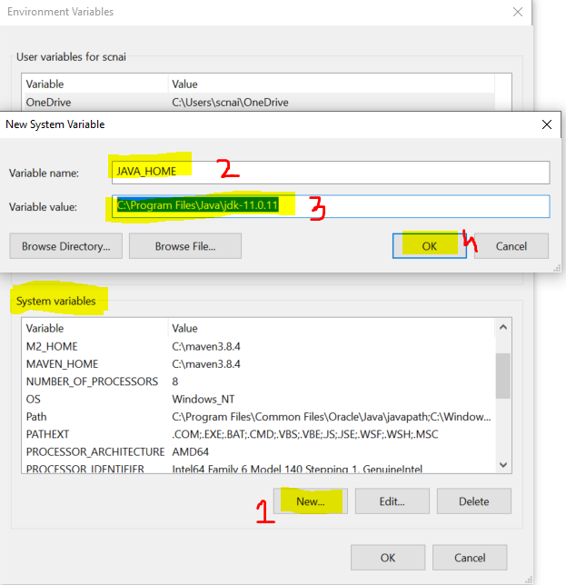
  - Set Path
    - Check for “path” variable inside ‘system variables’ section
    - Select “Path” variable and click on “Edit” Button
    - Click the “New” button on the new window
    - And set the variable value as follows
%JAVA_HOME%\bin
    - Click on “OK”
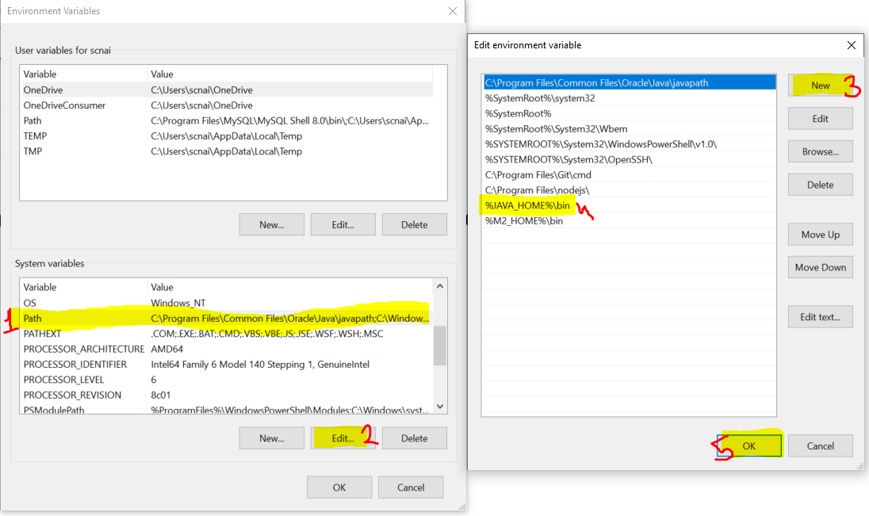
- Verify the Environment Variable Setup
  - Open CMD
  - Try the following commands
    - java -version
    - javac
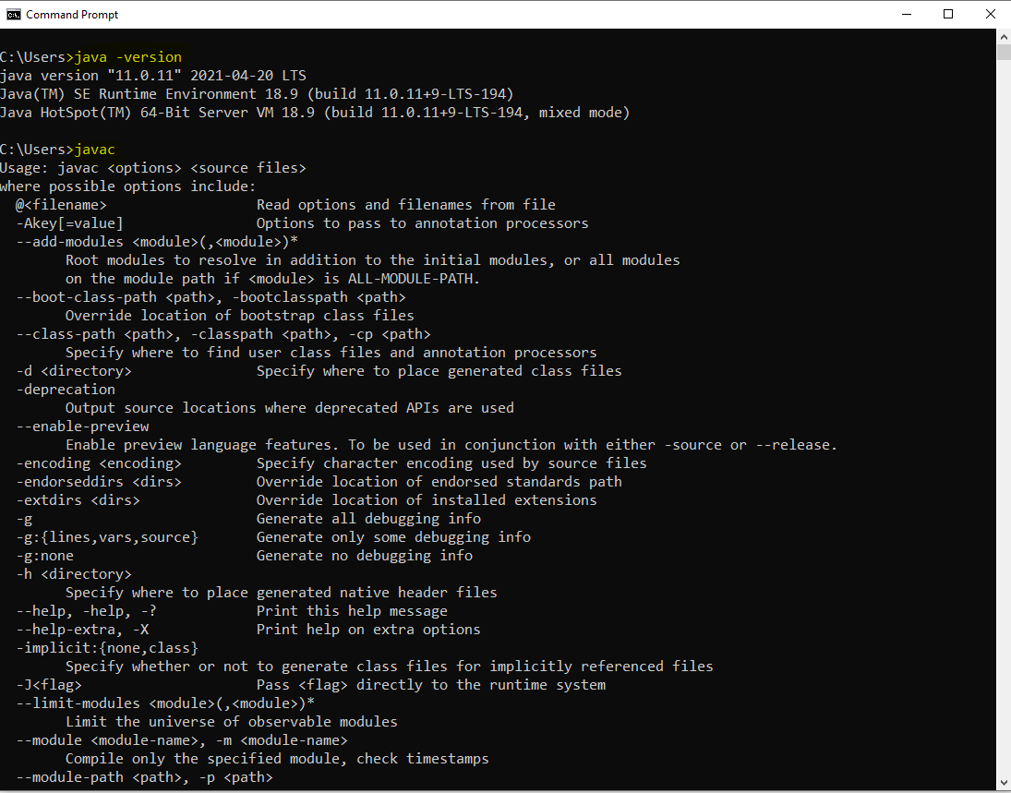

Java Introduction.
- It is introduced in 1990. Initially it is known as Oak Language. Then it is renamed as Java language.
- From Java 2nd version onwards, java language distributed into 3 editions.
  - Java SE (J2SE)
    - Java SE stands for Java Standard Edition.
    - All the basics of java concepts included in this edition and it is also known as Core Java.
    - Can Develop Console Based and Desktop Application.
  - Java EE (J2EE)
    - Java EE stands for Java Enterprise Edition.
    - It is a combination of multiple java technologies. It is also known as Advance Java.
    - It is majorly used for developing a Web Application.
  - Java ME (J2ME)
    - Java ME stands for Java Micro Edition.
    - Using this you can develop Embedded and Mobile application.
- Initially java language was managed by Sun Microsystem which acquire by Oracle on 20s.

Important Components of Java
- JVM
  - JVM stands for Java Virtual Machine.
  - It is use to execute the java program, and also support the all activities required for execution such as stating up of you code, memory allocation, communicating with OS.
  - To Execute the java program JVM must be present inside you system.
- JRE
  - JRE stands for Java Runtime Environment.
  - It is consisting of JVM and APIs. Which create the runtime environment for the java program.
  - On users system JRE must be available.
- APIs
  - APIs stands for Application Programming Interface.
  - It is a set of predefine functionalities which is provided by java language.
- JDK
  - JDK stands for Java Development Kit.
  - It is a combination of JRE, JVM, APIs and some development tools.
  - You can develop the java code, compile it and execute the java code.
  - JDK has present in Developers system.

Writing and Executing First Java Program
- Writing a java code
  - You can write a using IDE or Notepad or any editor tool.
- Java Program Syntax
  - Create Java class
    - In java everything must be write inside class except import and package statement.
    - Syntax:
public class <Class_Name>
{

}
  - Cerate Main Method inside java class
    - Main method is the first method which gets executed.
    - This method is a start point of java program.
    - This method will be called internally by java (JVM) when you execute your program.
    - Syntax:
public static void main(String args[])
{

}
  - Write an executable code into method.
System.out.println(“Hello, Welcome to first java program”);
- Save File
  - File Name must be same as public class name.
  - File extension must be .java.
- Compile the java code
  - In this sept the java code will be converted into a byte code and the binary file will be created.
  - As an outcome of the compilation step the .class file will be created.
  - In this step all the syntax validation will also happens.
  - To compile a code first Open a CMD
    - The path of the CMD must be pointing to a location where you save your java class. (to do this you can go to a folder where you save your java class, click on the address bar and type “cmd” and hit enter)
    - Execute a command to compile
javac FileName.java
- Execute Java code
  - Use same CMD
  - Execute a command to run java program
java className

Rules:
- In a source file you can create more than one classes. But only one class must be public and the file name must be same as public class name.
- In all the classes created in a source file can have a separate main method.
Keyword, Literal and Identifier
Keyword:
- Keywords are the reserve words by the java programming language.
- There are about 52 keyword present in java.
- Every keyword is in small case.
- Example:
public, class, void, static, protected, private, default, if, else, switch, where, for, do, while, int, short, long, byte, double, float, boolean, char, null, true, false etc.
literal:
- Literal are also consider as a values. Some values are fixed by java which is also in the list of keyword.
- String values are also known as literals.
- Example:
null, true, false
Identifier:
- Identifier are the words which is used by developer for identifying the program components.
- The identifiers are used to create variable, method, class, object names.
- Example:
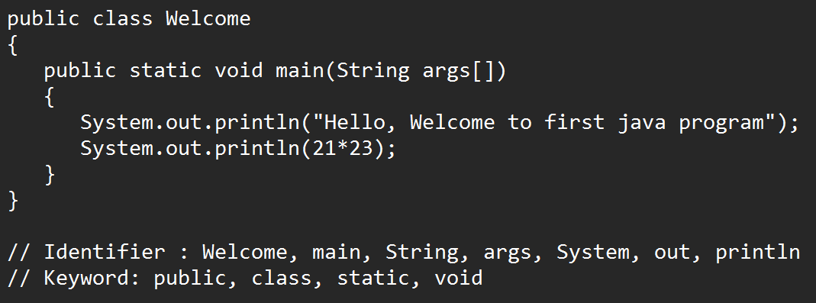
- Rules to create identifier:
  - Identifier must not be a keyword.
  - Identifier can contains alphabets, Number and symbols.
  - Only $ and _ symbols are allowed in identifier. No other symbol is allowed as an identifier.
  - Identifier must be start with alphabet or symbols. Identifier must not be start with number.
  - Identifiers are case sensitive and must not contains spaces.
  - There is no character limit to create identifier.
- Conventions to create method, variable and object name.
  - The name should be start with small case if it is a combination of multiple words then every word start with capital case from the 2nd word onwards.
  - Example: employeeId, studentName, printEmployeeDetails
- Convention to create class.
  - The class name should be starts with capital case and if it is a combination of multiple words then every word should be start with capital.
  - Example: Welcome, EmployeeDetails, AdminAddressDetails etc.
- Convention to create Constants:
  - Constants must be in capital case.
  - Example: GRAVITY, PI etc.

Data Type and Variable
DataType:
- Data Types are required to specify the type of values used in a program.
- Data types are used to create a variable.
- There are 2 types of data type in java
  - Primitive Data Type
    - Primitive Data type has a fixed size which is predefine in java.
    - Primitive data type are in non-object format.
  - Non-Primitive Data Type
    - Non-primitive data type doesn’t have any fixed size, its size will be decided as per it uses in the code.
    - Non primitive data types are always in the Object format.

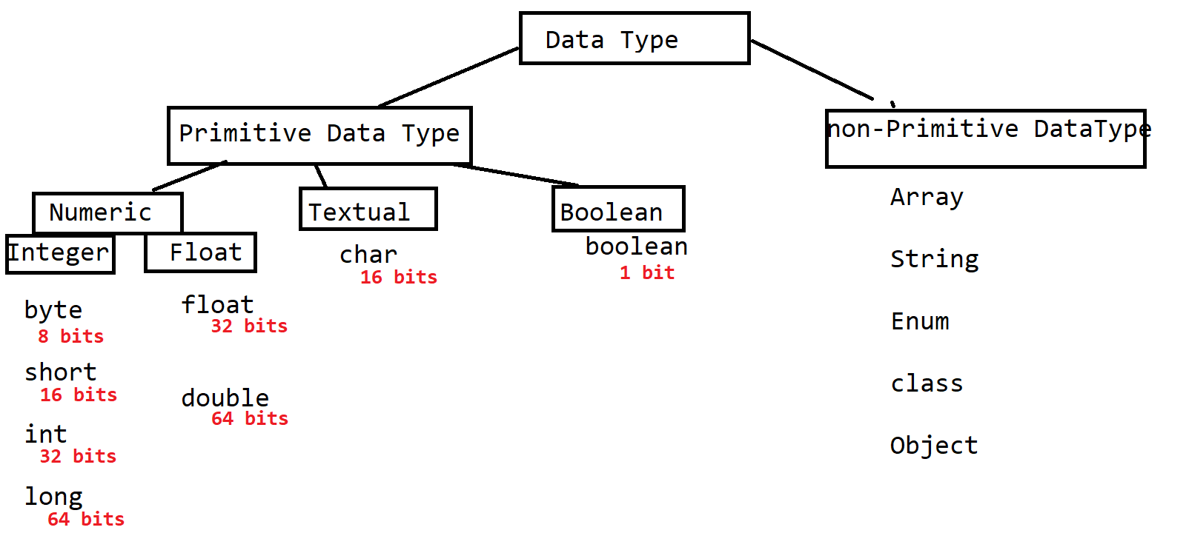

Variable
- Variables are use to store the values.
- Variables are use to display the values to the user.
- Variables are used in a math expression. It will be use for other expression also such as comparison expression.
- Variables are use to assign a value to another variable.
- Syntax:
DataType variable-name(identifier); // declaration of variable
Variable-name = value; // initialization of the variable

OR
DataType variable-name = value;

Task-1
WAP to store the product value and print the value of the product.
Store the Product id, product price, product quantity
And print the product id, product price, product quantity and the total product price (price * quantity)

Memory Foot prints for the variable

Formula to calculate the Range of the Numeric values
-2^{n-1} to 2^{n-1} -1
Here, the n is the number of bits

Example
byte : 2⁸⁻¹ to 2⁸⁻¹ -1
-128 to 127

Rules to use variables
- The numeric non-decimal values created without any data type by default allocated with the int memory.
- long
  - Long values should be created with suffix L or l.
  - Example: long phoneNumber = 9988770066L;
- The numeric decimal values created without any data type by default allocated with the double memory.
- float
  - float values must be created with the suffix F or f.
  - Example : float gravity = 9.8F;
- char
  - You can store single character or symbol as a values. This value must be in a single quotes (‘ ’)
  - You can also store a numeric non-decimal value inside char. It must be 0 or positive value and must not be in sing quotes.
  - Every char values can be represent as per a ASCII table.
https://www.asciitable.com/
  - Example:
char c1 = ‘A’;
char c2 = ‘@’;
char c3 = 65;
char c4 = -65; // not allowed
- boolean
  - Boolean value must be true or false only.
  - In java 0 and 1 is not consider as a Boolean value.
  - Example: boolean b = true;
boolean b = 1; // not allowed

Primitive Datatype Variable Casting
- Casting is a process in which you can convert the value from one data type to another.
- There are 2 types of casting.
  - Implicit Casting
    - The conversion of the data type from one type to another happens internally.
    - Example:
byte a = 10;
int b = a; // Implicit casting
  - Explicit Casting
    - The conversion from one data type to another will have to do manually else compiler will give an error at compilation.
    - Explicit casting can give you logically incorrect output if you handled it inappropriately.
    - Example:
int x = 10;
byte y = (byte) x; // explicit casting

Type of Variables
- The type of variables is decided on the bases of position of the variable created inside program.
- There are 3 types of variables
  - Local Variable
    - The variables which are created inside a method is called as local variable.
    - This variable can be access inside a method only. It cannot be access outside method.
    - Local variables have to initialized before use else compiler will give an error.
  - Instance variable
    - The variable which is created inside class and outside any method is called instance variable.
    - These variables can be access in all the method of the class which is non static. These variables cannot be access in static method.
    - If you do not initialized the instance variable then java will initialized it with default value when the class object gets created.
  - Static/class Variable
    - The variables which are created inside class and outside any method using static keyword is called static or class variable.
    - This variables can be access in all the method of the class.
    - If you don’t initialized this variable then it will get initialize by default values at class loading.

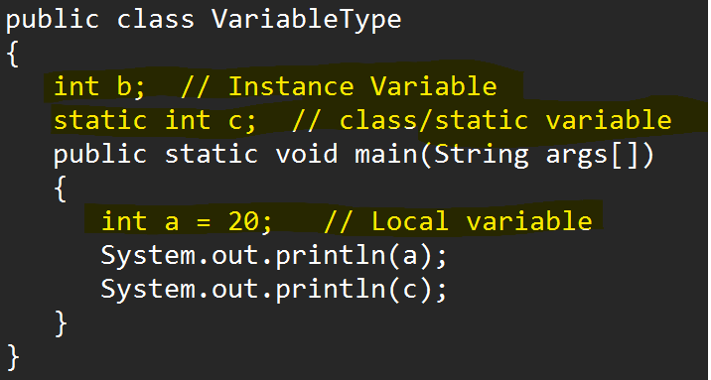

Default Values
Data Type | Value
byte  short  int  long | 0
float  double | 0.0
char | 0 or \u0000
boolean | false
Non-Primitive | null

Note: These values are only appliable for the instance and Static variable

Operator

- Arithmetic Operator
  - These operators are always return the numeric values.
  - Example: +, -, *, /, %
- Assignment Operator
  - Example: =, +=, -=, *=, /=
- Relational Operator
  - These operators always returns the Boolean values that is true or false.
  - These operators are used in conditional or Boolean expression.
  - Example: <, <=, >, >=, ==, !=
- Logical Operator
  - Example: &, |, !
- Short circuit Operator
  - Example: &&, ||
- Increment and decrement operator
  - Can increment and decrement value by 1.
  - There are two types of operations in this
    - Pre increment/decrement: first assign a value and then increment/decrement it
    - Post increment/decrement: first increment/decrement the value then assign it
  - Example ++, --
- Ternary Operator:
Example - ?, :
Where ? is an if condition and : is an else

Task-1
- WAP to add 2 int number and print the square and cube of the addition

Comments in Java
- Comments are use to create a code level documentation.
- Commented lines are not consider while the execution of the program.
- There are 3 types of comments in java.
  - Single Line comment
    - The commented line is not consider while execution and also it will not be a part of .class file.
    - Symbol:
// Line to comments
  - Multiline comment
    - You can comment out the multiple lines at a time. The commented will not be a part of .class file.
    - Symbol:
/*
First Line
Second line
.
*/
  - Documentation comment
    - You can write a documentation for you code using this command. The commented lines will be a part of .class file.
    - Symbol:
/**
Documentation Lines
*/

Control Flow Statement
- Program flow is always in a sequence from top to bottom.
- To execute a statement on the bases of some condition or to execute a specific statement multiple time you required a control flow statement.
- This control flow statement is use to control the execution flow of the program. Based on sone condition or criteria you can decide which line is going to be execute and how many times it gets execution.
- There are 3 types of control flow statement
  - Sequential statement
    - This is the default behavior of any program where the program gets executed in a sequence.
  - Conditional Statement
    - Using this you can execute a statement or block of statement based on any condition or criteria.
    - Example: if Condition and its variations, Switch Cases.
  - Looping Statement.
    - Using this you can execute a statement or block of statement multiple time.
    - Example: while loop, do-while loop, for loop, enhance loop.

If Conditional Statement

- You can execute a statement(s) based in some condition.
- There are multiple variations of the if condition.

If Condition
Syntax:
if(condition/boolean expression)
{
statement(s)
}
In the above syntax it will execute the statement only if the condition is true

If else condition
Syntax:
if(condition/boolean expression)
{
statement(s)
}
else
{
statement(s)
}
In the above syntax it will execute the if statement only if the condition is true otherwise it will execute the statement from else block.
Note: else block has followed with if only

Else-if condition/ladder
- Using this can provide a condition check for the else block also.
- Syntax:
if(condition)
{
Statement(s)
}
else if(condition)
{
Statement(s)
}
else if(condition)
{
Statement(s)
}
else
{
Statement(s)
}
In the above syntax you can write as many else-if you want
Note: If any of the condition is true then no further conditions will be checked.
Nested if condition
- In this you can create one if condition into another.
- Syntax:
if(condition)
{
if(condition)
{
}
}
Task-1 -6-Sept-2022
WAP to find the vaccination slot
age is between 60-120
Your are in 1st slot of vaccination
age is between 40-60
Your are in 2st slot of vaccination
age is between 18-40
Your are in 3st slot of vaccination
If age is between 1-18
Your are in 4st slot of vaccination
If age not between 1-120
Invalid age
Switch Cases
- Switch can be use to improve the performance of the else-if structure which created to check the exact equality of the values.
- In the switch there is not value comparison happens or condition check happened inside the switch.
- Syntax:
switch(value)
{
case label:
Statement(s)
break;
case label:
Statement(s)
break;
case label:
Statement(s)
break;
default:
statement(s)
}

- Rules to use Switch case
  - In Switch case value, only byte, short, int, char, enum, String(jdk1.7) data type is allowed.
  - Every case label must be unique.
  - Case label data type must be match with the value data type.
  - If Multiple cases having same execution then you can combine a cases.
Example:
case 1:
case 8:
case 15:
case 23:
System.out.println("Monday");
break;

Task-1:
WAP to print following Output (using switch)
Create char variable
If char is ‘M’ or ‘m’ then print Monday
If char is ‘T’ or ‘t’ then print Tuesday or Thursday
If char is ‘W’ or ‘w’ then print Wednesday
If char is ‘S’ or ‘s’ then print Saturday or Sunday
If char is ‘F’ or ‘f’ then print Friday

While Loop
- While loop is use to execute a statement or block of statement multiple time.
- Syntax:
Variable Declaration and initialization (start point)
while(condition/Boolean expression)
{
Statement(s)
Increment/decrement the variable
}
- It is a pre-condition check. That is it will execute the statements from the loop only if condition is true.

Task-1
Print the table of number.
If number is 5
Output: 5
10
15
20
.
.
.
50

Do-while Loop
- Do-While loop is use to execute a statement or block of statement multiple time.
- Syntax:
Variable Declaration and initialization (start point)
do
{
Statement(s)
Increment/decrement of the variable
}
while(condition/Boolean expression);
- It is a post condition check. This will execute the loop at least once even after condition is false.

For Loop
- For loop is also used for executing a statement(s) multiple time.
- Syntax
for(Declare/initialize variable ; Condition ; Increment/Decrement/statements )
{
Statement(s)
}

Task-1 Using do-While Loop
WAP to print the square of all the values between 5-15
Output: 25
36
49
.
.
.
.
225

Task-2 using for loop
WAP to Print the even numbers from 1-50
Output: 2
4
6
.
.
.
.
50

Task-3 using while loop
WAP to Print the square of even numbers from 1-50
Output: 4
16
36
.
.
.
.
2500
Nested loop
- One loop can be created and execute inside another loop.
- Nested looping is used to work with table structure. (On the row and column)
- Nested loop can be achieve using any of the type of loop.
- Syntax:
for(Declare/initialize variable ; Condition ; Increment/Decrement) // outer loop // rows
{
for(Declare/initialize variable ; Condition ; Increment/Decrement) //inner loop //column
{

}
}

Task-1
Print the following pattern
1
2 2
3 3 3
4 4 4 4
5 5 5 5 5
Task-2
Print the following pattern
1
1 2
1 2 3
1 2 3 4
1 2 3 4 5
Task-3
Print the following pattern
* * * * *
* * * *
* * *
* *
*

Enhance For Loop / For Each Loop
- This loop is use to iterate/get collection values one by one.
- Using Enhance for loop you can get all the values from the collection. It internally maintains the index.
- Syntax:
for( Variable x : collection_object)
{

}

Array
- Array is a group of values or objects.
- Array is group of similar data type of values or object.
- Array is a fixed in size.
- For creating an Array you must know the data type and the size of the values.
- Array is a non-primitive data type.
- Array is indexed based.
- Indexes are always start from 0.
- Indexes are always managed internally by java.
- To set and get the values form array you have to use index.
- There are multiple types array in java such as 1-D array, 2-D, Multi-Dimensional (Jagged Array) Array
- There are 3 steps to create array
  - Array Declaration
  - Array Instantiation (Object creation)
  - Array Initialization.

1-D Array
- Data Will be store in the form of row.
- Using length function you can get the total number of values (size) present inside array.
- You can also find the last index of the array using length function.
Last index = array.length - 1
- Syntax:
Array Declaration
DataType identifier[];
Array Instantiation (Object creation)
Identifier = new DataType[Size];
Array Initialization.
Identifier[index] = value;

Different ways to create 1-D Array

double percent[]; // declaration of array
percent = new double [6]; // instance/Object creation
percent [0] = 77.28; // Initialization of array
percent[1]= 88.76;

double percent[] = new double[6]; // declaration and instance/Object creation of array
percent[0] = 77.28; // Initialization of array
percent[1]= 88.76;

double percent[] = new double[] {77.28, 0.0, 88.66, 56.65, 77.88, 71.12};

double percent[] = {77.28, 0.0, 88.66, 56.65, 77.88, 71.12};

Task-1
Create an array which store the marks of 5 subjects. Calculate and print the percentage.
Additional Req: Print the Percent and the grade (Distinction, 1st class ,2nd class ,pass class or fail)

2-D Array
- Can store a data in the form of row and column.
- It is also known as matrix.
- Here, length function returns the total number of rows in array.
array.lengh : return the total number of rows
array[row_index].length : return the total number of values in a row
- Syntax:
Array Declaration
DataType identifier[][];
Array Instantiation (Object creation)
Identifier = new DataType[ROW_Size][COLUMN_Size];
Array Initialization.
Identifier[row_index][column_index] = value;

Different ways to create 2-D Array

1.
double percent[][]; // declaration of variable
percent = new double[4][6]; // Instance Creation
percent[0][2] = 77.23; // initialization of array
percent[2][4] = 81.2;
2.
double percent[][] = new double[4][6]; // declaration and Instance Creation
percent[0][2] = 77.23; // initialization of array
percent[2][4] = 81.2;

3.
double percent[][] = new double[][] { {56, 67, 56, 67, 87, 67},
{56, 68, 45, 28, 34, 87},
{84, 75, 87, 34, 81, 34},
{76, 87, 98, 89, 35, 23}
};
4.
double percent[][] = { {56, 67, 56, 67, 87, 67},
{56, 68, 45, 28, 34, 87},
{84, 75, 87, 34, 81, 34},
{76, 87, 98, 89, 35, 23}
};

Task-1
Create an array which store the 4 students 5 subject marks. Calculate and print the percentage.
Also Print the highest percent.
Additional Req: Print the Percent and the grade (Distinction, 1st class ,2nd class ,pass class or fail)

Multi-Dimensional Array (Jagged Array)
- In this type of array you can have a different number of columns in a row.
- In a 2-D array the rows are fixed and column can be different.
- Syntax:
int marks[][] = {
{87, 67, 87},
{79, 78},
{87, 89, 54, 56},
{72, 83, 84, 56, 77}
};

Class, Object and Methods

Class
- Class is a collection of state and Behavior.
- State also known as data member or variables and behavior is also known as member function or methods.
- Along with variables and methods you can also create constructor and another class which is known as inner/nested class.
- You can access the members of the class in to another class by creating object.
- Syntax:
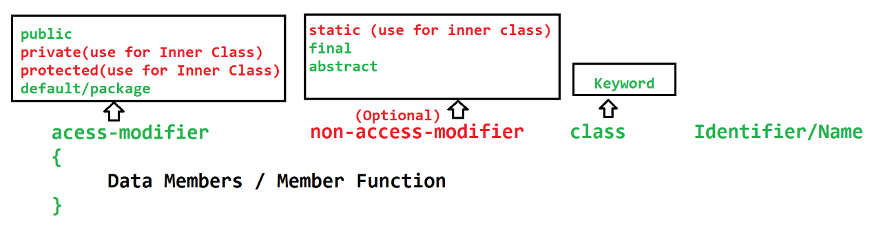

Method
- Method is a collection of variables (local variable) and statements.
- Method is use for writing a logical code. Which can be reuse at multiple location.
- Methods are also useful to divide complex logic into smaller chunk of code.
- Main Method is called by Java/JVM when you execute a java program. To execute a custom method you have to call it manually using a class Object.
- Methods can accept the values as an input parameter and also return a single value as a response.
- The values pass for the input parameter is also known as argument.
- Types of Methods
  - Predefine/Build-in Methods
    - The methods which is provided by language/framework.
  - Custom/User Define methods
    - The methos which is created by developer.
- Syntax:
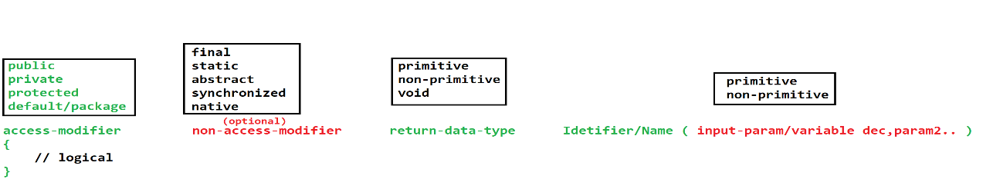

Object
- Object is a representation of the class.
- Using Object we can access the properties (variables and methods) of class.
- To use the properties of the class we have to use dot(.) operator
- You can create any number of objects of the class
- Every Object has independent memory and separate copy of the Instance variable.
- In Java you can create object using new operator.
- Syntax:
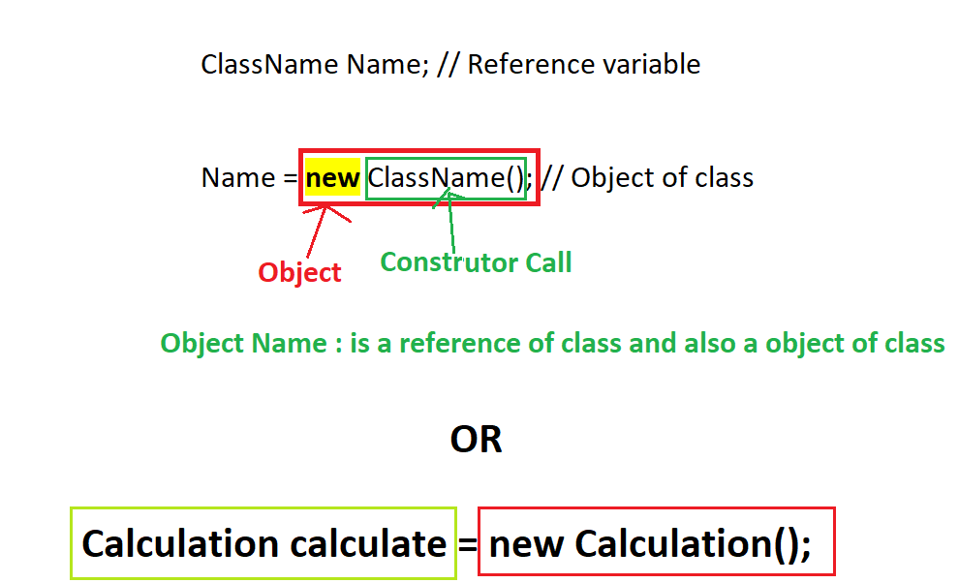

- Memory Footprints for Object Creation

- There are main 2 types of memory
  - Stack:
    - In this memory the method execution will happened
    - Stack Memory will be clear automatically when the method execution completes.
    - It is based on LIFO (Last In First Out) concept.
  - Heap:
    - Objects gets created inside Heap.
    - Heap memory gets clear automatically the GC (Garbage Collection) process.
    - This GC process will be executed by Java after every specific interval.

Task-1
Create class Employee which has id, salary, yearExp and gender (char) as instance variable, create a method printEmpDetails() which display the information for the Employee.
Create a another class with main method in which you will create 3 employees (3 objects of employee) set the values for them and print their details.

String in java
- String is a non-primitive Data type.
- String is an array of character. (combination of multiple characters)
- In Java String values are always in the double quotes(“Value”)
- To work with string java has provided multiple classes
  - String class
  - StringBuffer class
  - StringBuilder class
- These classes are the build-in classes. And there is multiple build-in function provided in this class using which you can perform operations on existing string values.

String Class
- String is a build-in class.
- String class present inside java.lang package.
- String class is a final class.
- String objects are immutable. That is once you assign a value to a string it never changes by applying any of the string function.
- In String the value internally store in the form for index and values format (array format).
- To use a String you have to create object of String class. Object creation can be achieve by 2 ways.
  - With new operator
    - The object will be store inside Heap directly.
    - Syntax:
String str = new String(“Value”);
  - Without new Operator
    - The object will be core in the SCP which is part of Heap.
    - Example:
String str = “value”;

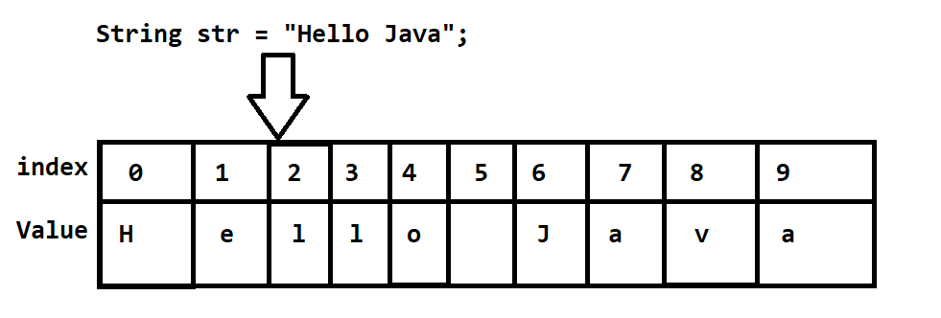

String Constant Pool (SCP)
- All the string values store in side SCP which is created without new operator.
- While storing any values inside SCP it will first check of the same value is present or not. If same value is present then no new object will be created of it instead it will returns a same object.

StringBuilder
- Can store string value using this class.
- StringBuilder is a build-in class
- StringBuilder is a final class which is present inside java.lang package.
- StringBuilder object is mutable. That is if you made any changes inside the string value from the StringBuilder then it will update the original value.
- In StringBuilder no SCP concept applicable.
- You can use StringBuilder and its functionality by creating an Object of class.
- Syntax:
StringBuilder object = new StringBuilder(“Value”);

StringBuffer
- Can store string value using this class.
- StringBuffer is a build-in class
- StringBuffer is a final class which is present inside java.lang package.
- StringBuffer object is mutable. That is if you made any changes inside the string value from the StringBuffer then it will update the original value.
- In StringBuffer no SCP concept applicable.
- You can use StringBuffer and its functionality by creating an Object of class.
- All the methods of the StringBuffer are synchronized.
- The Object of StringBuffer is thread safe.
- It is slower in the performance than StringBuilder.
- Syntax:
StringBuffer object = new StringBuffer(“Value”);

User Input

- Command Line Argument
  - Command Ling Argument is use to accept the values from the user using main method input parameter.
  - The value provided by the user will be added into a separate index of the method argument.
  - The use input will always in the String type.
  - You can pass a multiple values which must be separated by space.
  - User can provide a values from command line (CMD) while executing a java program
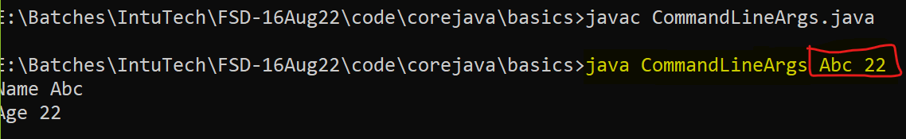

- Scanner Class
  - Scanner is a predefine class in java
  - This class is present inside java.util package
  - Using this class you can accept the values from user using console, file or String.
  - To use scanner class you have to create an object and you can use the nextXXX methods to accept the values.
  - Using this you can get the values from the user at runtime.

Eclipse IDE

- Download Eclipse .zip file.
https://www.eclipse.org/downloads/download.php?file=/technology/epp/downloads/release/2022-09/R/eclipse-jee-2022-09-R-win32-x86_64.zip
- Extract a ZIP file into appropriate location
- Click on the eclipse application file.
- Setup a Workspace
  - Create a Location where you wanted to create all your projects, and java files.
- Set the Perspective of the eclipse
  - Perspective option is available inside the right top of the eclipse window
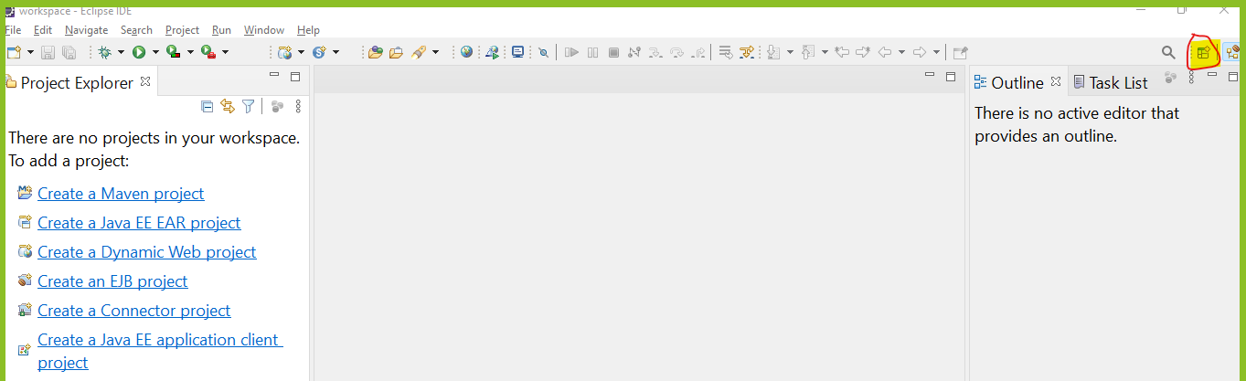
  - Select a “Java” option from list and click on “Open” button

Object Oriented Concepts (OOPs)
- Base of the OOPs concept is class and Object
- There are 4 main concepts in the OOPs
  - Encapsulation
    - Is a wrapping of data member (Variable) and member function (method) into a single unit.
  - Inheritance
    - Accessing the properties of one class into another class. using this you can establish a parent and child relation.
  - Polymorphism
    - One object can be behaves in a multiple form.
  - Abstraction
    - Hiding a complexity and display only an important detail is called abstraction.

Encapsulation
- Is a wrapping of data member (Variable) and member function (method) into a single unit.
- Class is also a kind of encapsulation.
- As per the recommendation, do not provide access to an instance variable directly outside class, provide them access using a methods.
- In encapsulation hide the data members in a class and provide access to it using methods (Getter and Setter)
- Data can be hide using a private access modifier (Mark all the instance variable as private).
- Provide access to them using getter and setter methods.
- Setter Methods
  - Setter methods are use to set the value.
  - Setter methods should be start with (prefix) ‘set’ word and followed with variable name.
  - Setter methods accept the values which needs to set and no return anything.
- Getter Methods
  - Getter methods are use to get the values
  - Getter methods should be start with (prefix) ‘get’ word and followed with variable name.
  - Getter methods will not accept any input value but return the value.
- Advantage
  - Can Achieve Data Hiding.
  - Can control who can access what.
  - Can achieve a loose coupling.

Inheritance
- Accessing the properties of one class into another class. using this you can establish a parent and child relation.
- In the Inheritance you can access all the non-private properties of parent class into child class.
- In java Inheritance can be achieve using extends keyword
- In OOPs there are total 5 types inheritance, but java support only 3 types directly and another 2 types can be achieve in java directly but it can be achieve using interface.

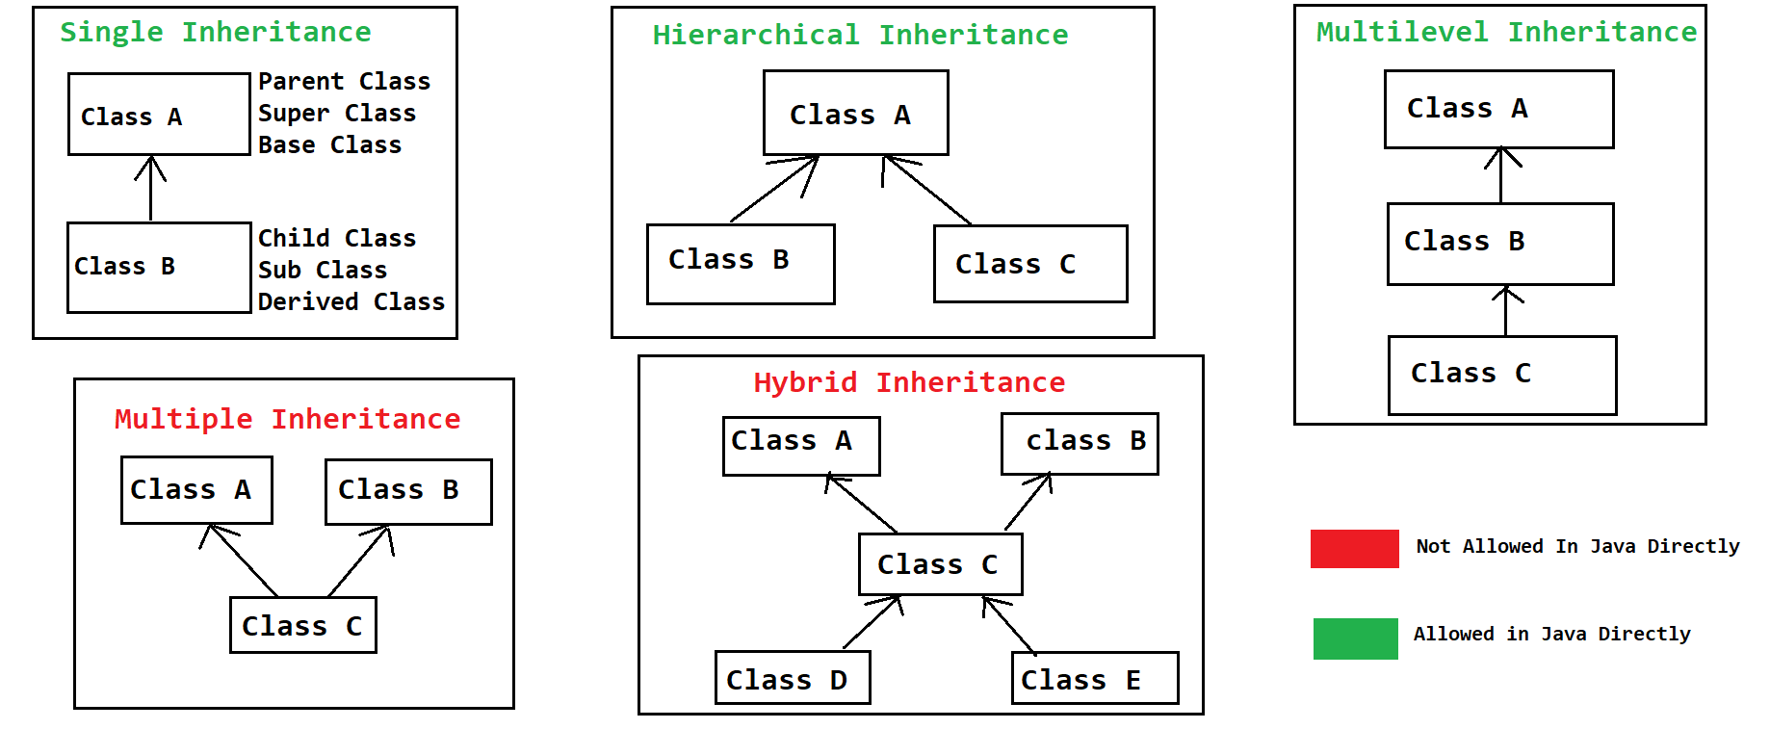
- In the inheritance IS-A relation will be established between a class.
- In Java One class can extends only one class at a time. (You cannot create multiple parents for a single child class.)
- Multiple and Hybrid inheritance is not allowed because, if both the parent has similar property then there can be ambiguity (Confusion) while accessing this property and due to this both type of inheritance are not allowed in java.
- Advantages
  - Can achieve the reusability (can reuse the variables and methods).
  - Can achieve extensibility.
  - It is used to achieve runtime polymorphism.
- You can create an Object of child class and can assign to a parent class reference this type of object is called as polymorphic Object. (Evexry Parent class reference can hold the object of child class)
Syntax:
Parent obj = new Child();
- In the property execution it will aways access the property on the bases of object.

Object Class
- It is a build-in class.
- This class is a super class of all the java classes.
- In a object class the common functionalities are written and provided in every class.
- Some of the methods of Object class
  - toString() : it gets called when you print the object directly and it will return the ClassName@HashCode as a output
  - hashCode(): It return the proxy memory location of the object.
  - equals(): it is use to compare 2 object.
  - getClass(): To get the Object Class
  - finalized(): gets called before the object of the class is going to deleted
  - wait(), wait(int), wait(int, long)
  - notify()
  - notifyAll()

FAQ on Inheritance
What is Inheritance?
Types of Inheritance?
Which Types are supported in Java?
Which type are not-supported in java and Why?
Advantage of Inheritance?
How To Achieve inheritance?
What is IS-A Relation in java?
What is Object class and method of object class?

Constructor
- It is a special kind of method. Which will be called at the time of object creation of the class.
- Constructor is use to initialize the instance variable.
- There are rule to create Constructor
  - Constructor name must be same as class name.
  - Constructor must not have a return data type.
  - Constructor can be create with any access modifier (public, private , protected and default).
  - Constructor gets called automatically while object creation. You do not have to call Constructor manually.
  - Every class has a Constructor, if you don’t create manually then java will add a default Constructor in a class. but if you provide a Constructor then java will not add any Constructor.
  - There can be multiple constructor in a class. every constructor must be created with a different parameter. This is also known as constructor overloading.

this, super, static, final keyword
- this keyword
  - Using this keyword you can access the instance variable of same class, access constructor and method of the same class.
  - This keyword is an object of current class.
  - To call one constructor from another constructor of same class, the constructor call must be a first statement in a constructor.
- Super keyword
  - Super keyword is use to access the variable, method and constructor of the super class.
  - Super keyword is use for a super class property and it is not an object of super class.
  - Every Constructor of the Child class calls the super class default or no parameterized constructor using a super keyword.
  - Every constructor has super() as a first line by default.
- Static Keyword
  - Static keyword is use to create a class/static method or variables.
  - The static properties can be access outside class without using Object of class, to access these properties you can use a class name.
  - Static properties are the sharable properties between all the object. And objects will not have a copy of the static properties.
  - Static properties are loaded at the earliest stage while class loading and before the Object/Heap memory creation.
  - You cannot access the non-static properties into a static method.
  - You cannot use super and this keyword into a static method.

- Final Keyword
  - Is use to create a constant. Constant means the fix values/implementation
  - You can use final keyword for class, method or variable.
  - Final Variable
    - The value of the variable is fixed and no one can changes the value of final variable once it is assign.
  - Final Method
    - The Implementation/logic of the method is fixed and no one can changed the method implementation by overriding the method.
  - Final Class
    - Final class cannot be inherit (Use as a parent). Can create Object of final only inheritance is restricted.

Package, Import and Access Modifier
- Package statement
  - Package is a group of java classes which is having similar functionality.
  - You can consider package as a folder in the file system.
  - Create a package
    - To create a package you have to use package keyword.
    - Package statement must be a first statement in a java file.
    - There can be only one package statement in a file.
    - Package statement must be present outside any class.
    - Package statement in a java file is applicable for all the class in a file.
    - You can also create nested packages.
    - Syntax:
package packageName1.packageName2;

- Import Statement
  - Import statement is use to import the classes from one package to another.
  - Rules to use import statement
    - Import statement must be after a package statement.
    - There can be a more than one package statement in a file.
    - Import statement must be outside class.
    - Import stamen is applicable for all the classes from the file.
    - Syntax:
import package1.package2.Class;
you can import single class from a package
import package1.package2.*;
you can import multiple classes from a package

Access Modifier
- It is a way to restrict the access of properties from another class
- There are 4 access modifiers
  - Public
  - Private
  - Protected
  - Default/package

Access Modifier | Properties Access in same class | Properties access in different class form same package using Object | Propertied access in different class form same package using Inheritance | Propertied access in different class form different package using Inheritance | Propertied access in different class form different package using Object
public | YES | YES | YES | YES | YES
protected | YES | YES | YES | YES | NO
default/package(applies if not explicitly assign) | YES | YES | YES | NO | NO
private | YES | NO | NO | NO | NO

Arrange the Access Modifier by their restriction from Highest to Lowest order.
Highest to Lowest restriction
private default protected public

Polymorphism
- Single Object can be used in a multiple way.
- Polymorphism is also known as multiple form.
- There are 2 types of polymorphism
  - Compile time polymorphism
    - The method call resolve at the time of compilation and the same will be followed at the execution time.
    - The example of compile time polymorphism is Overloading.
  - Runtime polymorphism
    - The method call will be resolve at the execution time or run time.
    - The example of compile time polymorphism is Overriding.

Overloading
- Overloading is a way in which method name is same with different parameter list having different implementation.
- The parameter list must be different by any one of the following ways
  - Can change the data type of parameter.
  - Can change the number of parameter.
  - Can change the sequence of parameter.
- Overloading can be done on same class or sub class.
- In the Overloading return data type may or may not be change
- The access modifier may or may not be same.
- Can throw new and broader checked exception.
- Can overload static method. That is you can overload main method.
- You can overload final methods also.
- StringBuffer and StringBuilder are the examples of overloading.
- Advantage of Overloading
  - Improve the readability of the code.
  - Using this you provide easy way to access the functionalities.

Overriding
- Overriding must be done in sub-class.
- In the overriding method name must be same with same input parameter.
- The return data type of overridden method must be same if it is primitive or void, or it can be sub class.
- Access modifier can be same or it can be changes but it must be less restrictive.
- Cannot throw new and broader checked exception.
- You cannot override static method.
- You cannot override final method.
- Advantage:
  - You can change the default implementation of the parent class method into child class.

Abstraction
- Abstraction is a way to hide the complex implementation and display only the important functionality to the user.
- Abstraction can achieve by 2 ways
  - Abstract Class
    - Is use to achieve 0 to 100% abstraction. You can achieve partial abstraction using abstract class.
  - Interface
    - Is used to achieve 100% abstraction.
- Abstract Class
- In this you can achieve 0 to 100% abstraction. Majorly use to achieve partial abstraction.
- Abstract classes can contains abstract method. The class which is created by abstract keyword.
- Abstract methods are the methods which do not have any implementation and just declaration. Abstract methods are created with abstract keyword.
- The implementation of the abstract methods has to provide inside sub-class. to provide implementation you have override the method.
- Your sub class of the abstract class has to provide implementation for all the abstract method.
- You cannot create Object of abstract class, but you can use it as a reference of it.
- One abstract class can be extends by another abstract class and there you do not have to provide implementation for abstract methods.
- Abstract class can have a constructor which invoked at the time of sub class Object gets created.
- Abstract class can have a static and final method but those method must be non-abstract.
- You cannot use static or final keywords in the combination of abstract keyword.

- Interface
  - Use interface keyword to create a interfaces.
  - Interface is not a class but it will get a separate .class file after compilation.
  - Interface is 100% abstract. That is in interface all the methods are by default abstract.
  - Interface implements on class.
  - When one interface implements on a class then, you have to provide implementation for all the abstract method.
  - You cannot create Object of interface but it can be used as a reference
  - You can implements the interface on abstract class, in this case it is not mandatory to provide implementation for all abstract method.
  - It is mainly used as a top level in the hierarchy.
  - In the interface all methods are by default public and abstract.
  - In the interface all variables are by default public static final.
  - All the properties of the interface are public, no other access modifier is allowed inside interface.
  - You cannot create static and final methods inside interface. (till jdk 1.7)
  - You cannot create constructor inside interface.
  - One interface can extends one or more than one interface.
  - You can achieve multiple inheritance using interface
    - One interface can extends more than one interface.
    - One class/abstract class can implements more than one interface.
    - One class/abstract class can extends another class/abstract class and implements more than one interface.

Different Between Interface and Abstract class?

Interfaces in JDK 1.8
- In Interface you can create an implemented method. This method is called as default method.
- Inside interface you can create a static and final methods.
- Inside interface you can create main method and execute the interface same as class.
- The functional Interface is introduced in the JDK 1.8 and later version which is used to achieve the functional programming. These are the interfaces which has only one abstract method.

Type of Interface
- Regular interface
  - The interface which we create in the not mal coding.
- Functional Interface
  - The interface which has single abstract method.
  - You can use a @FunctionalInterface annotation to make sure about the functional interface.
- Marker Interface
  - The interface which is created without any member/property is called marker interface.
  - These are the blank interface.
  - Serializable interface is an example of marker interface.
  - These interfaces are you to notify JVM to provided special functionality at the time of code execution.

Exception Handling
Exception is an unwanted scenario which occurs at the time of program execution, due to this program will terminate abnormally.
Exception Handling is an approach to handle the exception which is occurs at program execution due to which you can avoid the program termination.

Read and Understand Exception

Exception Hierarchy

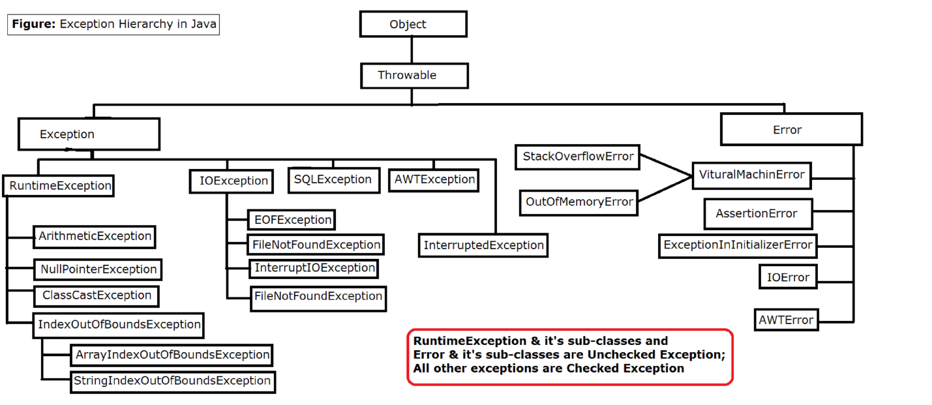

Exception | Error
Exceptions occurs due to a programing issues | Errors are mostly occurs due to a system issues
Program execution can be continue by handling an exception. | You cannot continue the program execution by handling an error

Keyword in Exception Handling
- try: you can write a statement which may throw exception inside try.
- catch: Catch is use to handle the exception thrown from try block.
- finally: is use to execute a statement always. It provide the guarantee of execution.
- throw: is use to raise exception manually/programmatically.
- throws: is use to populate exception to the caller.

try
- try is a block which is use to write a statement which may throw exception.
- Try block has to write with catch, finally or both.
- Syntax:
try
{
Statement(s)
}

catch
- Catch block is use to handle the exception thrown from the try block.
- Inside catch block you can provide an alternative code which executions on the occurrence of the exception.
- You have to provide exception type while writing a catch block.
- Catch block has to come with try block only.
- Syntax:
catch(ExceptionClass ref)
{
Statement(s)
}
- You can have a multiple catch block for a single try.
  - To do this you have to make sure that no parent exception has to handle before child, Parent exception catch block has to write after the child exception catch block.

finally
- Finally block gives a grantee of execution.
- The statements which you wants to execute always can be write inside finally block.
- Finally block will be execute irrespective of try and catch execution.
- There can be only one finally block of a try.
- Finally block has to come with try block.
- Mostly finally block is use to close a resources.
- Syntax:
finally {
Statement(s)
}

Exception process in Java
- Exception Scenario/Condition get Identified.
- Identify and Create Object of the Exception class
- The Exception Object will be throw from the statement. Which is also known as raising an exception.
- Once this object is thrown from the statement it will be catch by the catch block if the exception causing line is written inside try block. Otherwise exception will be propagated to a caller and at the end if it is not handle then program will terminate abnormally.

Throw
- This keyword is use to raise the exception manually.
- You can throw build-in exception or you can also throw your own exceptions.
- Using throw keyword you can throw object of exception from the statement level.

Throws
- This keyword is use to propagate the exception at caller level.
- Using this keyword you can notify the JVM that you are not going to handle the exception inside method and the exception has to send at caller level.
- Throws keyword has to write on method declaration level.
- Throws keyword must be followed with the Exception classes.

Custom Exception
- Its is a user define Exception.
- Steps to create Custom Exception
  - Create a java class
  - Extends the java class with the Exception class or any of its sub class.

Multi-Threading
- Thread is a light weight process or it is a part of process.
- You can have multiple thread is an application.
- Thread can run parallel.
- Thread are use to improve the performance of the application and also can execute the task independently.
- Thread will be created programmatically, but it will executed by JVM internally.
- You do not have a full control on the execution of thread. And hence you cannot predict the tread output. Also the thread output can be different in different OS, Processor or different version of java.
- There is a default created by a java internally for execution of the program. The name of the default thread is “main”.
- Java has provided easy way to crate a thread.

Create Thread in Java
- Thread can be create in java using 2 ways.
  - Thread Class
  - Runnable Interface
- Runnable interface is implemented by Thread class.
- Steps to create thread in java
  - Create a java class.
  - Implements/Extends Runnable interface/Thread class.
  - Override a run method to provide task to a thread.
  - Make thread ready to run using start method.

Thread class Methods
Method | Description
run() | In this methos you can assign the task to a thread. This method gets called by JVM when thread executes.
start() | Using this method you can make thread ready to run. Here, the thread will not start the execution by using this method.
currentThread() | This is the static method, This method return the Object of currently executed thread. By printing the object of thread you will get a following details Thread[Thread-0,5,main] is a [thread name, priority, thread group]
setName(String)  getName() | These methods are use to set and get the name of the thread.
setPriority(int)  getPriority() | These methods are use to set and get the priority values of the thread.  In Set Priority you have to make sure that value must be between 1-10.  Where 1 is the MIN_PRIORITY, 5 NORMAL_PRIORITY, 10 MAX_PRIORITY. The priority may or may not be consider while execution of the program.
sleep(long)  sleep(long , int) | This is a static method of thread class, using this you can pause the execution of the thread for a specified time. The time must be in milliseconds and nanoseconds. This methods throws an checked exception (InterruptedException) which has to handle at coding time.
join()  join(long)  join(long, int) | Join Method will pause the execution of current thread and with for another thread to complete the execution or wait till the given time expire. It throws an InterruputedException which has to handle.

Thread Life Cycle
- Thread Life Cycle is managed by JVM.
- It is an execution flow of the Thread.
- There are different stage in the thread life cycle.

Synchronization
- It is a process in which you can ask another thread to wait until completing the execution of another thread on share resource.
- There can be a data inconsistency issue while multiple thread using a shared Object/resource to resolve this issue you can use a synchronization process.
- In this process the locked and unlocked process will be happened on Object.
- Synchronization can be use by 2 ways
  - Using a synchronized method
  - Using a synchronized block
- There are 2 main disadvantage of synchronization
  - It will slow don’t the application performance.
  - It may occurs the dead lock scenario.

