Advance Java

Servlet Technology

JSP Technology

Development if Dynamic Web application

**Tomcat Server Setup**

1. Download the Tomcat server.

<https://tomcat.apache.org/download-90.cgi>

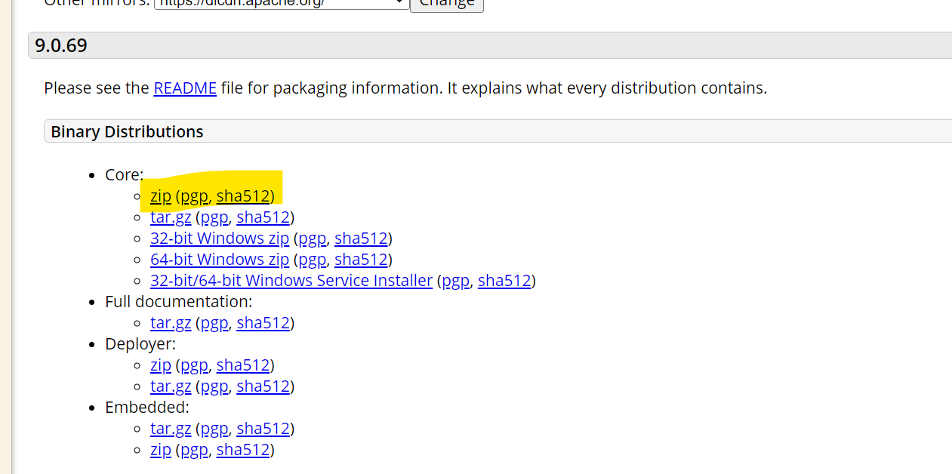

1. Extract the tomcat server.
2. Setup tomcat into Eclipse.
   1. Open a workspace
   2. Set Eclipse perspective to “**Java EE**”

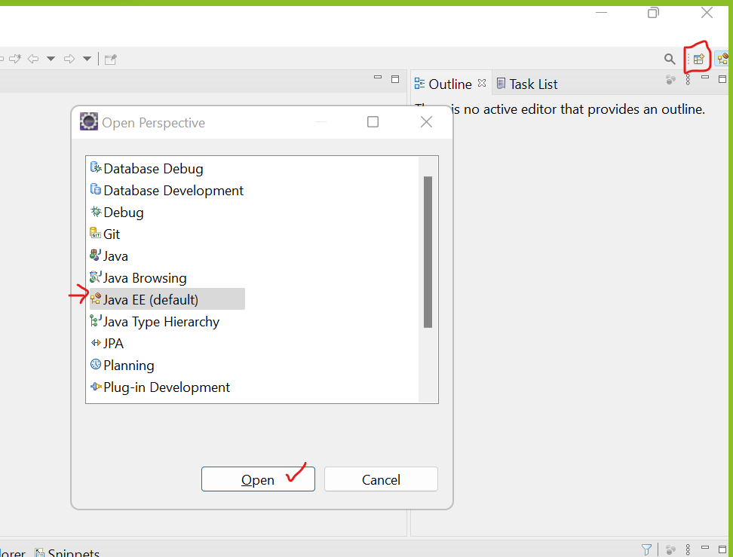

* 1. Setup server into eclipse
     1. Go to “Servers” tab at the bottom of the screen.
     2. Click on the link to create new server.
     3. From the new window expand ‘Apache’ option.
     4. Select a tomcat version which is downloaded or installed
     5. After selecting the version click on “Next” button.
     6. Browse for an installation/extracted folder of the tomcat.
     7. Select a tomcat root/parent folder path.
     8. Click on “Next” and then click on “Finish”.
     9. Right click on the tomcat server from “Servers” tab and select “Start” option.
     10. You can see the startup message in the console “INFO: Server startup in [827] milliseconds”.

**Web Application**

1. It is also known as client server application.
2. This application can be access over a network.
3. To run this applications then you do not requires any installation or setup on you system.
4. There are 2 types of web application
   1. Static Web Application
      1. The web application/sites which content is same for every user.
      2. These applications are mostly an informative web sites.
      3. You can develop these types of application using a Front end technology such as

Html, CSS, JS etc.

* 1. **Dynamic Web Application**
     1. The content of the page will be different for every user.
     2. These applications are like social sites, e-commerce site, banking sites etc.
     3. You will required front end and backend both the technologies to develop such type of application.

**Structure of Web Application (Component)**



**Steps to Create Dynamic Web Application**

1. ‘‘File” Menu -> “New” Option -> click on “Dynamic Web Project”
2. Provide Name of the project in the new window.
3. Make sure that you target runtime must be selected and it must not be “<None>”
4. Click On “Next” again click on “Next” button
5. Make Sure that you have checked “Generate web.xml deployment descriptor” option.
6. Click on Finish button.



**Servlet**

1. Servlet are the java classes. Which is use to create a dynamic web pages.
2. The file extension of the servlet is .java
3. In side servlet you can write a java code and HTML, CSS code to create a web page.
4. Servlet do not have main method.
5. Servlet classes are executed by Server.
6. Every servlet has a unique URL using which the end user can access the functionalities from the servlet.
7. Servlets are mainly used for Getting a user request and Data, processing a request and generate a response.
8. Servlet Objects will be create and manage by a servlet container which is a part of server.
9. In an application there is only one servlet object created which is shared between a multiple request.

**Steps to Create a Servlet**

1. Right click on src/main/java -> “New” option -> click on “Servlet” option
2. Provide a class name -> Click on “Next”
3. You can see the URL of the servlet on the screen (set the default option in this screen) -> click on “Next” button
4. Select the “service” checked box and de-select other check boxes -> click on “Finish”

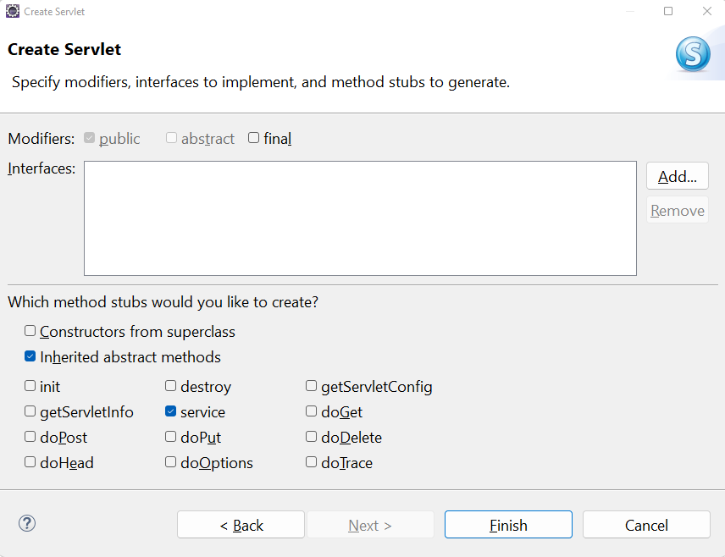

**Return Response from the servlet**

1. Set the type of response which is going to end user.
2. This response type is also known as MIME type

<https://developer.mozilla.org/en-US/docs/Web/HTTP/Basics_of_HTTP/MIME_types/Common_types>

1. Response type can be set using a response method

**response.setContentType(“MIME-TYPE”);**

1. Get an Object of PrintWirter to write a text/html type of response.

**PrintWriter out = response.getWriter();**

1. Use print method to return a response.

**out.print(“<Response>”);**