**Data Base**

1. It used to store data and maintains the data.
2. Using Database you get the results easily using a query.
3. This data will be maintain for a longer period of time.
4. There are different type of databases Present in the market
   1. **Relational Database**
      1. You can store a values in the form of rows and column, in the database and table format.
      2. There can be a multiple tables which will be related with each other using primary and foreign key
      3. This data is also known as structure data.
      4. Example:

**MySql**, Oracle, Sql Server, Postgrace etc.

* 1. Document Database
     1. It is use to store a data into a document format and those document are in the form of JSON.
     2. It is not in the structure type and in the table format.
     3. Example:

MongoDB

* 1. Graph Database
     1. The data store in the form of tables, rows. But it will be represented as a graph.
     2. Example:

Neo4J

Database Download and installation

MySql:

<https://dev.mysql.com/downloads/installer/>

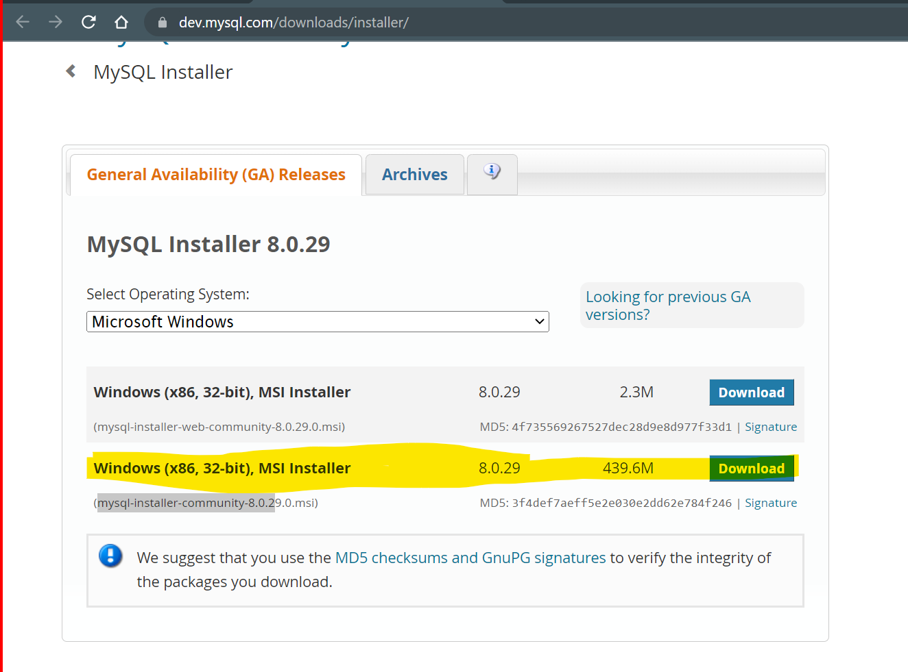

Install MySql:

<https://www.youtube.com/watch?v=OM4aZJW_Ojs>

**Important**

Note down the port number (3306), username (root) and password during the Setup.

**SQL (Structure Query Language)**

1. SQL is use to execute a query in the Database.
2. This is the query language which needs to be follow to interact with DB.
3. SQL Has different categories in which the queries are distributed.
   1. **DDL (Data Definition Language)**
      1. Using this you can create, modify and drop a structure of the table and the different database object like table, index, database, view. Procedure, triggers etc.
      2. SQL Operations like CREATE, ALTER, DROP can be performed in this type.
   2. **DML (Data Manipulation Language)**
      1. Using this you can insert, update, delete the records in the tables.
      2. SQL Operation such as INSERT, UPDATE, DELETE can be performed in this type.
   3. **DQL (Data Query Language)**
      1. Using this you can retrieve the records from the Database. There can be clause, Joins used in this retrieval operation.
      2. SQL operations such as SELECT can be perform in this type
   4. **TCL (Transaction Control Language)**
      1. Using this you can make group of queries and it can be manages using in a transaction. This transaction can be successfully completed or it can be reverted.
      2. SQL operation like COMMIT, ROLLBACK, SAVEPOINT in this type
   5. **DCL (Data Control Language)**
      1. Using this you can control which can access what from the database.
      2. You can manage the user permissions.
      3. SQL operation like GRANT, REVOKE is this type.

**Data Types in MYSQL**

<https://www.w3schools.com/mysql/mysql_datatypes.asp>

1. String data type
2. Numeric data Type
3. Date time data type

**DDL (Data Definition Language)**

1. Create database and table in MYSQL
   1. Create Data base

Syntax : CREATE DATABASE <DatabaseName>;

Example: CREATE DATABASE fsd16Aug;

* 1. To Enter inside a database

Syntax: USE <DatabaseName>

* 1. Create Table

Syntax: CREATE TABLE <tableName> (Columnname Datatype, _ , _ , _ , );

Example: CREATE TABLE employee(id int, name varchar(20), city varchar(20), salary double);

1. View the list of database/table
   1. To get the list of all the available Database

SHOW DATABASES;

* 1. To get the list of available tables in a specific Datatbasee

SHOW TABLES;

* 1. To get the metadata(info) of the table

DESC <table_name>

1. Alter Query
   1. These are use to modify the structure which is already exist.
   2. Add new Column in Table
      1. Syntax: ALTER TABLE <tableName> ADD COLUMN <ColumnName> <DataType>
      2. Example: ALTER TABLE employee ADD COLUMN doj date;
   3. Modify the existing column
      1. You can modify the column details like Datatype, length, default value etc.
      2. Syntax: ALTER TABLE <tableName> MODIFY COLUMN <ColumnName> <DataType
      3. Example: ALTER TABLE employee MODIFY COLUMN name varchar(50);
   4. Remove the existing column
      1. Syntax: ALTER TABLE <tableName> DROP COLUMN <column_name>
      2. Example: ALTER TABLE employee DROP COLUMN age;
   5. Rename the column
      1. Syntax: ALTER TABLE <tableName> RENAME COLUMN <OldName> TO <New_Name>
      2. Example: ALTER TABLE employee RENAME COLUMN id TO empid;
2. Deleting the Database Objects (table/database)
   1. You can use drop query to delete the any database object
   2. This will be permanently delete from the Database.
   3. Syntax: DROP <ObjectType> <ObjectName>;
   4. Example: DROP TABLE employee;
   5. Example: DROP DATABASE fsd16aug;

Data Manipulation Language (DML)

1. Is use to work with the records from the tables.
2. You can manipulate the records from the table.
3. You can perform Insert, Update and Delete operation on the Data.
4. While handling data make sure that all string and date and timestamp type of values must be in single quotes and all the numeric values must be without single quotes.
5. Insert Operation
   1. To create new record(row) inside table.
   2. Syntax:

INSERT INTO <tablename>(columnname , _ , _ , _) VALUES(value1, value2, _, _,_)

* 1. Example

INSERT INTO emp(id,name,city,salary,doj) VALUES(12,'Abc','Pune',64364.43,'2020-02-15');

INSERT INTO emp VALUES(1,'Xyz','Mumbai',88364.43,'2015-03-15');

INSERT INTO emp(id,name,city,doj) VALUES(2,'Pqr','Mumbai','2022-01-20');

INSERT INTO emp VALUES(11,'Test1','Mumbai',34534.43,'2020-06-22'),(13,'Test3','Nagpur',54534.43,'2018-05-11'),(14,'Test4','Pune',64534.43,'2019-07-2');

1. Update Operation
   1. You can update the existing record details using update query
   2. Syntax:

UPDATE <tablename> SET columname=updatedvalue, columname=updatedvalue WHERE <condition>;

* 1. Example:

UPDATE emp SET salary = salary+((salary/100)*10);

UPDATE emp set salary=34343.56 WHERE id=2;

1. Delete Operation
   1. You an delete the data from the database.
   2. You can delete the data based on condition using Where clause.
   3. Syntax:

DELETE FROM <tablename> where <condition> ;

* 1. Example:

DELETE FROM emp WHERE id=15;

Data Query Language (DQL)

1. It is use to retrieve the data from the DB.
2. In this SELECT query is used with multiple variation such as using conditions, Clauses, join etc.