**Maven**

1. Maven is a build tool.
2. Gradle is another tool which is same as a maven and which is also a build tool.
3. Maven is use in the development process starting from the creating application till the execution of the application.
4. Maven **Archetype** is use to get the project structure of the application. It will provide you a project template.
5. Maven helps you to compiles the code (mvn compile).
6. Maven helps you to execute the unit test case of the code (mvn test).
7. Maven helps you to creating the project bundle (.jar, .war) (mvn package).
8. You can also run the project using Maven (mvn deploy)
9. Maven also helps to manage the dependencies (the jar files).

**Maven Setup**

1. Download Maven Zip file (<https://maven.apache.org/download.cgi>)

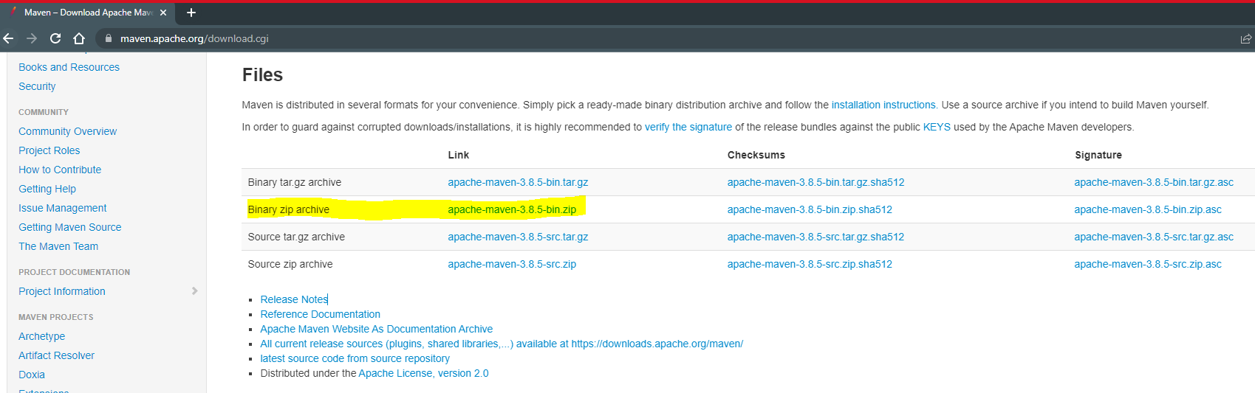

1. Extract in into a specific location (prefer C dive)
2. Setting the environment variable for Maven
   1. **MAVEN_HOME**

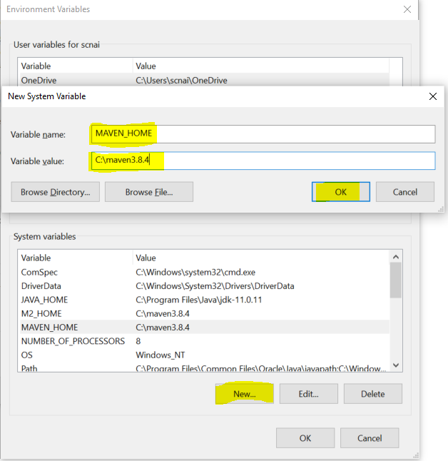

* 1. **M2_HOME**

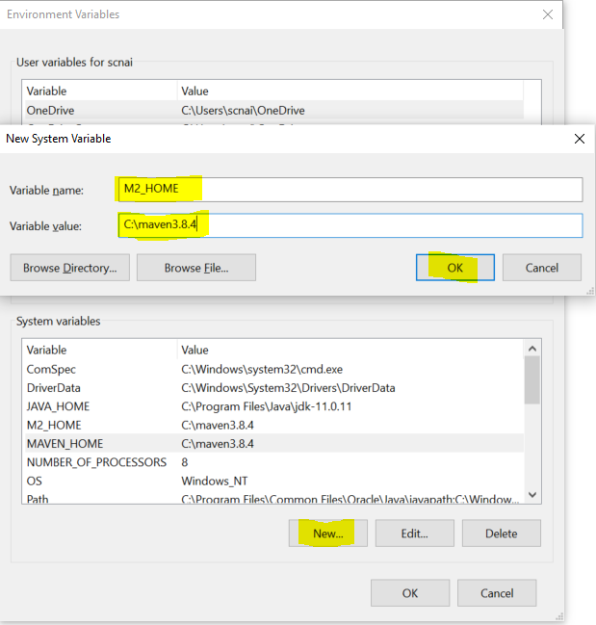

* 1. **Path**

Edit the existing Path Variable and add new value **“%M2_HOME%\bin”**

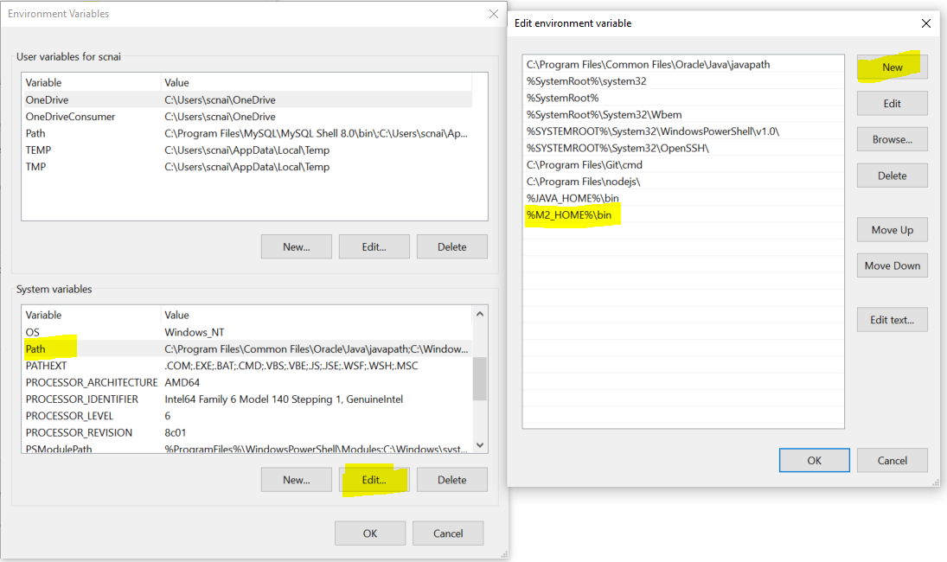

1. **Verify Maven Setup**
   1. Open CMD
   2. Execute following command

“**mvn -version**”

