MySql Installation:

<https://dev.mysql.com/downloads/installer/>

<https://www.youtube.com/watch?v=7_dv1R-3p1c>

**Data Base**

1. Data Base is collection of data which is store in the structure manner.
2. In the data base Data is store in the form of row and column (table)
3. You can interact with the database using SQL (Structure Query Language)
4. SQL is a language using which you can execute a queries to work on the data.
5. These queries will be common for all type of Database except some minor changes.
6. There are different of the Data base
   1. Relational Database
      1. The data store in a table format (Row and Column)
      2. There will be a Primary key and Foreign Key relation in these table
      3. Example: Mysql, Oracle, Mysql server, H2, Darby, Postgrace, DB2
   2. Document Database
      1. The data store in the form of JSON.
      2. There is no primary or foreign key relation in this JSON.
      3. Example: MangoDB
   3. Graph Database
      1. The Data store in form of table or JSON.
      2. The data can be view in a visualized was by Tree structure.
      3. Example: Noe4j
7. Databases are used to store and manage the data easily and more meaningful way and you can easily get the report for analysis using queries.

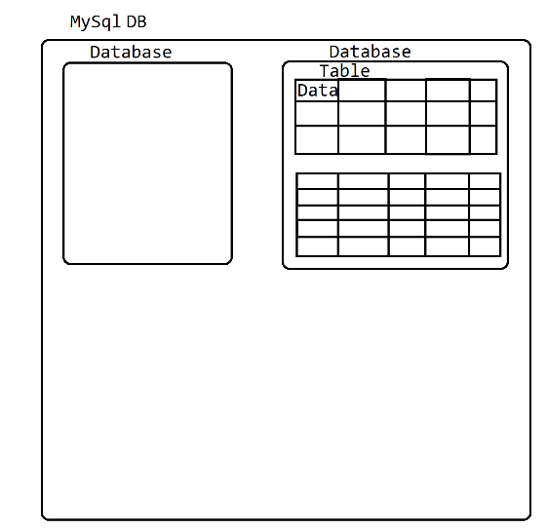

**SQL (Structure Query Language)**

1. Using this Language you can interact with Database.
2. You can execute a query using CMD or UI
3. Topics included in SQL
   1. Data Type
      1. <https://www.w3schools.com/sql/sql_datatypes.asp>
   2. Different Categories Queries

DDL, DML, DCL, TCL, DQL

* 1. Constraints
  2. Different type of Joins

**Queries:**

**DDL (Data Definition Language)**

1. To Get the list of all the database in MySql

**show databases;**

1. To select a specific Database in MySql

**Use <Database_Name>**

1. To Get the list of table in the MYSQL

**show tables;**

1. To create your own database

**Create <ObjectName> <DB_Name>;**

Example: **create database fsd19jan;**

* 1. To create any object inside Mysql you can use a Create command
  2. The Object in database are Database, Table, Constraints, Index, View, Tigger, Procedure, Function, Cursor.

1. Create table query

Syntax: create table <table_name> (column1 datatype, column2 datatype, column2 datatype, ….);

Example: **CREATE TABLE employee (**

**id int primary key,**

**name varchar(20) not null,**

**contact varchar(10) Unique,**

**salary double check (salary>=100000 and salary<=5000000),**

**gender char(1) check (gender in ('M','F','O')),**

**isActive Boolean,**

**doj date);**

1. Alter table
   1. Is use to modify the table or column.
   2. 3 types of alter query
      1. Add

ALTER TABLE employee **ADD** age int;

* + 1. Modify

ALTER TABLE employee **MODIFY** COLUMN age float;

* + 1. Drop

ALTER TABLE employee **DROP** COLUMN age;

1. Rename Table and column

Rename Table: ALTER TABLE employee **RENAME TO** empInfo;

Rename Column: ALTER TABLE empinfo **RENAME COLUMN** contact **TO** phone;

1. Drop Object in DB
   1. Drop is nothing but deleting the object from the DB.
   2. Wjen you drop Database and table, the data in the table will also be deleted.
   3. Syntax

Drop <object> <Objectname>

* 1. Example

Drop database fsd19jan;

Drop table empinfo;

**Sql Constraints**

1. Constraints are the rules that can be apply on the data in the table.
2. These rules are applied on the data at time of storing into table.
3. Following are the SQL contains
   1. **Not Null**: The values will never be null. Null values cannot insert into column.
   2. **Unique**: All values from the column will be unique and duplicate values are not allowed
   3. **Primary Key**: It is a combination of NotNull and Unique. By Making any column as Primary Key internally index will created for the faster search. Also This primary key column can be use as a foreign key to relate multiple table with each other.
   4. **Foreign Key:**  The values can be null and can be duplicate, these values will be linked with another table primary key.
   5. **Check:** To Set the condition on the Data like range check, Data list check.
   6. **Default:** To set the default value for the column, By default the default values will be null in the SQL.

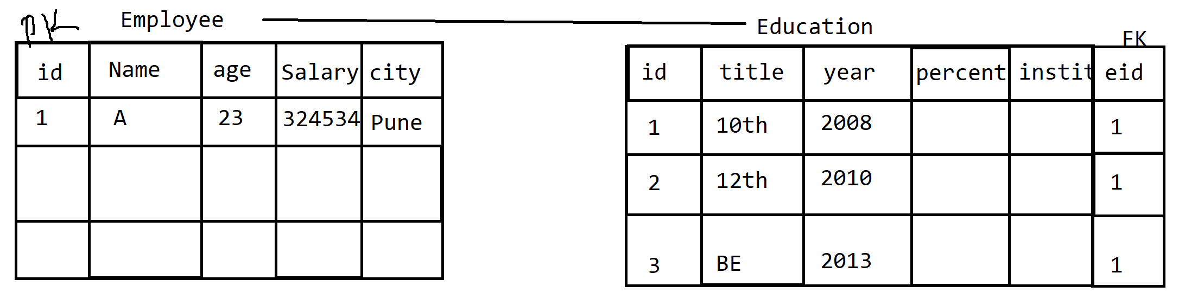

**DML (Data Manipulation Language)**

1. In this type command you can work with the data.
2. Using these types of queries you create new records/data, modify existing data, delete the data, get/retrieve the data.
3. This is also known as CURD (Create Update Retrieve Delete)
4. There are different type of queries
   1. Insert: You can create or add new data into the table
   2. Update: Can update/modify existing data
   3. Delete: Can delete the records
   4. Select: can get the records
5. **Insert Query**
   1. Syntax

INSERT INTO <tableName>(Column1, Column2,….) VALUES(val1, val2, val3,…);

* 1. Example:

INSERT INTO employee(id, name, contact, salary, gender, isActive, doj) VALUES(1,'A','9988778787',3124534.43,'M',true,'2022-01-12');

INSERT INTO employee VALUES(3,'C','9943124432',1124534.43,'F',true,'2022-03-12');

In the above syntax column name is not provided, it is optional only in the case where the sequence and the values for all columns are provided.

INSERT INTO employee VALUES(6,'F','8923224432',1824534.43,'M',true,'2002-05-10'),

(7,'G','7713224432',2824534.43,'F',false,'2012-01-22'),

(8,'H','6723224432',1224534.43,'M',true,'2017-02-11');

You can insert multiple records a t a time using this syntax.

1. Select Query
   1. This query is use to get the data store into the database.
   2. Select query can be use with clauses, operators, function(Date, String, arithmetic function), Joins.
   3. Syntax:

Select column1, column2, column3,… from <TableName>

Select * from <TableName>

1. Update Query
   1. Using update query you can update the data from existing row.
   2. You can update multiple rows or single rows at a time
   3. Syntax:

UPDATE <tableName> SET column=value;

UPDATE <tableName> SET column=value where condition;

**Clause/Operators**

1. Clause are use to add a filtration while retrieving rows/data from table.
2. Operators are mostly use to write a condition on the data.
3. Some of the commonly used clauses
   1. Where Clause
      1. In the where clause you can write a conditions on the column so that only a specific records will be selected. These is one of the way using which you can filter the records from the database.
   2. Like Clause
   3. Limit clause
   4. Order by Clause
   5. Distinct clause
   6. Group By Clause
   7. Having Clause