**Git and GitHub**

**Git:**

It is VCS (Version Control System) tool. This has installed on the local system. Using which you can work with the local repositories. It will also use as local client for GitHub.

Link to download Git: <https://git-scm.com/downloads>

Installation Guide: <https://www.youtube.com/watch?v=4xqVv2lTo40>

**GitHub:**

It is a web application which provides cloud repository also known as remote repository

Create Account on GitHub: <https://github.com/signup?ref_cta=Sign+up&ref_loc=header+logged+out&ref_page=%2F&source=header-home>

**GitHub Desktop**

Installation Link:<https://desktop.github.com/>

**VCS (Version Control System)**

1. Version control System is use to create a backup of your files and maintains the version of the file.
2. You can easily switch between a versions.
3. It will also store all details related to version like owner, files, date time, message etc.
4. You can also compare file from two version easily.
5. It is an efficient and easy way to maintain a backup/version of your file.
6. There are 2 types of version control tool.
   1. Centralized VCS
      1. All the files, their version and their details will be store at the central system.
      2. There will be a single service to which other systems will be connected.
   2. Distributed VCS
      1. All file, version and details will store on all client system.
      2. Every client work as a client and server both.

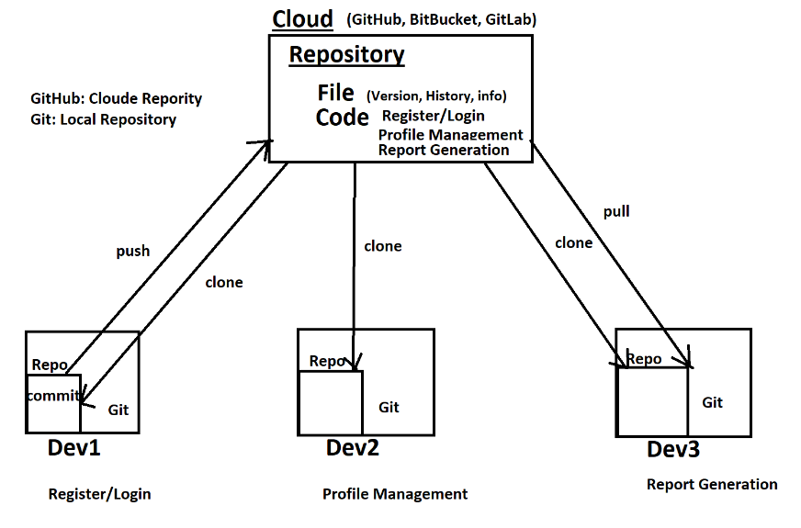

**Git Command**

To execute any git command you can use Git Bash (Git Command Line Client)

**Create/Get Repository**

**Create Local Repository**

**git init :** This command is use to create a local repository.

Empty Repo will be create and .git folder will be created in local repo.

**File Level Operation inside Git.**

1. There are different stage of files
   1. Untrack File:- The file which is newly created and it not managed by git.
   2. Track File:- The file which is maintain by Git (known File to git). And the file version maintained by git. There are different status of track file like new file, modified file, renamed file, delete file.
   3. Staging Area: It is allocation where you are currently working
2. git status: Can see the status/stages of files

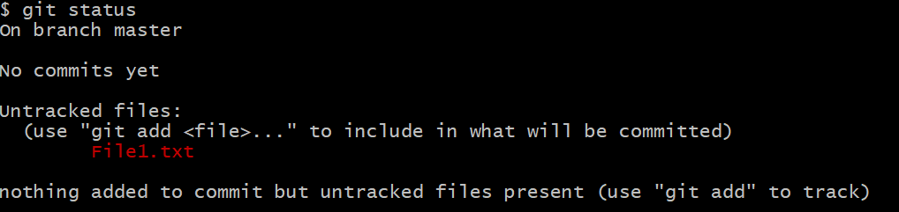

1. **git add:** Can add the changes and become ready for commit.

**git add <filename> : to add single file**

**git add . : to add all files at a time**

1. **git commit :** using this command git can start maintaining a version for this file, if version is already there then it will create a new version

**git commit -**m “Message”

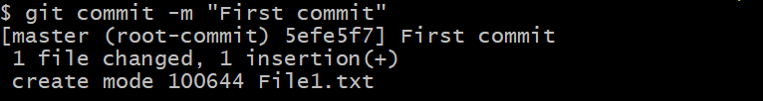

1. **git log:** is use to check the commit details

**git log**

**git log --summary**

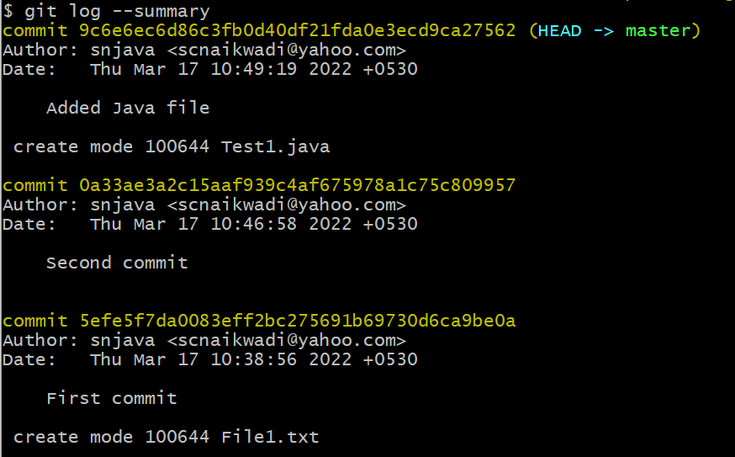

**git log --oneline**

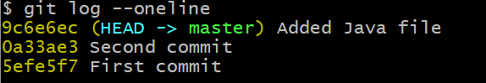

1. **git checkout**

This command is use to switch between commits or branches.

**git checkout <Commit_id>**

Using above command you can switch to any other commit.

**Git checkout <branch_name>**

Using above command you can switch into another branch.

1. Branch
   1. Branch is a separate working copy of the original code.
   2. This is use to perform any modification on the original code separately and further it can be merge into a main branch.
   3. There are different type of branched followed in real time like feature, defect, cutom, hotfix etc.
   4. Default branch create by git is **master**
   5. Default branch in github is **main**

**git branch:** This will list out the all the branches available.

**git branch <Branch_Name> :** Using this command you can create a new Branch.

Merge the code from One branch to Another

1. Switch to a branch where you wants to merge the code.
2. Use following command to merge the changes

**git merge <Branch_Name>**

the branch name in above command must a name of the branch which you have to merge

**Remote/Cloud Repository**

1. These repositories are created at central location or in the cloud.
2. These repositories are accessible from any where by any of the user using internet.
3. To create and use cloud repository you have to use some cloud platform like GitHub, BitBucket, GitLab etc.
4. To create cloud repository, you have to create account on this platform. Can create free account with some limited access.
5. Login into account and then you can create maintain your repository.

Git Config Command to ass username and email id.

To Add user Name

Git config -global user.name “<GitHub_User_Name>”

To Add user email

Git config - global user.email “<GitHub_User_Email>”

**Git clone:**

This command is use to clone/fetch the cloud repository into your local system. This command has to use only one to replicate cloud repo on the local system.

**git clone <Cloud_Repo_URL>**

**git push**

this command is use to push the changes committed on local repositor to Cloud Repository.

**Git pull**

To Get the changes done at cloud/remote repository into a local repository.

If changes are in the same branch than use following command

**git pull**

if changes are made in another branch of Cloud Repository then use following command

**git pull origin <Branch_Name>**