**Maven**

1. Maven is a build tool.
2. Gradle is another tool which can be use for a same purpose.
3. Maven is use to create a project structure. There are multiple project structure available inside maven, this structure is also known as **archetype** (Project template).
4. Maven also help you to compile the code. (mvn compile)
5. Maven also help us to execute the test cases. (mvn test)
6. You can package your application in .jar or .war using maven package command (mvn package)
7. Can deploy the maven application which can be run further using deploy command(mvn deploy)
8. Along with this maven will also help us to manage the jar file in the project which is also known as dependencies.

**Maven Setup**

1. Download Maven Zip file. (<https://maven.apache.org/download.cgi>)

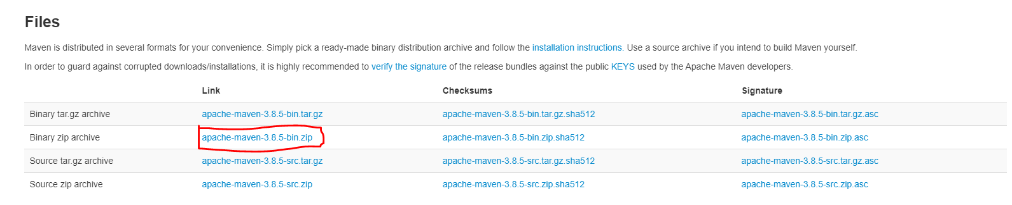

1. Extract Zip file into any location (Prefer C drive)
2. Setting the environment variable for maven.
   1. **MAVEN_HOME** : Create a New Variable and set Path of Maven extracted folder

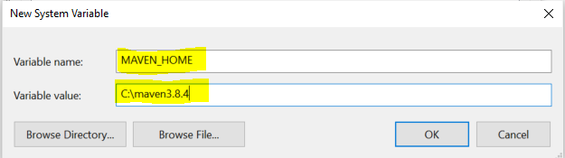

* 1. M2_HOME: Create a New Variable and set Path of Maven extracted folder

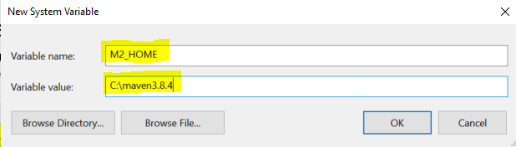

* 1. Path: Use Existing path variable and create new value inside Path variable

Value Must be: **%M2_HOME%\bin**

1. Verify Maven Setup

Open a command prompt and use following command **mvn -version**

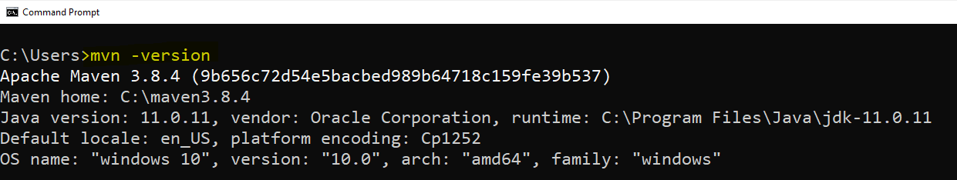

**Create Maven Project using IDE (Eclipse)**

1. File Menu -> “New” Option -> “Maven Project” option
2. Click on Next button on new window.
3. Select Archetype (Project Structure)
   1. There are multiple archetype available some of are maven official archetype or some are 3rd party.
   2. **maven.archetype.quickstart :** Use this type to create core java application
   3. **maven.archetype.webapp :** Use this type to create dynamic web application
4. Set the Group Id (Package Structure)
5. Set Artifact Id (Project Name)
6. Set Version (Project version)
7. Click on Finish.

**Maven Project Structure**

