Full Stack Development Java
Front End

Back End
Core Java
Basics of Java
Java intro, Installation and Setup for Java, Writing and executing first java program, Data Type, Control flow statements, Operators, Array, Class, Objects, methods, Java Build-class, String classes.
Object Oriented Programing in Java
Encapsulation, Inheritance, Polymorphism, Abstraction, constructor, Java keyword, final, static, super, this, access modifier, package
Advance of Core Java
Exception Handling, Threading, Collection, JDBC.
Advance Java (JSP, Servlet)
Spring Boot Framework

Database
SQL, MYSQL Database

Tools (DevTool)
Git
GitHub
Maven
Postman
Swagger

Software
JDK
Eclipse IDE
MySql Database
Git
Maven
Postman

Download JDK (1.8 and above).
https://www.oracle.com/in/java/technologies/downloads/
Note: Download Installer instead of zip file

Java Documentation
https://docs.oracle.com/en/java/javase/11/docs/api/

Logical Program Solving
https://www.hackerrank.com/
https://www.hackerearth.com/

Java Setup
- Download JDK
https://www.oracle.com/java/technologies/downloads/
Download the Installer for you operating System.
- Install JDK
- Verify the Installation
  - You can verify the installation file into C:\Program File\java\<jdk-version-folder>
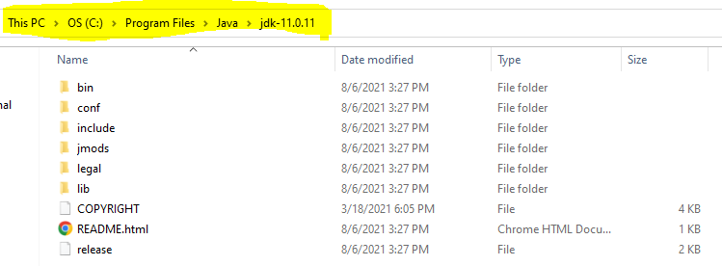
- Setup Environment Variable
  - Set JAVA_HOME
    - Go to Start and Search for “Environment” word and select the “Edit System Environment Variable” option.
    - Click on the “Environment Variable” button on the new window.
    - Select “New” Button from the ‘System Variables’ section
    - Provide the following details into text box
      - Variable Name: JAVA_HOME
      - Variable Value: <JDK-Path>
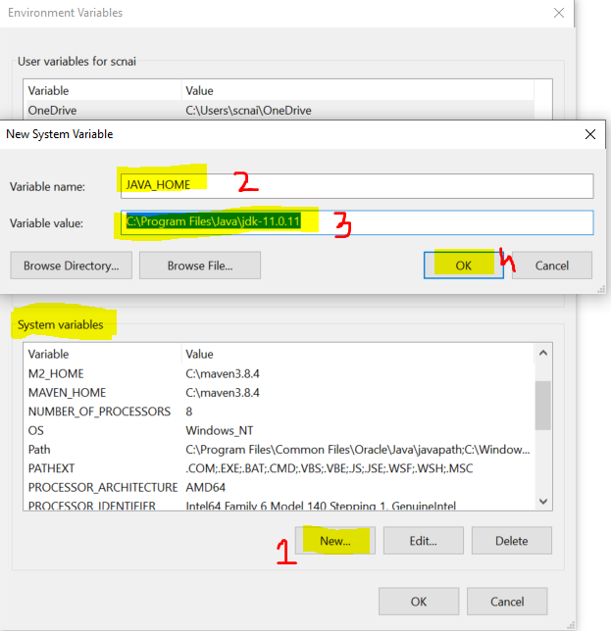
  - Set Path
    - Check for “path” variable inside ‘system variables’ section
    - Select “Path” variable and click on “Edit” Button
    - Click the “New” button on the new window
    - And set the variable value as follows
%JAVA_HOME%\bin
    - Click on “OK”
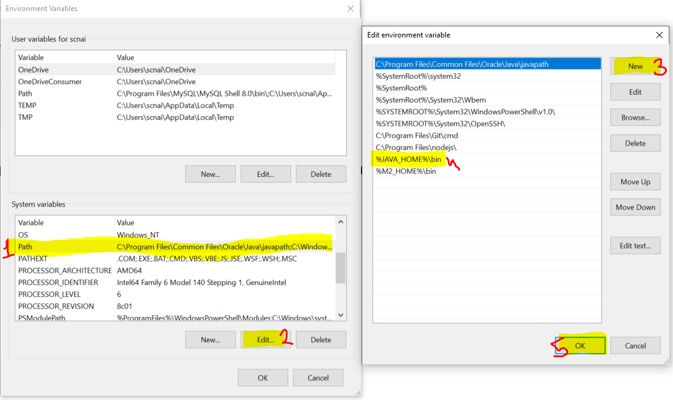
- Verify the Environment Variable Setup
  - Open CMD
  - Try the following commands
    - java -version
    - javac
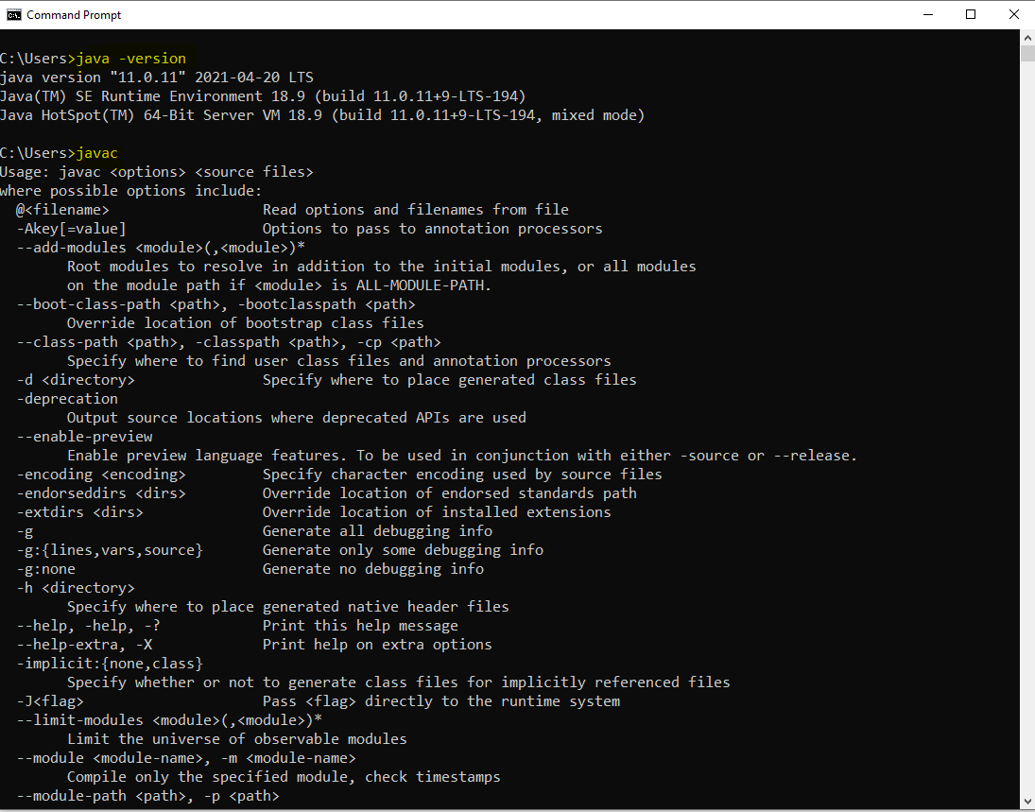

Types Of Application/Software
Mobile Application
Web Application
Desktop Application
Embedded Application
Console Based Application

Java Intro
- Edition of Java
  - J2SE/JSE
    - JSE stands for Java Standard Edition
    - It is also known as core java.
    - Desktop and console based application can be developed in this edition.
  - J2EE/JEE
    - JEE stands for Java Enterprise Edition
    - Is also known as Advance Java.
    - Mainly used for developing Web Application
  - J2ME/JME
    - JME stands for Java Micro Edition
    - Mainly used for Mobile application and Embedded Application.

Key Component for the Java Program
JVM
- JVM stands for Java Virtual Machine
- It is mainly use to execute the java program.
- Allocation of the memory while execution of the program, Communication with OS for execution, Clearing up memory after specific interval will be taken care by JVM.
- There are three stages of Program execution in JVM
  - Class Loader
  - Bytecode verifies
  - Execution
JDK
- JDK stands for Java Development Kit.
- This provide an environment to develop and execute the java program.
- JDK is a combination of multiple tools/components such as JVM, JRE, Lib(API) and some of development tools like javac, javap, javadoc
JRE
- JRE stands for Java Runtime Environment.
- JRE is used to execute the Java Programs only.
- JRE must be present on Client system.

API
- API stands for Application Programming Interface.
- API are the set of predefine class, interfaces and the functionalities provided by Java.
- These APIs will be available in the form of .jar file in java.
Writing and Executing First Java Program
- Writing a java code
  - You can write a using IDE or Notepad or any editor tool.
- Java Program Syntax
  - Create Java class
    - In java everything must be write inside class except import and package statement.
    - Syntax:
public class <Class_Name>
{

}
  - Cerate Main Method inside java class
    - Main method is the first method which gets executed.
    - This method is a start point of java program.
    - This method will be called internally by java (JVM) when you execute your program.
    - Syntax:
public static void main(String args[])
{

}
  - Write an executable code into method.
System.out.println(“Hello, Welcome to first java program”);
- Save File
  - File Name must be same as public class name.
  - File extension must be .java.
- Compile the java code
  - In this sept the java code will be converted into a byte code and the binary file will be created.
  - As an outcome of the compilation step the .class file will be created.
  - In this step all the syntax validation will also happens.
  - To compile a code first Open a CMD
    - The path of the CMD must be pointing to a location, where you save your java class. (to do this you can go to a folder where you save your java class, click on the address bar and type “cmd” and hit enter)
    - Execute a command to compile
javac FileName.java
- Execute Java code
  - Use same CMD
  - Execute a command to run java program
java className

Java Program Execution Process

Rules
- To execute the java program you don’t required a .java file you can execute the program using by .class file.
- One java file (Source file) can have more than one java class. Just you have to make sure that only one class must be public. You can have main method in all the classes in a file.
- The .class files will be generated for a classes present inside a file and not for a .java file.

Keyword, Identifiers and literals
Keyword
- Keywords are the reserve words used by a java programming language.
- The meaning for these words are implemented by java internally.
- All keywords are in small case only.
- There are 52 keywords present in java
- Example:
public, class, static, void, int, byte, short, long, double, float, boolean, char, if, else, for, while, do, switch, default, final, super, this, null, true, false.

Literal
- Literals are the values. Mostly String values are also consider as literals.
- The values which are also consider as keywords are known as literal
- Example: null, true, false.

Identifier
- Identifiers are the words which can be used for coding perspective are knowns as Identifier.
- The words which are used for class, method, variable, Object name are consider as an Identifier.
- There are rules to create Identifier in java
  - Identifier must not be keyword
  - Identifier must be start with character or symbol ($ and _)
  - In Identifier there are only two symbols are allowed which $ and _
  - Identifier can contain numbers but it must not be start with number.
  - Identifier are case sensitive and spaces are not allowed in it.
  - There is no limit of number of character in Identifier.
- There are conventions to create a class Identifier
  - The name of a class should be start with capital case.
  - If it is a combination of multiple words then every word should be start with capital
  - Example: Student, StudentDetails, EmployeePersonalDetails
- There are conventions to create a method, variable, Object Identifier
  - The name of variable, method or object should be start with lower case.
  - If it is a combination of multiple words then it should be start with lower case and all other words should be start with capital.
  - Exaxmple: printDetails, employeeId, printStudentDetails
- There are conventions to create a constant
  - The name of the constant should be in a complete capital case
  - If it is a combination of more that one word then every word should be separated by ‘_’
  - Example: PI, GRAVITY, COPMPANY_NAME

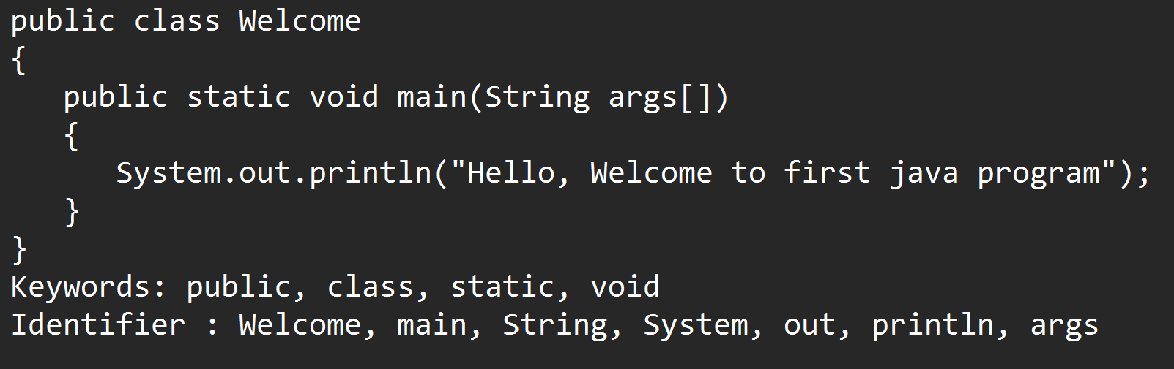

Comments in Java
- Comments are the way to write an information inside a code which can be use for a future use.
- By using comment you can make any code non-eligible for the execution.
- There are 3 types of comments in java
  - Single line comment
    - Syntax
// line to comment
  - Multi-line comment
    - Syntax
/*
line to comment
*/
  - Documentation Comment
    - It is use to provides the code level documentation. These comments are also a part of compiled code.
    - Syntax
/**
Code level documentation
*/
Data Type and variable

Data Type
- Using Data type you can store a different type of values in java program.
- These values will get a specific memory based on the data type specify to this.
- In Java there are main 2 categories of the Data Type
  - Primitive Data Type
    - Are the values which is in non-object format.
    - These values will have a fixed sized.
  - Non-Primitive Data Type
    - Are the values which is in the form of Object.
    - There is no fix size for the non-primitive data type.

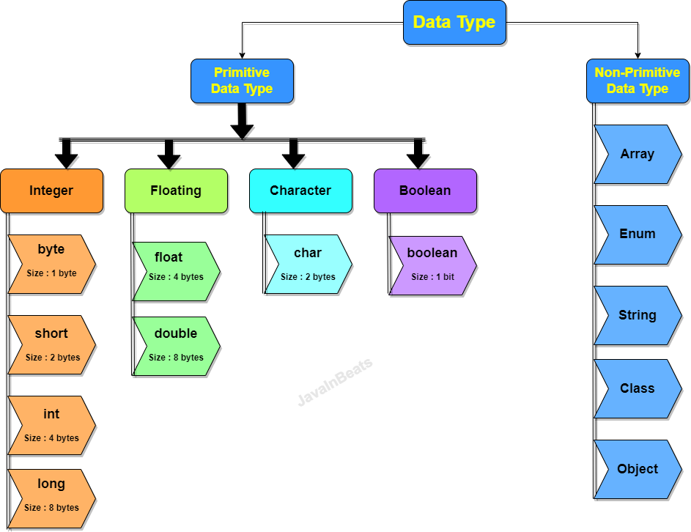

- Integer Type
  - In this type you can store a numeric value which is non decimal type.
  - You can store the negative and positive values.
- Floating type
  - You can store a numeric value which is with or without decimal type.
  - You can store negative and positive
- Character Type
  - You can store a value with single character.
  - In this you can store character, Symbols or also numeric values which must be a positive.
  - The symbol and the char value must be store inside single quotes (‘ ’)
- Boolean type
  - You can store a true or false value only
Data Type Memory Footprints

Range for the numeric values

Formula to get the range of value
- 2^{n-1} to 2^{n-1} - 1
Here, n is the number of bits.

byte : - 2⁸⁻¹ to 2⁸⁻¹ – 1
-128 to 127

Rules to store Values in Data Type
- long:
  - the values should be suffix with l or L.
- float
  - The value must be suffix with f or F.
- char
  - char values must be in single quotes.
  - You can store symbols or numeric values also along with alphabets.
  - You can store all the ASCII values inside char.
  - The numeric values in char must not be negative.

Variables
- Variables are use to store values/data into a program.
- Variables are use to print the values as an output.
- Variable is use for a mathematical calculation.
- Variables are use to assign value to another variable
- Syntax:

Data_type identifier; // Variable declaration
identifier = value; // Initialization of variable.
OR
Data_type identifier = value;

Type of variable
- There are 3 types of variable
  - Local Variable
    - Variable which is created inside method or inside method argument is called as Local Variable.
    - Local variable can be access within a method only it cannot be used outside method.
    - Local variable has initialized before use.
  - Instance variable
    - Variable which is created inside class and outside any method is called instance variable.
    - This variable is accessible inside class and also outside class using Object.
    - Instance variable can be initialized with default value if you have not provided any value explicitly.
  - Static/class variable
    - Variables which are created outside any method but will present inside class with static keyword.
    - These variables are accessible inside class and also into another class using Class name.
    - Static variable can be initialized with default value if you have not provided any value explicitly.

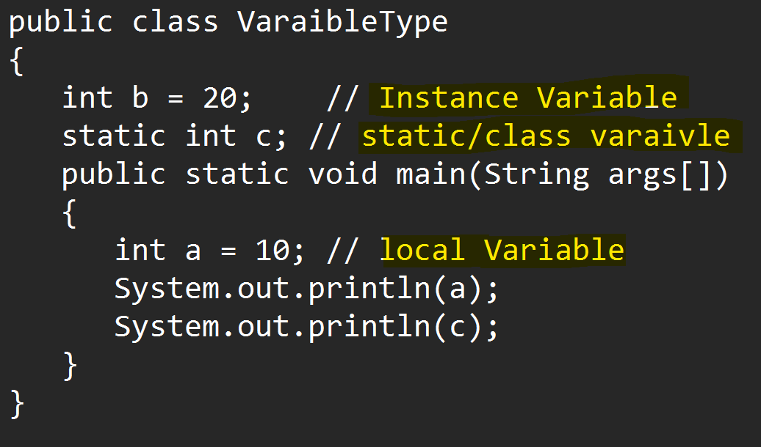

Default values for variable
Data Type | Default Value
byte  short  int  long | 0
float  double | 0.0
char | 0 or ‘\u0000’
boolean | false
Non-primitive | null

Note: These default values are only applicable to a instance and Static variables

Primitive Variable Casting
- Casting is a process in which one data type of values can be converted into another data type.
- There are 2 types of casting
  - Implicit Casting
    - The casting which is done by java automatically and internally without adding any extra code.
  - Explicit Casting
    - The casting will not happen by java, for this developer has to add some extra code in the program.
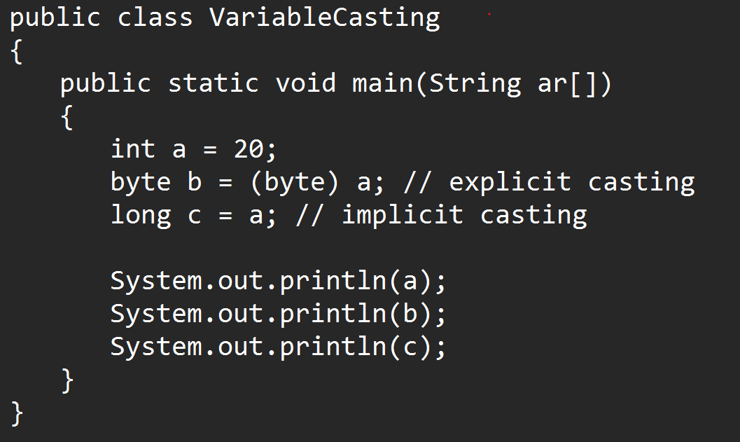

Operators
- Operators are use to perform different types of operation.
- This is use in a math expression or comparison of the values.
- Arithmetic Operator
+, -. /, *, %
- Assignment operator
=, +=, -=, /=, *=
- Increment and Decrement Operator
  - You can increment or decrement the original value by 1
  - It can be use by 2 ways
    - Pre Increment and Decrement
    - Post Increment and Decrement
++, --
- Relational Operator (It always return the boolean values, that is why it is use to write a logical/boolean/conditional expression)
<, <=, >, >=, ==, !=
- Logical Operator (It can use for 2 numeric value or 2 logical expressions)
&, |, !
- Short Circuit Operation (It is used to combine a multiple logical expression)
&&, ||
- Ternary operator
? (if), : (else)

Control Flow Statement
- Using control flow statement you can control the execution flow of the program.
- There is different type of control flow statements
  - Sequential statement
    - By Default program executes in a sequence.
  - Conditional Statement
    - Based on specific scenario you can decide whether to execute the statement or block of statement or not.
    - It can be achieved by multiple ways such as if conditional statement and its variation, switch cases.
  - Looping Statement
    - Looping statement you can execute a statement or block of statement multiple time.
    - It can be achieved by multiple ways such as while, do-while, for, enhance for.

If Condition and its variations

If condition:
It is used to execute a statement or block of statement based on the condition/scenario.
Syntax:
if(Boolean/conditional expression)
{
Statement(s)
}

If-else condition
- It use to execute the statement based on condition trye and also you can set up a statement if the condition is false.
- Else has to followed with if part. You cannot use only else part.
- Syntax:
if(conditional Expression)
{
Statement(s)
}
else
{
Statement(s)
}

Else-if condition
- Its is use to execute the else statement based on condition. It is also known as else if ladder.
- Here, you can also set the condition check for your else part.
- In this structure if any of the expression is true then it will not execute the rest of the expressions.
- Syntax:
if(Condition expression)
{
Statement(s)
}
else if(Condition Expression)
{
Statement(s)
}
else if(Condition Expression)
{
Statement(s)
}
else
{
Statement(s)
}

Nested if cases
- You can create one if into another if.
- The once structure can be created inside another structure.
- Syntax:
if(condition expression)
{
if(condition expression)
{
Statement(s)
}
}

Task-1
Create an int variable age
Age between 1-12 – Kids Age
Age Between 13-18 – Teen Age
Age Between 19-60 – Adult Age
Age Between 61-110 – Old Age
And age other than this – Invalid Age

Switch Case
- This cases will be used in a scenario where you are needs to compare the exact match for the value.
- Syntax:
switch(value)
{
case label:
statement(s)
break;
case label:
statement(s)
break;
case label:
statement(s)
break;
default:
statement(s)
}
- Rules to use switch case
  - The value inside switch must be byte, short, int, char, String, enum type only.
  - All the labels must be unique.
  - The data type of value and the label has to match.
  - Break statement is not mandatory but if you don’t provide it, then it will generated an unexpected result.
  - If multiple cases has same execution then you can combine the cases.

Task-1 (Using switch case)
Create an int variable day and assign a value for day variable
day=1, 2, 3, 4, 5 => It’s a Working Day
day=6, 7 => It’s a Weekend
any other value = Invalid Day..
Task-2
Create a char variable month and assign a char value
‘J’ or ‘j’ – January or June or July.
‘F’ or ‘f’ – Feb.
‘M’ or ‘m’ – March or May.
‘A’ or ‘a’ – April or Aug.
‘S’ or ‘s’ – Sept.
‘N’ or ‘n’ – Nov.
‘D’ or ‘d’ – dec.
‘O’ or ‘o’ – Oct.
Other than this = Invalid month Character

Looping Statement
- Is use to execute a statement or block of statement multiple time.
- There are different ways to achieve a looping statement
  - While
    - You can execute the statement(s) multiple time.
    - This is also known as pre condition check.
    - Syntax:
Variable declaration and initialization
while(boolean/conditional expression)
{
Statement(s)
Increment/Decrement of variable
}
  - Do-while
    - You can execute the statement(s) multiple time.
    - This is also known as Post condition check.
    - Syntax:
Variable declaration and initialization
do
{
Statement(s)
Increment/Decrement of variable
}
while(boolean/conditional expression);

  - For
    - Using for loop you can execute the statement or group of statements multiple time.
    - Syntax:
for(declaration/initialization ; conditional expression;Increment/Decrement/statement)
{
Statement(s)
}

  - Enhance for
    - It is use to iterate the value of collection one by one.
    - Syntax:
for( Variable declaration : collection )
{
Statement(s)
}

  - Nested Loop
    - Nested Loop is use to work with a row and column structure.
    - Nested loop is a way using which you can write a one loop inside another.
    - Syntax
for( ; ; ) // Used for a ROW
{
for( ; ; ) // Used for a Column
{

}
}

Task-1 (Using do-while)
Create a variable num of type int assign a value to it and print the table for the number.
Example: if num=5
Then Ouput: 5
10
15
.
.
50

Task-2 (Using While)
Print all the odd values between 1 – 50
Output: 1
3
5
7
.
.
49

Array
- Array is a group of similar type of values.
- Array is use for same type of values having fixed in size.
- Array is use to store multiple values in a single variable which will be easier to manage and maintain.
- Array is an indexed basis.
- Index is a specific position where the values are store.
- Index always start from 0.
- Index are always managed by programming language internally.
- Indexes are use to set and get the values form array.
- If you handle the index incorrectly then you will get an java.lang.ArrayIndexOutOfBoundsException
- There are different types of array
  - 1-Dimentional Array
  - 2-Dimentional Array
  - Multi-Dimensional/Jagged Array.
- To create and use array you have to follow 3 syntax
  - Array Declaration
  - Array Instantiation (Object creation)
  - Array Initialization
- 1-Dimentional (1-D) Array
  - You can store the values in the form of row.
  - To crate and use 1-D array you have to follow the following steps
    - Array Declaration
      - Here you can declare the array which is going to create in a program.
      - Syntax:
DataType identifier[];
    - Array Instantiation (Object creation)
      - In this stage the memory for an array will be created and inside memory you can store the values.
      - In this stage you have to specify the number of values you wanted to store inside array.
      - Syntax:
Identifier = new DataType[Size];
    - Array Initialization
      - In this stage you can provide a custom value inside array.
      - To set the custom value you have to use a index.
      - Syntax:
Identifier[index] = value;

Different ways to create 1-D array
- There are 4 ways using which you can create array.

Way-1
double percent[]; // Declaration of Array
percent = new double[10]; // Instantiation of array
percent[0] = 77.88; //initialization of array
percent[1] = 72.81;
percent[2] = 62.11;
percent[3] = 72.51;
percent[4] = 45.81;
percent[5] = 76.41;
percent[6] = 65.22;
percent[7] = 89.81;
percent[8] = 55.90;
percent[9] = 67.31;

Way-2
double percent[] = new double[10]; // Declaration and Instantiation of Array
percent[0] = 77.88; //initialization of array
percent[1] = 72.81;
percent[2] = 62.11;
percent[3] = 72.51;
percent[4] = 45.81;
percent[5] = 76.41;
percent[6] = 65.22;
percent[7] = 89.81;
percent[8] = 55.90;
percent[9] = 67.31;

Way-3
double percent[] = new double[] {77.88, 72.81, 62.11, 72.51, 45.81, 76.41, 76.41, 65.22};

Way-4
double percent[] = {77.88, 72.81, 62.11, 72.51, 45.81, 76.41, 76.41, 65.22};

Length Function:
- Using length function of array you can get the total number of values present inside array.
- Syntax:
array.length
- You can also find the last index using length function
Last index = array.length – 1

Task-1
Store a percentage for one student (10th, 12th, Higher education semester wise) and print the average of the percent.
2-Dimensional (2-D) Array
- In 2-D array you store the data in the form of row and column which is also known as Metrix.
- Syntax
    - Array Declaration
      - Here you can declare the array which is going to create in a program.
      - Syntax:
DataType identifier[][];
    - Array Instantiation (Object creation)
      - In this stage the memory for an array will be created and inside memory you can store the values.
      - In this stage you have to specify the number of values you wanted to store inside array.
      - Syntax:
Identifier = new DataType[Row-Size][Column-Size];
    - Array Initialization
      - In this stage you can provide a custom value inside array.
      - To set the custom value you have to use a index.
      - Syntax:
Identifier[row-index] [column-index] = value;

Length Function in 2-D Array
- Array.length: It will return a total number of rows.
- Array[row-index].length: It will return a total number of columns for the specified row.
Different way to create 2-D array

Way-1
double percent[][]; // Declaring Array
percent = new double[3][5]; // Instantiation of array
percent[0][0] = 67.65; // Initialization
percent[0][1] = 87.15;
percent[0][2] = 61.45;

Way-2
double percent[][] = new double[3][5]; // Declaring and Instantiation of Array
percent[0][0] = 67.65; // Initialization
percent[0][1] = 87.15;
percent[0][2] = 61.45;

Way-3
double percent[][] = new double[][]{
{76, 78, 45, 78, 56},
{76, 89, 56, 98, 56},
{88, 66, 89, 98, 67}
};

Way-4
double percent[][] = {
{76, 78, 45, 78, 56},
{76, 89, 56, 98, 56},
{88, 66, 89, 98, 67}
};

Task-1
Create an array which can hold the 5 students 4 subject marks.
Print the Marks of every student in table format along with the percent.
Also Print the Grade of the Student.
And Also print the Highest Percentage.

Multi-dimenational Array
- This array is also based of the row and column structure.
- It is used to store the values which has fixed and variable number of column.
- Its is also known as Jagged array.
- Example:
int array[][] = {
{34, 56, 768},
{23, 45},
{54, 67, 89, 34, 768, 23},
{32, 54, 76}
};

Class, Object and Method

Class
- Class is a collection of state/variables/data member and behavior/methods/member function.
- Along with variables and methods you can also create a constructure or another class(Nested class) in a class.
- The data member and member function of class can be used outside class using the Object.
- Syntax to create class
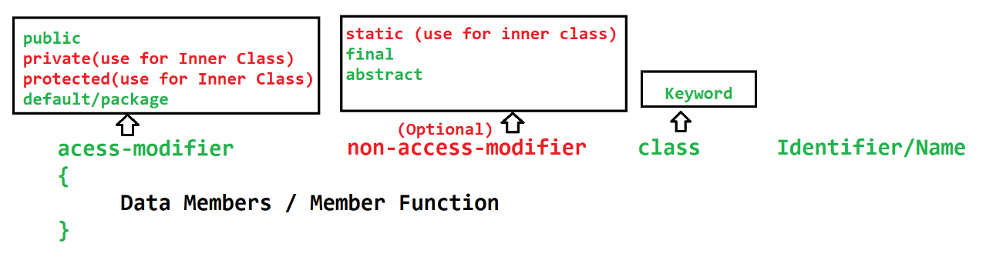

Method
- Method is a collection of variables and the executable statement.
- Methods are used to write a logical code. The code written inside methods can be reuse from the different location of the program/project.
- Method is also help to reduce the complexity of the program by dividing a logic into a smaller chunk or code.
- To execute the logic from the method, methods has to execute manually by calling them directy or by using Object.
- Methods can accept the values which is known as input parameter. There can be more than one parameter. The values which is passed to parameters are called arguments.
- Method can return the output of the execution as a return type. There can be onlt single return type.
- Types of methods
  - Build-In Method (Predefine) Method
    - The methods which are provided by language/framework.
  - Custom method (User define) Method
    - The methods created programmatically.
- Syntax:
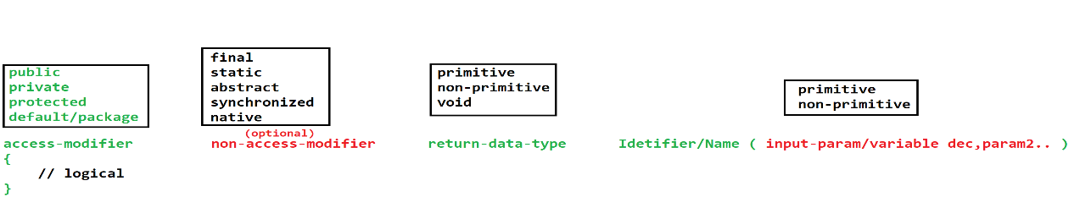

Object
- Object is a representation of the class.
- Using an object you can access the properties of the class (variables and methods).
- To access the properties of the class you have to use dot(.) operator.
- In Java you can create Object using new operator
- Syntax
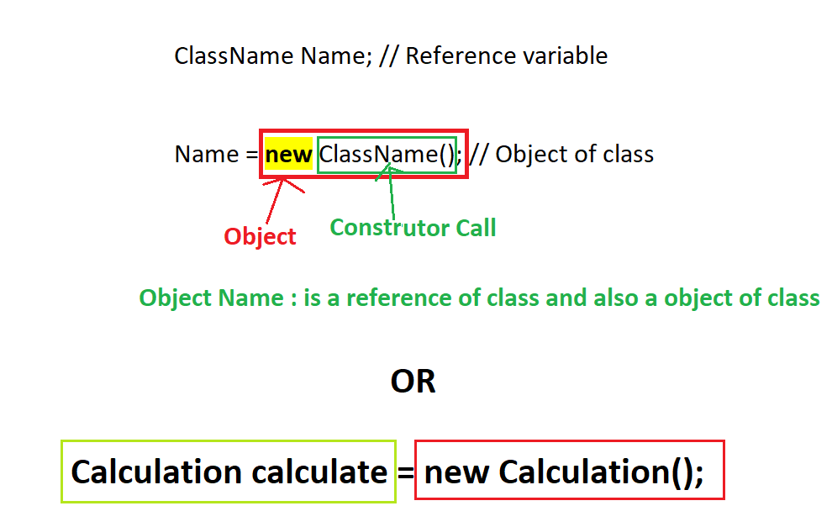

Accept User Input in Java
- You can accept the values from the user using console or UI.
- Here, we will see how to accept values from console.
- There are multiple ways and classes provided by java to accept the user input.
  - Command Line Argument
  - Scanner Class
  - Console Class
  - Buffer Classes
- Command Line Argument
  - This is use to accept the user input before the execution of program.
  - Command Line argument are the values which is provided while tying the command for java program execution.
  - These arguments (values) will be received into a java program inside main method and the String array.
  - All the arguments (values) will be in the string format only.
  - You have to convert it into specific format manually.

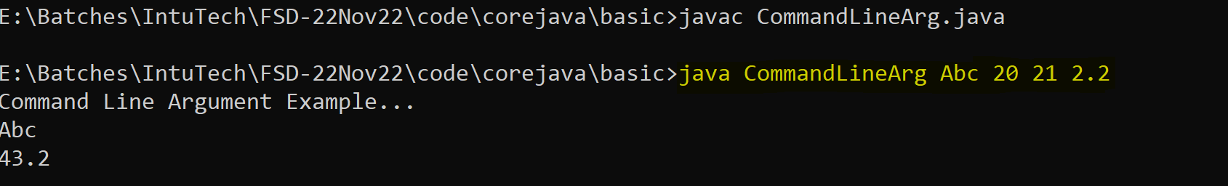

- Scanner Class
  - Scanner class is use to accept the user input in the middle of program execution.
  - You can accept input into any data type without any manual conversion.
  - Scanner class is the build-in class by java
  - This class is present inside java.util package.
  - To use this class you have to import it into java program and also create an object of the class.
  - In the scanner class you can use different methods to accept the data of different type.
  - There is nextXXX(), is use to accept the different type of values.
  - You can use next() method to accept a string type of values.

Wrapper Class

Primitive Data Type | Wrapper Classes
byte | Byte
short | Short
int | Integer
long | Long
float | Float
double | Double
char | Character
boolean | Boolean

String in Java
- String is an array of character.
- String is use to store a multiple character or combination of symbol, Numbers and characters.
- In java string values always provides into double quotes (“Value”)
- To Store String in java you can use following build-class
  - String
  - StringBuffer
  - StringBuilder

String Class
- String class is used to store an array of character.
- String class is a build-in class. This class has multiple methods to perform the operations on the string values.
- String class is present inside java.lang package.
- String class is a final class.
- To Use String class you have to create object of String class, which can be achieve by 2 ways.
  - With new Operator
String str = new String(“Value”);
  - Without new operator
String str = “Value”;
- Memory foot prints of string
- String Objects are immutable. Immutable means the original value of the string remain same (Does not change) even after using any of the method of the string class.
- The string Object will be store inside Heap always, and there is a SCP memory allocation for the string which created without new operator.
- SCP
  - SCP is a String Constant Pool
  - The String value which is created without new operator are store inside SCP.
  - While creating object (Storing data) inside SCP, it will first check if same object is already present or not.
  - If Object with same value is present then, no new object will be created the same will be return to a new reference.
  - If no same value object present then only new object will be created inside SCP.

Task-1
Create a String variable with value “Welcome” and print the String in Reverse way using String class
Output : emocleW (Hint: use toCharArray() Method)

Task-2
Create a String variable with value “FirstName MiddleName LastName” and print the output in to following way
Output : LastName MiddleName FirstName (Hint: use split() Method)

StringBuilder
- This class is use to store a string value.
- This is the java build-in class.
- This class is present inside java.lang package.
- This class is a final class.
- By Creating Object of this class you use the functionalities of the class
StringBuilder builder = new StringBuilder(“<Value>”);
- There are multiple methods inside string class using which you can perform operation on existing string.
- Here the SCP concept is not applicable.
- The object of this class is mutable. The Original Value will be change after implementation the methods of this class.

StringBuffer
- This class is use to store a string value.
- This is the java build-in class.
- This class is present inside java.lang package.
- This class is a final class.
- By Creating Object of this class you use the functionalities of the class
StringBuffer builder = new StringBuffer(“<Value>”);
- There are multiple methods inside string class using which you can perform operation on existing string.
- Here the SCP concept is not applicable.
- The object of this class is mutable. The Original Value will be change after implementation the methods of this class.
- StringBuffer Objects is thread safe. At a time only one thread can perform the operation on StringBuffer object.
- The methods of StringBuffer are synchronized.
- It is slower in the performance than StringBuilder.

Eclipse IDE (Integrated Development Environment)

- Download Eclipse .zip file.
https://www.eclipse.org/downloads/download.php?file=/technology/epp/downloads/release/2022-12/R/eclipse-jee-2022-12-R-win32-x86_64.zip
- Extract a ZIP file into appropriate location
- Click on the eclipse application file.
- Setup a Workspace
  - Create a Location where you wanted to create all your projects, and java files.
- Set the Perspective of the eclipse
- Perspective option is available on the right top of the eclipse window
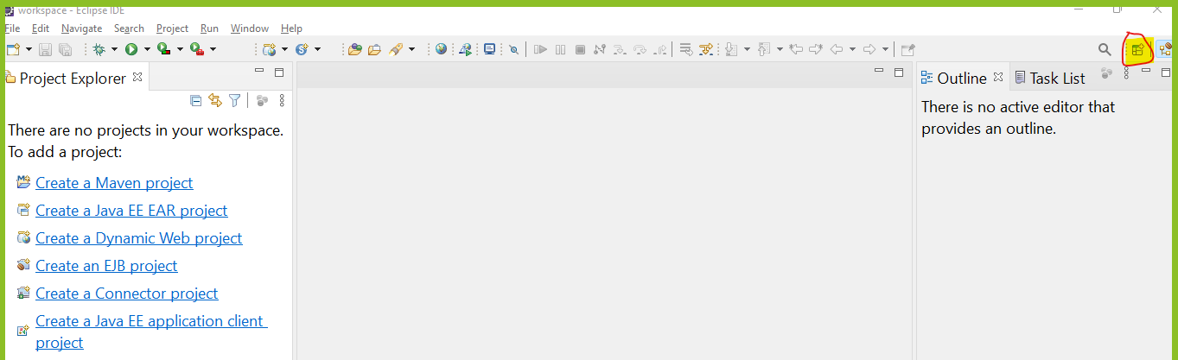
- Select a “Java” option from list and click on “Open” button

Object Oriented Programing (OOPs)
- Base of OOPs concept is class and Object
- There are 4 main concepts of OOPs
  - Encapsulation
    - It is a wrapping of data member(variable) and member function(method) into single unit.
  - Inheritance
    - Inheriting the property (Variables and methods) of one class into another class which is also known as Parent and child.
  - Polymorphism
    - One object can be behave in a multiple form.
  - Abstraction
    - Hiding the complexity and display only the important details/function is called abstraction.

Encapsulation
- Encapsulation is wrapping of data member (variable) and member function (method) into single unit.
- Class is also a kind of encapsulation.
- As per the recommendation, do not access the instance variable of one class directly into another class using object, instead use the methods to access them.
- In Encapsulation you can hide the data using Private access modifier and provide them access using a getter and setter methods.
- Setter Methods
  - Setter methods are used to set the values for the instance variable.
  - This method mostly starts with “set” word as a prefix and will be followed by variable name.
  - This method accepts the value which needs to be assign to an instance variable and not return anything.
- Getter methods
  - Getter Methods is used to get the values of the variable.
  - This method mostly starts with “get” word as a prefix followed with variable name.
  - This method will not accept anything but return the values.
- Advantage of Encapsulation
  - Can Achieve the data hiding.
  - Can control who can access what.
  - Can achieve the loose coupling.

Inheritance
- Access the properties of one class into another class. Inheritance will create a parent and child relation between two classes.
- The parent and child relation are also known as IS-A relation in java.
- Using inheritance, you can access the non-private variables and methods of the parent class into child class.
- To achieve inheritance, you can use extends keyword in java.
- In OOPs there are 5 types of inheritance, but in java only 3 are directly supported and other 2 are not directly supported but in can be achieve by interface.
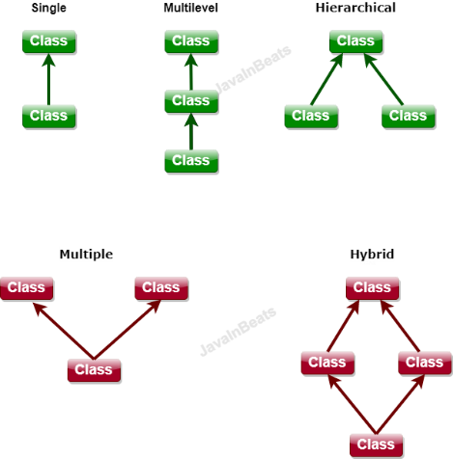
- In java Single, Multilevel and Hierarchical inheritance is directly supported and Multiple and Hybrid is not directly supported in java but it can be achieve by using interface.
- In Java One class cannot extends (inherit) more than one class at a time.
- Parent class is also known as super class or Base class and child class is also known as Sub class or derived class.
- Advantages of Inheritance
  - Reusability
  - Extensibility
  - Inheritance is required to achieve runtime polymorphism.

Object Class in Java
- Object class is a super (parent) class of all the java classes.
- If class do not have any parent class then java will add a Object class as a parent class.
- Every Java class will have the properties of Object.
- Object class is use to define all the common properties which are required inside all the java classes.
- There are multiple methods present inside this class, which is as follows
  - toString()
  - equals()
  - hashCode()
  - wait(), wait(long), wait(long,int)
  - notify()
  - notifyAll()
  - finalized()
  - getClass()

Constructure In Java
- It is use to construct the values. That is, it is use to initialize (providing values) the instance variable.
- Every java class has a constructure. If you do not provide manually/explicitly then, java will provide a constructure internally which is known as default constructure.
- If any constructure provided explicitly then java is not responsible to provide a constructure.
- Constructure gets called at the time of object creation and you do not have to call it manually.
- Rules to create constructure
  - Constructure must have a same name as Class name.
  - Constructure must not have a return data type.
  - Constructure can be create using any access modifier (private, public, protected, default/package).
  - There can be a more than one constructure in a class with different parameter list (also known as constructure overloading).
  - Constructure cannot be call using an object dot operator like method it will always gets called at object creation time.

super, this, static, final Keyword

super Keyword
- Super keyword is use to access the properties of super (Parent) class
- By using super keyword you can access the methods, variables and constructor of super class.
- Super keyword is use for super class variable and method in a case where the property with same name is already available inside parent and child class both.
- Super is also use to access the constructor of super class.
  - Every Sub-class constructor by default calls a super class default/no-parameterized constructor. Because every constructor has super() as a first line by default.
  - You can explicitly (manually) call any constructor of super class using super keyword. But the rule is you must have to call a super class constructor from sub class constructor only and it must be a first line in a constructor.
this keyword
- This keyword is use to access the property of same (current) class.
- This keyword is also known as current object of the class. (Points to a current class object)
- Using this this keyword you can access the Variables, methods and constructor of the same class.
- Using this keyword you can access the one constructor from another constructor if same class.
  - To call one constructor from another, you must have to call it from constructor only (One constructor only call another constructor).
  - The constructor calling line must be a first statement.
  - As first statement of the every constructor either you can use this or a super keyword (you cannot use both the keywords at a time).

final keyword
- Final keyword is use to create a constant.
- Final keyword can be used for a class, method, variable.
- Final variable
  - The value of the final is fixed in an application one it is assign. It cannot be changes thought the program.
  - You can create a constant value using final variable.
  - Final variable can be an instance, static or local variable.
- Final Class
  - The final class cannot be inherited (cannot use as a super class) and its methods implementation will be fixed.
  - Final class variables and methods are not final by default.
- Final method
  - Final methods cannot be override and the implementation of the final method is fixed.

Static Keyword
- Static properties can be access without Object using class name.
- The properties which are frequently use those can be mark as a static.
- You can create static method, variable and class (must be an inner class)
- All static properties load inside memory at the time of class loading stage.
- Static Variable
  - You can create a static variable inside class and outside any method only. Static variables cannot be create inside method.
  - Static variables can be access without class Object using only class name.
  - Static variables loaded inside a memory at class loading time.
- Static method
  - Static methods are also access using class name and without class Object.
  - Static methods can access only the static properties of class directly and to access the non-static properties you have to create Object of the class.
  - Inside static method you cannot use aa super and this keyword.
- Static class
  - Static class must be a inner class and it can be never outer class.
  - Static class properties are not by default static, you can mark it as a static explicitly.

Package, Import and Access modifier statement
Package Statement
- Package is a group of classes into a single location.
- By using package you can create a group of class having similar functionality.
- For every package internally it creates an folder inside file system.
- Rules and conventions to create package
  - Package statement must be a first statement in a java file.
  - Package statement is created outside any class and inside the file.
  - Package statement must be start with package keyword followed with the name of package.
  - There can be nesting of the packages which is denoted by dot(.)
  - As per the convention, create package name into a small case.

Import statement
- Import statement is use to import the java class from one package to another.
- Using import statement you can provide an access for the class inside an another class from different package.
- By default every java class has the access of all the classes form java.lang package.
- There are some rule to use import statement
  - Import statement must be a write after package statement.
  - Import statement has to write outside class and inside java file.
  - There can be multiple import statement present inside a file.
  - You can either import a single class from the package or you can import all the classes from the package.
- Example
import package.classname;
Is use to import the single java class from the package.
import package.*;
You can import all the java classes from the package.
Access Modifier
- It is a way to restrict the access of properties from another class
- If you don’t provide any access modifier then by default it is consider as a default/package.
- There are 4 access modifiers
  - public
  - private
  - protected
  - default/package

Access Modifier | Properties Access in same class | Properties access in different class form same package using Object | Properties access in different class form same package using Inheritance | Properties access in different class form different package using Inheritance | Properties access in different class form different package using Object
public | YES | YES | YES | YES | YES
protected | YES | YES | YES | YES | NO
default/package(applies if not explicitly assign) | YES | YES | YES | NO | NO
private | YES | NO | NO | NO | NO

Arrange the Access Modifier by their restriction from Highest to Lowest order.
Highest to Lowest restriction
private default protected public

Polymorphism
- Same thing can be use in a different way is called polymorphism.
- Single Object can be used for executing different behavior.
- There are type of polymorphism
  - Compile time polymorphism
    - The method call resolves at the time of compilation and same will be followed at the execution.
    - The example of compile time polymorphism is overloading
  - Runtime polymorphism
    - The method call is resolve at the time of execution or runtime of the program.
    - The example of compile time polymorphism is Overriding

Overloading
- Overloading is a way to create a method with a same name having different parameter list.
- In overloading, method name must be same and input parameter must be different.
- You can make the parameter list different by following ways
  - Can change the data type of parameter.
  - Can change the number of parameter.
  - Can change the sequence of parameter.
- Overloading can be done is same class or sub class.
- In overloading return type may or may not be same.
- In overloading access modifier may or may not be same.
- Can throw new and broader checked exception.
- Can overload static methods. (Main method can be overload)
- Can overload final methods.
- Real time Example of overloading
  - StringBuffer and StringBuilder has append() and insert() method which is an example of overlading.
- Advantages
  - Improve the Readability of the code.
  - You can provide an easy way to access the functionality.

Overriding
- Overriding is a way to create a method with a same name having same parameter list.
- In overriding, method name must be same and input parameter must be same.
- Overriding must be done in sub class.
- In the overriding return data type must be same (if it is primitive or void) or it can be sub type.
- Access modifier must be same or it can be less restrictive.
- Cannot throw new and broader checked exception.
- You cannot override static methods
- Cannot override final method.
- Advantage
  - You can change the default implementation of parent into child class.

Task
- Difference between overloading and Overriding with one programming example.

Runtime Polymorphism
- The method call is resolve at the time of execution or runtime of the program
- To achieve the runtime polymorphism, you have to follow the 3 steps
  - There has to be an inheritance between classes.
  - The method has to override inside sub class.
  - Call the overridden method using polymorphic Object.

Polymorphic Object
- It is a way in which you can create an Reference of parent class and Object of child class.
- Every parent class reference can hold the Object of every child class.
- This type of objects are used to archive the runtime/dynamic polymorphism.
- Example:
Parent Obj = new Child();

Abstraction
- Hiding the complexity and display only the important details/function is called abstraction.
- In this concept the complex implementation will be hidden from the user and only the functionalities will be display
- Can achieve 2 ways
  - Abstract class
    - Abstract class is a way using which you can achieve the 0-100% abstraction. Which is also known as partial abstraction.
  - Interface
    - Interface is a way using which you can achieve the 100% abstraction. Which is also known as full abstraction.
Abstract Class
- Abstract class is a way using which you can achieve the 0-100% abstraction.
- Abstract class can be create using abstract keyword.
- Abstract class can have an abstract and non-abstract method.
- Abstract method is a method, which is not having an implementation and only declaration is present.
- Abstract method can be created using abstract keyword.
- If you create any abstract method into class then that call has to be abstract.
- Mostly, abstract classes are use as a top level in the hierarchy (that is as a parent class).
- You cannot create an object of abstract class. but you can use as a reference.
- All the sub classes of the abstract class, must provide the implementation of all the abstract methods (override method) of the parent abstract class.
- One abstract class can extend on another abstract class, in this case you can skip the implementation for the abstract methods, the all properties of the parent abstract class will be inherited inside child abstract class including abstract methods.
- Abstract class can have a constructor. The abstract class constructor will be called at the time of it sub class object gets created.
- Can create any type of variable inside abstract class.
- Can create method with any access modifier. You cannot create private abstract.
- Private methods are allowed which must be non abstract.
- You cannot mark the abstract class or method as static or final.
- You can create a static and final meth.ods in side abstract class which must be non-abstract method.

Interface
- Interface is use to achieve full abstraction (100% abstraction)
- Interface will have only abstract methods (till JDK 1.7)
- Interface is not a class but it will get a .class file after compilation.
- Interface are created using an interface keyword.
- All the methods of the interface are by default public and abstract.
- All the variables of the interface are public static final
- Interface is use at the top level in the hierarchy. (Use as a parent always)
- Interface will be implements on another class.
- All the sub class of the interface has to provide implementation for the abstract method.
- You can implement the interface on an abstract class, in this case it is not necessary to provide the implementation for the abstract methods, it will be inherited as it is into abstract class.
- You cannot create object of the interface but it can be use as a reference.
- You cannot create constructor inside interface.
- You cannot create static method inside interface (till Jdk 1.7)
- You cannot create final method inside interface.
- All the members of the interface must be public, no other access modifier is allowed inside interface.
- One interface can extends another interface.
- You can achieve multiple inheritance using interface
  - One interface can extends more than one interface at a time.
  - One class can implements more than one interface
  - One class can extends another class and implements one or more interface.
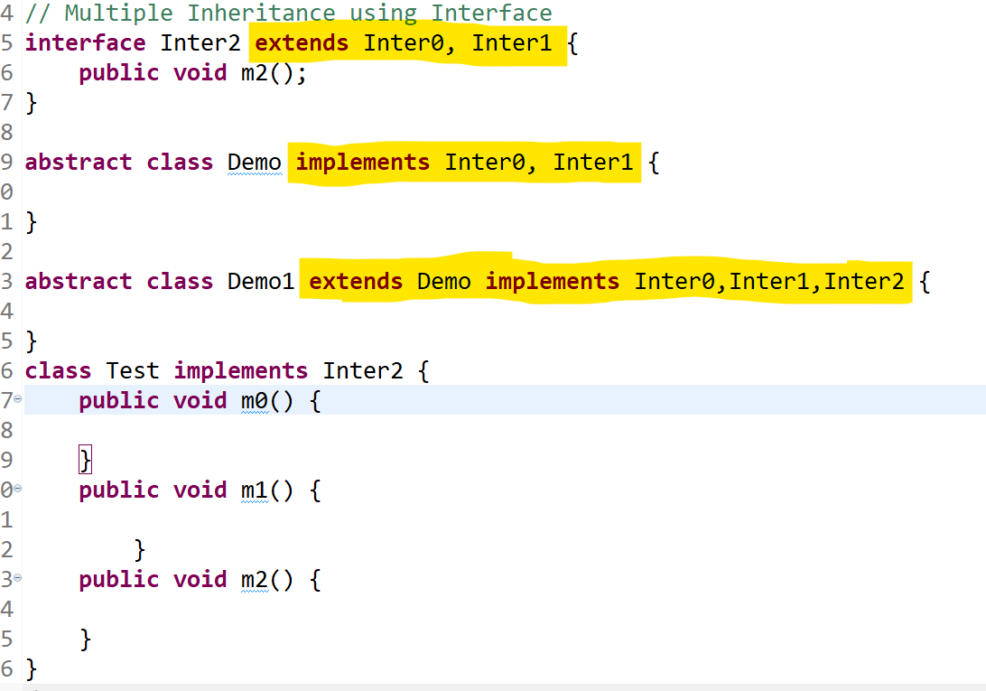

Interface Changes in JDK 1.8 and above
- Can Create a default method
  - You can create an implemented method inside interface.
  - This implemented methods must have to mark as default.
  - This feature is provided to assign the default behavior of the interface method.
- Can Create Static method
  - The method which has implementation and also those are marked as a static.
  - You can also create main method inside interface.
- Functional Interface
  - The interface which has only single abstract method is called functional interface.
  - To make ensure the created interface is functional interface java has provided the @FunctionalInterface annotation
  - You can create any number of default and static method inside functional interface but you have to create only one abstract method.

Exception Handling
Exception: It an unwanted scenario which occurs during the execution of the program, due to which the program execution will terminate abnormally.
Exception Handling: It is an approach to handle the exception which is occurs during the program execution which will help us to avoid the program termination.

Read and Understand the Exception
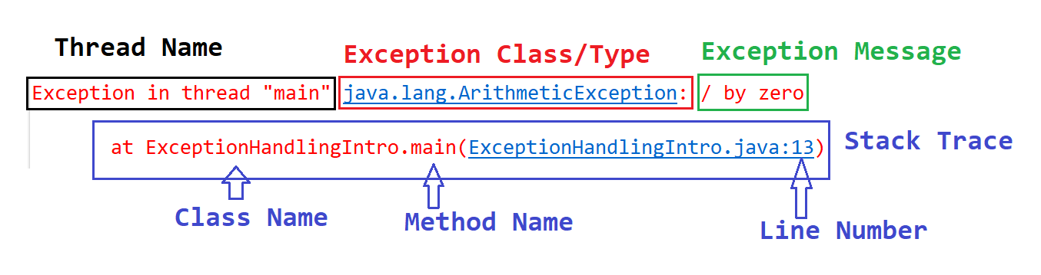

Exception hierarchy

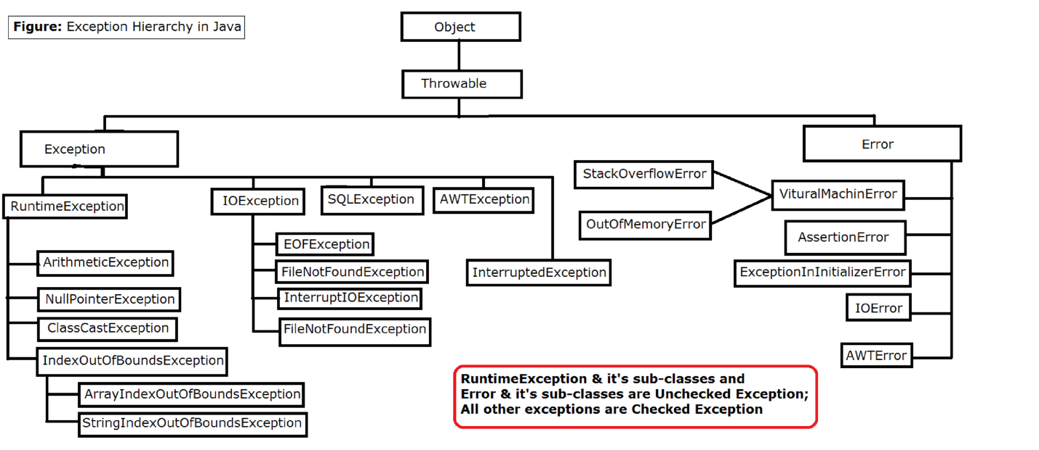

Keywords in Exception Handling
- try: try is block in which you can write a statement which may throw exception.
- catch: catch is block which is use to handle/catch the exception thrown from the try block.
- finally: finally is a block which is use to close the resources and it give you a guarantee of execution.
- throw: it is a keyword which is use to raise exception manually.
- throws: It is a keyword which use to propagate the exception outside methods.

try
- Try is a keyword this use to create a block which contains the statements which may throw exception
- Try block must be write with catch block, finally block or both.
- Syntax:
try
{
// Statement(s)
}

catch
- Catch is a keyword this is use to create a block which handles/catch the exception thrown from the try block.
- Inside catch block you have to specify the type of exception which is going to catch in it.
- In a catch block you can provide the alternative way to handle the exception.
- Can create more than one catch block for a single try.
- Syntax:
catch(ExceptionClass refVariable)
{
//statement(s)
}

finally
- Finally is a block which is use to close the resources in java.
- This block executes always irrespective of try and catch execution. It gives you a guarantee of execution.
- These can be only one finally block for a try.
- Syntax
finally
{
statement(s)
}
- There are scenarios where the finally block not executes
  - If JVM crash before execution of the finally.
  - If you exit from the program using System.exit(0)

Different between Checked and Unchecked Exception

Checked Exception | Unchecked Exception
The exception which is checked by compiler and raise an compile time error if you don’t handle it. | The exception which is ignore by the compiler ans not raise any compile time error of this.
Checked Exception has be handle at the time of coding. Otherwise program wont compile. | You can skip the handling of the unchecked exception at the coding time.
If any checked exception raised at execution time then program will never terminate abnormally | There can be a chances of program termination on the occurrence of unchecked exception at runtime.
Example: IOException, FileNotFoundException, SQLException | Example: ArithmeticException, IndexOutOfBoundException, InoutMistmatchException

Process for Exception
- Identification of Exception scenario.
- The Exception will be identify here and the Object of the exception will be created.
- Throw (Raise) the exception Object.

Throw Keyword
- Throw is use to throw exception manually.
- In this the Object of exception will be thrown from the statement.
- Using throw keyword you can throw one object of exception at a time

Custom Exception
- Custom Exception is created for the project specific requirement where you wanted to provide the manual implementation for exception.
- Steps to create custom exception
  - Create a java class and extends the class with any Exception class.
  - You can provide the custom implementation for the exception you created.
  - The custom exception has raise manually.

Throws
- Throws is use to propagate the exception at the caller level.
- Throws is use to forward exception outside method without handling it.
- Throws is use at a method declaration level (method signature).
- Throws is always followed with the exception class name.
- There can be multiple class Exception class provides in the throws declaration.

Difference Between
- Exception and Error
- Throw and Throws
- Checked and unchecked exception
- Final and finally

Multi-Threading
- Thread is a light weight process or it is a part of process.
- You can create multiple thread in an application
- Thread can run parallel.
- Thread are use to improve the performance of the application.
- It executes the task independently.
- Thread will create programmatically, but it can be executed by a JVM internally.
- You do not have a complete control on the execution of the thread, and hence you cannot predict the output of the thread.
- On the different OS or on the different JVM version can execute thread differently.
- By default every java program executes using a thread. The thread will be created by JVM which is also known as main thread.
- Every thread has it own memory which is also known as call by stack (Stack Memory). Every thread share the Heap memory.

Create thread in Java
- There are 2 ways to create thread
  - Thread Class.
  - Runnable Interface.
- Internally Thread class implements the Runnable interface.
- Steps to create thread in java
  - Create a java class
  - Implements/Extends Runnable Interface/Thread class
  - Override the run method and assign task to a thread.
  - Make thread ready to using start method.

Thread Class Methods
Method | Description
run() | It is use to provide the task/execution to a thread. This method will be called internally by JVM.
start() | This method is use to make thread ready to run. Here the thread will not start the execution on this method call it will just push into queue for the execution.
currentThread() | It is a static method, Which returns the Object of currently executed thread, you can get the following details by printing the thread object.  [Thread Name, Priority, Thread Group]
setName(String)  getName() | Methods to set and get the custom thread name.
setPriority(int)  getPriority() | To set or get the custom priority you can use this method. While setting the priority make sure that it has to be between 1 to 10.  1: MIN PRIORITY, 5:MID PRIORITY, 10:MAX PRIORITY
sleep(long)  sleep(long, int) | Sleep method is use to pause the execution of the thread for given time. This method is a static method which throws the check exception (InterruptedException).
join()  join(long)  join(long, int) | Join method is use to join the execution of one thread to another thread. It will pause the execution of current thread for any another thread until completing the execution or till the given time expires. This method throws the check exception (InterruptedException).
suspend() | The thread execution will be pause until someone calls a resume method. This is the deprecated method.
resume() | The suspended thread return back to runnable stage. This is the deprecated method.
stop() | To stop the execution of the thread manually.
wait()  wait(int milli)  wait(int millisec, long nanosec) | Using wait method you can pause the execution of current thread. The also release the lock acquire on the Object. It will go into pause state until the given time expire or some other thread calls the notify or NotifyAll method. This method throws the check exception (InterruptedException). This is present inside Object class. It has to use within synchronized block or method
notify()  notifyAll() | Notify method is use to notify single thread which in in waiting state and notify all will notify all the thread which are in waiting state. This is present inside Object class. It has to use within synchronized block or method
Thread Life Cycle
- Thread execution will be manage by JVM and it has been done using a different stages.
- These stages are called as Life cycle.
- There are 5 stages in thread life cycle.
  - New/Born Stage
  - Runnable Stage
  - Running Stage
  - Terminate/Dead stage
  - Wait/Sleep/Pause Stage

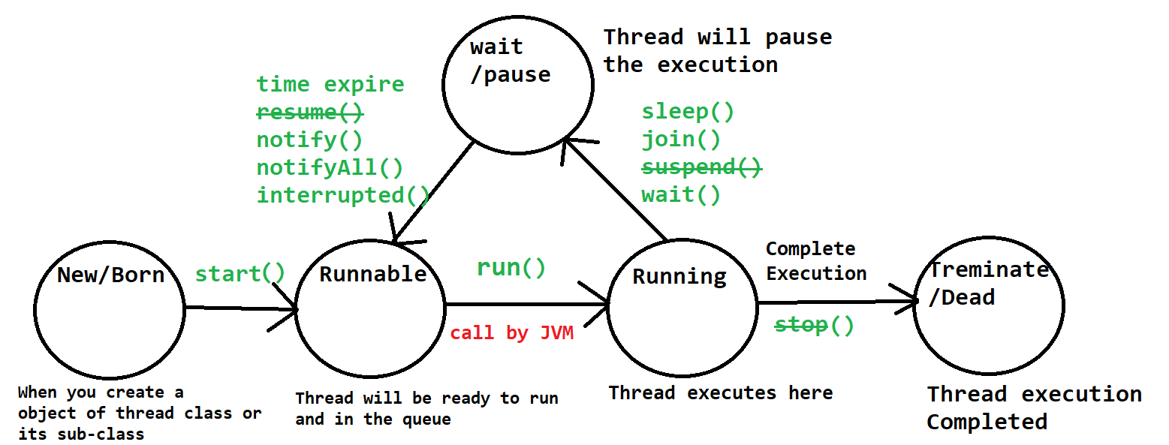

Interthread communication and Synchronization
- There can be a scenario where thread use a common resources (Heap memory).
- Due to this there can inconsistency issue raise due to this you may get an unexpected result.
- The Inconsistency issue can be resolve by acquiring lock on share resource when any thread is using it. Using this you can ensure that thread will use the share resource sequentially.
- This can be achieved by using synchronization (Synchronized) concept.
- Synchronization
  - It is a process in which you can lock the share resources is it is accessing by one thread, the lock will release automatically once the thread complete the execution.
  - Till the time one thread using the share resources the other threads has to wait for the execution.
  - The locking and unlocking the resources will be happen automatically in the synchronization.
  - It can be use in 2 ways
    - By making methods as synchronized
    - By using synchronized block

FAQ
- Different In Sleep, wait and Join
- Difference in notify and notifyAll

Collection Framework
- Collection is use to create a group of elements (Object).
- This grouping can be done for same or different type of objects.
- Collection provided multiple predefine class and interfaces using which you can collect the Object.
- Collection is based on the Data Structure (DS). This DS is implemented internally is a collection classes.
- You can create a group of elements based on the multiple criteria.
- All the classes and interfaces inside collection is present inside java.util package.
- There are 3 types of collection
  - List
  - Queue
  - Set

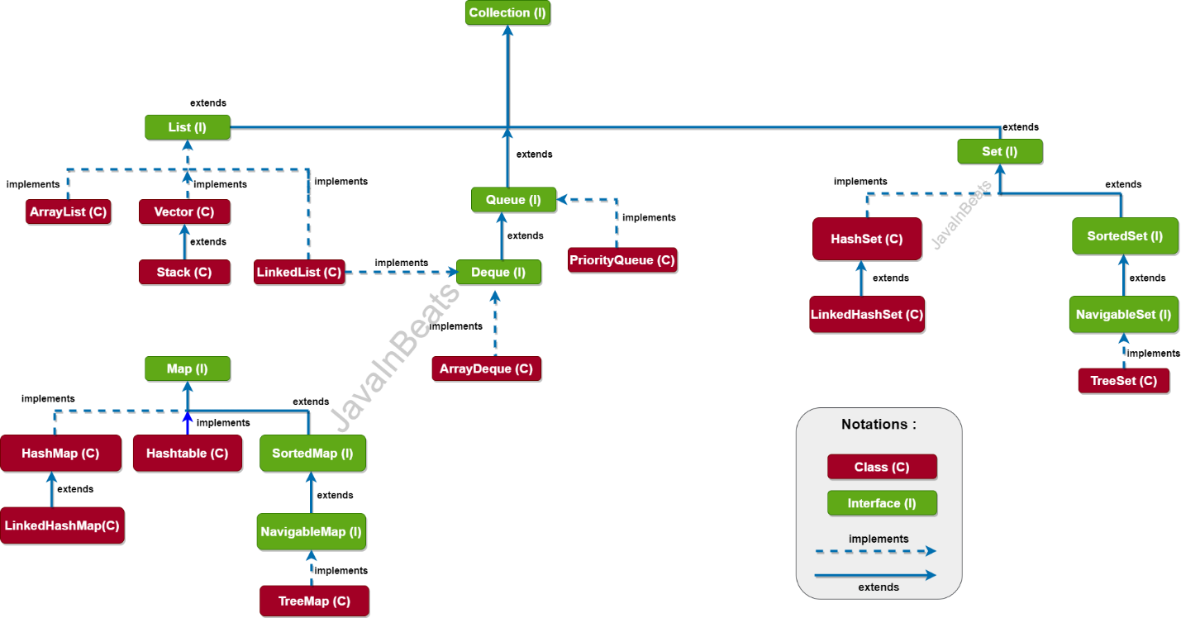

Important methods of collection interface
- add(Object): to add single object inside collection
- remove(object): to remove the single object from collection
- contains(object): To check if specific object is available inside the collection or not.
- size(): To get the total number of object present inside collection.
- clear(): to remove all the object from the collection.
- isEmpty(): is use to check whether collection is empty or not.
- addAll(collection): To add multiple objects at a time.
- removeAll(collection): Remove multiple values at a time from the collection.
- containsAll(collection): checks the group of values present inside collection or not.
- iterator(): to get the object from the collection one by one.

List Interface
- List is use to store the group of objects.
- You can store different type (Data Type) of object inside collection.
- List allows duplicate element (object).
- List is Dynamic In size.
- There are implemented classes of List interface
  - ArrayList
  - LinkedList
  - Vector

ArrayList
- ArrayList is an implementation of the List Interface.
- ArrayList is use to store different type of Object.
- The Object are dynamic in size.
- Duplicate Values are allowed inside array.
- ArrayList Is backed by array. It stores the object internally based on index.
- ArrayList maintains the insertion order. That is its order and not sorted.
- ArrayList allows random access because it implements RandomAccess Interface.
- ArrayList is slower in the performance while updating the data.
- ArrayList is faster in the Iteration.

Vector
- Vector is an implementation of the List Interface.
- Vector is use to store different type of Object.
- The Object are dynamic in size.
- Duplicate Values are allowed inside array.
- Vector Is backed by array. It stores the object internally based on index.
- Vector maintains the insertion order. That is its order and not sorted.
- Vector allows random access because it implements RandomAccess Interface.
- Vector is slower in the performance while updating the data.
- Vector is faster in the Iteration.
- Vector methods are synchronized.
- Vector is thread safe.
- It provides slower performance than ArrayList

LinkedList
- LinkedList is an implementation of the List, Queue and Deque Interface.
- LinkedList is use to store different type of Object.
- The Object are dynamic in size.
- Duplicate Values are allowed inside LinkedList.
- LinkedList in based on the Doubly Linked list.
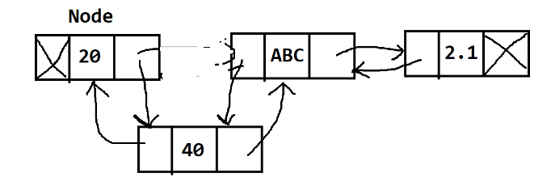
- LinkedList is not based on the index.
- LinkedList is faster for updation but slower in the iteration.
- LinkedList is order and not sorted. Insertion order will be maintain.
- LinkedList is based on FIFO (First In First Out) and also LIFO (Last In First Out)
- LinkedList not allows random access because it not implements RandomAccess Interface.

FAQ for List Interface
Different Between LinkedList and ArrayList?
Different Between Vector and ArrayList?

Set Interface
- Set is a type of collection which is used to store unique elements.
- You cannot store the duplicate values.
- You can store different type of values except TreeSet.
- It is dynamic in size.
- Set is not an indexed based.
- Implemented class of Set
  - HashSet
  - LinkedHashSet
  - TreeSet

HashSet
- HashSet is implements Set Interface.
- HashSet allows different type of values and it is dynamic in size.
- HashSet allows only unique values.
- HashSet is based on the hashing algorithm.
- It used for faster searching.
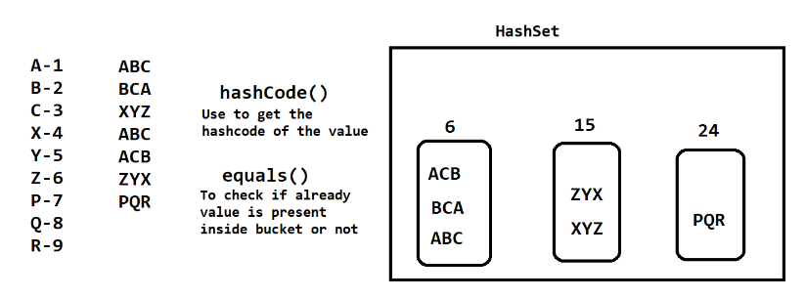
- Internally hashCode() and equals() methods are used to maintain the uniqueness of the value.
- HashSet is a unorder and unsorted.
- It not maintains the insertion order.

LinkedHashSet
- LinkedHashSet extends HashSet.
- LinkedHashSet allows different type of values and it is dynamic in size.
- LinkedHashSet allows only unique values.
- LinkedHashSet is based on the hashing and doubly linked list algorithm.
- It used for faster searching and faster updation.
- Internally hashCode() and equals() methods are used to maintain the uniqueness of the value.
- LinkedHashSet is a order and unsorted.
- It maintains the insertion order.

TreeSet
- TreeSet implements Set, SortedSet and NavigableSet interface.
- TreeSet is dynamic in size.
- TreeSet allows only similar type of values.
- TreeSet is based on Balance tree algorithm.
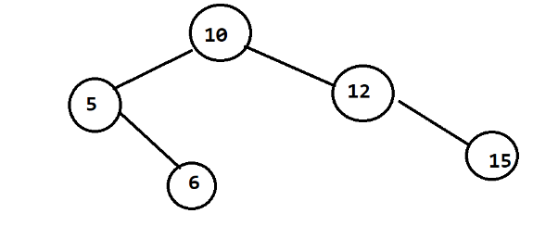
- TreeSet maintains the natural sorting.

