**SQL**

1. Database is use to store the data in the specific format.
2. These data will be store in a secondary memory so, it can be used at any point of time.
3. Data can be replicated.
4. Large amount data can be handle using Database.
5. To interact with Data you can use query language.
6. Different Database available
   1. **Relational Database**
      1. It is use to store the data in the structure format.
      2. That is the data will be store in the form of table (row and column).
      3. Data can be distributes into multiple tables.
      4. The multiple tables can be related with each other with foreign key and primary relation.
      5. Example: **MySql**, Oracle, Sql Server, Postgrace, H2, IBM, DB2 etc..
   2. Document Database
      1. The data store in the form of JSON document.
      2. Example: MongoDB, Cassendra etc.
   3. Graph Database
      1. In Graph database the data will be store in any form but it will be represented as a graph format.
      2. Example: Neo4J etc.

Database Download and installation

MySql:

<https://dev.mysql.com/downloads/installer/>

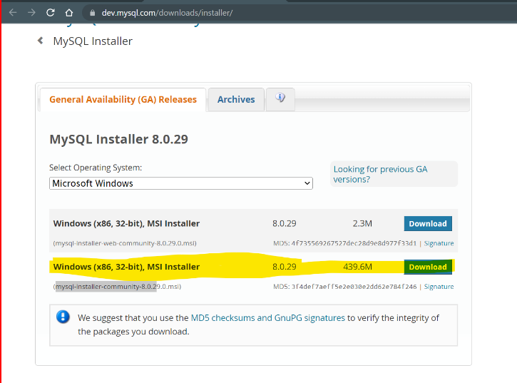

Install MySql:

<https://www.youtube.com/watch?v=OM4aZJW_Ojs>

**Important**

Note down the port number (3306), username (root) and password during the Setup.

**MySql Jar File**

<https://repo1.maven.org/maven2/com/mysql/mysql-connector-j/8.0.32/mysql-connector-j-8.0.32.jar>

**SQL Queries**

1. SQL is a query language which is use to interact with the database.
2. SQL is divided into multiple categories
   1. DDL
      1. DDL stands for Data Definition Language
      2. This is use to **create**, **alter** (modify), **drop** (remove) the database objects.
      3. Table, database, index, procedures etc. are called as database objects
   2. DML
      1. DML stands for Data Manipulation Language.
      2. Is use to work with the data from the table.
      3. **Insert, update, delete** the records/data form the table
   3. DCL
      1. DCL stands for Data Control Language
      2. To Add or remove the restrictions on the database operations.
      3. You can set the user specific access/restriction.
      4. **GRANT** and **REVOKE** are the operations.
   4. TCL
      1. TCL stands for Transaction Control Language.
      2. You can create group of query, which can be added inside a single transaction and that transaction can be implemented completely or reverted all the changes.
      3. This can be manage by **COMMIT, ROLLBACK and SAVEPOINT**
   5. DQL
      1. DQL stands for Data Query Language
      2. Is use to retrieve the data form the database.
      3. **SELECT** type of query is use here.

**Create and Use Database**

1. Create database

CREATE DATABASE <NAME>;

Example: CREATE DATABASE fsd22Nov;

1. Use Database

USE <Name>

Example: USE fsd22Nov;