Git and GitHub

Install Git on Local System
Download the Git from following URL
https://git-scm.com/downloads

Open an Account on GitHub
Create an free account on GitHub
https://github.com/

Version Controlling Tools (VCS – Version Control System)
- These are use to manage a version of the code.
- These tools are help to maintain the code changes, and the backup of the code will be manage.
- It is capable to integrate the code from multiple people in an automated way.
- It will maintain the version of the code. Using which you can switch from one version to another.
- It also maintains the complete history of the every version such as date and time, message, user, files to changed etc.
- VCS are of 2 types
  - Centralized VCS
    - There is a single server and multiple clients connect to a single server.
    - If the server gets corrupted due to any reason then all the code and metadata can be loss
  - Distributed VCS
    - There is a single server and multiple client which is also behaves like an server which connected to a single server.
    - In this case if the main server got corrupted then you can easily recover it from any of the client.

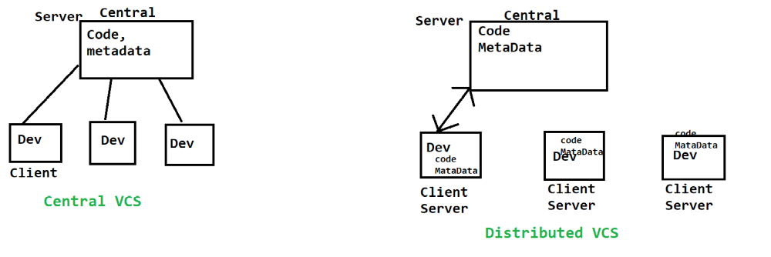

Git and GitHub Concepts

Git:
- Is an application which needs to be install on the local system.
- Using Git you can create and manage a local repository which is only accessible on a same system.
- Git can be connect to git hub to push the local changes into remote location.

GitHub:
- GitHub is a web application which is used by login in into it.
- Using GitHub you can create and manage the remote/cloud repository which can be accessible to multiple users.
- This is also consider as a central repository.

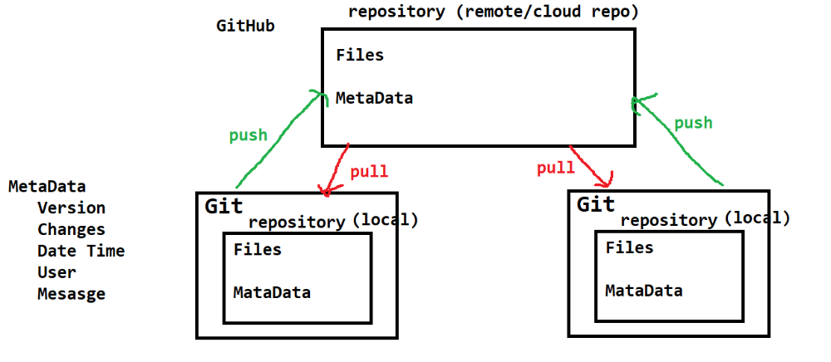

Git
- You have to download and install the Git on you local system.
- To work with git you can use either a GitBash (Linux Command Prompt) or GitUI Tool
- You can create a local repository to start maintain your files versions

Setup an Git Config

- To Get the list of Git configs
git config –-list
- To Set the user and the email into git config
git config --global user.name “<UserName>”
git config --global user.email “<EmailID>”

Creating Git Local Repository
- Create an Empty Folder.
- Right Click in Folder and open Git Bash
- Use a following command to create local empty repository.
git init
- On the creation of local repository you will get an .git folder which is by default hidden
- This folder is used by git internally to manage the metadata and all the further git operation.

You can start managing the files and their metadata into the local repository

There are different status will be maintain for the file by GIT
- Untrack file
  - These files are new files for the git and there is no previous version available for this file.
  - These files are created newly and you can add those file into git for tacking using command (git add)
- Track File
  - The files prior version is manage by git and there are any modifications happed on these files are called as a track file.
  - There are multiple track file status will be maintain by GIT
    - New File
    - Modified File
    - Rename File
    - Delete File

To Check the File status
Using following command you can check the status of the files.
git status

To Add Files changes into Git
The file changes has to add inside a git before getting a versions of the files
git add <Filename> : to add a single file
git add . : To add all the changes at a time.

To Commit the changes into Git
Using a commit command you can get a version of the changes you done in a session.
After commit you will get an version number which is alpha numeric value generated for every commit.
git commit -m “<Message>”

To Get the details about previous commits
Using the following command you can get the details of previous commits
git log

To switch between a commits or branches
Using following command you can switch between one commit to another or one branch to another.
Git checkout <commit_id>
Git checkout <branch_name>

Git branch
- Branch is the separate working copy of the original code, where one can make a modification without making any changes into original code. these changes can be manage, test independently and it can be merge into the original code copy.
- Get a list of all available branches
git branch
- Create a branch
git branch <branch_name>
- To Delete a branch
git branch -d <branch-name>

Type of branches
- Feature Branch: it is use to develop any new feature into a code.
- Defect Branch: It is use to perform the code changes for the defect.
- Release branch: It is use to release a new version of code.
- Hotfix branch: It is use to fix a priority defects
- Master/main: this is the default branch in git ang git hub. (git default branch master and github default branch is main)

Merge The Branch
- You can merge the changes of One branch into another.
- To do this you have to use following steps.
  - Switch to a branch where you wanted to merge the changes. (use git checkout command)
  - Use a git merge command to merge the changes
git merge <branch_name>

GitHub Repository:
Create a new repository on local and connect the same with cloud repo use following command
git init
git add README.md
git commit -m "first commit"
git branch -M main
git remote add origin <GitHub_URL>
git push -u origin main

push an existing local repository to the cloud repository the use following command
git remote add origin <GitHub_URL>
git branch -M main
git push -u origin main
git remote
- This command is use connect the local repository with cloud repository.

git push
- To Push the local repository changes into Remote/cloud repository.

git pull
- To pull the changes which is available on remote repo but not available on local repo.

Pull Request Process
- Create a new branch for you code changes into GitHub
- Pull the newly created branch on the local git (git pull)
- Checkout into the remote branch using following command
git checkout -b <local_branch> <remote branch name>
Example: git checkout -b feature/user-login-app origin/feature/user-login-app
- Make a changes into local branch, add those changes, commit those changes into local branch.
- To bring those changes on GitHub you needs to push it using git push command.
- The changes will be available on the separate branch of the github.
- To merge those changes into main branch you needs to raise the Pull Request(PR)

