Spring Boot
- SpringBoot Introduction
- Why and what is spring boot
- Diff in Spring Boot and Spring framework
- Create spring Boot Application
- Spring Boot configuration using .properties

- Spring Core
- Setter Injection (SI)
- Constructor Injection (CI)
- Dependency Injection (DI - Autowiring)
- Spring Annotations

- Spring Boot REST API
- Creating Spring Rest Controller
- Using GET, POST, PUT, DELETE REST APIs
- Consuming rest API using postman
- Spring Boot database connection using jdbc in service and repository layer
- Consume/Produce Data in JSON.
- REST API documentation using Swagger (Open API)

- Spring Boot ORM
- Introduction to JPA Hibernate
- Creating Entity class and Annotations
- Creating and using JPA repository
- CURD Operation using JPA Hibernate
- Entity Relationship (OneToOne, OneToMany, ManyToOne)
- Working with custom queries using HQL and Native Query

Spring Framework
- Spring IOC (Inverse Of Control)
- It is also known as framework of framework.
- Spring is based on the Java language.
- Spring Provide multiple modules to perform to handle different type of use cases
  - Spring Core
  - Spring JDBC
  - Spring ORM (JPA/Hibernate)
  - Spring MVC
  - Spring REST
  - Spring Batch
  - Spring Cloude
  - Spring Security
  - Spring JMS
- Spring framework Documentation Link
https://docs.spring.io/spring-framework/reference/index.html

Spring Framework vs Spring Boot
- Spring Framework
  - Dependency Management is difficult in case of multiple spring modules used in an application.
  - Configuration of the different module is difficult.
  - You need to setup all the required application for the spring framework project.
- Spring Boot
  - Spring boot make dependency management easy by using their starter project. This will help you to manage all the required dependencies using single starter project dependency.
  - Spring Boot Provides auto-configuration which help to provide module configuration internally. You can customized it later as per the requirement.
  - It provided embedded setup such as embedded tomcat and h2 database etc.

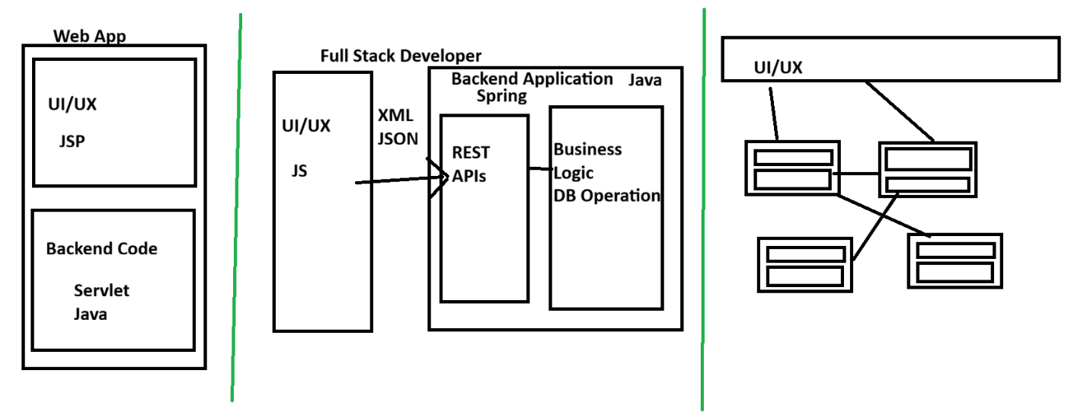
Creating Spring Boot Application.
There are multiple was to create Spring Boot application.
- Using STS (Spring Tool Suit)
- Spring CLI (Command Line Interface)
- Using Spring Initializer (web Application)
https://start.spring.io/

Spring Boot Properties
http://docs.spring.io/spring-boot/appendix/application-properties/index.html

Spring Core

- Spring Bean.
  - The Java Object which is created by Spring and managed by spring those java class object known as spring bean.
  - You can create a spring bean classes by using following annotation.
@Component
@Controller, @RestController
@Service
@Repository
  - By Default spring scan all the bean classes within a package and sub-package where main class is present.
  - It will not scan a bean class for the different package within a same project. To enable spring to scan the any other package within project you can use following annotation
@ComponentScan(basepackages = {“Package1”, “Package2”})
  - Another way to create a spring bean is by using @Bean annotation.
In this case you can create a object of the java class programmatically and handover the object which you created manually to the spring.

- Spring Container
  - Containers are use to store the objects.
  - Spring contains 2 types of container
    - ApplicationContext.
      - This container can be use for wen application.
      - This support all the spring features.
    - BeanFactory
      - This container can be use for a small application such as desktop application.
      - This container does now support all of the features of spring such as AOP, transaction etc.
  - These containers are use to manage the lifecycle of objects.
  - If there is more than one object of the same class available inside container. In that case you needs to specify the name of object while fetching it from the container.
  - You can get the name of the object by defining it explicitly using name attribute of the @Bean annotation or you can use the method name as a object name.
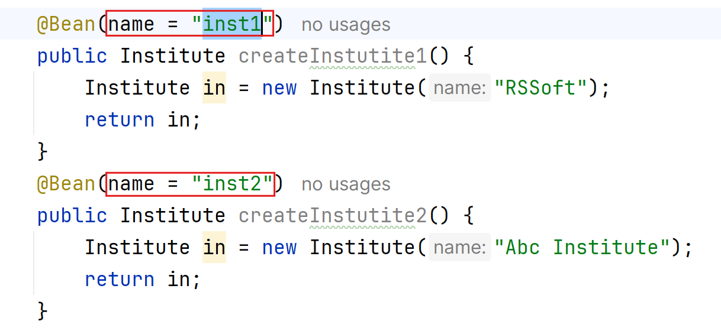
  - You can also make any one object as a primary object so that the primary object will be provided you until you explicitly specify.
