Web Application
Static Web Application
Content of the page is same for all user
Web developer
Tech stack: HTML, CSS, JS, Jquery (client side)
Dynamic Web Application
Content of the page is differ for every user
Java Developer
Tech Stack: HTML, CSS, JS, Jquery (client side)
Jsp and servlet (server side)

Tomcat Server Setup
- Download tomcat
https://tomcat.apache.org/download-90.cgi
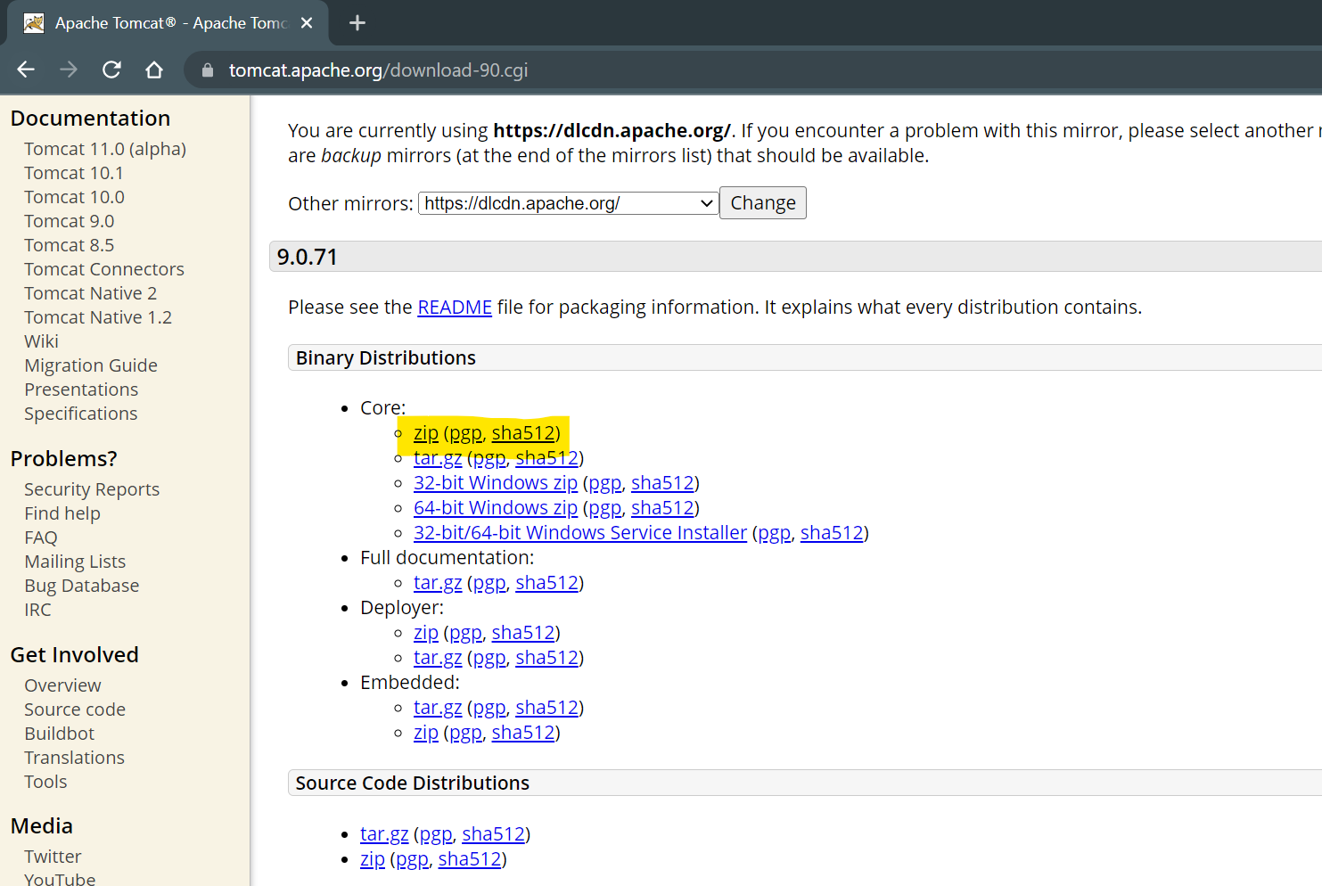
- Copy and paste the zip file into specific location.
- Extract the Zip File
- Server Setup in Eclipse
  - Set the “JavaEE” perspective
  - Select “Servers” tab from the bottom for the window
  - Click on the link to add new server.
  - Expand “Apache” option from the list in the new window.
  - Select a version which you downloaded
  - Click on “Next”
  - Browse and set the path of the location where you extracted the server zip file.
    - Path of the parent folder of bin,lib, config etc.
  - Click on Next and Finish

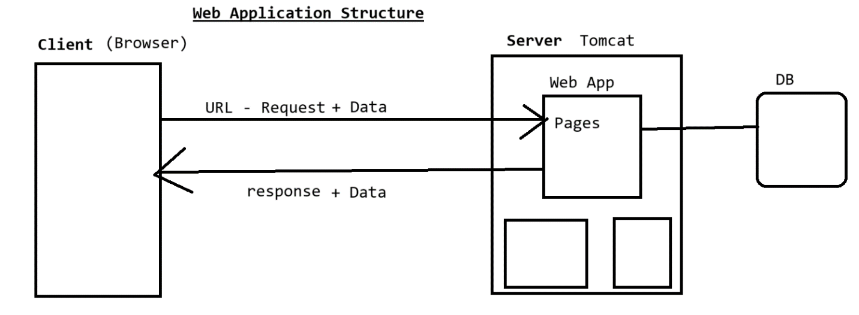

Steps to create Web application
- Go “File” Menu -> “New” -> select “Dynamic Web Project”
- Provide Name of the application and make sure that Target Runtime is selected and not <none>
- Click on “Next” -> click On “Next”
- Make sure that “generate Web.xml Deployment Descriptor” option is checked/selected

Request (URL)


Web Application Structure
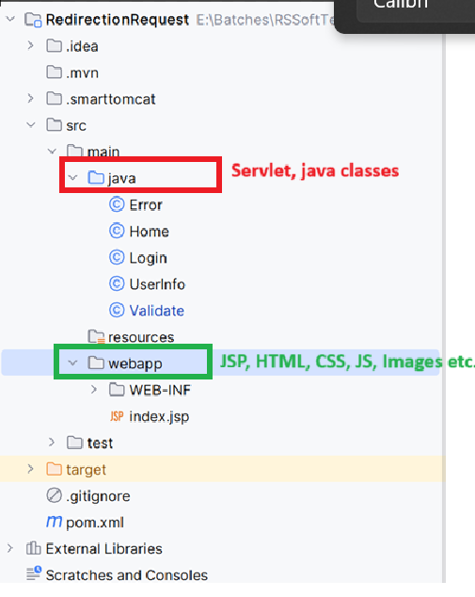

Servlet
- Servlet is a java class.
- In servlet main method is not used.
- Servlet will be execute by the server (Servlet Container).
- Servlet are execute and can be access by using URL.
- Servlet are use to create dynamic web pages.
- In the servlet you can use java code along with HTML (HTML in JAVA)
- Servlet has to create inside src/main/java
- Servlet are use to get request, process a request and generate the response

Ways To Create Servlet
- Create java class and use Java EE APIs to create servlet
- Implements Class with Servlet interface
- Extends class with GenericServlet abstract class
- Extends class with HttpServlet abstract class
- Override the service method to work with request and repones.
- Provide the URL for the servlet using @WebServlet annotation on class.
  - Use @WebServlet Annotation on class
  - Provide the URL of the servlet which must be starts with “/”
- Override the methods to perform operation
init(ServletConfig)
service(HttpServletRequest, HttpServletResponse)
destroy()

Maven Dependency for Servlet API
<dependency>
<groupId>jakarta.servlet</groupId>
<artifactId>jakarta.servlet-api</artifactId>
<version>5.0.0</version>
<scope>provided</scope>
</dependency>

Parameter
1. Parameter is a user data
2. It always include into URL after '?'
3. There can be multiple parameters in the URL which will be separated by '&'
4. Parameters has two parts one is key and another value.
5. Parameter Key will be the name of the HTML component and value is the user provided text.
6. Parameters are always in String.

Redirection Techniques
- It is use to transfer the request from one page to another without any user interaction.
- There are 2 ways to redirect user request
  - Request Dispatcher
    - It is use to transfer same/existing request from one page to another.
    - In this no new request will be created to redirect from one page to another.
    - Due to which the data from the original/existing request will be available on the next page.
    - Request Dispatcher is a class which has 2 function which can be use for redirection. (also known as server side redirection)
    - Syntax:
RequestDispatcher dis = req.getRequestDispatcher(“URL”);
dis.forward(req, resp);
dis.include(req, resp);
    - Forward function is use to transfer request to next page.
    - Include Function is use to include the content of next page into existing page.

  - Send Redirect
    - It is use to transfer new request from page to another.
    - In this case new request will be created to redirect on new page.
    - The data from the existing request will be deleted or not available in the new request due to which no data will be available on the next page.
    - It can be use to redirect at client side (also known as client side redirection)
    - This is a function which can be call using response object.
    - Syntax:
resp.sendRedirect(“URL”);

JSP Tags
to write a java code on JSP

1. Scriplet Tag
This tag is use to write a java code on JSP page.
The java code written inside this tag will become a local code.
This java code will become a part of _jspService method
Using this tag can create only local variable, and instance/static variable cannot be created using scriptlet tag.
Syntax:
<%
Local Java Code
%>

2. Expression Tag
This tag is use to display java values on UI.
The Code written inside this tag will be added inside service method and inside out.print(____)
This is also a local code.
Syntax:
<%=
Java Expression
%>

3. Declaration Tag
This tag is use to write a java code which becomes an Class Level code
The java code written inside this tag will be a part of java class and will be added outside service method.
Using this can create static/instance variables
Syntax:
<%!
Java Code
%>

JSP Implicit Object
- The Object which are created and make available automatically within every JSP page.
- There are 9 implicit objects available on every JSP page.
- All the object are available within service methods.
- These objects are accessible from expression and scriptlet tag only. These objects cannot be access within declaration tag.

Object | Class/Interface
request | HttpServletRequest
response | HttpServletResponse
out | JspWriter
session | HttpSession
application | ServletContext
pageContext | PageContext
config | ServletConfig
exception | Throwable
page | Same as this keyword.

Session Tracking techniques
- It is a way to retain the old request user data into new request.
- Using this techniques you can pass the old request data into next request.
- There are different session tracking techniques.
  - Hidden Form field
    - This is use to retain the old request data into new request which is generated through a form submission (Form and Submit button).
    - This can be achieve by holding the old request data into hidden fields in the form tag.
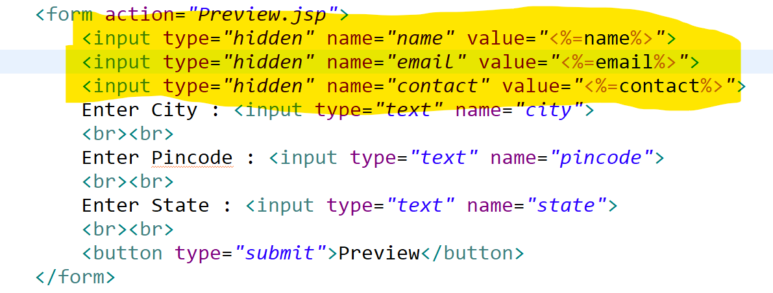
  - URL rewriting
    - This is use to retain the old request data into new request which is generated through the anchor tag or send redirect.
    - Using this you can add the parameters manually inside URL.
    - Example:
      - Anchor Tag
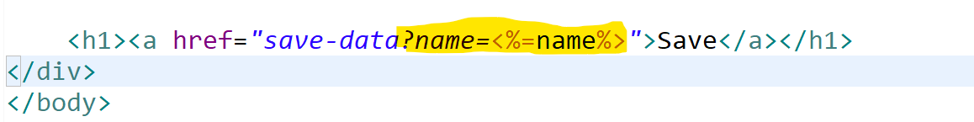
      - Send Redirect
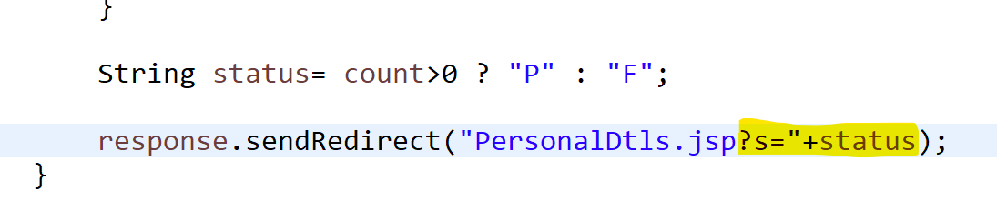
  - Cookies
    - This is use to maintain the user data at client side.
    - Disadvantage
      - Can store only String type of user data using cookies.
      - There is limit to store user data using cookies which is of 40 cookies.
      - Cookies can be decline or disable by Client.
  - HttpSession
    - This is use to maintain the user data at server side
    - Create/get Session
HttpSession session = request.getSession();
Above syntax to get the new session or if session is already exist then it will return the same/existing session
    - Set Value inside session
session.setAttribute(“Key”, value);
In the session you can set the value using above syntax, in this Key will always be in string format and value will be in object format
    - Get the value form session
session.getAttribute(“Key): Object
From the session you can get the value using above syntax, you have to provide key and it will return you the value in object
    - Destroy Session
session.invalidate()
It deleted the session from the server side.

