Web Application
- The applications which can be access through network and browser are knowns as web application.
- These web applications are also known as client and server application.
- In this application client communicate with the server and server respond to the client.
- Web application has 2 types
  - Static Web Application
    - These are the application where content of the page remains same for all the users. And those are the informative application.
    - Tech Stack: HTML, CSS, JS etc.
  - Dynamic Web Application
    - The Content of the page will be change for every user.
    - Tech Stack: HTML, CSS, JS, JSP, Servlet etc.

Type Of Application
- Web Application
- Mobile application
- Desktop Application
- Console Based Application
- Embedded Application

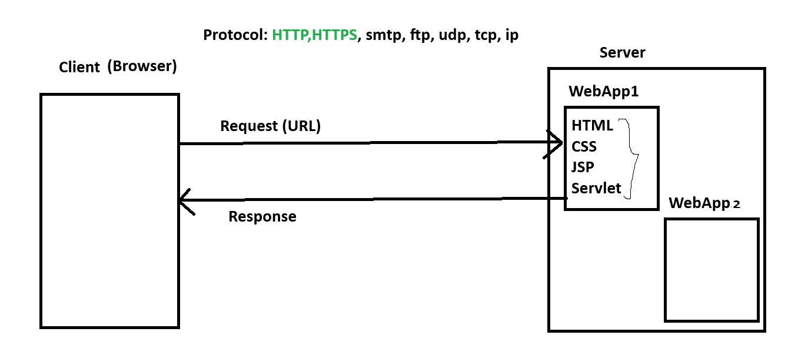

Local Setup
- Download Server.
  - Download Apache Tomcat server from following URL
https://dlcdn.apache.org/tomcat/tomcat-10/v10.1.50/bin/apache-tomcat-10.1.50.zip
  - Extract the ZIP file into a specific location
- Configure tomcat into Intellji
  - Install a plugin ‘Smart Tomcat’
go to ‘setting’ -> ‘Plugin’ -> ‘Marketplace’ tab -> Search for ‘Smart Tomcat’
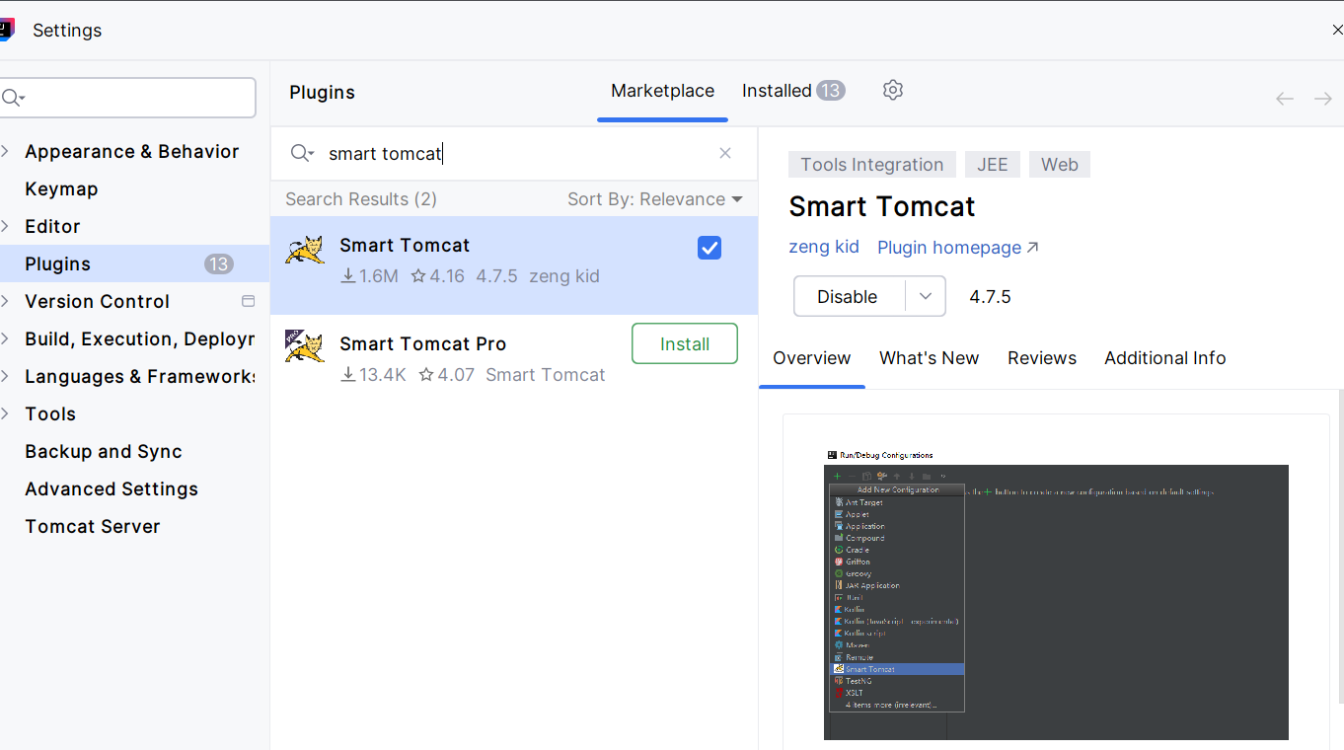

Create a Web Application using Maven build Tool
- File -> New -> Project -> Maven Project
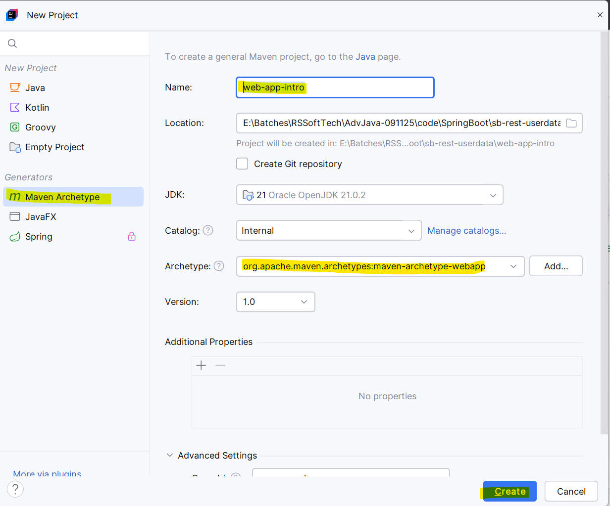

Run Web application using Tomcat Server
- Click on the ‘Current File’ from right top of the Inteillj. Select “Edit Configuration” Option
- Click On “Add New” link from the new window. Select “Smart Tomcat” Option.
- Provide an Application name.
- Click On “Configure” button to add tomcat server.
- Click on ‘+’ button on new window then navigate to a path where you extracted the tomcat server and select a parent folder which has bin,conf folders.
- Click On App and Run the application.
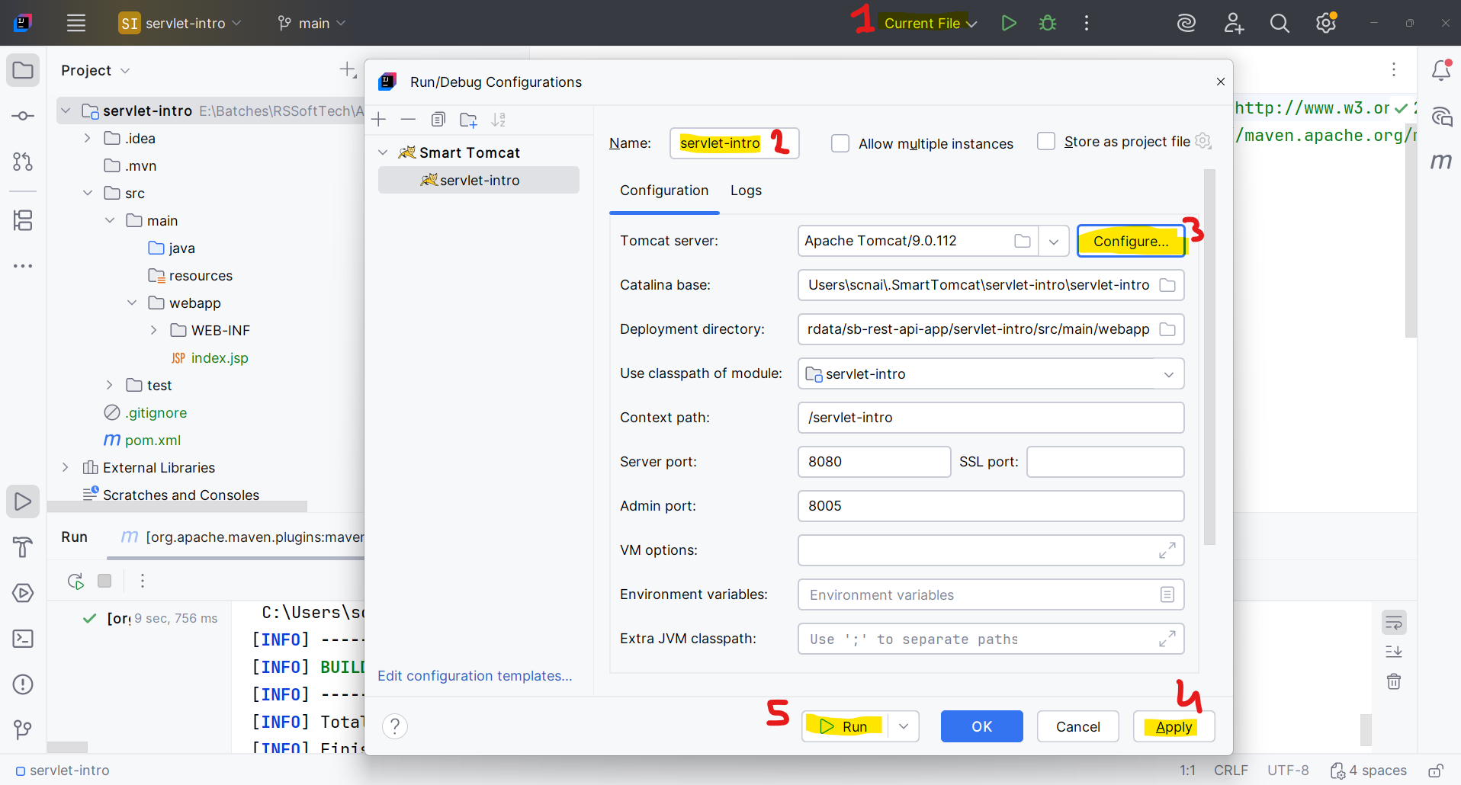

Servlet
- Servlet is a java class
- In these java classes main methos will not be used.
- Servlet java classes will be run at the server side using servlet container.
- Servlets are access using a URL.
- Servlet is use to create a dynamic web page.
- Servlet accept a request, process a request (user data) and generate a response
- Servlets gets created inside src/main/java

Add a Dependency inside pom.xml file
<dependency>
<groupId>jakarta.servlet</groupId>
<artifactId>jakarta.servlet-api</artifactId>
<version>5.0.0</version>
<scope>provided</scope>
</dependency>

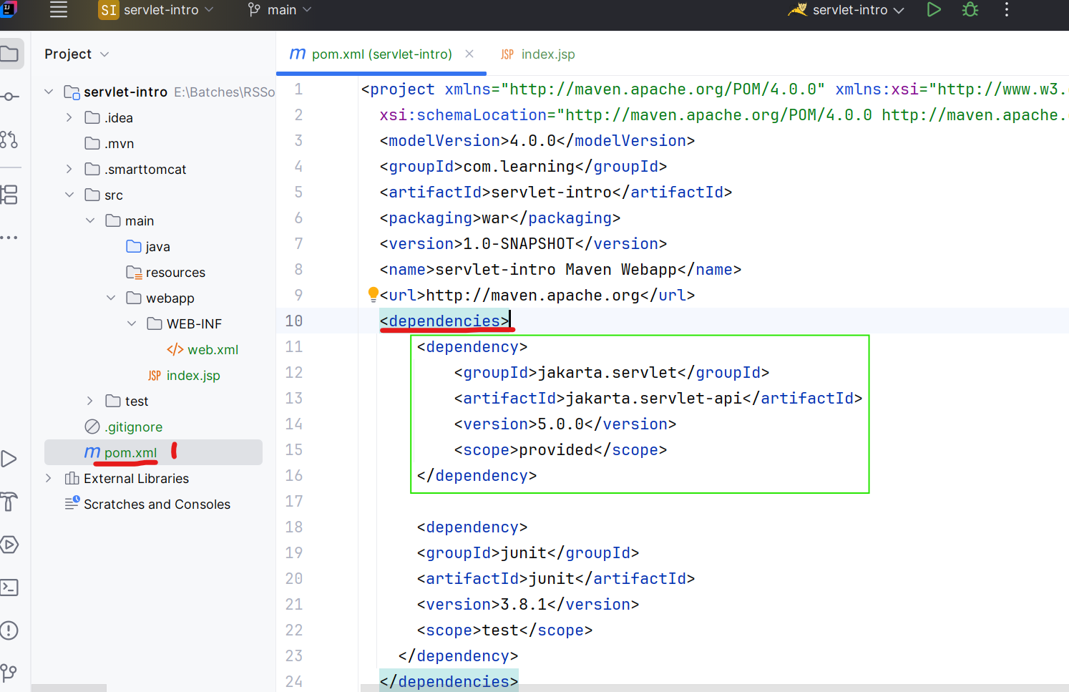

Cleans and Build the application (mvn clean install)
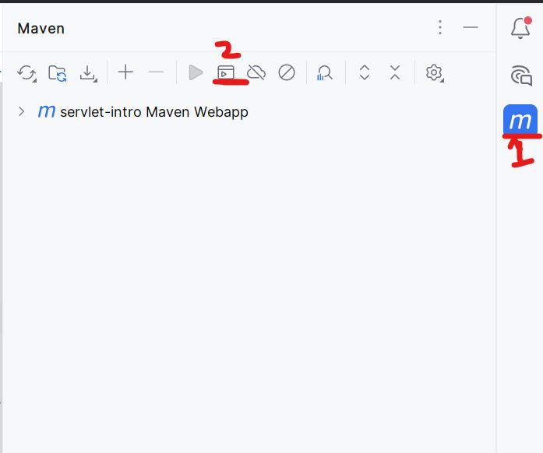

How to Create Servlet
- Create a Java class (which must not contains main method).
- To mark java class as a servlet you can use any one option form the following
  - Implements Servlet Interface
  - Extends GenericServlet Abstract class
  - Extends HttpServlet Abstract class
- Override a service method from the Abstract Class. Here you will add all the logic related to request and response
- Provide a URL for a servlet using @WebServlet annotation at the class level.
  - URL must be start with ‘/’
  - Do not add spaces in side URL
  - Use small cases to define url

Parameter:

- Parameters are always pass from the URL (Request).
- Parameters added in the URL after ‘?’
- Parameters are the user details which pass at the server side.
- Parameters are always in string type.
- Parameters has 2 parts Key and value
Key is the name of the html component
Value is the details filled by the client
- There can be more than one parameters present in the URL and those are separated by ‘&’

Ways To generate a new Request
- After Click on Submit button and form gets submitted (form-submit button)
- After Click on the anchor tag (hyperlink)
- Using sendRedirect for servlet concept.
- By Refresh button

Attribute
- Attributes are the ways to pass a user data from one page to another.
- Attribute can be of object type.
- Every Attribute has 2 parts Key and value. Where key is in String type and Value will be of Object type.
- Can set and get the attribute manually using following methods
setAttribute(“KEY”, Object);
getAttribute(“KEY”) : Object

Redirection techniques
- Using Redirection techniques, you can redirect user from one page to another without any user action or user intervention.
- There are 2 redirection techniques
  - Request Dispatcher
    - This technique is use to send the original/same request from one page to another i.e. it will not create a new request to go from one page to another and use the existing request.
    - As no new request will be created here the data from the original request will be available to the next page.
    - This is also known as server-side redirection. Can redirect within server.
    - Syntax:
RequestDispatcher des = requestObj.getRequestDispatcher(“<URL>”);
des.forward(requestObj, responseObj);
des.include(requestObj, responseObj);
  - Send Redirect
    - This technique is use to send a new request from one page to another.
    - The data from the original request will not be available on the next page as new request got generated
    - This is also known as client-side redirection. Can redirect across the server.
    - Syntax:
responseObj.sendRedirect(“<URL>”);

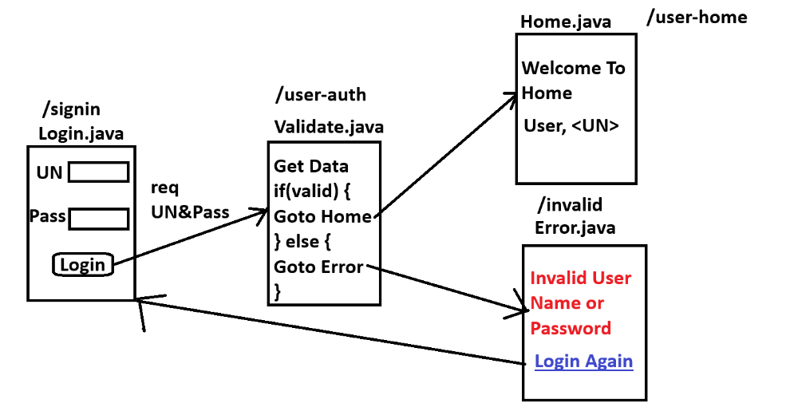

JSP (Java Server Page)
- JSP is use to create a dynamic web pages.
- JSP is extended version of servlet.
- Using JSP you can design the application pages easily because On JSP you can use the HTML, CSS, JS code directly without any java code. That is JSP is a JAVA IN HTML.
- In JSP page you can also write a java code to make it dynamic using scripting tags/elements.
- File extension of the JSP page is .jsp.
- Every JSP page has a URL which is by default its /pageName.jsp
- Every JSP page gets converted into Servlet internally before execution.
- JSP pages has to create inside src/main/webapp folder of the application

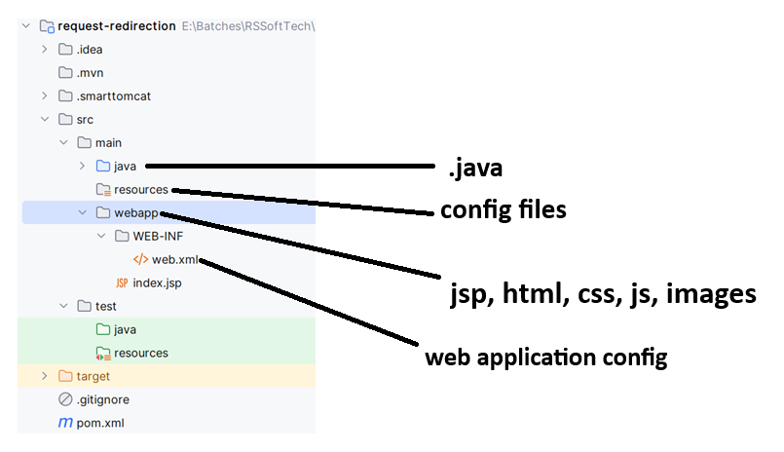

Servlet lifecycle
- Servlet Life cycle will be manage by Servlet Container.
- There are 3 stages of servlet life cycle
  - Init
    - In this stage the servlet initialization can be done.
    - Here you can initialize the properties, resources while servlet creation.
    - As part of this stage internally init(ServletConfig) method gets called and it will call while creating an object of servlet after constructor.
    - There is only one object of the servlet gets created so that init method gets calls only once in a life cycle.
  - Service
    - In this stage the request and response processing will be done.
    - Here you can get the user request, process the request and generate the response.
    - As part of this stage internally service(req, resp) methos gets called.
    - Service method gets called multiple time (for each request) in a life cycle.
  - Destroy
    - In this stage you can perform the cleanup activity.
    - Here you can release the resources or perform the cleanup activities.
    - As a part of this stage destroy() methos will be called and it get called when object of the servlet gets deleted.
    - As there is only one object of servlet so delete methos gets called only in a life cycle.

JSP LifeCycle
- JSP life cycle will also manage by Servlet Container.
- There are 5 stage in the JSP life cycle
  - Translation stage
    - The JSP Page (.jsp file) get converted into Servlet (.java file) by servlet container.
  - Compilation Stage
    - Here .java file (converted servlet) gets converted into .class file.
  - Init
    - Is used to perform the initialization activities.
    - Internally _jspInit() will be used.
    - It gets executed only once in a lifecycle.
  - Service
    - Is use to perform the request and response processing.
    - Internally _jspServle() will be used.
    - It gets executed multiple time in a lifecycle.
  - Destroy
    - Is use to perform the cleanup activities.
    - Internally _jspDestroy() function gets called.
    - It gets executed only once.

Jsp Scripting elements/Tag
- Using this tags you can write a java code on JSP Page.
- You cannot perform nesting between scripting element.
- There are 3 tags
- Scriptlet Tag
  - To write a local java code which gets added within service method.
  - Syntax:
<%
Java Code
%>
- Expression Tag
  - To Display a java expression result as an output on browser.
  - This code is also added within service methos and inside out.print(<expression>)
  - Syntax:
<%=
java expression
%>

- Declaration tag
  - To write a java code which is outside any methos and inside java class (Instance and static code)
  - Syntax:
<%!
Java Code
%>

Implicit Object
- The object which are readily created on every jsp page.
- There is total 9 implicit object.
- These Object are available within Service(_jspService()) method and hence these object can be access on the JSP page only within scriptlet and expression tag.
Object | Class/Interface Name
request | HttpServeltRequest
response | HttpServletResponse
session | HttpSession
page | Same class object which is same as ‘this’ keyword in java
application | ServletContext
out | JspWriter
pageContext | PageContext
exception | Throwable
config | ServletConfig

Session Tracking techniques
- Maintaining a user details into multiple requests.
- Usually, whenever new request gets generated, the old request will be deleted and hence the data from the old request will also be deleted.
- Following are the session tracking techniques
  - Hidden Form Field
    - When new request gets generated using Form tag and submit button.
    - In this case the data will be added within a form in the hidden format and it will pass from the request automatically once form is submitted.
  - URL rewriting
    - When new request gets generated using anchor tag or send redirect techniques.
    - In this case you can add a parameters inside URL manually by rewriting the URL.

  - Cookie
    - User data will save at the user/client side which is in the browser and it will be sent to server with every request.
    - Cookie will hold a key and value where both must string. Value must be string and without spaces.
    - There can be maximum 40-41 cookies store at client.
    - There are Persisted and non- Persisted cookie. Where Persisted cookie has expiry date and non-persisted cookie will be deleted once browser session ends.
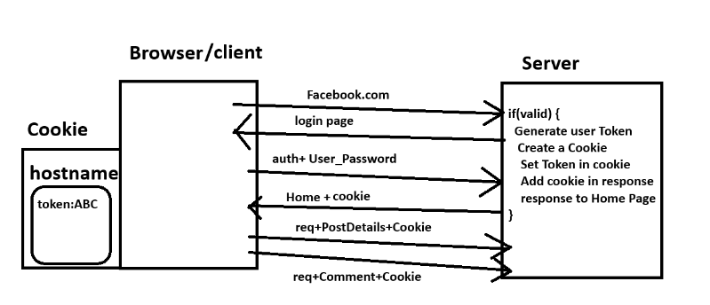

  - HttpSession
    - User data will be save at the server side and can be access anytime within session at the server.
    - Mainly this technique is use in the login functionalities.
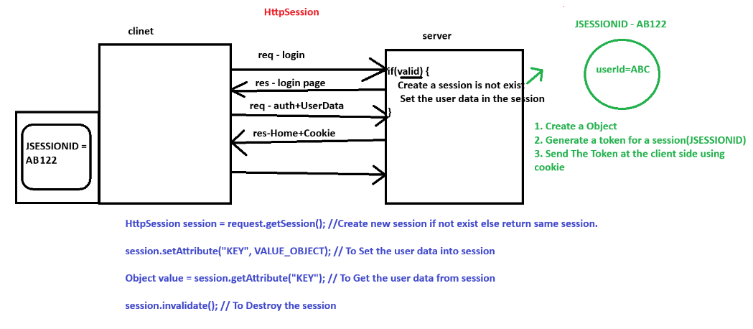

Example-1
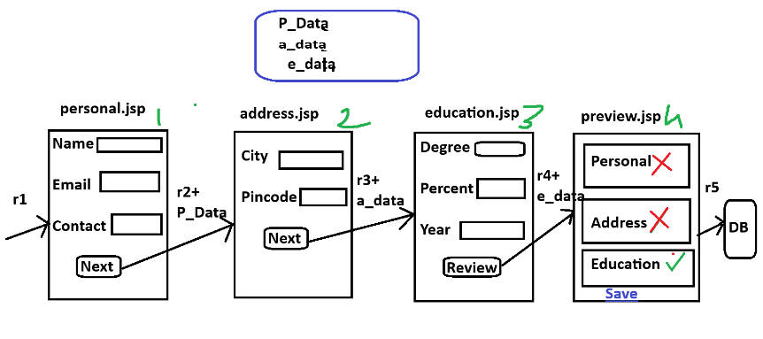

Example-2
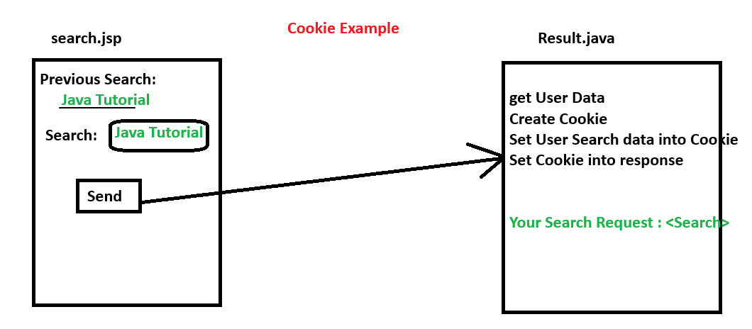

Example-3
