JDBC (Java DataBase Connectivity)

- JDBC provide multiple APIs to interact with the database.
- APIs means predefine class, interfaces, functionalities.
- Examples of APIs
  - Connection interface
  - DriverManager
  - Statement
- In case of DB operation, it throws a SQL checked Exception.
- All of the JDBC APIs are available in java.sql package

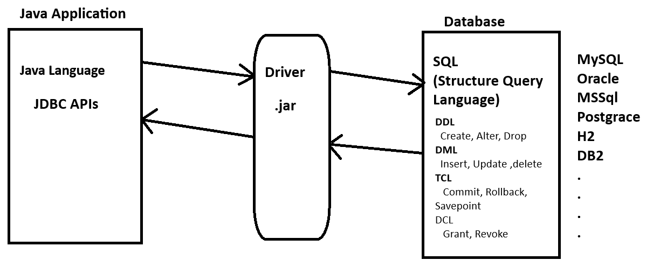

Steps to interact With Database
- Register Driver
  - Register a Database specific Driver/class
  - This Driver class will be available within database jar file.
  - Internally Driver Object will be created and load inside memory
  - Syntax:
Class.forName(“DRIVER_CLASS”);
- Create DB Connection
  - Here, you connect java application with the database.
  - As a part of this step will get an Object Connection.
  - To connect with database following details needs to provide
    - Database URL
      - It consists of protocol, DB Host, port, resource
    - Database User Name
    - Database Password
  - Syntax:
Connection conObj = DriverManager.getConnection(URL, USERNAME, PASSWORD);
- Create Statement
  - In this step you can hold the sql queries.
  - This sql queries will be executed in the next step.
  - For every sql query you have to define a separate Statement.
  - There are 3 types of statements
    - Statement
      - Using Statement you can execute a DDL and DML queries.
      - Statement is simple to implemented but it has multiple issues as follows
      - It slower in the execution than other options.
      - It is not secure and sql injection can be happen in this case.
      - It does not provide parameterize query feature.
      - Syntax:
Statement stmt = conObj.createStatement();
    - PreparedStatement
      - Using PreparedStatement you can execute DDL and DML queries.
      - This option is secure and no sql injection possible here.
      - It is faster than Statement option
      - You can write a parameterized query.
      - Syntax:
PreparedStatement stmt = conObj.prepareStatement(“QUERY”);
    - CallableStatement
      - Using CallableStatement you can execute the procedures.
      - This is fastest option from the other 2 type of statement.
      - Syntax:
CallableStatement stmt = conObj.prepareCall(“{call name(param)}”);
- Execute Statement
  - You can execute the query and get the result back into java application.
  - In this step you have a methods to get query executed and to get result into java program.
  - In this step there are 3 options(method)
    - executeUpdate()
      - Is use to execute DML, DDL type of queries except Select query.
      - This method returns the int value which is the count of records affected after query execution.
      - Syntax:
int count = stmtObj.executeUpdate();
    - executeQuery()
      - is use to execute the Select type of query (DQL).
      - This method return the object of ResultSet. In which you can find all the data selected by query.
      - Syntax:
ResultSet rs = stmtObj.executeQuery();
    - execute()
      - Is use to execute all type of queries.
      - This method returns the Boolean value as a result. If it return true so you can access a ResultSet from it and if returns false then you can get the int value as a response.
      - Syntax:
boolean flag = stmtObj.execute();

- Close Connection
  - Is use to release the memory acquire by DB connection.
  - As a part of this step you just have to call close method.

Extracting Data From Result Set handling
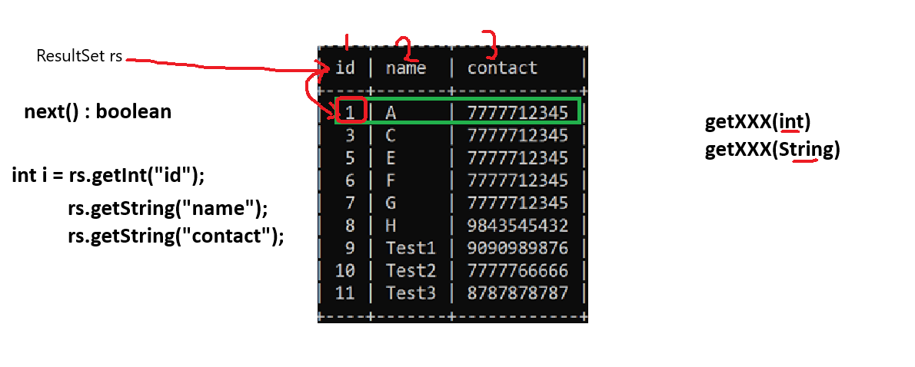

Task – 30-12-2025
Create a Database Connection Code

Task – 02-Jan-26
Create a following table by executing create table query from java application
Table: employee
Columns: id pk, name, email, city, contact
Perform insert, update, delete DB operations using queries from java application.

Task – 03-jan-26
- Get the Employee info from the use at application run time using scanner and insert the user provided details into table (using Parameterized query)
- Get the employee id and contact number from the user and update the employee contact. (using Parameterized query)
- Get the City from the user and print all the employee details from that city;

Task – 4-jan-26
- WAP to execute following DB Operations
  - WAP to create a table product with column as id(int), name(string), price(double), quantity(int).
  - WAP to accept the product details from the user and insert into table.
  - WAP to accept the id and quantity of the product from user and update the details in the product table.
  - WAP to accept the id of the product from user and delete the product of that id from table.

- Create a table with name “Cart” and has column Id, name, price, quantity
Create a Menu Driven Program
  - To Add into Cart
Get the product details for user and insert into table
  - To Remove from cart
Get the Product Id from the user and delete the product from the table
  - To Update Cart
Get the product id and the quantity from the user and update the product quantity
  - To View Bill
Get all the records from that cart and display on console also display the Payable amount
Hints
- To Create menu driven program use Switch case (get the choice from the user using scanner)
- Check the use choice into switch case and call the appropriate method

