Spring Boot
- Spring is a java based framework.
- Spring Boot is use to develop application faster and reduce the development efforts.
- Using Spring Boot you can create production ready application.
- Spring Boot provides the embedded tomcat server, DB(H2) server, embedded kafka internally.
- Spring Boot is flexible framework and highly configurable. Where you can customize according to your requirement.
- Spring Boot majorly used for Full stack or microservice application.
- Spring Framework divided into multiple modules. These modules used in the project as per the requirements.
  - Spring IOC/Core
  - Spring JDBC
  - Spring ORM/JPA
  - Spring MVC
  - Spring REST
  - Spring Batch
  - Spring JMS
  - Spring Security
  - Spring Cloud
- How to use spring module
  - Add Dependency of the respective module.
  - Add a module specific configuration.
  - Use Module APIs to develop the functionality.
Spring Boot Docs: https://spring.io/projects/spring-boot

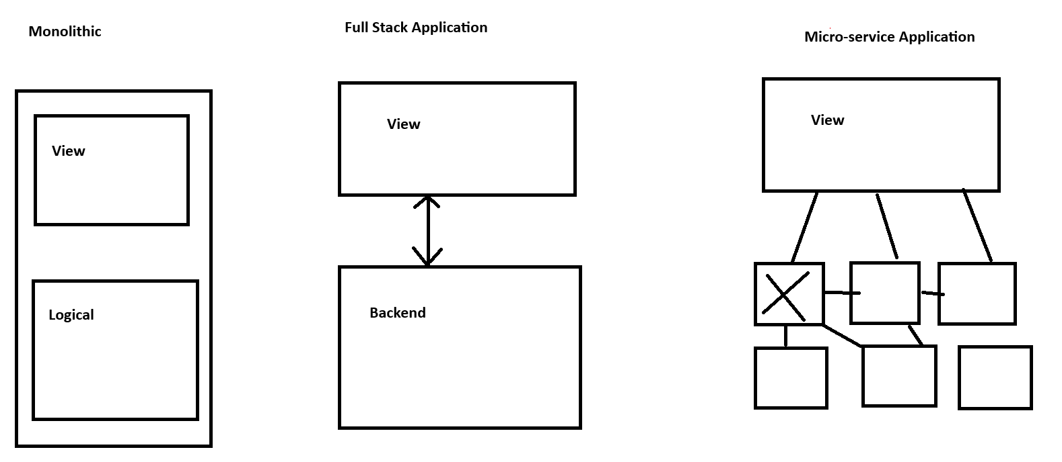

Spring Boot Application Creation
- Using Spring Tool Suit (STS)
https://spring.io/tools#vscode
- Spring CLI
https://docs.spring.io/spring-boot/installing.html#getting-started.installing.cli
- Using Spring Initializer (Web Application)
https://start.spring.io/
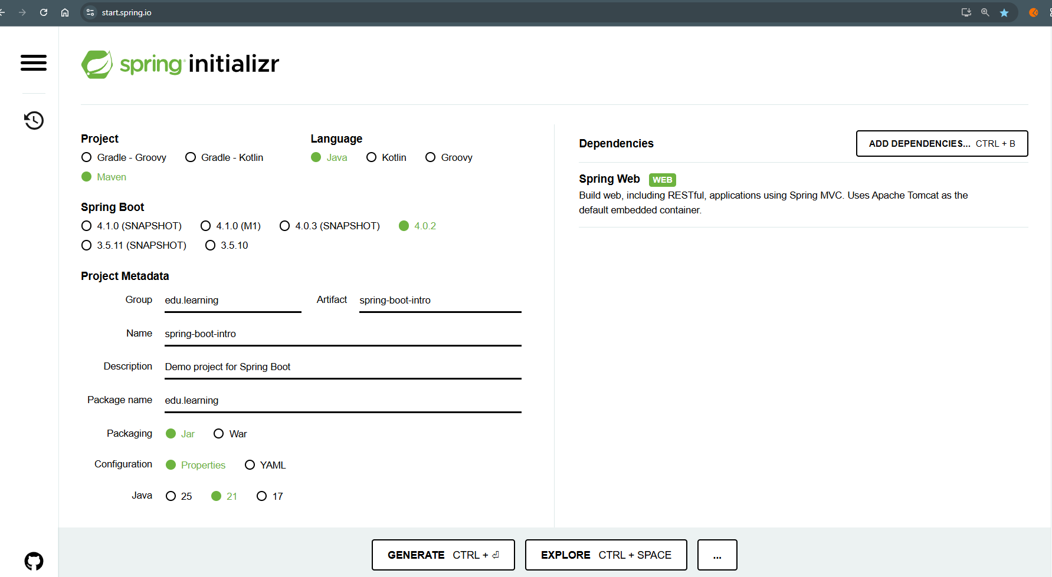

@SpringBootApplication
- This annotation is use to define at the start point of your application.
- This annotation is a combination of 3 annotations internally
- @Configuration
  - To declare a configuration class.
  - These classes will be loaded in the spring container at the initial stages.
- @EnableAutoConfiguration
  - This is use to enable the auto configuration feature of the spring boot.
  - In this case if you do not provide a configuration for the module explicitly then spring provides the default configuration of the module.
- @ComponentScan
  - Is use to scan and load all the spring bean classes in the application.

Spring IOC/Core
- Spring Bean Classes
- Spring Container
- Setter Injection (SI), Constructor Injection (CI) and Dependency Injection (DI)
- Annotations such as @Component, @Bean, @Autowire, @Qualifier etc.
- Autowire

Spring Bean
The java classes whose object will be created and manage by Spring Container.
These classes can be a custom class or predefine spring classes.
To declare a spring bean classes you can use any one annotation form the following
@Component, @Controller, @RestController, @Configuration, @ControllerAdvice, @Service, @Repository etc.

Spring Bean Scope
Using scope of the bean you can define when and how many object of the bean class will be created.
You can specify the scope of the bean class using @Scope annotation
- Singleton
This is the default scope. Here, Spring creates an object of bean class at the application start up and there will one object of bean per container. This scope will be used for a core applications.
- Prototype
In this scope multiple objects of the bean class will be created and objects gets created whenever user request to the container. This scope will be used for a core applications.
- Request
In this scope the new object of the bean class will be created for every Http Request. this scope is used for a web application.
- Session
In this case new object will be created for per HttpSession. this scope is used for a web application.
- GlobalSession
In this case one object will be created in an application. this scope is used for a web application.

Dependency Injection
- It is a process of injecting object of one class into another class.
- Spring can inject the spring bean class object into any of another spring bean class using @Autowire annotation.
- @Qualifier annotation is use to specify the object to be injected. This annotation has to be use with the @Autowire annotation and cannot be use alone.

Spring REST
REST is a Representation State Transport
REST API are use to establish the communication between multiple application which are build on a different language.

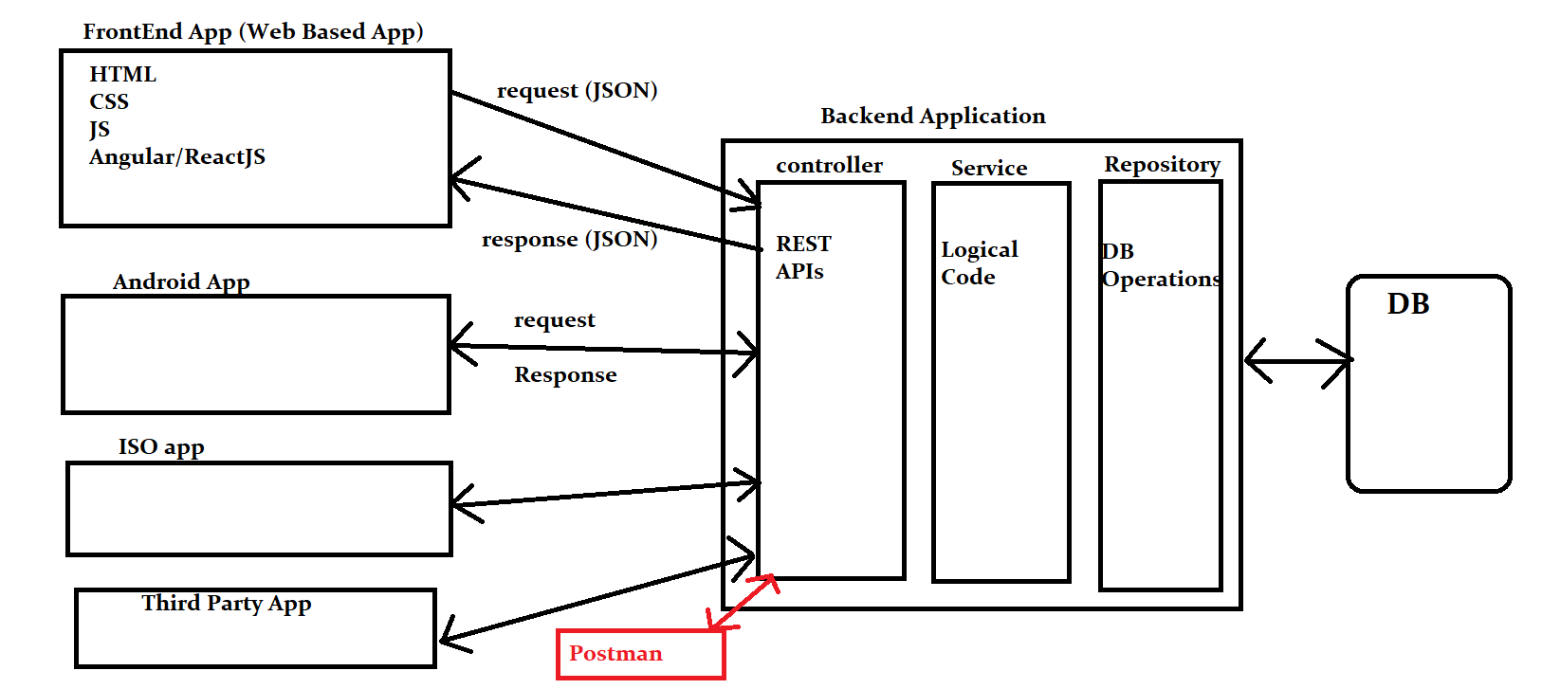

JSON
- JSON stands for JavaScript Object Notation
- JSON is use for data transmission between multiple application based on different/same languages.
- JSON represent the data in the KEY and VALUE format.
- KEY must be of String data type.
- Values can be of String, Number, Boolean, Array, JSON Object
- Every KEY and VALUE pair will be called as JSON element.
- JSON will be represented as JSON Object ‘{}’ or JSON Array ‘[]’
- JSON Object contains the JSON elements (Key value pairs)
{
“name”: ”ABC”,
“age”: 22,
“salary”: 43343.23,
“isActive”: true,
“contacts”: [ 99887788, 99889989, 8979879 ]
}
- JSON Array contains the values.
[ “Abc”,”Xyz”,”LMN” ] String JSON Array
[ 99887788, 99889989, 8979879 ] Numeric JSON Array

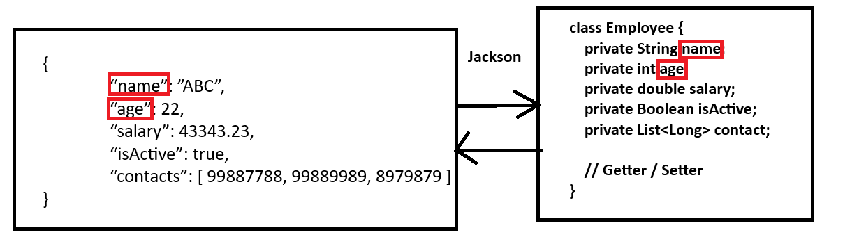

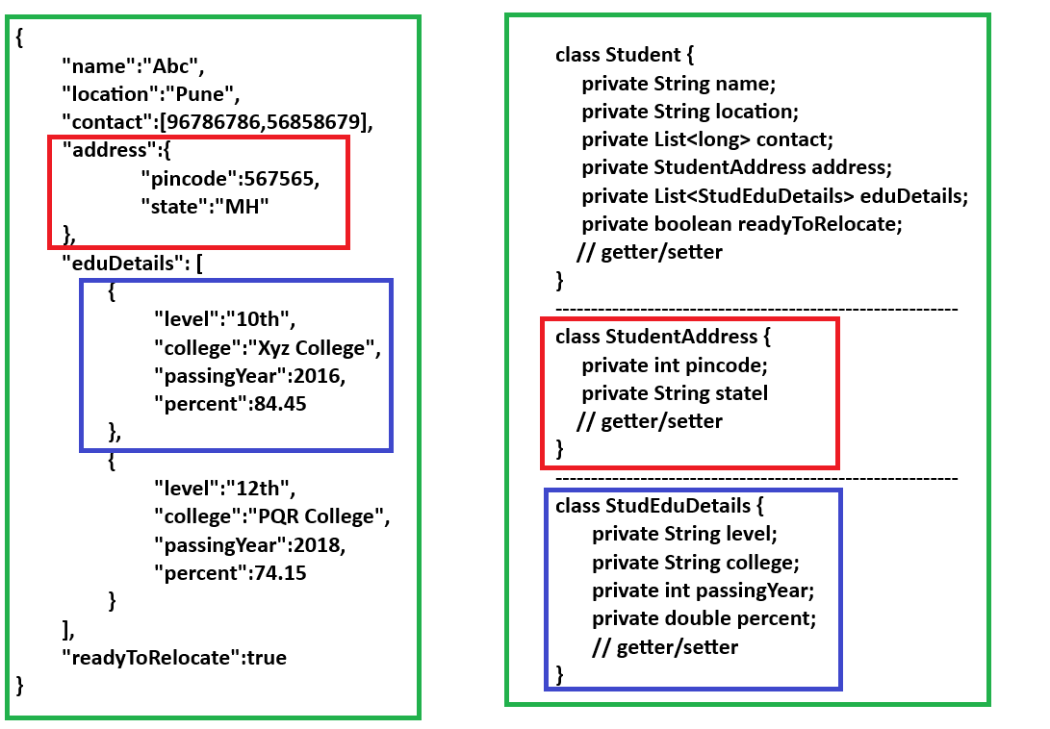

User Data Inside REST API
- Using Request Parameter
  - It is use to get the data using request parameter which is added in the URL after ‘?’
  - To receive the data from the request parameter, in the spring boot application you need to create an input variable and annotate them using @RequestParam annotation.
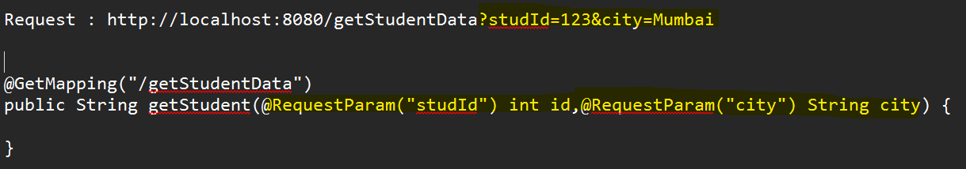

- Using Path Variable
  - It is use to get the user data which is a part of URL itself.
  - The user data will be added dynamically inside the URL.
  - To receive the data from the request parameter, in the spring boot application you need to create an input variable and annotate them using @PathVariable annotation.
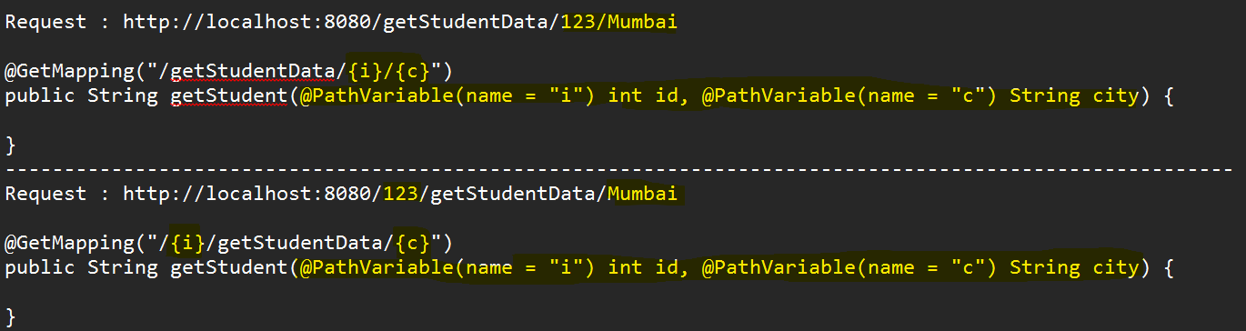

- Using Request Body/JSON
  - It is use to get the user details from the request Body in JSON form.
  - To receive a data in the spring boot application, you needs to create a java class which private fields and getter setter.
  - Create a reference of the java class as method input parameter in the controller and annotate it with @RequestBody

HTTP methods for REST API
- GET
  - GET methos is recommended to get/retrieve the records from the backend application.
  - To support the GET HTTP method you need to use @GetMapping annotation in spring boot.
  - GET method is an Idempotent method. If you execute the same request multiple times you will get an exactly same response.
- POST
  - POST method is use to create a new record at the backend application.
  - To support the POST methos you need to use @PostMapping annotation.
  - POST method is a non-Idempotent method. If you execute the same request multiple times you will get a different response (it will create a new entry always).
- PUT
  - PUT methos is recommended to update(all data) the records with all values from the backend application.
  - To support the PUT HTTP method you need to use @PutMapping annotation in spring boot.
  - PUT method is an Idempotent method. If you execute the same request multiple times you will get an exactly same response.
- DELETE
  - DELETE methos is recommended to delete the records from the backend application.
  - To support the DELETE HTTP method, you need to use @DeleteMapping annotation in spring boot.
  - DELETE method is an Idempotent method. If you execute the same request multiple times you will get an exactly same response.
- PATCH
  - PATCH methos is recommended to partial data updation from the backend application.
  - To support the PATCH HTTP method, you need to use @PatchMapping annotation in spring boot.
  - PATCH method is an Idempotent method. If you execute the same request multiple times you will get an exactly same response.

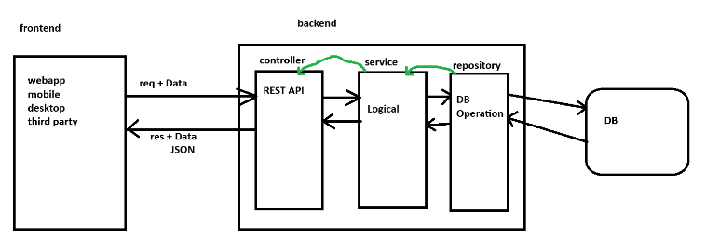

Spring Java Persistent API (JPA)
- JPA is a standard which is provided by JAVA to interact with database.
- Multiple Framework based on the JPA standards such as Hibernate, Eclipse link etc.
- Hibernate is known as a ORM tool. ORM tool is an Object Relational Mapping.
- ORM tools is a way using which you can interact with the database table through a java Object. Which makes your application database agnostic.
- Hibernate Manages the database connection internally.
- It converts the checked SQL exception into unchecked exception.
- Hibernate Generated and execute the DDL, DML, DQL queries internally.
- Hibernate will map the Database result with the java Object and it also supports collection mapping.
- Hibernate also supports the Caching. Primary cache provided by default by hibernate and you can also enable secondary cache using hibernate.
- Spring JPA internally use Hibernate as a JPA implementation.
- Every Entity class must have a primary Key.

Spring JPA Project Creation

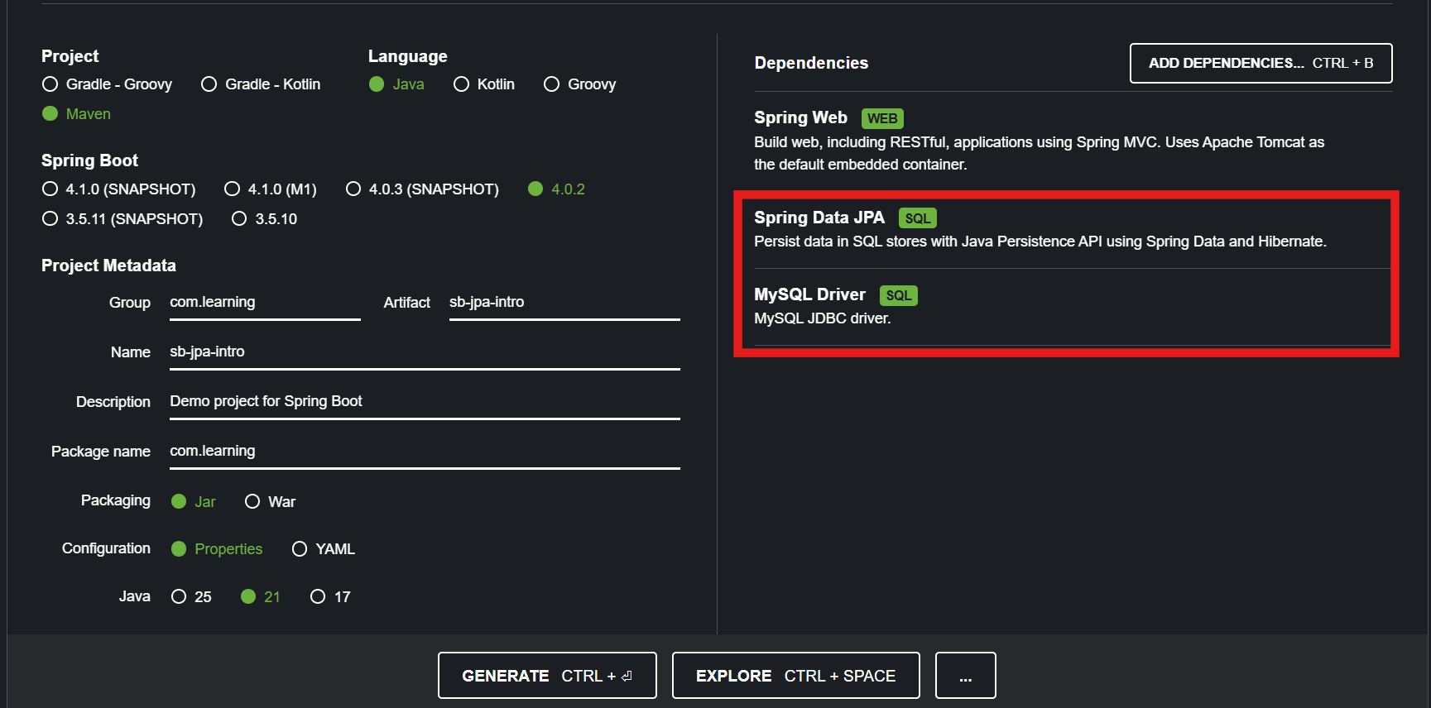

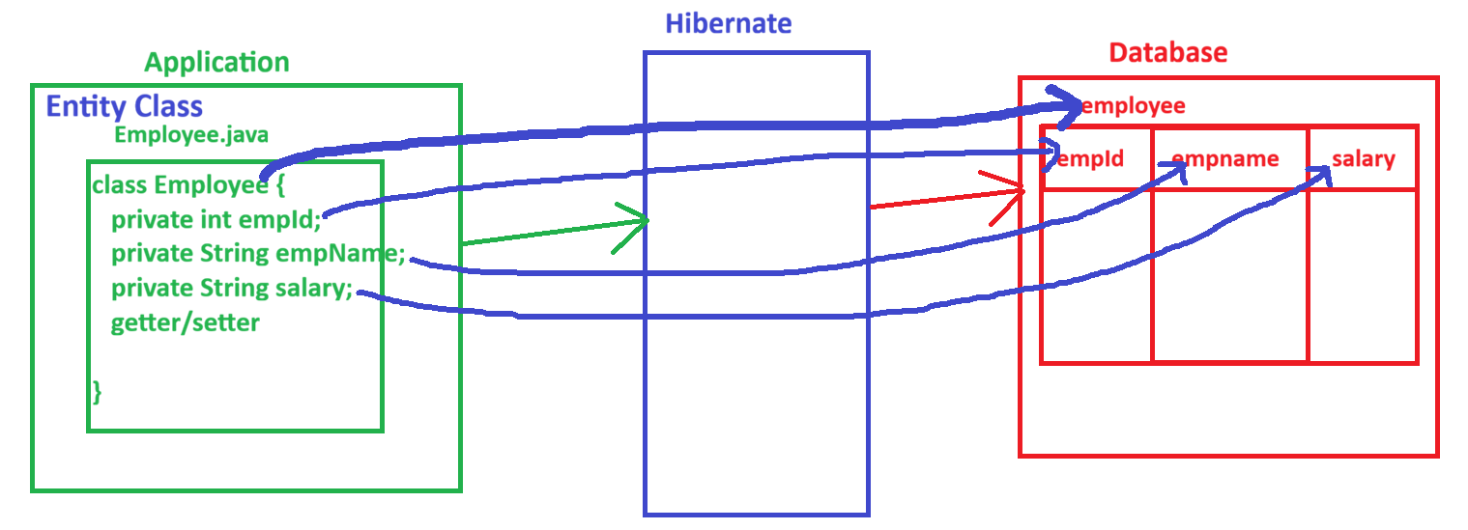

Perform Database Operations
- You can perform the database operations using 3 ways
- To get the JPA options you need to create a Repository.
  - Using a predefine APIs (functions)
    - Here Spring provides multiple function to get the query and execute it.
    - The methos such as save, findAll, FindById, deleteById, deleteAll
    - This option you can use to perform all the basic DB operations and the operations based on Primary key column.
  - By Creating Custom methods with a define set of rules
    - This option will be used whenever you want to execute a select query.
    - In this you can create method, where method must be following a define rules.
    - Rules Reference URL
https://docs.spring.io/spring-data/jpa/reference/jpa/query-methods.html#jpa.query-methods.query-creation
  - By Providing Queries manually
    - Here you can provide your own queries by 2 ways
      - HQL/JPQL- Hibernate Query Language/ Java Persistent Query Language
Here you will use an Entity class name and Variable name in the query instead of table name and column name.
Every HQL gets converted into SQL internally before execution.
      - SQL – Structure Query language
This is the sql query which usually used in the Database. Herre table name and column name will be use.
This is also known as a native query.
    - To execute a query manually you can use a @Query Annotation on the method inside repository.
    - For a DML type of query (insert, update, delete) along with @Query annotation you have to use @Modifying and @Transactional annotation.

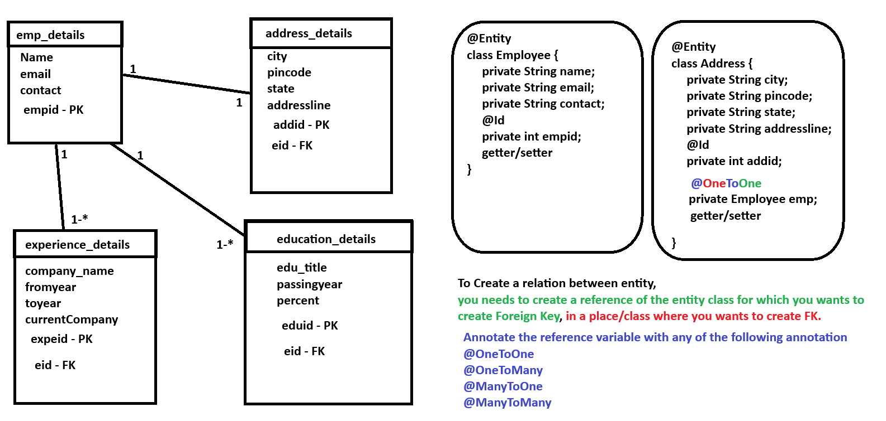

- Spring IOC/Core
  - Core concepts of a spring
- Spring JDBC
  - This is the traditional way of DB communication where Spring provided some support for Connection handling but the query execution and result extraction has to do manually.
- Spring ORM/JPA
  - This is based on the JPA Framework where spring use Hibernate as a implementation.
- Spring MVC
  - In this case you can create an application which has View, Controller and Model implementation within a java project. For View mostly JSP, thymeleaf, Vadeen technologies can be use
- Spring REST
  - This module will be use to develop a REST based application. And These REST APIs will be consume by any other application.
- Spring Batch
  - Spring Batch is use to process a record in batch where record volume us large.
- Spring JMS (Java Messing System)
  - In Spring JMS using a Messaging Queue the data can be send to other application in this case consumer and producer are used.
- Spring Security
  - Authorization and Authentication support provided by this module.
- Spring Cloud
  - This module supports the feature for microservice development.

