EXPT NO: 3 | IMPLEMENTATION OF CONVOLUTIONAL NEURAL NETWORKS (CNNs) FOR IMAGE CLASSIFICATION
DATE:

PRE-LAB QUESTIONS (PROVIDE BRIEF ANSWERS TO THE FOLLOWING QUESTIONS)
- What is a Convolutional Neural Network (CNN)?
A CNN is a deep learning model designed mainly for images. It automatically learns features such as edges, shapes, textures, and objects through convolutional layers.
- What are the functions of convolution and pooling layers in a CNN?
Convolution layers extract important image features using filters, while pooling layers reduce feature-map size, computational complexity, and overfitting while retaining important information.
- Differentiate between image classification and object detection.
Image classification identifies the main category or label of an image, whereas object detection identifies multiple objects and locates each object using bounding boxes.
- Why is image preprocessing important before training a CNN model?
Image preprocessing improves image quality and consistency by resizing, normalizing, and removing unwanted variations. This helps CNNs train faster, learn better features, and achieve improved accuracy.
- What are the advantages of using benchmark datasets such as CIFAR-10 or Kaggle image datasets.
Benchmark datasets provide standardized, labeled data for training and evaluation. They enable fair comparison between models, measure performance reliably, support experimentation, and help researchers reproduce results.

AIM
To design, implement, and evaluate a Convolutional Neural Network (CNN) for image classification using a benchmark image dataset.

SOFTWARE REQUIREMENTS
- Python
- TensorFlow/Keras or PyTorch
- Google Colab
- Matplotlib
- Kaggle Dataset (e.g., CIFAR-10, Cats vs Dogs, Intel Image Classification)

OBJECTIVES
Students will be able to:
- Understand the architecture of Convolutional Neural Networks.
- Implement a CNN model for image classification.
- Train and evaluate a CNN using a real-world image dataset.
- Visualize training and validation performance.
- Analyze the effectiveness of CNNs for image recognition tasks.

PROCEDURE
PART A: DATASET PREPARATION
- Perform the following tasks:
- Download an image dataset from Kaggle or use CIFAR-10.
- Load the dataset.
- Preprocess images by resizing and normalization.
- Split the dataset into training, validation, and testing sets.

PART B: CNN MODEL IMPLEMENTATION
Build a CNN model consisting of:
- Convolution layers
- ReLU activation
- Max Pooling layers
- Fully Connected layers
- Softmax output layer

Compile the model using:
- Appropriate optimizer
- Cross-entropy loss function

PART C: MODEL TRAINING AND EVALUATION
Train the CNN model.
Record:
- Training accuracy
- Validation accuracy
- Training loss
- Validation loss
- Testing accuracy
Plot:
- Accuracy vs Epoch
- Loss vs Epoch

PART D: PERFORMANCE ANALYSIS
Analyze:
- Classification accuracy
- Confusion Matrix
- Sample predictions
- Misclassified images
Discuss the strengths and limitations of CNNs for image classification.

(CODE: CONATAINS STUDENT ROLL NOS
SCREENSHOT OF CODE
SCREENSHOT OF OUTPUT)

GitHub: - https://github.com/snjy-r13/DEEP-LEARNING-24BAD407/tree/main/EX-3
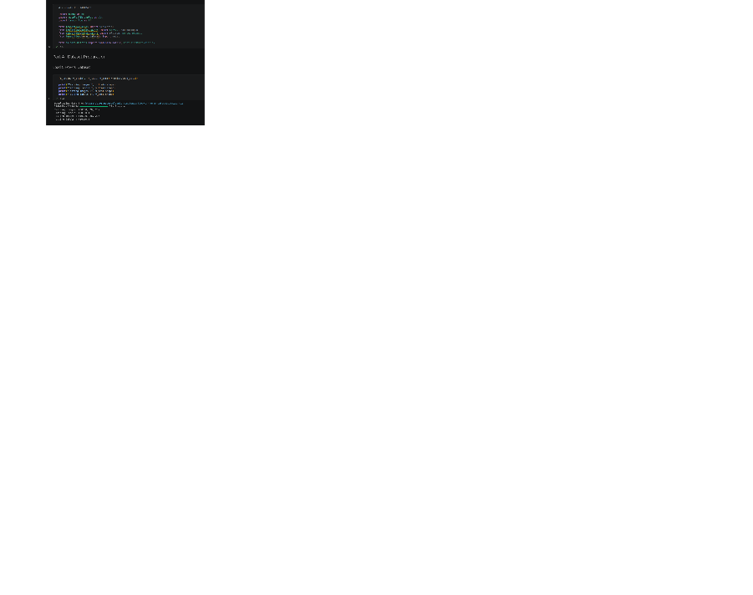
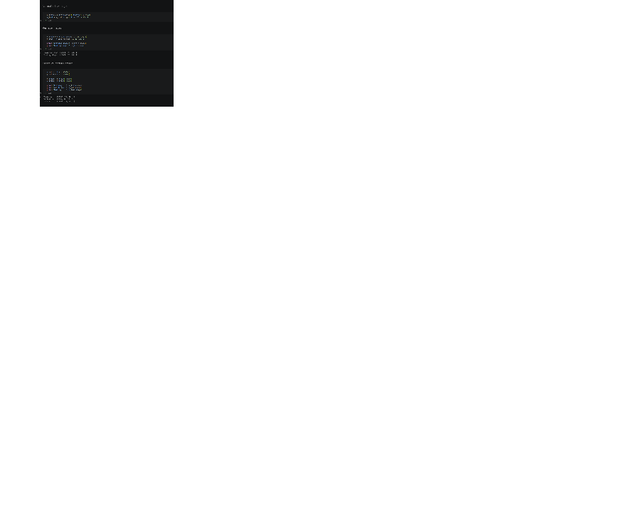
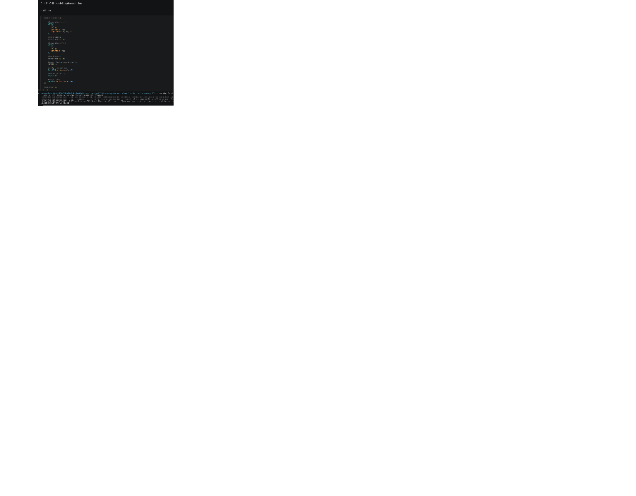

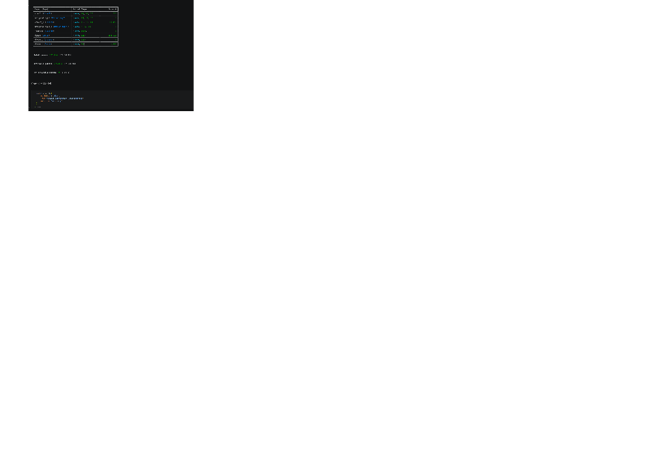
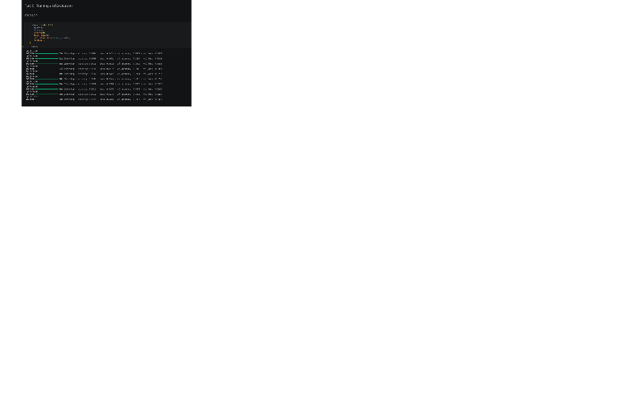
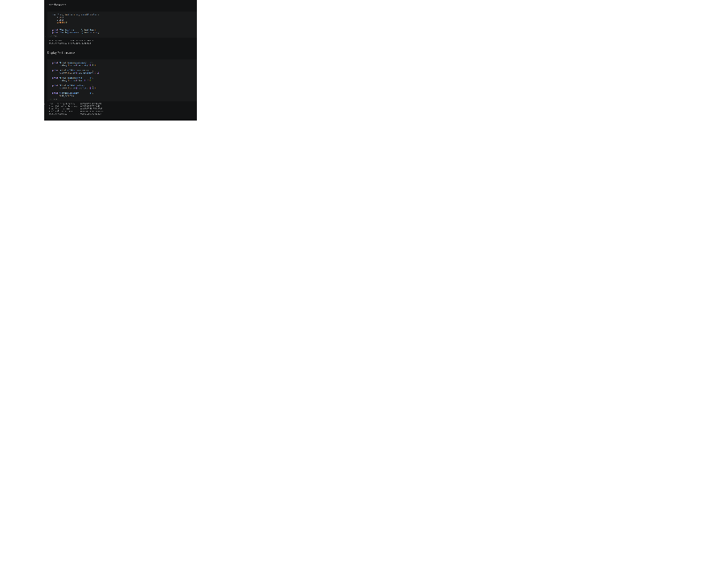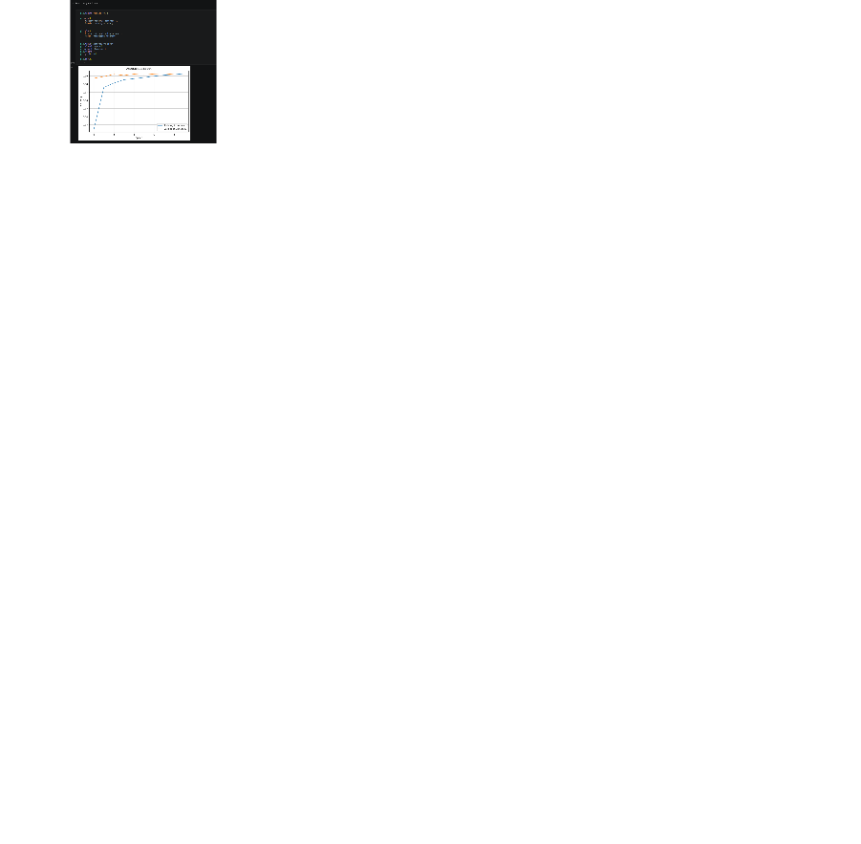
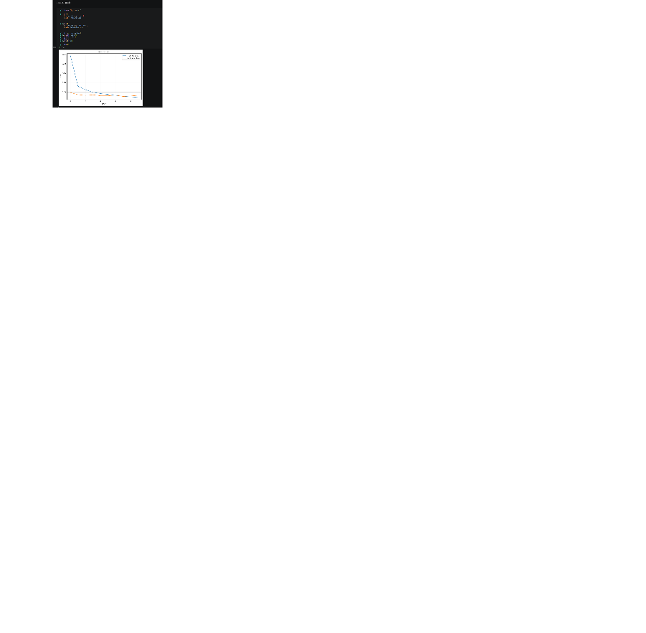
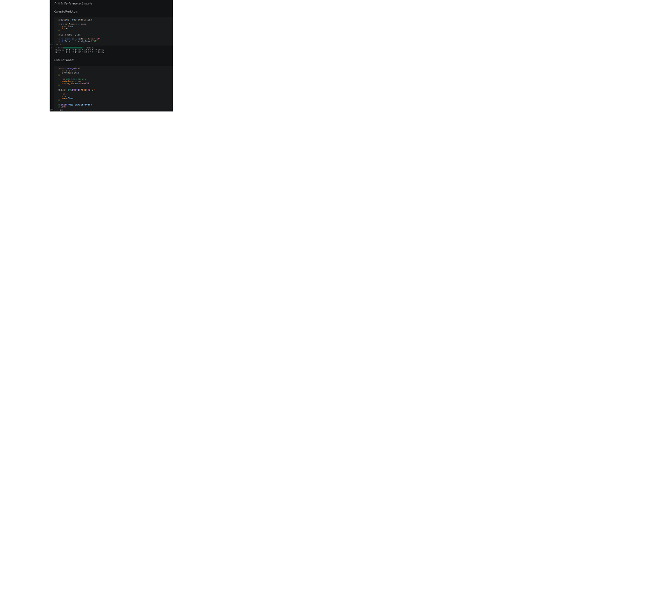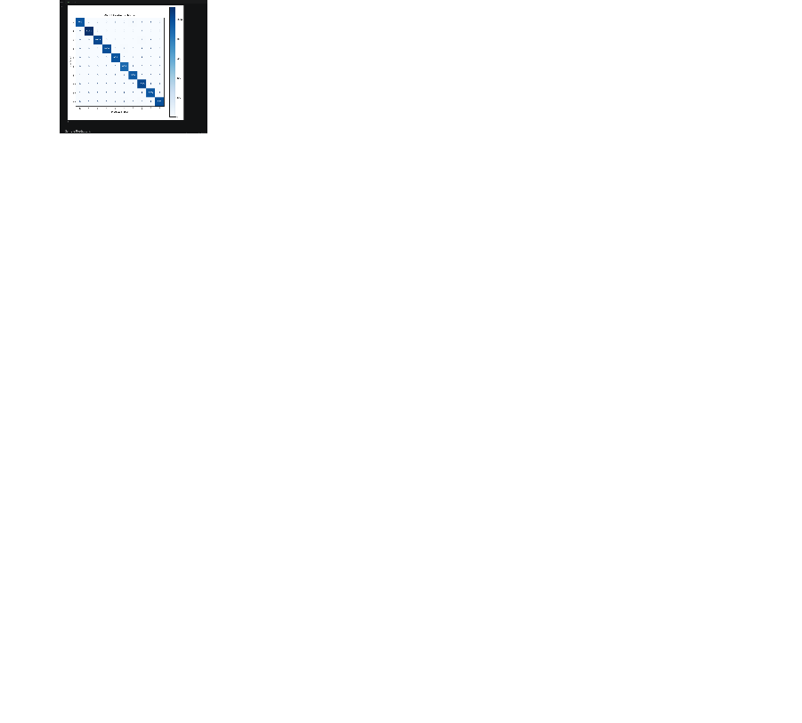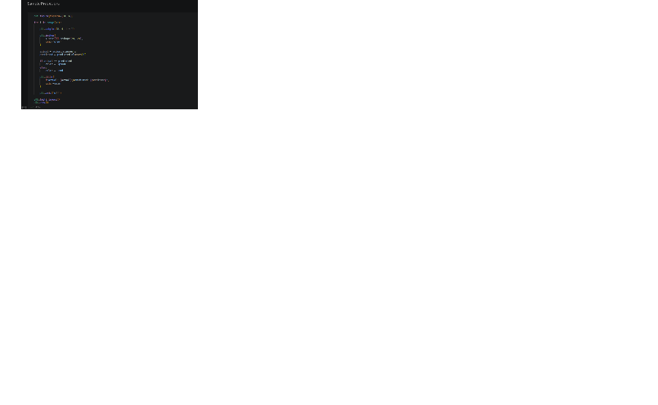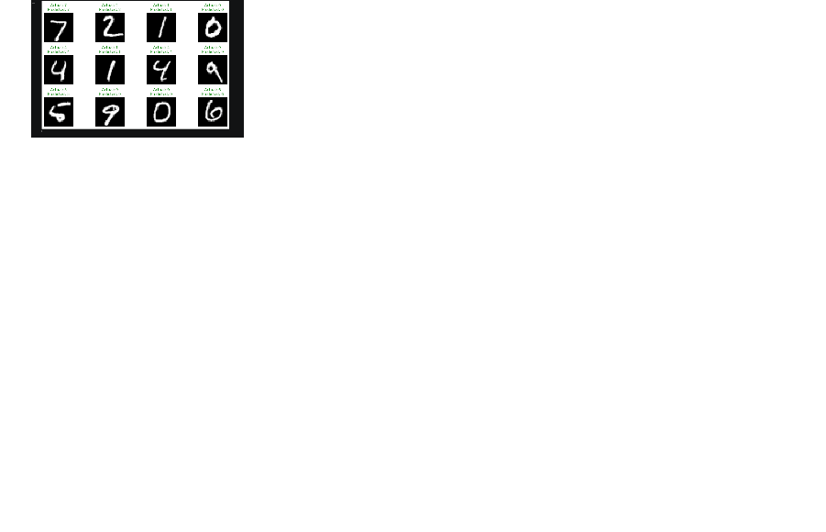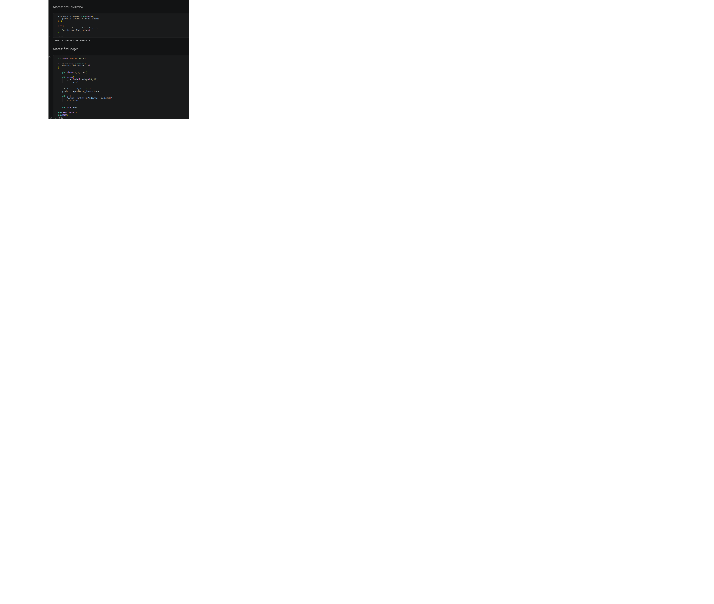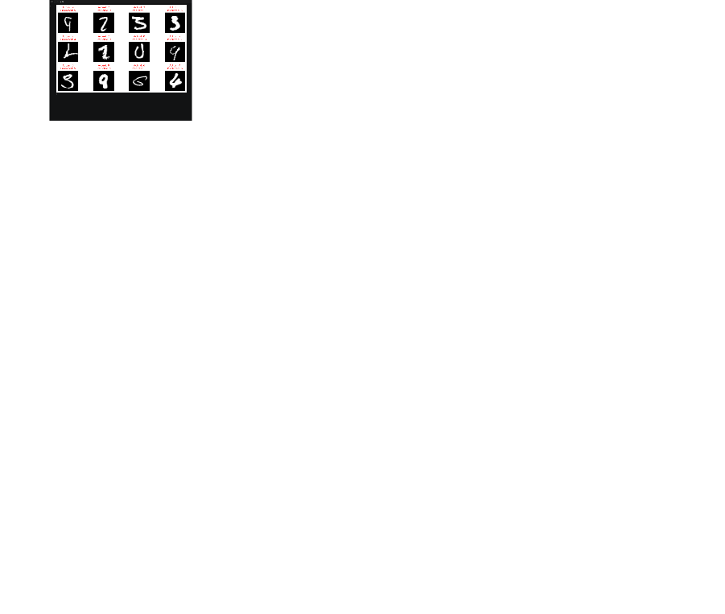

EXPECTED OUTCOME
Students will gain practical experience in designing, training, and evaluating CNN models for image classification and understand how CNN architecture influences classification performance.

POST-LAB QUESTIONS (PROVIDE BRIEF ANSWERS TO THE FOLLOWING QUESTIONS)
- Why are convolution layers more effective than fully connected layers for image processing?
Convolution layers preserve spatial relationships, detect local patterns, and use fewer parameters than fully connected layers, making them computationally efficient and effective for extracting image features.
- How does Max Pooling improve CNN performance?
Max Pooling reduces feature-map dimensions, lowers computational requirements, retains the most important features, and provides some translation invariance, helping reduce overfitting.
- Which hyperparameters significantly affected your CNN model performance?
Learning rate, batch size, number of convolutional filters, kernel size, number of epochs, optimizer, and dropout rate significantly influenced CNN training speed, accuracy, and generalization.
- What challenges did you encounter while training the CNN model?
Common challenges included overfitting, limited training data, selecting suitable hyperparameters, slow training, class imbalance, and achieving high validation accuracy without sacrificing generalization.
- Suggest two improvements that can increase the classification accuracy of your CNN.
Use data augmentation to create diverse training images and apply transfer learning with a pretrained CNN model. Both techniques can improve feature learning and classification accuracy.

ASSESSMENT
Description | Max Marks | Marks Awarded
Pre Lab Exercise | 5
In Lab Exercise | 10
Post Lab Exercise | 5
Viva | 10
Total | 30
Faculty Signature

