* Symmetric Matrix properties

1. Definition :
$$A=\left(A_{ij}\right) ∀ i,j ≡ A=A^{T}$$

2. Properties

* All eigenvalues of a real symmetric matrix is real

$$Ax=λx$$

Then

$$λ^{*}=λ$$

* The eigenvectors are orthogonal, i.e.,

$${Ax}_{i}=λx_{i} , i=1,2,…, n$$

Then

$$x_{i}^{T}x_{j}=0 , ∀ i≠j$$

* Similar transform : let $Q=[x_{1},…, x_{n}]$

$$AQ= diag\left(λ\right)Q$$

Hence $$Q^{T}AQ=diag\left(λ\right)$$

1. Exercise 6
2. Find transform matrix $C$ such that $X' \sim N(0,P^{'})$

$$X'=CX , X \sim N(0, P)$$

Sol: $P= \left[\begin{matrix}9 & 0 & 0 \\ 0 & 2.5 & 0.5 \\ 0 & 0.5 & 2.5\end{matrix}\right]$, eigenvectors E of $P$ is

$$E=\left[\begin{matrix}1 & 0 & 0 \\ 0 & 1 & 1 \\ 0 & 1 & -1\end{matrix}\right]$$

Check the diagonal transform

$$E^{T}PE = \left[\begin{matrix}9 & 0 & 0 \\ 0 & 6 & 0 \\ 0 & 0 & 4\end{matrix}\right]$$

Hence define $C=E^{T}$, the new RV $X'$ is

$$X'=CX$$

Has the covariance $P^{'}$ is

$$P_{Z}^{'} =\left[\begin{matrix}9 & 0 & 0 \\ 0 & 6 & 0 \\ 0 & 0 & 4\end{matrix}\right]$$

1. The PDF of $Z$ is

$$X' \sim N(0, P_{Z}^{'})$$

The PDF is $$f\left(x^{'}\right)=\frac{1}{{\left(2π\right)}^{\frac{n}{2}} {\left|P^{'}\right|}^{1/2} }\exp\left(-\left(\frac{1}{2}\right){\left(x'-m\right)}^{T}{(P^{'})}^{-1}\left(x'-m\right)\right)$$

Hence the constant likelihood of a gaussian is $f\left(x\right)=constant$, implies

$${\left(x_{1}^{'} x_{2}^{'} x_{3}^{'}\right)}^{T}{\left[\begin{matrix}9 & 0 & 0 \\ 0 & 6 & 0 \\ 0 & 0 & 4\end{matrix}\right]}^{-1}\left(\begin{matrix}x_{1}' \\ x_{2}' \\ x_{3}^{'}\end{matrix}\right) =c$$

$$\frac{{X_{1}^{'}}^{2}}{9}+\frac{{X_{2}^{'}}^{2}}{6}+\frac{{X_{3}^{'}}^{2}}{4}=c$$

Within the constant likelihood, $X^{'}=CX$

$\left(X^{'T}X^{'}\right)≤c, -→{\left(CX\right)}^{T}CX=X\left(C^{T}C\right)X≤c$,

Hence

$$P_{X}^{'}\left\{ \left(X^{'T}X^{'}\right)≤c\right\} =P_{X}\{ X\left(C^{T}C\right)X≤c \}$$

1. Define a new RV as

$$Y_{11}=\frac{X_{11}^{'}}{σ_{11}} , Y_{22}=\frac{X_{22}^{'}}{σ_{22}} ,Y_{33}=\frac{X_{33}^{'}}{σ_{33}}$$

In matrix form

$$Y= \left[\begin{matrix}1/σ_{11} & 0 & 0 \\ 0 & 1/σ_{22} & 0 \\ 0 & 0 & 1/σ_{33}\end{matrix}\right]\left[\begin{matrix}X_{11}' \\ X_{22}' \\ X_{33}'\end{matrix}\right]=ΣX^{'}$$

Hence $Y= ΣX^{'}=ΣCX$

$$P_{Y}\left(Y≤r\right)=P_{X^{'}}\left(X^{'}Σ^{T}ΣX^{'}≤r\right)=P_{X}\left(XC^{T}Σ^{T}ΣCX≤r\right)$$

1. The surface area of a sphere with radius r is $4πr^{2}$

Hence $$=1/{\left(2π\right)}^{\frac{3}{2}} \int_{0}^{c}{4πr^{2}\exp\left(-\frac{r^{2}}{2}\right)dr}$$

* I could not find the closed form of this integral. Using matlab integral.

>>[fun=@(x)exp(-x.^2).\*x.^2](mailto:fun=@(x)exp(-x.%5e2).*x.%5e2)

>>q =integral(fun,0,1)

>>Value=sqrt(2/pi)\*q

>> 0.1512

If c = 2, then Value = 0.3373

* Error function

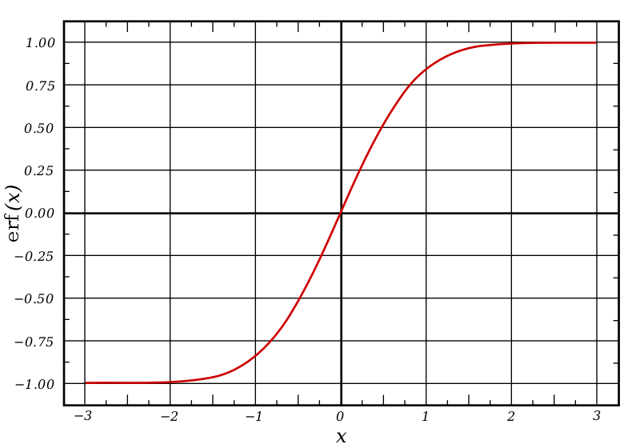<https://en.wikipedia.org/wiki/Error_function#/media/File:Error_Function.svg>