%%% Final Example.

* total expectation : proof (in the finite partitions) as <https://en.wikipedia.org/wiki/Law_of_total_expectation>

example.

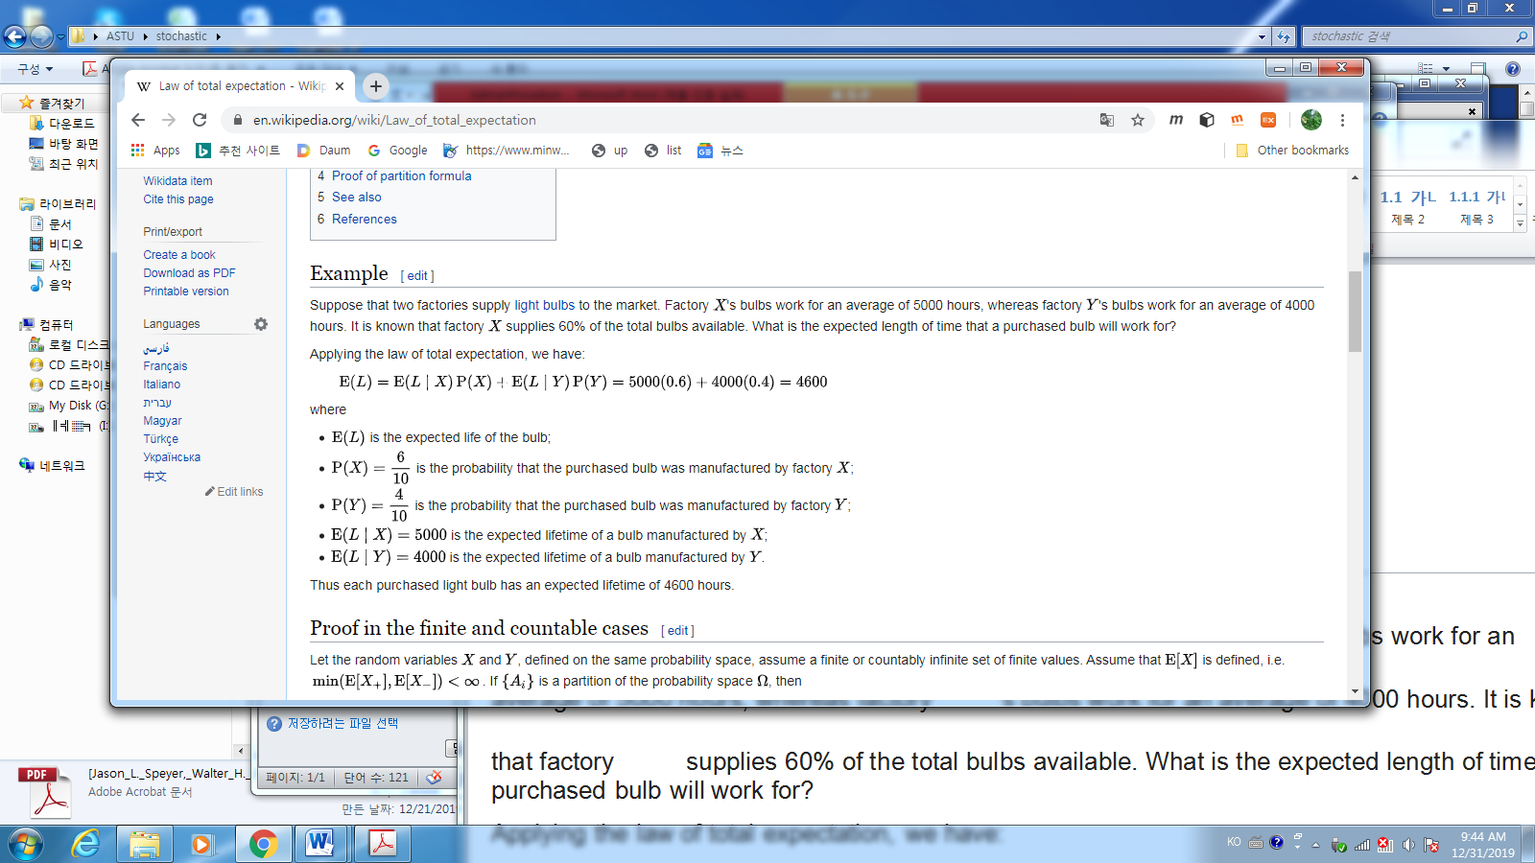

1. Chapter 2. Problems 35. prove

$$E[y\left(x-E\left[x | y\right]\right)]=0$$

Solution: First $E\left[yE\left[x | y\right]\right]$ is considered. Using Lemma 2.34

$$yE\left[x | y\right]=E\left[yx | y\right]$$

Hence $$E\left[yE\left[x | y\right]\right]=E\left[E\left[yx | y\right]\right]$$

$$=\int_{-∞}^{∞}{\int_{-∞}^{∞}{y}xf\left(x,y | y\right)dxf(y)}dy (1)$$

Since

$$f\left(x,y | y\right)=f\left(x,y\right)f\left(y\right)=f\left(x | y\right),$$

Hence (1) is

$$=\int_{-∞}^{∞}{\int_{-∞}^{∞}{y}xf\left(x | y\right)dxf(y)}dy \\ =\int_{-∞}^{∞}{\int_{-∞}^{∞}{y}xf(x,y)dx}dy \\ =E[yx]$$

implies

$$E\left[yE\left[x | y\right]\right]=E\left[yx\right]$$

i.e.,

$$0=E\left[yE\left[x | y\right]\right]-E\left[yx\right] \\ =E\left[yE\left[x | y\right]-yx\right] \\ =E\left[y\left(E\left[x | y\right]-x\right)\right] \\ =E\left[y\left(x-E\left[x | y\right]\right)\right] Q.E.D$$

1. Chapter 3. Problems 7

Prob. 🡪

Prob 🡨

1. Ch.3 problem 8 discrete Kalman

* Model
$$x_{k+1}=x_{k}+w_{k}$$

$$z_{k}=x_{k}+v_{k}$$

$$E\left[w_{k}\right]=0, E\left[w_{k}^{2}\right]=\frac{1}{2}=W, E\left[v_{k}\right]=0, E\left[v_{k}^{2}\right]=\frac{1}{4}=Γ$$

* initial: k=0 $$E\left[x_{0}\right]=1, E\left[x_{0}^{2}\right]=2$$

$${\overline{x}}_{0}=1, M_{0}=E{\left[x_{0}\right]}^{2}-{\left(E\left[x_{0}\right]\right)}^{2}=3$$

a) compute a priori / prediction ( $M_{k})$ and posteriori /correction covariance $(P_{k})$ for $k=1,2$

For k= 1; covariance:

+prediction $M_{1}:$ Since at $k=0$, there is no previous estimation, assume $P_{0}=M_{0}$

$$M_{1}=ϕ^{2}P_{0}+W={3ϕ}^{2}+\frac{1}{2}=\frac{1}{2}(6ϕ^{2}+1)$$

+correction $P_{1}:$

$$P_{1}=\left(M_{1}^{-1}+V^{-1}\right)={\left(\frac{1}{M_{1}}+\frac{1}{\frac{1}{4}}\right)}^{-1}={\left(\frac{1+4M_{1}}{M_{1}}\right)}^{-1}=\frac{M_{1}}{1+4M_{1}}=\frac{\frac{1}{2}\left(6ϕ^{2}+1\right)}{1+2\left(6ϕ^{2}+1\right)}$$

For $k=2$

+prediction $M_{2}=ϕ^{2}P_{1}+\frac{1}{4}$

+correction $P_{2}={\left(M_{2}^{-1}+2\right)}^{-1}$

b) compute optimal gain

For k= 1;

+ $K_{1}=P_{1}{\left(\frac{1}{4}\right)}^{-1}=4P_{1}$

For $k=2$

+ $K_{2}=P_{2}{\left(\frac{1}{4}\right)}^{-1}=4P_{2}$

c) compute optimate estimator ${\overline{x}}_{k}(prediction) and {\hat{x}}_{k}(correction, the estimator)$ with

$$z_{1}=ς_{1},z_{2}=ς_{2}$$

For k= 0;

+ at t=0, the correction is assumed : ${\hat{x}}_{0}= {\overline{x}}_{0}$

1. prediction : ${\overline{x}}_{1}=ϕ{\hat{x}}_{0}=ϕ{\overline{x}}_{0}$

For $k=1,$

correction : ${\hat{x}}_{1}={\overline{x}}_{1}+k_{1}(ς_{1}-{\overline{x}}_{1})$

For $k=2,$

+prediction: ${\overline{x}}_{2}=ϕ{\hat{x}}_{1},$

+correction: $, {\hat{x}}_{2}={\overline{x}}_{2}+k_{2}(ς_{2}-{\overline{x}}_{2})$

1. Ch.3 problem 11

$$f\left(x,y\right)= \left\{\begin{aligned}1, 0≤y≤2x, 0≤x≤1 \\ 0 else \end{aligned}\right.$$

Find $E[X|y=0.5]$

Solution:

$$E\left[X | y=0.5\right]= \int_{-∞}^{∞}{xf\left(x | y= .5\right)dx}$$

First

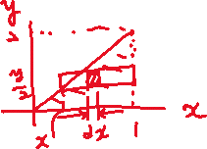

(check whether it is a pdf.

$$1=?= \int_{0}^{2}{\left(1-\frac{y}{2}\right)dy}$$

$$=y{\left.​\right|}_{0}^{2}-\frac{1}{4}y^{2}{\left.​\right|}_{0}^{2}=1. OK..)$$

Hence

$$f\left(x | y=0.5\right)=\frac{f\left(x,y\right)}{f\left(y\right)}=\frac{1}{1-\frac{y}{2}}=\frac{2}{2-0.5}=\frac{2}{1.5}=\frac{4}{3}$$

$$E\left[X | y=0.5\right]= \int_{-∞}^{∞}{xf(x|y=0.5)dx}=\frac{4}{3}\int_{0}^{1}{x}dx=\frac{4}{3}\left(\frac{1}{2}\right)x^{2}{\left.​\right|}_{0}^{1}=\frac{4}{6}=\frac{2}{3}$$

1. Ch.4 prob 4

$$A=UΣV^{T},$$

Prob_1)

$$A^{T}Ax=λx , λ=e.value,x=e.vector of A^{T}A$$

$$A^{T}A=VΣ^{T}U^{T}UΣV^{T}=VΣ^{T}ΣV^{T}$$

Now multiplying $V^{T}$ at the both sides,

$$A^{T}AV=VΣ^{T}ΣV^{T}V=VΣ^{T}Σ=V diag(σ_{1}^{2}, σ_{2}^{2},…,σ_{n}^{2})$$

which implies the column vectors of $V$ are eigen vectors of $A^{T}A$ and sigma values $σ_{1}^{2}, σ_{2}^{2},…, σ_{n}^{2},$ are eigen vectors of $A^{T}A$

Prob_2 ) $eig \left(A^{T}A\right)= ?eig(A A^{T})$

No, the $\dim\left(A^{T}A\right)≠\dim\left(A A^{T}\right),$ hence the $eig \left(A^{T}A\right)≠ eig(A A^{T})$

But!! As you know if $A_{m×m}$ is a square matrix, then $eig\left(M\right)=eig\left(M^{T}\right) ∀ M,$

Hence if $A_{m×m}$ is a square matrix, then

$$eig\left(A^{T}A\right)=eig(AA^{T})$$

1. Ch.4 prob 10

Define $<u,v> = \int_{0}^{2π}{uv}dt$ is an inner product, then

$$\int_{0}^{2π}{u_{i}u_{j}dt}= \left\{\begin{aligned}1 i=j \\ 0 i≠j\end{aligned}\right.$$

which implies that $u_{1}\left(t\right), u_{2}\left(t\right), u_{3}(t)$ is an orthonormal basis in this space.

Hence the minimum mean square approximation (estimator) $\hat{x}$ of $x$ is the orthogonal projection in the space of span $\{u_{1}, u_{2}, u_{3}\}$

$\hat{x}=a_{1}u_{1}\left(t\right)+a_{2}u_{2}\left(t\right)+a_{3}u_{3}\left(t\right).$

Hence

$a_{i}= <x, u_{i}> = \int_{0}^{2π}{xu_{i}dt}$

can be determined. For example

$$a_{1}= <x, u_{i}> = \int_{0}^{2π}{xu_{i}dt}=\frac{1}{\sqrt{π}}\left(\int_{0}^{π}{(sin{t})(1)}dt+\int_{π}^{2π}{\sin{t}(-1)}dt\right)$$

(a)Remember the Fourier series $f\left(x\right)$ on $\left[0 2π\right]$,

$$f\left(x\right)=\frac{1}{2}a_{0}+\sum_{n=1}^{∞}{(a_{n}\cos{nx}}+b_{n}\sin{nx )}$$

(b) how about

$$u_{1}\left(t\right)=\frac{1}{\sqrt{2π }},u_{2}\left(t\right)=\frac{1}{\sqrt{π }}\cos{t},u_{3}\left(t\right)=\frac{1}{\sqrt{π }}\cos{2t},$$

(c) consider $\{1,t,t^{2}\}$, which is independent with $<a_{j},a_{i}> = \int_{0}^{1}{a_{i}a_{j}dt}$.

-Find the orthogonal basis,

- Find the least square estimator of $x\left(t\right)=\sqrt{t} , t∈[0, 1]$

1. Ch.4 prob 11
2. Ch.4 prob 12 LSE in static systems(batch type)

$$z_{k}=x+v_{k},$$

$$v_{k}: i.i.d, z=\left\{z_{1},z_{2},…,z_{N}\right\}-→E\left[v_{k}\right]=E\left[v\right]$$

Let the matrix form

$$\left[\begin{matrix}z_{1} \\ z_{2} \\ \begin{matrix}⋮ \\ z_{N}\end{matrix}\end{matrix}\right]=\left[\begin{matrix}1 \\ 1 \\ \begin{matrix}⋮ \\ 1\end{matrix}\end{matrix}\right]x+ \left[\begin{matrix}v_{1} \\ v_{2} \\ \begin{matrix}⋮ \\ v_{n}\end{matrix}\end{matrix}\right]$$

$$Z=Φx+V$$

1. The least square estimator is
$$\hat{x }={\left(Φ^{T}Φ\right)}^{-1}Φ^{T}Z=\frac{1}{N}(z_{1}+z_{2}+…+z_{N})$$

2. Since the estimation error $ε_{N}= \hat{x}-x$

$$ε_{N}= \hat{x}-x$$

$$=\frac{1}{N}\left[z_{1}+z_{2}+…+z_{N}\right]-x$$

$$=\frac{1}{N}[v_{1}+v_{2}+…+v_{N}]$$

By the assumption $E\left[v_{i}\right]=0$

$$E\left[ε_{N}\right]=0,$$

And the estimation error variance is

$$E\left[ε_{N}^{2}\right]=\frac{1}{N^{2}}E{\left[{(v}_{1}+v_{2}+…+v_{N}\right)}^{2}] \\ =\frac{N}{N^{2}}E\left[v^{2}\right] ∵v_{i},v_{k} are independent$$

$$=\frac{1}{N}E\left[v^{2}\right] ∵v_{i},v_{k} are independent$$

Hence the estimation error variance converges to 0 as $N$ converges to infinite

1. If we do not know $E\left[v\right]$, then

$$E\left[ε_{N}\right]=\frac{1}{n}E\left[v\right] ≠0$$

implies the estimator is biased. And You may show the estimation error variance converges to zero as $N$ converges to infinite.

This means even if the variance converges to zero, the mean of the estimator does not converge to the true value, implies the estimator is unbiased.

How to estimate $v$ along with $x$ and $z_{k}$? If we know $x$, then

$$v_{k}=z_{k}-x$$

$E\left[v_{k}\right]=E\left[v\right]=E[z_{k}]-x$.QED

1. Ch.4 prob. 13

$$y=Ax$$

$$x=\left(x_{1},x_{2},…,x_{n}\right)$$

$y=a_{1}x_{1}+a_{2}x_{2}+,…,+a_{n}x_{n}$

* $y$ is a linear combination of column vectors of $A$%%%%%%%
$${\left(H^{T}H\right)}^{-1}H^{T}={\left({\left(UΣV^{T}\right)}^{T}\left(UΣV^{T}\right)\right)}^{-1}$$

$$={\left(VΣ^{T}U^{T}UΣV^{T}\right)}^{-1}Φ^{T}$$

$$={\left(\left(V{(Σ}^{T}Σ\right)V^{T}\right)}^{-1})Φ^{T}$$

$$=diag{\left(σ_{i}^{2}\right)}^{-1}Φ^{T}$$

* The least square estimator is

$$\hat{x}={\left(H^{T}H\right)}^{-1}H^{T}z= {\left({\left(UΣV^{T}\right)}^{T}\left(UΣV^{T}\right)\right)}^{-1}H^{T}z$$

$$={\left(VΣ^{T}U^{T}UΣV^{T}\right)}^{-1}H^{T}z$$

$$={\left(\left(V{(Σ}^{T}Σ\right)V^{T}\right)}^{-1})H^{T}z$$

$$=diag{\left(σ_{i}^{2}\right)}^{-1}H^{T}z$$

implies $\hat{x}$ is a linear combination of row vectors of $H$

1. Ch.4 prob 19
$$z=Hx+ν , x\sim N\left(\overline{x},M\right), ν\sim N(0,V)$$

2. Least Square estimator ${\hat{x}}_{LS}={(H}^{T}{H)}^{-1}H^{T}z$
3. Check the bias:

$$E\left[{\hat{x}}_{LS}\right]=E\left[{(H}^{T}{H)}^{-1}H^{T}\left(Hx+ν\right)\right]=E\left[x+{(H}^{T}{H)}^{-1}H^{T}ν\right]= \overline{x},$$

Hence it is unbiased.

1. The error variance is

$$E\left[\left({\hat{x}}_{LS}-x\right){\left({\hat{x}}_{LS}-x\right)}^{T}\right]$$

$$=E\left[{((H}^{T}{H)}^{-1}H^{T}\left(Hx+ν\right)-x)({(H}^{T}{H)}^{-1}H^{T}\left(Hx+ν\right)-{x)}^{T} \right] \\ =E\left[\left(x-{\left(H^{T}H\right)}^{-1}H^{T}ν -x\right){\left(x-{\left(H^{T}H\right)}^{-1}H^{T}ν -x\right)}^{T} \right] \\ =E\left[\left({\left(H^{T}H\right)}^{-1}H^{T}ν \right){\left({\left(H^{T}H\right)}^{-1}H^{T}ν \right)}^{T} \right] \\ =E\left[{\left(H^{T}H\right)}^{-1}H^{T}νν^{T}{H\left({\left(H^{T}H\right)}^{-1}\right)}^{T} \right] \\ =\left[{\left(H^{T}H\right)}^{-1}H^{T}V{H\left({\left(H^{T}H\right)}^{-1}\right)}^{T} \right] (1)$$

If $V=σ^{2}diag(I)$, then

$$=σ^{2}{\left({\left(H^{T}H\right)}^{-1}\right)}^{T} (2)$$ This is not the minimum error variance. The estimator of the minimum error variance of is the conditional expectation estimation as $E[x|z]$, and the minimum error variance is

$$E\left[\left({\hat{x}}_{MV}-x\right){\left({\hat{x}}_{MV}-x\right)}^{T}\right]$$

$$=( M^{-1}+H^{T}V^{-1}H)^{-1}$$

$$=( M^{-1}+\frac{1}{σ^{2}}H^{T}H)^{-1} (3)$$

Do you think it is true

$$σ^{2}{\left({\left(H^{T}H\right)}^{-1}\right)}^{T}≥ =( M^{-1}+\frac{1}{σ^{2}}H^{T}H)^{-1}$$

I have not seen the formal proof, but it is true.

%%%%%% reference of prob 2(Ch.2 prob.7)

$$z=Hx+v$$

$$x\sim N\left(\overline{x},M\right), v \sim N(0,V)$$

$$z\sim N(H\overline{x}, HMH^{T}+V)$$

$$E\left[x | z\right] \sim N(\overline{x}+{\left(M^{-1}+H^{T}V^{-1}H\right)}^{-1}H^{T}V^{-1}\left(z-H\overline{x}\right), {\left(M^{-1}+H^{T}V^{-1}H\right)}^{-1})$$

Scalar Case

$$M≔σ_{x}^{2}, V≔σ_{v}^{2}$$

$$x\sim N\left(\overline{x}, σ_{x}^{2}\right), v\sim N(0,σ_{v}^{2})$$

$$z\sim N\left(\overline{x},σ_{x}^{2}+σ_{v}^{2}\right)$$

* $E[x|z]$:

$1)$ variance

mean

3) Summary:

$E[x|z]$ is the gaussian random variable of $z$ with mean

$$E\left[E\left[x | z\right]\right]$$

$$=E\left(\frac{\frac{1}{σ_{x}^{2}}}{\left(\frac{1}{σ_{x}^{2}}\right)+\left(\frac{1}{σ_{v}^{2}}\right)}\overline{x}+ \frac{\frac{1}{σ_{v}^{2}}}{\left(\frac{1}{σ_{x}^{2}}\right)+\left(\frac{1}{σ_{v}^{2}}\right)}z\right)$$

$$=\frac{\frac{1}{σ_{x}^{2}}}{\left(\frac{1}{σ_{x}^{2}}\right)+\left(\frac{1}{σ_{v}^{2}}\right)}\overline{x} + \frac{\frac{1}{σ_{v}^{2}}}{\left(\frac{1}{σ_{x}^{2}}\right)+\left(\frac{1}{σ_{v}^{2}}\right)}E\left[z\right]=\overline{x}$$

And the variance

$${\left(\frac{1}{σ_{x}^{2}}+\frac{1}{σ_{v}^{2}}\right)}^{-1}$$

which is less than $\left(σ_{x}^{2}+σ_{v}^{2}\right)$