Mid-term Exam for 1st year Extension Control PG

Reference: “Modern Control Engineering”,K.Orgata, 5th edition.

Student: Gure Olfuda Feyisa

1. Transfer function
   1. Transfer functions

$$G_{1} \left(s\right)=\frac{s+1}{s^{2}+2s+10}, G_{2}\left(s\right)=\frac{s-1}{s+5}$$

Find the transfer function for each cases (program 2-1).

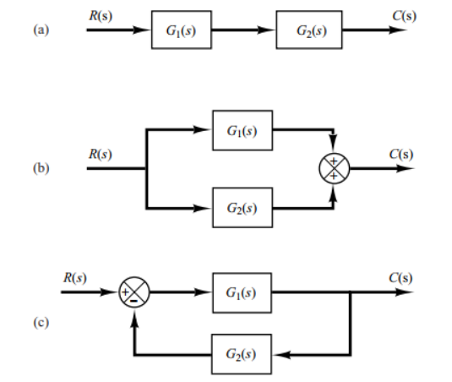

* 1. Transformation from transfer function to state space representation and vice versa

1. Given the transfer function as (Program 2-2)

$$\frac{Y\left(s\right)}{U\left(s\right)}=\frac{s^{2}+1}{s^{3}+5s^{2}+25s+5}$$

Find a state space representation

1. Transient – Response Analysis
   1. Step responses(Program 5-2) from the state space representation

Consider multi-input and multi output systems as

$$\left[\begin{matrix}{\dot{x}}_{1} \\ {\dot{x}}_{2}\end{matrix}\right]= \left[\begin{matrix}-1 & 0 \\ 10 & 0\end{matrix}\right]\left[\begin{matrix}x_{1} \\ x_{2}\end{matrix}\right]+ \left[\begin{matrix}1 & 1 \\ 1 & 0\end{matrix}\right]\left[\begin{matrix}u_{1} \\ u_{2}\end{matrix}\right]$$

$$\left[\begin{matrix}y_{1} \\ y_{2}\end{matrix}\right]=\left[\begin{matrix}1 & 0 \\ 0 & 1\end{matrix}\right]\left[\begin{matrix}x_{1} \\ x_{2}\end{matrix}\right]+ \left[\begin{matrix}0 & 0 \\ 0 & 0\end{matrix}\right]\left[\begin{matrix}u_{1} \\ u_{2}\end{matrix}\right]$$

Draw the output with input $u_{1}=u_{2}$ are the unit step functions

* 1. Step responses(Program 5-5) from the transfer function  
     Given the transfer function as

$$G\left(s\right)=\frac{s+2}{s^{2}+2s+5}$$

Draw the unit step response

* 1. Output comparisons with various damping ration in second order system(program 5-6)

Given the transfer function as

$$\frac{C\left(s\right)}{R\left(s\right)}=\frac{1}{s^{2}+2ξs+1}$$

Draw the outputs as

* 1. Impulse response(program 5-8)

Given the transfer function

$$\frac{C\left(s\right)}{R\left(s\right)}=\frac{s+0.5}{s^{2}+0.2s+10}$$

Draw the impulse response

* 1. Response with an arbitrary input(program 5-13)

Given the state space representation system

$$\left[\begin{matrix}{\dot{x}}_{1} \\ {\dot{x}}_{2}\end{matrix}\right]= \left[\begin{matrix}-1 & 0.5 \\ -1 & 0\end{matrix}\right]\left[\begin{matrix}x_{1} \\ x_{2}\end{matrix}\right]+ \left[\begin{matrix}0 \\ 1\end{matrix}\right]u$$

$$y=\left[\begin{matrix}1 & 0\end{matrix}\right]\left[\begin{matrix}x_{1} \\ x_{2}\end{matrix}\right]$$

With the input as

* 1. Response with an initial value given.(program 5-16)

Given the state space model with the initial points as

$$\left[\begin{matrix}{\dot{x}}_{1} \\ {\dot{x}}_{2}\end{matrix}\right]= \left[\begin{matrix}0 & 1 \\ -3 & -5\end{matrix}\right]\left[\begin{matrix}x_{1} \\ x_{2}\end{matrix}\right]+ \left[\begin{matrix}0 \\ 0\end{matrix}\right]u, x\left(0\right)= \left[\begin{matrix}-1 \\ -2\end{matrix}\right]$$

$$y=\left[\begin{matrix}0 & 0\end{matrix}\right]\left[\begin{matrix}x_{1} \\ x_{2}\end{matrix}\right]$$

Draw the response to initial conditions