3.9 Range and Null space of a matrix

1) projection: <https://en.wikipedia.org/wiki/Vector_projection>

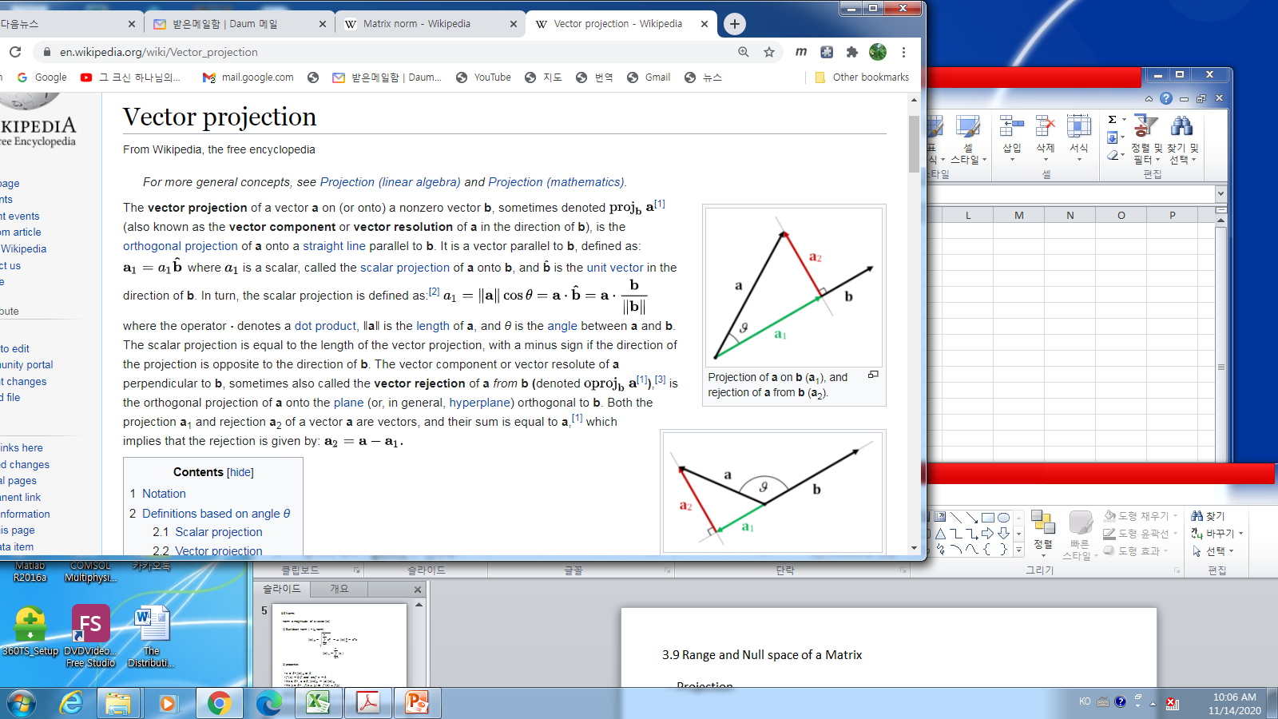Example:

Let vector $a, b ∈R^{2}$

Find vector $b^{*}$ such that the distance is minimum, i.e.,

$$\left\|b^{*}-a\right\|≤ \left\|tb-a\right\| ∀t$$

$b^{*}$: the projection $a$ to $b$, $P_{b}(a)$

Solution: from the picture, $b^{*}=a_{1}$ which is on the vector $b$.

From the definition of dot product

$$a∙b=\left\|a\right\|\left\|b\right\|\cos{θ}$$

implies

$$\cos{θ=\frac{a∙b}{\left\|a\right\|\left\|b\right\|}}$$

Hence the $b^{*}$ can be derived as

2) The Null space

* Def: The null space of a matrix $A ∈R^{n×n}$, $Ν(A)$ is a set of all vectors $x$ that solve to $Ax=0$
$$N\left(A\right)= \left\{x∈R^{n}:Ax=0\right\}$$

* Fact
* Fact:

Every solution to $Av=b (‼ if it is solvable)$ has the form $v_{p}+v_{n}$:

1. The particular solution: ${Av}_{p}=b,$
2. The null solution(homogeneous solution): ${Av}_{n}=0$,
3. The general solution: $v_{g}=v_{p}+v_{n}$

* Example
$$x+2y+3z=3$$

$v=v_{p}+v_{n} , v_{p}= \left[\begin{matrix}x_{p} \\ y_{p} \\ z_{p}\end{matrix}\right] , v_{n}= \left[\begin{matrix}x_{n} \\ y_{n} \\ z_{n}\end{matrix}\right]$

* 1) $v_{p}:$
$$\left[\begin{matrix}1 & 2 & 3 \\ 0 & 0 & 0 \\ 0 & 0 & 0\end{matrix}\right]\left[\begin{matrix}x_{p} \\ y_{p} \\ z_{p}\end{matrix}\right]= \left[\begin{matrix}3 \\ 0 \\ 0\end{matrix}\right]$$

$$v_{p}= \left[\begin{matrix}1 \\ 1 \\ 0\end{matrix}\right], or \left[\begin{matrix}1 \\ 0 \\ -\frac{3}{2}\end{matrix}\right], or,…$$

* 2) $v_{n}$
$$\left[\begin{matrix}1 & 2 & 3 \\ 0 & 0 & 0 \\ 0 & 0 & 0\end{matrix}\right]\left[\begin{matrix}x_{n} \\ y_{n} \\ z_{n}\end{matrix}\right]= \left[\begin{matrix}0 \\ 0 \\ 0\end{matrix}\right]$$

$$v_{n}=c_{1}\left[\begin{matrix}0 \\ 1/2 \\ -1/3\end{matrix}\right]+c_{2} \left[\begin{matrix}1 \\ 0 \\ -1/3\end{matrix}\right] ∀c_{1}, c_{2}$$

* 3) $v_{g}$
$$v_{g}=v_{p}+v_{n}=\left[\begin{matrix}1 \\ 1 \\ 0\end{matrix}\right]+c_{1}\left[\begin{matrix}0 \\ 1/2 \\ -1/3\end{matrix}\right]+c_{2} \left[\begin{matrix}1 \\ 0 \\ -1/3\end{matrix}\right] \\ =\left[\begin{matrix}1 \\ 0 \\ -3/2\end{matrix}\right]+ c_{1}\left[\begin{matrix}0 \\ 1/2 \\ -1/3\end{matrix}\right]+c_{2} \left[\begin{matrix}1 \\ 0 \\ -1/3\end{matrix}\right]$$

* Differential equation

Consider a linear differential equation as

$$y^{''}+3y^{'}+2y=\frac{d^{2}y}{dt^{2}}+3\frac{dy}{dt}+2y=1$$

1. The homogeneous solution:

$\frac{d^{2}y}{dt^{2}}+3\frac{dy}{dt}+2y=0-→y_{h}=c_{1}e^{-t}+c_{2}e^{-2t}$

1. The particular solution

$\frac{d^{2}y}{dt^{2}}+3\frac{dy}{dt}+2y=2 -→y_{p}=1$

1. The general solution

$y_{g}=y_{h}+y_{p}=c_{1}e^{-t}+c_{2}e^{-2t}+1$

1. If initial points are given such as

$$y\left(0\right)=1,\frac{dy}{dt}\left(0\right)=1$$

To get $c_{1} , c_{2}$, applying the initial conditions

$$y\left(0\right)=c_{1}+c_{2}+1=1$$

$$\frac{dy}{dt}\left(0\right)= -c_{1}-{2c}_{2}=1$$

$c_{1}= 1, c_{2}=-1$

Hence the solution is

$$y\left(t\right)=e^{-t}-e^{-2t}+1$$

3.10 The determinant

The determinant of $A$, $\left|A\right|$

$A= \left|\left[\begin{matrix}a_{11} & a_{12} \\ a_{21} & a_{22}\end{matrix}\right]\right|=a_{11}a_{22}-a_{12}a_{21}$

$A= \left|\left[\begin{matrix}a_{11} & a_{12} & a_{13} \\ a_{21} & a_{22} & a_{23} \\ a_{31} & a_{32} & a_{33}\end{matrix}\right]\right|=a_{11}a_{22}-a_{12}a_{21}$

$=\left|\begin{matrix}a_{11} & a_{12} & a_{13} \\ a_{21} & a_{22} & a_{23} \\ a_{31} & a_{32} & a_{33}\end{matrix} \begin{matrix}a_{11} & a_{12} & a_{13} \\ a_{21} & a_{22} & a_{23} \\ a_{31} & a_{32} & a_{33}\end{matrix}\right|$

$$=a_{11}a_{22}a_{33}+a_{12}a_{23}a_{31}+a_{13}a_{21}a_{32}-a_{11}a_{23}a_{32}-a_{12}a_{21}a_{33}-a_{13}a_{22}a_{31}$$

* How to calculate the determinant easily?

3.11 Quadratic Forms and Positive definite

1) quadratic forms

2) Definite matrix for a symmetric matrix

- Positive definite matrix $A$

$$∀ x, x^{T}A x>0 , x≠0$$

* Positive semi definite matrix $A$
$$∀ x, x^{T}A x≥0 , x≠0$$

* Property

For any matrix $A$, $A^{T}A$ is a symmetric and positive semi definite.

3.12 Eigenvalues and Eigenvectors

* Definition: Given a square $A_{n×n },$ a scalar $λ$ and corresponding vector $x$ satisfying the following equation,

$$Ax=λx, x≠0$$

$λ:$ eigenvalue of $A$

$x:$ eigenvector of $A$

* Facts

1. Find eigenvalues

$$Ax=λx-→\left(A-λI\right)x =0$$

* $\left|A-λI\right|=0$, which is called as the characteristic equation

1. Example 1

* $A= \left[\begin{matrix}1 & 2 \\ 0 & 3\end{matrix}\right],$ the determinant of $\left(A-λI\right)$ is

$$\left|\begin{matrix}1-λ & 2 \\ 0 & 3-λ\end{matrix}\right|=\left(1-λ\right)\left(3-λ\right)-2×0=0$$

Hence $λ=1,3$

1. Eigenvector for

🡪

1. Eigenvector for

🡪

1. Example 2

* $A= \left[\begin{matrix}0 & -1 \\ 1 & 0\end{matrix}\right],$ the determinant of $\left(A-λI\right)$ is

$$\left|\begin{matrix}-λ & -1 \\ 1 & -λ\end{matrix}\right|=λ^{2}+1=0$$

Hence $λ= ±j , j^{2}= -1$

1. Eigenvector for

🡪

1. Eigenvector for

🡪

1. Example 3

$$A= \left[\begin{matrix}1 & 1 & 2 \\ 1 & 2 & 1 \\ 2 & 1 & 1\end{matrix}\right]$$

Using matlab,

$$λ_{1}=-1, x_{1}={\left(1 , 0 , -1\right)}^{T} \\ λ_{2}=1, x_{2}={\left(1,-2 ,1\right)}^{T} \\ λ_{2}=4, x_{2}={\left(1,1,1\right)}^{T}$$

3.13 Eigenvalues and Eigenvectors of Symmetric Matrices

* Properties of a symmetric matrix $A$

1. All of the eigenvalues of $A$ are real number
2. Eigenvector $x_{i},$ are orthogonal, i.e.,

$$∀ i, j x_{i}^{T}x_{j}=0, i≠j$$

* Optimal problem related to eigenvalues and eigenvector

Consider the following maximum problem, for a positive definite matrix $A$

$$\max_{x ∈R^{n} }{x^{T}A x }, subject to {\left\|x\right\|}_{2}^{2}=1$$ sol:

$$\max_{x ∈R^{n} }{x^{T}A x }= \max_{i}{λ_{i}}=λ^{*} , x^{*}=corresponding to λ^{*}$$

&& Review of Ordinary Differential Equations

<https://www.math.ubc.ca/~feldman/m267/odeReview.pdf>

1. Definition 1

* Ordinary differential equation (ODE)

$$\frac{d^{2}y(t)}{dt^{2}}+y\left(t\right)=0 (1)$$

Sol: $y\left(t\right)=c_{1}\cos{t}+c_{2}\sin{t}$

* Partial differential equation

$$\frac{∂^{2}u}{∂x^{2}}+\frac{∂^{2}u}{∂y^{2}}=1$$

Sol: $u\left(x,y\right)=\frac{1}{4}(x^{2}+y^{2})$

* The order of ODE

-The highest derivative of ODE

* The linear ODE

$$a_{0}\left(t\right)\frac{d^{n}y}{dt^{n}}+a_{1}(t)\frac{d^{n-1}y}{dt^{n-1}}+,…+a_{n-1}\left(t\right)\frac{dy\left(t\right)}{dt}+a_{n}\left(t\right)y\left(t\right)=F\left(t\right) (2)$$

Ex. Non-linear ODE

$\left(\frac{d^{2}y}{dt^{2}}\right)\frac{dy\left(t\right)}{dt}+y\left(yt\right)=0,\frac{dy}{dt}+e^{y\left(t\right)}=0$

* Constant coefficient linear ODE if $a_{0}\left(t\right),a_{1}\left(t\right),…a_{n}\left(t\right) are constant$
* Homogeneous ODE: in (1), $F\left(t\right)=0$. Otherwise it is in-homogeneous or non-homogeneous
* An initial value problem

Given (2) and given initial conditions such as

$y\left(0\right)=1,\frac{dy}{dt}\left(0\right)=0$

* Boundary value problem

Given (1), and given boundary conditions as

$$y\left(0\right)=1, y\left(1\right)=0$$

Theorem 2

1. The general solution to ODE (2) is of the form

$$y_{g}\left(t\right)=y_{p}\left(t\right)+c_{1}y_{1}\left(t\right)+c_{2}y_{2}\left(t\right)+ ,…,+c_{n}y_{n}(t)$$

Where

1. $n$ is the order of ODE
2. the particular solution $y_{p}\left(t\right)$ is any solution to (2)
3. $c_{1},c_{2},…,c_{n}$ are arbitrary constants
4. $y_{1}, y_{2},…,y_{n}$ are $n$ independent solutions to the homogeneous equation
$$=a_{0}\left(t\right)\frac{d^{n}y}{dt^{n}}+a_{1}\left(t\right)\frac{d^{n-1}y}{dt^{n-1}}+,…+a_{n-1}\left(t\right)\frac{dy\left(t\right)}{dt}+a_{n}\left(t\right)y\left(t\right)=0$$

5. Given any initial conditions $b_{0}, b_{1},…, b_{n-1}$, there is exactly one solution to (2)

Example.3

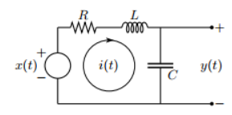

$LC y^{''}\left(t\right)+RC y^{'}\left(t\right)+y\left(t\right)=E_{0}\sin{(ωt)}$

1. The homogeneous solution $y_{h}\left(t\right)$

$$LC y^{''}\left(t\right)+RC y^{'}\left(t\right)+y\left(t\right)=0 (3)$$

Assume $y_{h}\left(t\right)=e^{τt}$. Then (3) is

$$LCτ^{2} e^{τt}+RC τe^{τt}+e^{τt}=0$$

$$\left(LCτ^{2}+RCτ+1\right)e^{τt}=0$$

which yields to

$$τ= \frac{-RC ±\sqrt{R^{2}C^{2}-4LC}}{2LC} ≡τ_{1}, τ_{2}$$

1. If $R^{2}C^{2}-4LC≠0$,
$$y_{h1}\left(t\right)=e^{τ_{1}t} , y_{h2}\left(t\right)=e^{τ_{2}t}$$

2. If $R^{2}C^{2}-4LC≠0$
$$y_{h1}\left(t\right)=e^{τ_{1}t} , y_{h2}\left(t\right)={te}^{τ_{2}t}$$

3. The particular solution $y_{p}\left(t\right)$

Assume $y_{p}\left(t\right)=Asin(ωt-ϕ)$

Then (3) will be

$$-LCω^{2}A\sin\left(ωt-ϕ\right)+RCωA\cos\left(ωt-ϕ\right) +A\sin\left(ωt-ϕ\right)=E_{0}\sin{(ωt-ϕ+ϕ)}$$

Since

$$\sin\left(A+B\right)=\sin{A\cos{B+\cos{A\sin{B}}}} \\ \left(1-LCω^{2}\right)A\sin\left(ωt-ϕ\right)+RCωA\cos\left(ωt-ϕ\right)$$

$$=E_{0}\cos{ϕ\sin\left(ωt-ϕ\right)+E_{0}\sin{ϕ\cos{(ωt-ϕ)}}}$$

Matching coefficients yields to

$$\left(LC ω^{2}\right)A =E_{0}\cos{ϕ}$$

$$RC ω =E_{0}\sin{ϕ}$$

Hence

$$ϕ=\tan^{-1}{\frac{RCω}{1-LC ω^{2}}}$$

$$A= \frac{E_{0}}{\sqrt{{\left(1-LC ω^{2}\right)}^{2}+R^{2}C^{2}ω^{2}}}$$

1. The general solution

$$y_{g}=y_{p}+c_{1}y_{h1}+c_{2}y_{h2}$$

Example 4 Boundary Value problem

Remark: for the initial value problem, there exists a unique solution. However for the boundary value problems, it may not exit solution or the exact only one solution.

Let the ODE be

$$y^{''}+y=0$$

1. the homogeneous solution $y_{h}(t)$
$$y_{h}\left(t\right)=c_{1}\sin{t +c_{2}\cos{t}}$$

2. The solution does not exist with the boundary condition

$$BC : y\left(0\right)=0, y\left(2π\right)=1$$

$0=y\left(0\right)=c_{1}\cos{0+c_{2}\sin{0=c_{1}}}$

$1=y\left(2π\right)=c_{1}$

* Contradict since

-🡪 No solution satisfying this boundary conditions

1. The solution exists with the boundary condition

$$BC : y\left(0\right)=0, y(\frac{π}{2})=1$$

$0=y\left(0\right)=c_{1}$

$1=y\left(\frac{π}{2}\right)=c_{2}$

Hence $y\left(t\right)=\sin{t}$