Introduction: System Analysis

<https://ctms.engin.umich.edu/CTMS/index.php?example=Introduction&section=SystemAnalysis>

<https://ctms.engin.umich.edu/CTMS/index.php?example=Introduction&section=ControlPID>

1. Dynamic system
2. A mass, spring and damper system

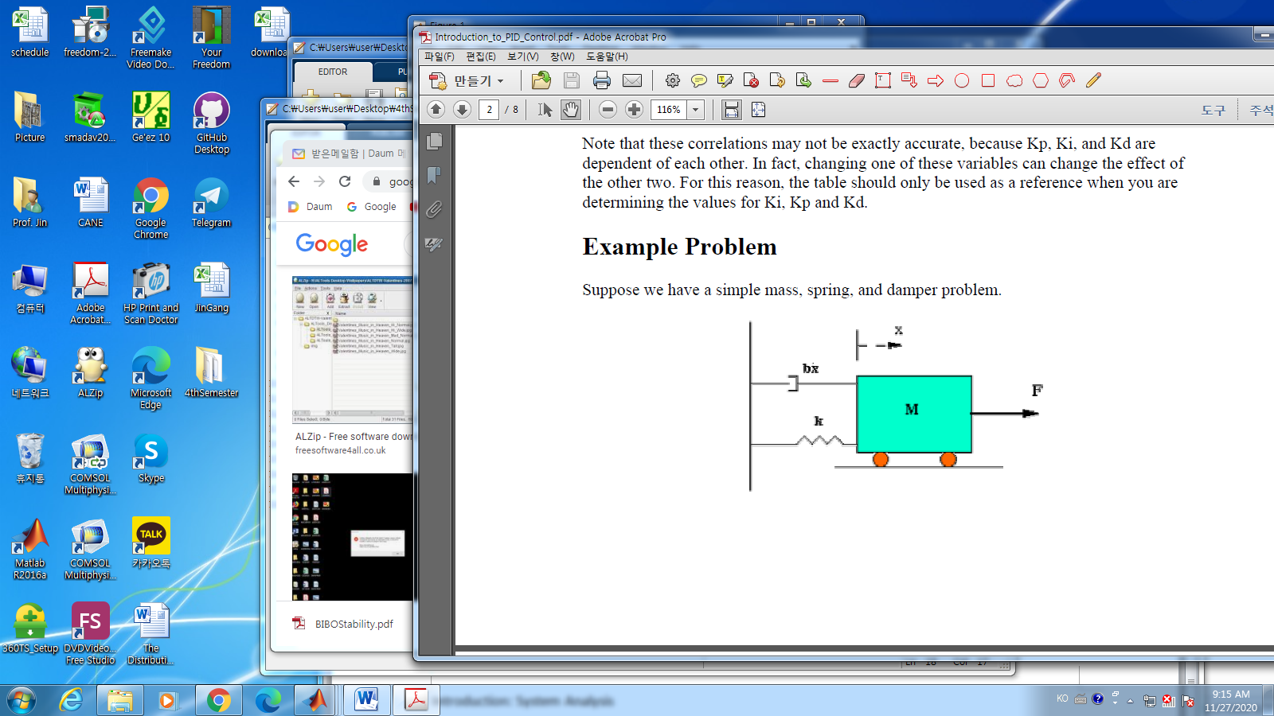

1. circuit

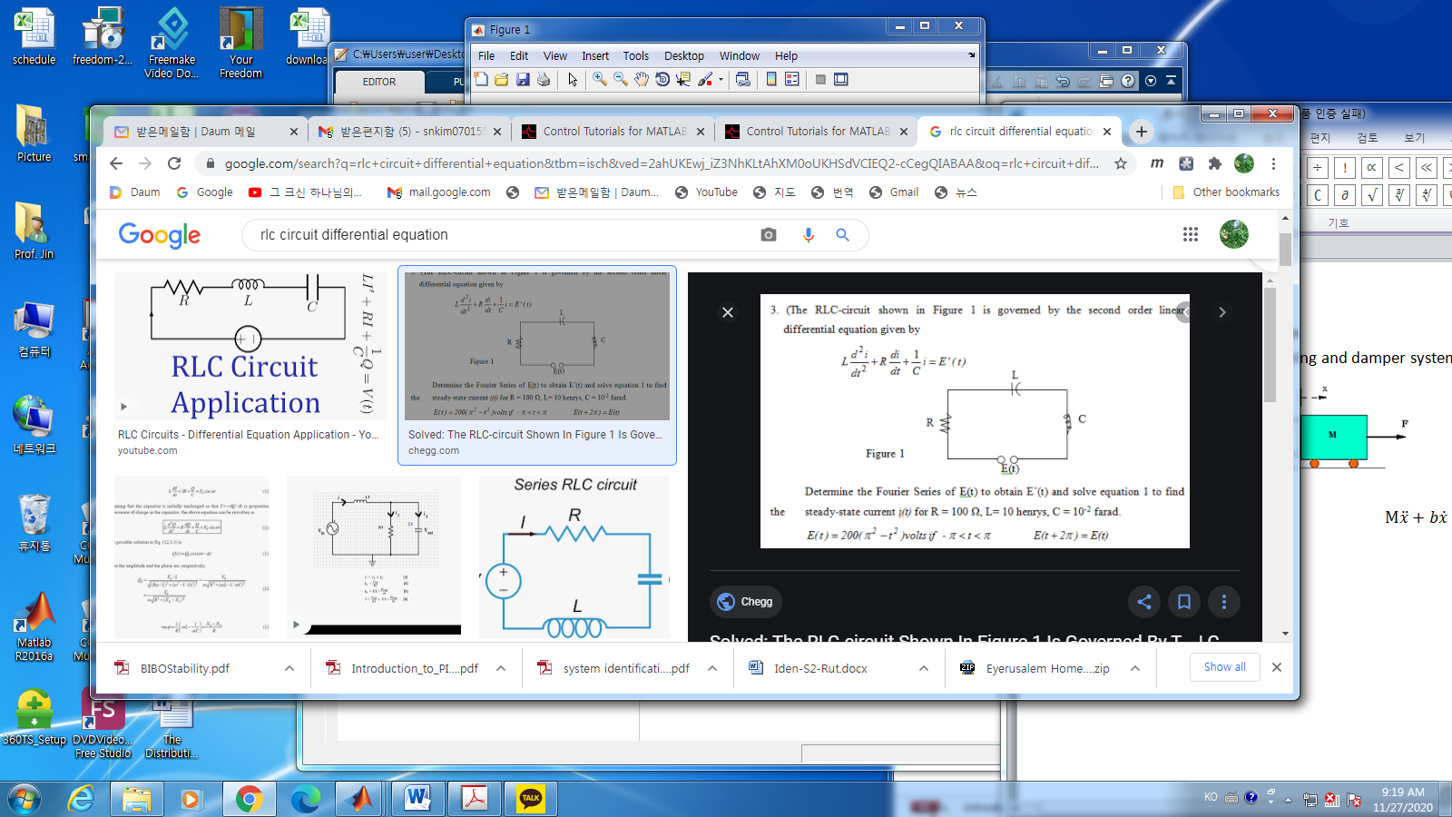

1. Basic terminology
   1. Time response

* General solution :
* Transient response

: depends on initial conditions

* Steady State response

: depends on system inputs

* Domain : time
  1. Frequency response

Linear Time Independent system

In the steady state, if a input is a sinusoidal (magnitude, frequency, phase)

* Output has same frequency but different magnitude and phase of the input.

1. Laplace transform

Time domain 🡪 frequency domain

1. In the steady state

%% radian

1. 3.1415…., a ir-rational number
2. the length of a circle with radius =
3. the relation between radian and angle
4. the frequency,
5. the angular frequency

Examp; sin wave

1. Transfer function
   1. Stability

Bounded input bounded output

1. Frequency domain

The poles of the transfer function are in LHP in “s”

Ex.

Poles of G(s) are all in the Left Half Plane (LHP) in the complex domain

* Poles of G(s) are all in LHP 🡪 BIBO Stable   
  1. First Order system

1. The transfer function
2. DC gain

The ratio of the mag. Of the steady state output to the magnitude of the step input

%% The final value theorem

The unit step has the Laplace as

%% The output at the steady state is

1. Time constant with step input

The first order system time constant is , where

1. With zero initial condition
2. With no-input

Step-response

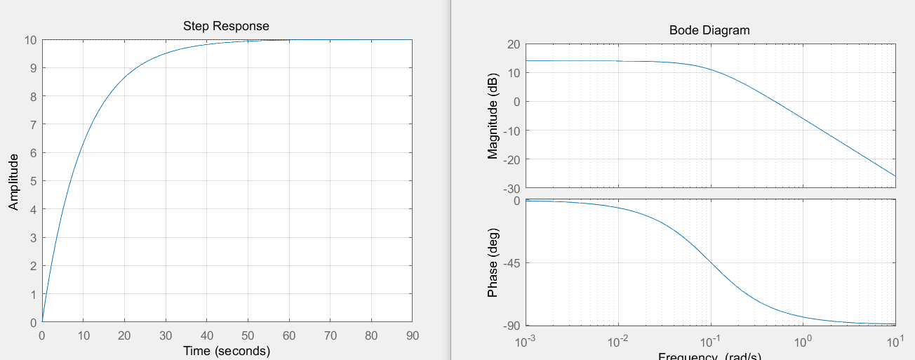

1. Settling time : 90%
2. Rise time : from 10 to 90%
3. Bode Plot

%%%

In the lower range of frequencies,

%%%%

* 1. Second order system

1. Governing equation

The transfer function

1. Terminologies

-DC gain

-Damping ratio

-Natural frequency

1. 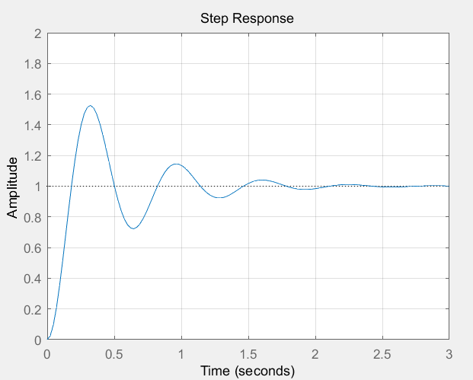Under damped System :
2. Overdamped

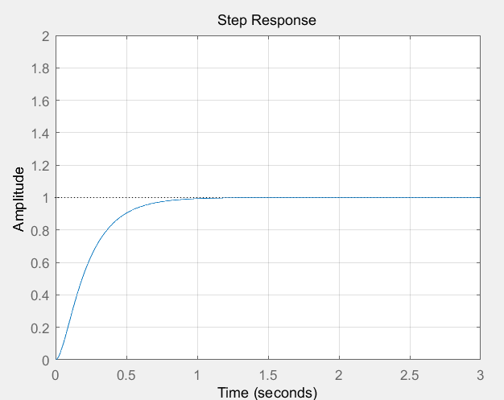

1. Critically damped
2. Undamped

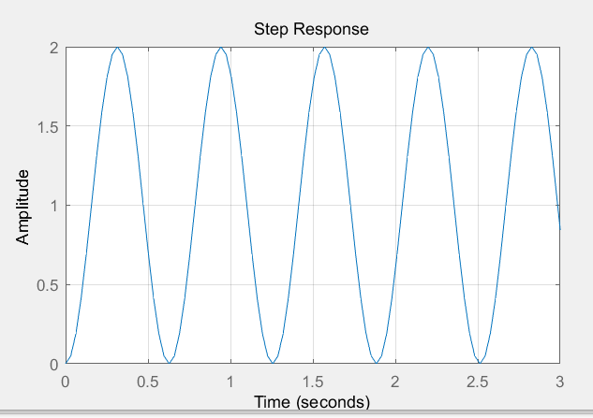

1. Bode plot

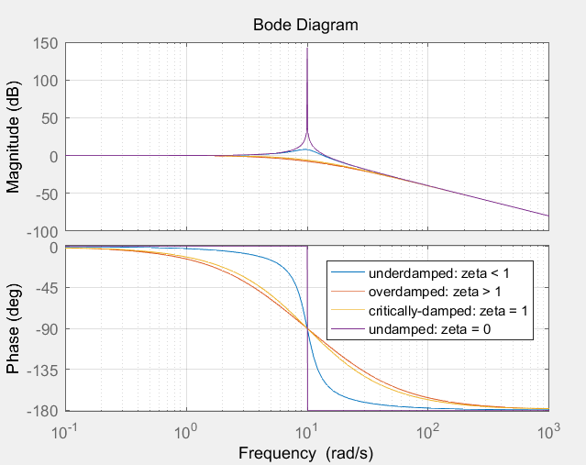

1. Dynamic System

* Time invariant:
* Linear Time Invariant
* State space representation
* State variables
* Input control vector
* The system matrix , Input matrix , Output matrix , feedforward matrix
* Transfer Function Representation
* Laplace transform
* The frequency domain method

Using the property,

If all the initial condition are zero

* The transfer function

1. System poles , zeros
2. System gain =
3. Equivalence to the state space
4. Example – Electrical System

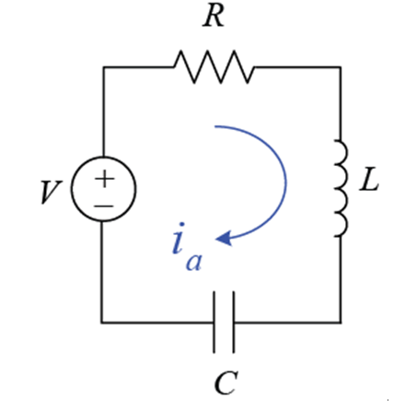

* 1. Governing equation

Remember

1. Define the state
2. The state space representation

The output we may choose as

1. The transfer function is