Introduction to PID control

1. Introduction

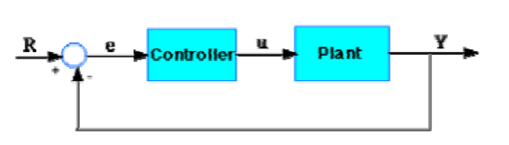

$R:$ the reference input , the desired value

$Y:$ the output

$e=R-Y :$ the tracking error =the reference input – the output

negative feedback

* 1. PID controller

The transfer function from $e$ to $u$

$$K_{p}+\frac{K_{I}}{s}+K_{D}s$$

$K_{p}:$ Proportional gain

$K_{I}:$ Integral gain

$K_{D}:$ Derivative gain

which is equivalent to in time domain

* 1. A simple example

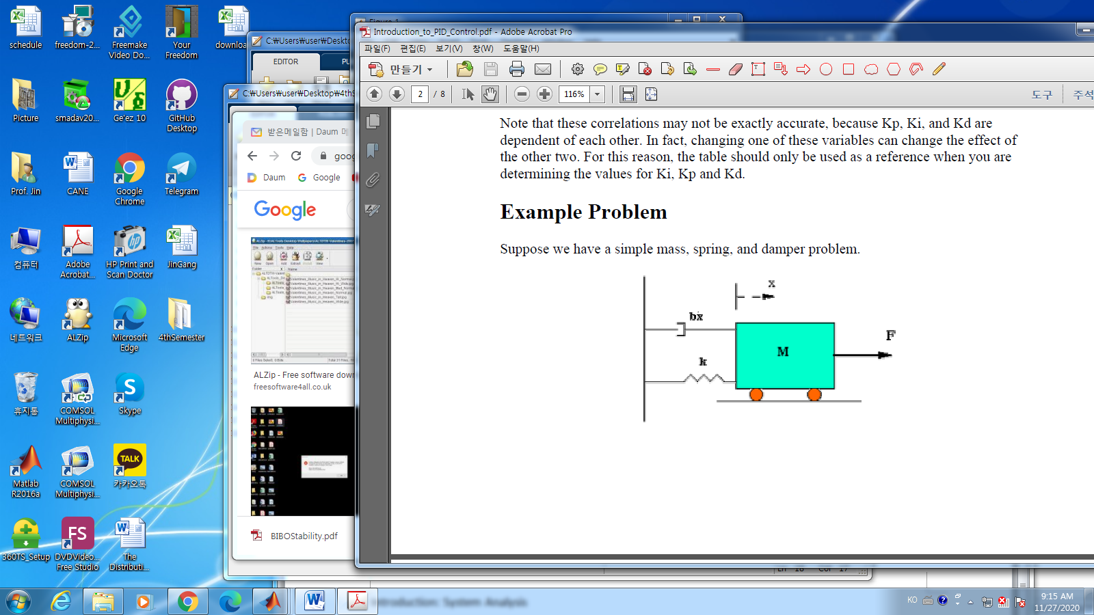

* Run Simulink in matlab

>> smulink

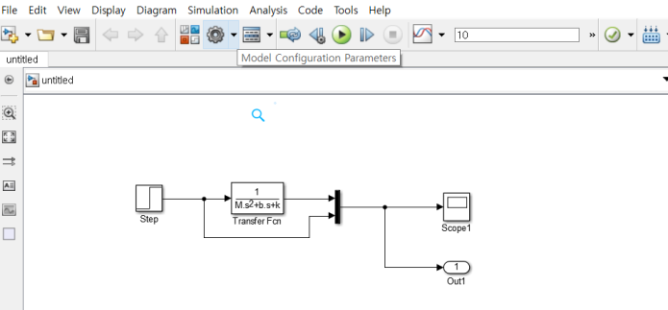

1)sampling time

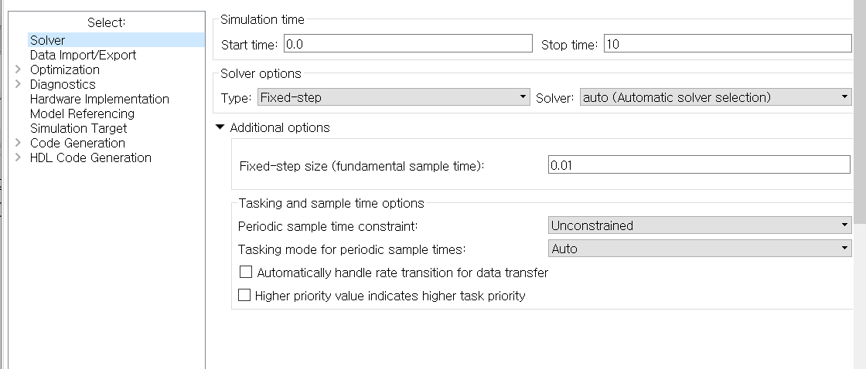

1. data import/export

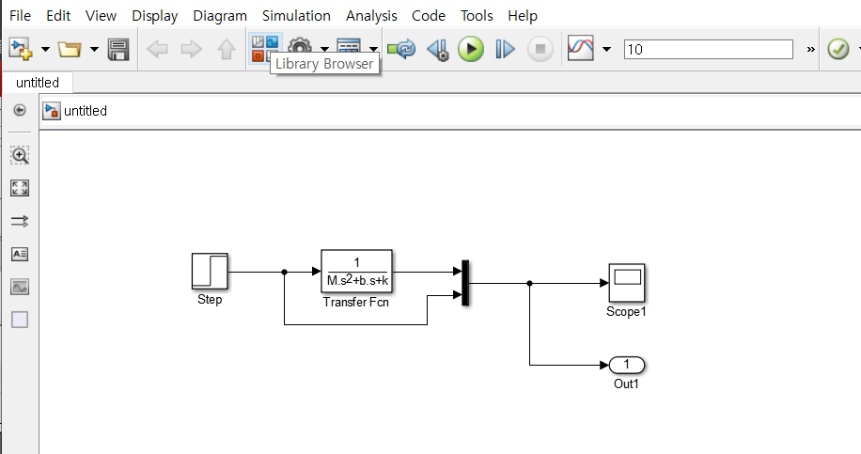

1. draw blocks ;

-simulink 🡪 sources , sink , signal routing,

-save the file

4) open a script window,

- define variables

5) run the script file

6) run the Simulink file

1. Mathematical Model

$$M\frac{d^{2}x}{dt^{2}}+b\frac{dx}{dt}+kx =F$$

$M:$ 1kg

$b:$ 10N.s/m

$k:$ 20N/m

$F:$ 1 N , applied force ,

1. Open loop step response
2. Steady state gain = 0.05/1 = 0.05 🡪 **want to be “1”**

Input value = 1

Output (Steady state value) = 0.05

1. Settling time : time to 90% of steady state value 1.5sec 🡪 **decrease**
2. Proportional control

2.1 Model

$$\frac{X\left(s\right)}{F\left(s\right)}=\frac{K_{p}}{s^{2}+10s+\left(20+K_{p}\right)}$$

For the Steady State Gain,

$$\frac{K_{p}}{20+K_{p}}\sim 1$$

2.2 Design the gain

$$K_{P}=300$$

2.2 Results

a) reduce the rising time, the steady state error, the settling time

b)increase the overshoot

1. Proportional and Derivative
   1. Model
 $$\frac{X\left(s\right)}{F\left(s\right)}=\frac{K_{D}s+K_{P}}{s^{2}+(10+K_{D})s+\left(20+K_{p}\right)}$$

  2. Design
 $$K_{P}=300, K_{D}=10$$

  3. Results
2. Reduce the overshoot
3. Proportional and Integral
   1. Model
 $$\frac{X\left(s\right)}{F\left(s\right)}=\frac{K_{P}s+K_{I}}{s^{3}+10s^{2}+(20+K_{P})s+K_{I}}$$

  2. Design
 $$K_{P}=30, K_{I}=70$$

  3. Results
4. Reduce the steady state error, overshoot,
5. Increase the rising time
6. Proportional, Derivative and Integral
   1. Model
 $$\frac{X\left(s\right)}{F\left(s\right)}=\frac{K_{D}s^{2}+K_{P}s+K_{I}}{s^{3}+(10+K_{D})s^{2}+(20+K_{P})s+K_{I}}$$

  2. Design
 $$K_{P}=350, K_{I}=300, K_{D}=50$$

  3. Results
7. Reduce steady state error, overshoot, rising time
8. In summary
9. Obtain an open loop response
10. Determine the specifications
11. Add a proportional control to improve rising time
12. Add a derivative control to improve the overshoot
13. Add an integral control to eliminate the steady state error
14. Be sure, If your output meets your specifications, keep the controllers as small as possible.