PID tuning method

1. Matlab PID Controllers
   1. Matlab provides PID controller

In Simulink – continuous library – PID controllers,

$$G\left(s\right)=K_{p}+\frac{K_{I}}{s}+D\left(\frac{Ns}{s+N}\right)=K_{p}+\frac{K_{I}}{s}+D\left(\frac{s}{\frac{s}{N}+1}\right)$$

where

$K_{p}:$ proportional gain

$K_{I}:$ Integral gain

$D:$ Differential gain

$N:$ Filter gain

See ; $\left(\frac{s}{\frac{s}{N}+1}\right) \sim s$ if $N is large$. In general $N\sim 10$.

1. Major characteristics of the closed-loop step response
   1. Rise Time : the tile up to 90% of the steady state
   2. Overshoot: the peak level is higher than the S.S.(S.S.)
   3. Settling time: the time for the system to converge to its S.S.
   4. Steady-State error: The difference between S.S. and the desired value
2. The effects of PID controllers

|  |  |  |  |  |
| --- | --- | --- | --- | --- |
| Pesponse | Rise Time | Overshoot | Settling Time | S.S. error |
| $$K_{p}$$ | Decrease | Increase | NT | Decrease |
| $$K_{I}$$ | Decrease | Increase | Increase | Eliminate |
| $$D$$ | NT | Decrease | Decrease | NT |

1. Ziegler-Nichols Tuning Rules
   1. Based on Step Response of Plant

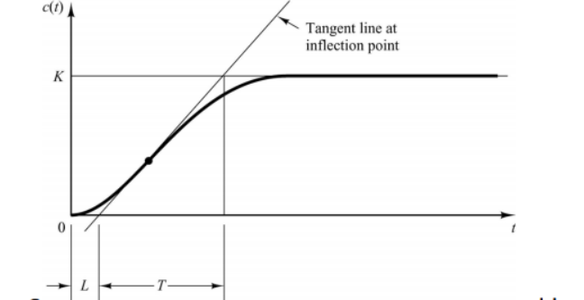

1. Two constants

$L:$ Delay Time

$T:$ Time constant

1. Values of Gains

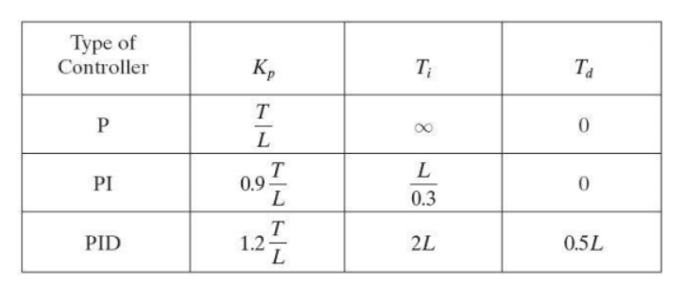

* 1. Second Method

1. Two Constants

$K_{cr}:$ the smallest value up to system output to be oscillate

$P_{cr}:$ the period of the first S.S. osilation.

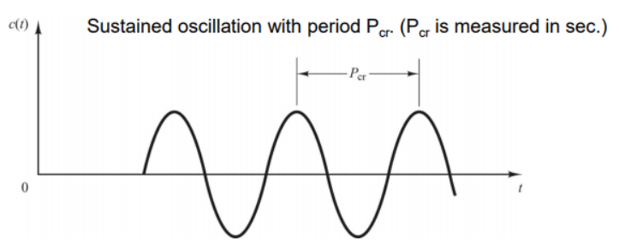

1. Values of Gains

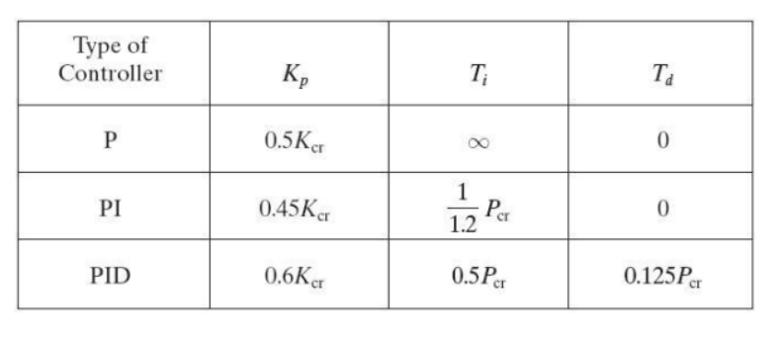

* 1. The output using Ziegler-Nichols features
* With unknown plant models, the overshoot will be less than 25 % with a good settling time.

1. Matlab PID controllers

In Simulink, PID controller toolbox is provided with a good graphic output for user-friendly.

Example : a second –order system

PID_Tuning_1.slx with Tut_Week_5.m

Example: FOTD system(first order time delayed system)

Week_5_Time_delay.slx with Tut_Week_5.m

%% comments:

Time delay linear system :

$$e^{-τ_{d}s} \frac{K_{ss}}{T_{c}s+1}= \frac{K_{ss}}{T_{c}s+1}$$

Since $e^{-τ_{d}s }=\frac{1}{e^{τ_{d}s}}=1/(1+τ_{d}s+\frac{τ_{d}s^{2}}{2}+…+ )$, which introduces infinite number of poles in the system. This leads to be difficult to analysis by the standard control linear theory.

You may verify if time delay is a little bit long, then the feedback system may be unstable!!. Check Week_5_Time_delay example.