Introduction: System Identification.

* Def: System identification is the study of Modeling dynamic System from experimental data.

1. Modelling

* Mathematical Description of System Linear / nonlinear, Time invariant /varying.
* Parametric / non parametric

1. Parametric identification/estimation

Find …

3) Non-parametric Identification

Given, find

* Relation between Machine Learning / AI

Given data, find some features inside the data

* Machine Learning:

Supervised Learning : example/ training

Unsupervised learning: classification,

* System Identification: In/Out relations, Usually dynamic system

Ch.1 Introduction

1. Introduction
   1. System Theory
      1. Terminology

Input

Disturbance:

State:

Disturbance: , output disturbance (sometimes noise)

Output:

* + 1. Basic Problems
* Modeling / Analysis / Estimation / Control

1. Modeling

Relation between variables on the basis of prior knowledge, assumption about the uncertainties

Unknown / incomplete known coefficients :

1. Analysis

In system identification, **identifiability analysis:** “can the unknown parameter be uniquely, albeit locally, identified?”

1. Estimation

-State estimation / parameter estimation

-State estimation: based on the assumption that model is perfect, parameters are exactly known

-Parameter identification: estimate the model parameter from

1. Control :PID, LQG,..
   1. Mathematical Models
      1. Model Properties

-Discrete-time

-Continuous-time

* Linearity

Assumption: Input: corresponding output:

The system is linear if

Input: then Output:

* Time- Invariance

Assumption: input output .

Then if input ,then

* Causality: The output does not depend on the future value of the input
* Estimation/ Prediction
* Dynamics

If the system depends on its history, and not just on the present input, it is called a dynamic system. See (1.1), (1.2)

* + 1. Structural model Representations
* Ex.1.4 / 1.5 A liquid storage tank:

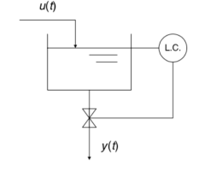The volume of the liquid in the storage tank: =

Inflows / outflows:

A proportional level controller:

* Let
* Differential Equation

1. The homogeneous solution: with
2. The total solution with initial condition
3. The system is linear
4. The system is time – invariant, because

1. The system is causal
2. The impulse response
3. Convolution model: the output is modelled as (1.5)
4. Differential equation model / state-space model

* Kim : Problem 1.2
* Kim’s comment : impulse response
* Property
* The impulse response function from (1.5)

Input = , output =

(Even if the limit of the integral to infinity,

Hence the output (the response) is

Hence is called the impulse response function.

Ex. Let a transfer function , what is the impulse response function?

%%%%%%%%%

1. System Response Methods
   1. Impulse Response
      1. Impulse Response Model Representation

* Convolution Model (Impulse response model)
* If is known, then is easily computed given
  + 1. Transfer Function Model Representation
* Laplace transform
* The transfer function
* Ex.2.1: Recall the liquid storage tank
* Kim’s comment:

1. The homogeneous solution:
2. The particular solution

Assume

Check this is the solution:

which leads to

Is the solution to

1. The total solution

%%%%%%%%%%

* The transfer function
  + 1. Direct Impulse Response Identification
* Identification of given in Discrete Convolution Model

1. Discrete convolution model

Assume the initial condition is zero, and

Therefore

1. Case of Pulse Input

In general, let input as

Then the output is from (2.5)

where the measurement noise

* The estimator of

The error

* should be large to minimize error
* : modeled as a memoryless, i.e., no dynamics.
* 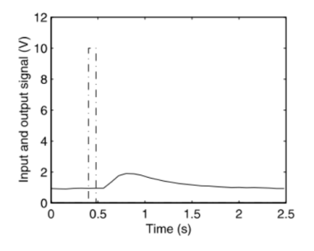Ex.2.2 Heating system
* Sampling time interval = 0.08

Input:

Output: the voltage of a thermometer

* Is this a linear system? You need to prove the linearity
* If it is a linear, then you may try to get a transfer function.
  1. Step response
     1. Direct Step Response
* Ex.2.3 Heating system

Input :

-Dead time(delay time) : 0.2sec

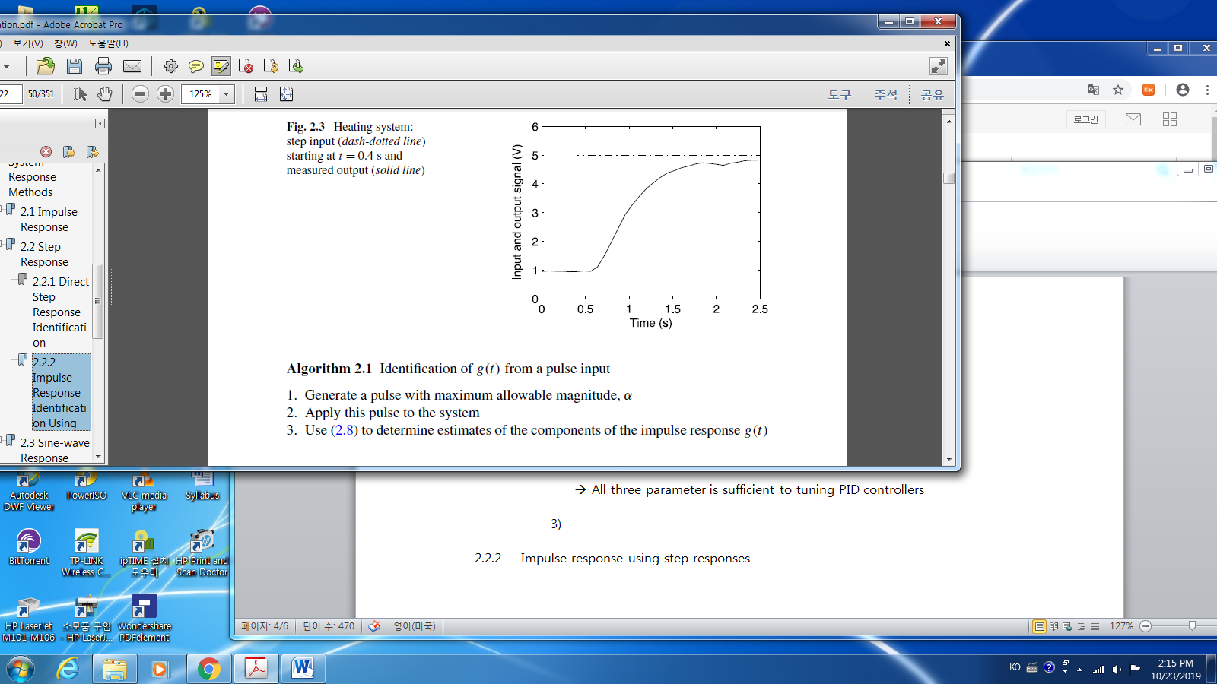-Time constant : time to reach to 63%(~1/e) of the steady state value : 0.4sec

-Static gain : ~ ~ (4.8-1)/(5-0)= 0.76

* Kim: Let’s assume as a first order time delay system as

🡪 All three parameter is sufficient to tuning PID controllers

* + 1. 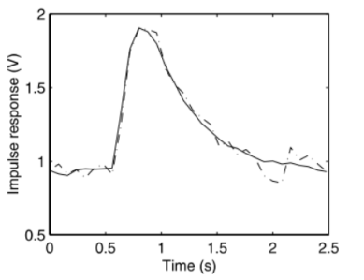Impulse Response Identification Using Step response

From (2.9) to (2.5)

* How to get :
* We may get

Then one of the estimator of is

* 1. Sine-Wave Response
     1. Frequency Transfer Function
* Continuous Frequency Response
* A sampled system: Discrete Frequency Response Function
* Kim’s comment Continuous / Discrete Fourier Transform

-Laplace transform, z-transform

* Kim’s comment: Pulse(z) transfer function with the zero initial condition

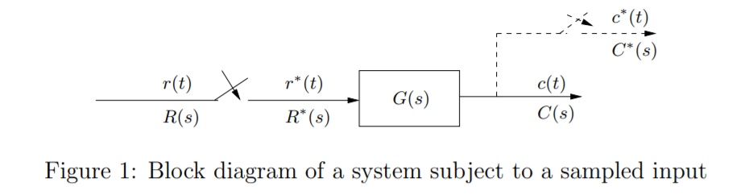

* Continuous time transfer function :
* Sampled(discrete) time transfer function:

The sampled output :

Since is periodic,

Define

z- transfer function :

In the text,

Comparing this with (a)

For the frequency domain analysis (in the steady state),

And let the notation be simple, the sampling time

* The time index as in (a) and in (2.13). Since in the text, the author assume that , in almost all places. You may assume, there is , then it is with

Hence

* Since (a) is derived in zero initial condition, hence the

where

%%%%%%%%%%%%

* Kim’s Comment : Sample and Hold

Sample and Hold: D/A converter,

* Zero-order / First –order
* 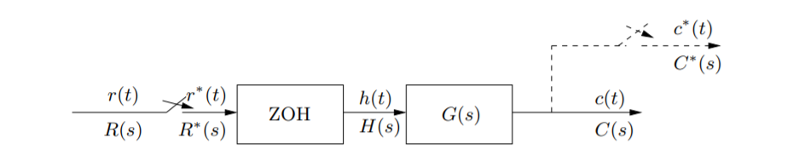Zero-order :

* Kim’s Comment : z Transfer function with the ZOH

Hence the equivalent z-transform is

Hence

%%%%%%%%

* + 1. Sine wave response Identification
* Input

Output from (2.5) with and

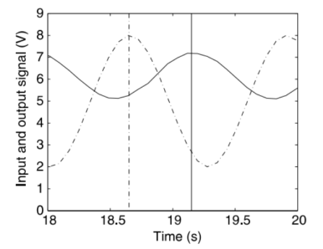

* Ex. 2.5

-.

-. Gain: ~ Phase delay =