1. Static System Identification
   1. Linear system
   2. Non-linear Static Systems
      1. Non-linear Regression

$$y=f\left(Φ, ϑ\right)+e$$

where

$\left[y\left(1\right), y\left(2\right),…, y(N)\right]:$ measurements

$f\left(Φ, ϑ\right):$ the known model

$ϑ:$ the unknown parameters to be estimated

$e:$ the prediction error ( the measurement noise)

* In the linear case,
  + 1. Non-linear Least square estimation
* The cost function (the sum of squares of the prediction errors)
$$J\left(ϑ\right)=ε^{T}ε={\left(y- f\left(Φ, ϑ\right)\right)}^{T} \left(y-f\left(Φ, ϑ\right)\right)$$

* The derivative of $J$ w.r.t unknown variables (to be estimated) $ϑ$
$$\frac{∂J\left(ϑ\right)}{∂ϑ}=-2\left(\frac{∂f\left(Φ, ϑ\right)}{∂ϑ}\right)\left(y-f\left(Φ, ϑ\right)\right)=0$$

* The sensitivity function $X\left(ϑ\right)∈R^{N×p},$

$N=$ the number of the measurements

$p=$ the number of the estimated aprameters

$$X(\hat{ϑ})= {\left[\begin{matrix}\frac{∂\hat{y}\left(1:\hat{ϑ}\right)}{∂ϑ_{1}} & … & \frac{∂\hat{y}\left(1:\hat{ϑ}\right)}{∂ϑ_{p}} \\ ⋮ & … & ⋮ \\ \frac{∂\hat{y}\left(N:\hat{ϑ}\right)}{∂ϑ_{1}} & … & \frac{∂\hat{y}\left(N:\hat{ϑ}\right)}{∂ϑ_{p}}\end{matrix}\right]}_{N×p} (5.67)$$

where

$\left[\begin{matrix}\frac{∂\hat{y}\left(1:\hat{ϑ}\right)}{∂ϑ_{1}} & … & \frac{∂\hat{y}\left(1:\hat{ϑ}\right)}{∂ϑ_{p}}\end{matrix}\right]:$ the first measurement with $\hat{ϑ}=({\hat{ϑ}}_{1},…,{\hat{ϑ}}_{p})$

$\left[\begin{matrix}\frac{∂\hat{y}\left(N:\hat{ϑ}\right)}{∂ϑ_{1}} & … & \frac{∂\hat{y}\left(N:\hat{ϑ}\right)}{∂ϑ_{p}}\end{matrix}\right]:$ the Nth measurement with $\hat{ϑ}=({\hat{ϑ}}_{1},…,{\hat{ϑ}}_{p})$

* In Linear case

$$X\left(ϑ\right)=\left(\frac{∂f\left(Φ, ϑ\right)}{∂ϑ}\right)=A$$

which is independent of $ϑ$.

%%% Kim’s comment

Since in (a), in general, $X(ϑ)$ is dependent of $ϑ$. In concept,

First estimation

Second estimation

y(1)

y(3)

y(2)

x(1) x(2) x(3)

Hence for each $\left(x\left(i\right), y\left(i\right)\right)$, the estimation is evaluated at $N$ times with different $({\hat{ϑ}}_{1}\left(i\right), …,{\hat{ϑ}}_{p}\left(i\right))$ recursively.

* In linear case

$$X\left(ϑ\right)=\left(\frac{∂f\left(Φ, ϑ\right)}{∂ϑ}\right)= A$$

which is independent of $ϑ$



$Φ-→ \frac{∂f\left(Φ, ϑ\right)}{∂ϑ}, Φϑ-→f(Φ, ϑ)$

%%%%%%

* Apply Least square as

$${\hat{ϑ}}_{i+1 }= {\hat{ϑ}}_{i}+{\left(X_{i}^{T}X_{i}\right)}^{-1}X_{i}^{T}\left(y-f\left(Φ_{i},{\hat{ϑ}}_{i}\right)\right)$$

%%% Kim’s example

1. Model

$$y={\left(x-a\right)}^{2}+e$$

(input, measurement) = $(x,y)$, unknown = $a$, one unknown.

1. The sensitivity function
$$S=\frac{∂y}{∂a}= -2\left(x-a\right)$$

2. Pick up an initial estimator as $\hat{a}=1.1$

The sensitivity function $S=$

1. Result

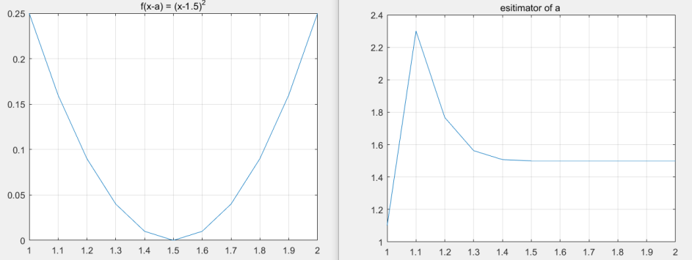

* Ex. 5.21 : Nitrification experiment

1. Modelling

Input:

-Nitrogen load $B=0.281 kg\frac{N}{m^{3}}day$

Output:

-The maximal oxygen demand rate $r_{smax}\left(t\right)$

Unknown

-Death rate of the nitrifying biomass : $b$

-Maximal growth rate of the nitrifying biomass : $μ_{max}$

$$r_{smax}\left(t\right)=r_{smax}\left(0\right)e^{-bt}+μ_{max}B(1-e^{-bt})/b$$

1. Formulation

* Define $ϑ={\left[b u_{max}\right]}^{T}$

1. Calculate the sensitivity $$S={\left[\frac{∂f\left(Φ, ϑ\right)}{∂ϑ_{1}} \frac{∂f\left(Φ, ϑ\right)}{∂ϑ_{2}}\right]}^{T}$$
$$r_{smax}\left(0\right)te^{-bt}-\frac{μ_{max}B}{b^{2}}+\frac{μ_{max}Bt}{b}e^{-bt}+\frac{μ_{max}B}{b^{2}}e^{-bt}$$

$$=\left[\begin{matrix}{-r}_{smax}\left(0\right)te^{-bt}-\frac{μ_{max}B}{b^{2}}(1-e^{-bt})+\frac{μ_{max}Bt}{b}e^{-bt} \\ \frac{B}{b}-\frac{B}{b}e^{-bt}\end{matrix}\right]$$

2. Results

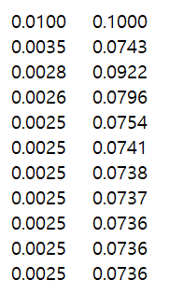

Estimated (b , umax)

