* Verification of time –delay system stability -- FOPTD system

$$1+\frac{ke^{-τs}}{s+1}=0$$

$$\left(s+1\right)+ke^{-τs}=0$$

1. Analytic solution :
   1. Routh : First approximation
 $$\left(s+1\right)+ke^{-τs}\sim \left(s+1\right)+k\left(1-τs\right)=0$$

 $\left(1 -kτ\right)s+1+k=0 -→ k<\frac{1}{τ}, and k> -1 -→ 0<k< \frac{1}{τ}$

 2. Pade approximation

Using Pade approximation first approximation,

$$\left(s+1\right)+k\frac{2-τs}{2+τs}=0$$

$$\left(s+1\right)\left(2+τs\right)+k\left(2-τs\right)=0$$

$$τs^{2}+\left(2+τ\right)s+2+2k-kτs=0$$

* Routh Hurwitz

$$τ 2+k$$

$$\left(2+τ-kτ\right) 0$$

Hence

$$2+τ-kτ>0 -→ \frac{2+τ}{τ}>k$$

Implies

$$0<k<(2+τ)/τ$$

1.3 Nyquist

$$-1=\frac{ke^{-τs}}{s+1} for s=jω$$

$-s-1={ke}^{-τs} -→ -jω-1=k(\cos{τω-j\sin{τω) }}$

$k\cos{τω}= -1 , ksin τω=ω$

$$\cos{τω}= -\frac{1}{k}, \sin{τω=\frac{ω}{k}}$$

$${\left(-\frac{1}{k}\right)}^{2}+{\left(\frac{ω}{k}\right)}^{2}=1 -→1+ω^{2}=k^{2}$$

where $ω$ is a solution to (1)

$$\tan\left(τω\right)= -ω (1)$$

Now to (1) there are infinity solutions to this equation. There is no analytic solution.

In conclusion, given $τ$, the smallest value $of ω$

$$0< k<{\left(1+ω^{2}\right)}^{1/2}, where tan\left(τω\right)= -ω$$

Now to (1) there are infinity solutions to this equation. There is no analytic solution.

The first $ω$ satisfies (1) is $ω\sim 2.03$ which yields to $k_{upperLimit} \sim 2.26$

1. Verification :

There are many approximated solutions for gain to insure the closed loop stability.

So I try these are simulate in Simulink. With the assumption $τ=1$, I check the stability

|  |  |  |
| --- | --- | --- |
|  | K |  |
| Routh Hurwitz |  |  |
| First approx.. | 0 < K < 1 | Too conservative |
| Pade | 0 < k < 3 | Not correct. |
| Nyquist |  |  |
| First approx.. | 0 < $k$ < 2.26 | Stable region   * Check if k> 2.26 |

1. In conclusion
2. If a model is assumed to be time delayed system, in order to check the stability, I recommend to use **Nyquist plot** and **Simulink**

* Convolution integral

1. Calculate the output of the following system
$$u\left(t\right)= \left\{\begin{aligned}1 0≤t≤1 \\ 0 otherwise\end{aligned}\right.$$

$$y\left(t\right)=y_{0}e^{-kt}+ \int_{0}^{t}{e^{-k\left(t-τ\right)}u\left(τ\right)dτ}, y_{0}=0, k=1$$

2. Solution : remember the convolution integral, and in the Iden. Textbook, you may see this kind of output with pulse input.

Now look at the input.so

If $0≤t≤1$

$$y\left(t\right)=y_{0}e^{-t}+ \int_{0}^{t}{e^{-\left(t-τ\right)}u\left(τ\right)dτ},$$

$$=\int_{0}^{t}{e^{-\left(t-τ\right)}u\left(τ\right)dτ}$$

$$=e^{-t}\int_{0}^{t}{e^{τ}u\left(τ\right)dτ}=e^{-t}\left(e^{t}-1\right)=1-e^{-t}$$

If $1<t$

$$y\left(t\right)= \int_{0}^{t}{e^{-\left(t-τ\right)}u\left(τ\right)dτ}$$

$$=\int_{0}^{1}{e^{-\left(t-τ\right)}u\left(τ\right)dτ}+ \int_{1}^{t}{e^{-\left(t-τ\right)}u\left(τ\right)dτ}$$

$$=\int_{0}^{1}{e^{-\left(t-τ\right)}u\left(τ\right)dτ}$$

$$=e^{-t}\left(e^{τ}|_{0}^{1} \right)=e^{-t}\left(e-1\right)$$

1. The graph

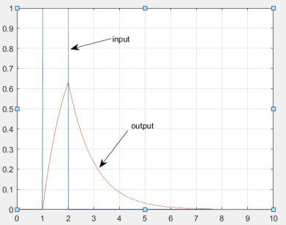

* Kalman filter

1. Block diagram for a Kalman filter

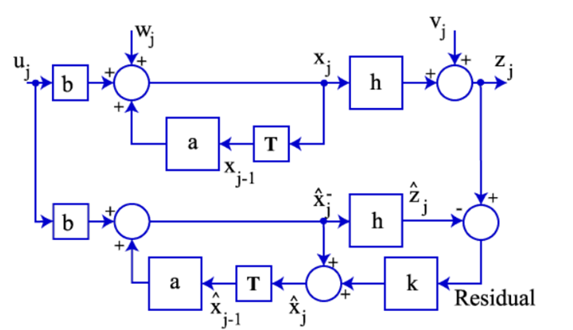

1. The kalman filter block

* It is implemented in the computer (almost all!!)
* What is the input of the kalman filter:

The measurement of the real plant, $z_{j}$. What is the input of the real plant? $u, w_{j}, v_{j}$ Do you differentiate the differences?

What is the output of the kalman filter? ${\hat{x}}_{j}^{-}, {\hat{x}}_{j}$ if you want. Do you differentiate the differences?