1. Random Variables and Stochastic Process
2. Conditional Expectations and Discrete-Time Kalman Filtering

* Introduction
* Model: the measurement is modeled as the sum of two 2 RVs.
* Known fact
* Unknown fact (You may have to calculate )

* Given a measure of , What is an estimator of For example
* Example

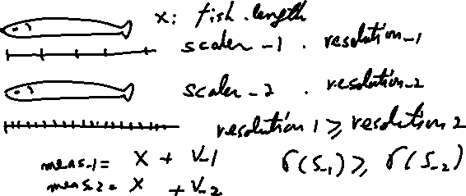

Now if we know the density of the fish, then

Weight = (density)*(volume) + noise ~ (density)*(length) + noise 🡪

1. The **minimum variance estimator**
   1. Some textbooks, it is called as the **minimum mean square error**

<https://en.wikipedia.org/wiki/Minimum_mean_square_error#:~:targetText=In%20statistics%20and%20signal%20processing,values%20of%20a%20dependent%20variable.>

* 1. Identification : the **least (mean) square error**

1. The maximum a posteriori estimator

Bayesian probability

* : = the posteriori PDF
* : = the priori PDF
* : the likelihood
  1. Minimum Variance Estimation
* Problem statement – static parameter estimation

where .

* The minimum variance estimator
* Remark 3.1.argmin
* (Skip): Define convex distance function

Is a non-negative and convex distance function.

-. Convex function: a function is convex if for any points, and some scalar such that

-. Example of a convex function

* (Skip): Define a loss function , such that

-.

-.

(Skip) Theorem 3.2(Sherman’s Theorem). Let x be a random vector with mean, , and density,. Let be a loss function as defined above. If . Is symmetric about and unimodal(i.e., has only one peak), then minimizes .

* Without observation, the minimum variance estimator.

Sol:

* Remark Sherman’s theorem is generalized of the above estimator.
* Theorem 3.6. Given the equation(3.1). if the estimate is a function of , then the minimum variance estimate is the conditional mean.

(Skip) Proof: let be an estimator of ( that means given is a constant).

Then for

Since the cross term is

.

Then

Since are independent of and is positive semidefinite,

1. is equivalent to

* Remarks:

1. It means
2. It is **unbiased**

* Ex.3.8: conditional mean and variance of the sum of two RV’s

Let measurement , , are independent. Find the the minimum variance estimate

* a priori information,
* a noise,

1. Before finding ,calculate (in the text book, characteristic function used)

We will use the convolution integral

* ,
* ,
* ,
* ,
* What is

1. Calculate . Hence first find .

Since ,

Hence

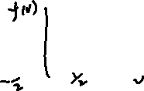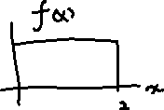

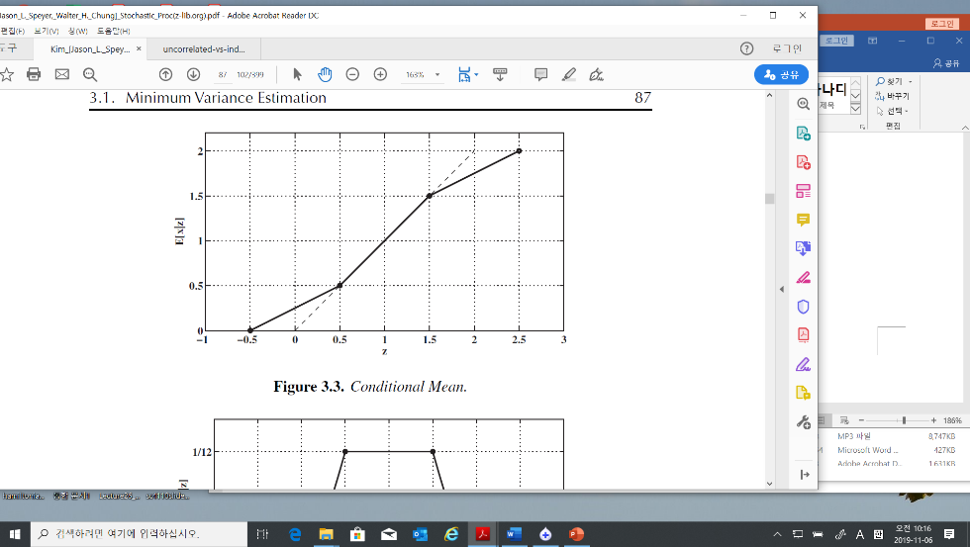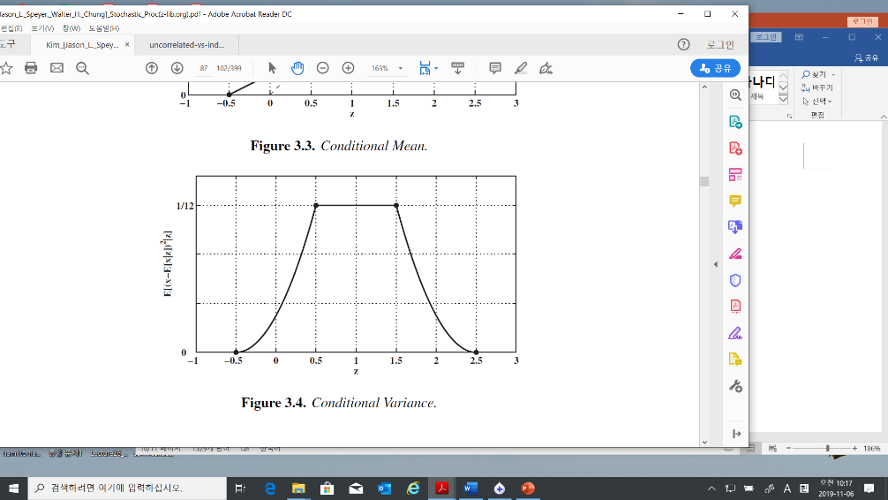



* What is the variance of ?
* If we choose the estimator , then the variance of error is
* Now You may compare the estimator. The first one is the conditional estimator, the other is the mean estimator.

1. The error variance for the conditional estimator: (at textbook p.88)
2. The error variance of the mean estimator is
3. Hence the mean estimator is not good compared to the MVE!!
   1. Conditional Estimate of a Gaussian Random Vector with Additive Gaussian Noise

* Modelling
* %% I will notify means is independent.
* Problem: find

To get the solution, we need

1. Since are gaussians, is a gaussian
2. , and are correlated.
3. How to find given ?

* Solution

where

* The minimum variance estimator of

= the conditional expectation given

~ mean of x + (scale) (measurement – mean of x)

* Uncertainty: if the variance of a RV is large, the uncertainty is large.
* Scaler case

* How to find ?

-first find : He use a trick. Define a new RV as

-second find : This is simple. As you know

* Tip: (3.5) Matrix inverse

Verify the inverse in (3.5) 🡺

And 🡨 You may try

* Tip.
  + 1. (Skip) Simplification of the Argument of the Exponential
    2. (Skip) Simplification of the Coefficient of the Exponential
    3. Processing Measurements Sequentially
* Batch process / real time process (sequential measurement)
* Extension of (3.2): Sequentially measuring of
* Goal: find sequential the conditional mean of given the sequential measurements

Where in (3.32) means corresponding to in (3.13) indexed n.

* Solution

With the sequential measurements, construct it as a batch model

Since

Hence

Substituting (3.21) and (3.20) into (3.14) gives

Multiplying (3.22) through by gives

where a new variable **defined** as

And **define** additional terms as

We get

For iteration calculation, define new variables at measurement

And



* Iteration with at time step

Multiplying by then



Or

* Important:

1. With the last measurement , the conditional mean of can be calculated by (3.14) or (3.32)



1. To get the , in the batch process you need more memory compared to the real time process
2. In general, .Hence we need recursively using (3.28)
3. Kalman gain:
   * 1. Statistical Independence(orthogonal) of the Error and the Estimate

* Orthogonal in Linear algebra

Let two vectors . Two vectors are orthogonal if the dot product of x and y,

1. Ex.

* Projection

<https://ocw.mit.edu/courses/mathematics/18-06sc-linear-algebra-fall-2011/least-squares-determinants-and-eigenvalues/projections-onto-subspaces/MIT18_06SCF11_Ses2.2sum.pdf>

If we have a vector b and a line determined by a vector a, how do we find the point on the line that is closest to b?

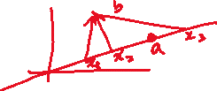

The vector from the closest point vector on the line to the vector should be perpendicular to the line

Hence

The projection vector on is defined .

* The statistical orthogonal

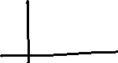

* 1. Maximum likelihood estimator

(Skip-But Later will review this) Maximum likelihood estimator

* 1. The Discrete-Time Kalman Filter: Conditional Mean Estimator
* Problem: A dynamic system given as

1. We measure
2. The conditional estimator (the MV estimator) is
3. The propagated estimator is

* *The propagated estimator:*

= a Priori Estimator / a Predicted estimator

= measurements are previous compared to a posteriori estimator







* *In general text book notations are as follows*
* The Estimator
* The Predictor 🡪 the upper accents are different ~~

1. Propagating the conditional mean = a priori = prediction

* Remember , not

1. Propagating the variance of the a priori
2. Updating the Conditional Mean: a posteriori

* Remember not

1. Updating the covariance: a posteriori

* Define: **Residual 🡪 innovation sequence**

From (3.44)

* Define Kalman Gain: the residual gain :

Hence (3.44.1) is

* Orthogonality Properties of the Conditional Mean Estimator

1. The Innovation Sequence is independent for each

Since, the mean of ,

And,

with these facts, therefore the covariance is

which implies the gaussian are independent.

1. Error is orthogonal to ,

* Example 3.9 (estimating the speed of a car)
* Problem: estimate traveled distance by car.

1. The speed of car = 55 mi/hr, for 1 hour, implies the distance is 55 mi
2. The trip meter shown 55.3 mi

What is the best estimated distance with two information?

* Method

1. The system is modelled as
2. We may guess
3. The variance by the measurement: the quantization of the trip meter is = 0.1(mi) 🡪 The variance of the trip meter ,
4. The variance by the process: the velocity varies +/- 1 (mi/hr), the variance of the process
5. The best estimator of the distance in mean square sense,
6. Comments:  
   - the variance of a uniform RV in (a,b) is

-. Compare