- Robust analysis
%% Review Week_7
- Fact: LQR controller
: gain margin >1/2 , phase margin = 60degree Robust!!
- Fact : LQR :
- Total system transfer function is of the order of two times that of the plant
- It is proved not robust to LQR
%% Kim’s comment
Gain margin, Phase margin from Nyquist
$$G\left(ω\right)=M\left(ω\right)e^{jP\left(ω\right)}$$
Nyquist stability criteria :
$$1+G\left(ω\right)=0$$
One simple application
- Gain margin = 10, then for constant gain $k,$ so that $kG(s)$ is stable in the closed loop system.
- Phase margin = 60 degree, for time delay $e^{-τs},$which has unity magnitude but phase delay as $τω$. Hence for any time delay $τ_{a}$ in forward of $G(ω)$, such that
$$τ_{a}ω<60,$$
Then $e^{-τ_{a}s}G(s)$ is stable in the close loop system
%%%
- The fundamental limitation on the controlled system
Sensitivity and complementary sensitivity function

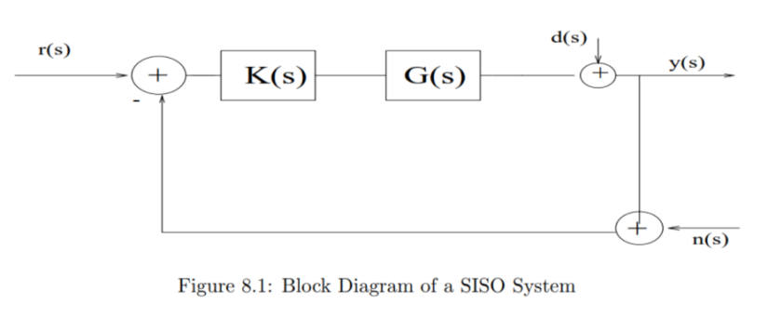

$$y\left(s\right)=\frac{G\left(s\right)K\left(s\right)}{1+G\left(s\right)K\left(s\right)}\left[r\left(s\right)-n\left(s\right)\right]+\frac{1}{1+G\left(s\right)K\left(s\right)}d\left(s\right) \\ =T\left(s\right)\left[r\left(s\right)-n\left(s\right)\right]+S\left(s\right)d\left(s\right)$$
S(s) : Sensitivity function
T(s): Complementary sensitivity function
- The fundamental limitation on the control
$T\left(s\right)+S\left(s\right)=1, ∀ G\left(s\right), K\left(s\right)$ :
- Control Objective
1) in the low frequency range
Reduce the model error and the disturbance effect, good command following,
$$G\left(ω\right)K\left(ω\right)≫M$$
2) in the high frequency range
Reduce the noise effect, $$G\left(ω\right)K\left(ω\right)≪M$$
What is the meaning of the above inequality in MIMO? , there is a tool Singular Value Decomposition, H-infinity controller
%%%%
- Robust Control [1]

- Model ;
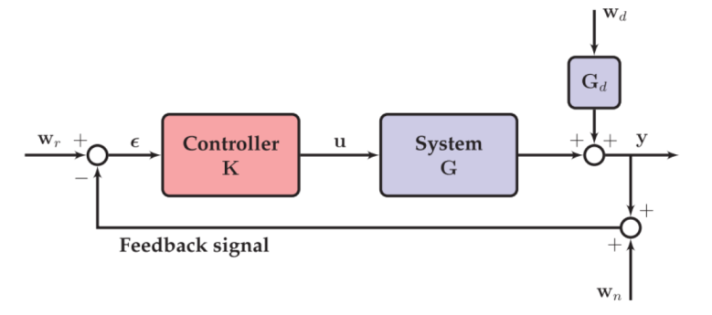
Consider the following block diagram

- Transfer functions
$$y=GK\left(w_{r}-y-w_{n}\right)+G_{d}w_{d}$$
- $y={\left(I+GK\right)}^{-1}GKw_{r}-{\left(I+GK\right)}^{-1}GK w_{n}+{\left(I+GK\right)}^{-1}{G_{d}w}_{d}$
- $y=T\left(S\right)w_{r}-T\left(s\right)w_{n}+S\left(s\right)G_{d}w_{d}$
- Terminology
  - Loop transfer function: the open loop transfer function
$L\left(s\right)=G\left(s\right)K\left(s\right)$
  - Tracking error
  - Tracking Error
$e\left(s\right)=w_{r}-y=Sw_{r}+Tw_{n}-SG_{d}w_{d}$
- Objective : for good performance $S(s)$ is small
- $\left\|S\right\|$ is small in frequency range
  - H-infinity norm
- In time domain
$${\left\|x\left(t\right)\right\|}_{1}=\left|x(t)\right|, {\left\|x\left(t\right)\right\|}_{2}= \int{x{\left(t\right)}^{2}}dt$$
- In frequency domain
$${\left\|S(ω)\right\|}_{2}= \int{S\left(ω\right)S^{*}(ω)}dω, {\left\|S(ω)\right\|}_{∞}=\max\left|S(ω\right|$$
- H-infinity norm of $S\left(ω\right)= {\left\|S(ω)\right\|}_{∞}$
- In scalar, it is the peak value in Bode magnitude plot.
- Singular values of $S\left(ω\right)$
- In Matrix case for all $ω∈[0 , ∞)$
$$Singular values of S=\sqrt{e-values (S\left(ω\right)S{\left(ω\right)}^{*})} =[σ_{M}, …, σ_{m},…]$$
%%% Bode plot it’s domain is frequency
Ex. $G\left(s\right)=\frac{1}{s^{2}+2s+10} , K\left(s\right)=1$
Bode plot of S(s) , T(s)
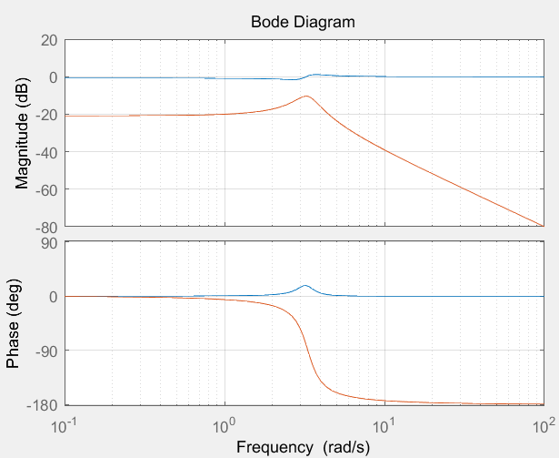

%%%

  - Controller objective to minimize the tracking error without exogenous inputs $w_{d}, w_{n}$. Find $K\left(s\right)$ s.t. $the magintude S\left(s\right)= {\left\|\frac{1}{1+GK}\right\|}_{∞}$ is small
Contradiction : $T\left(s\right)+S\left(s\right)=1$
  - All real systems will have a range of frequencies where $\left|S\right|>1$
- For any controller, the tracking error is degraded in this range!
- Not only the tracking error, the stability will be degraded by Nyquist analysis
- Loop shaping design / H-infinity design / loop transfer Recovery
- MIMO uncertainty problem [3]
- MIMO
In the SISO case, a good tool to check the stability due to model uncertainty is Nyquist plot( combined Bode plot).The measurements of the robustness are gain margin and phase margin. Let us see the gain margin $M\left(ω\right)$ and phase margin $P\left(ω\right).mega phase margin margin and n, . the model uncertainty$
In order to insure the stability with model uncertainty as, multiplicative uncertainty
$${L\left(s\right), G}^{*}\left(1+L\left(s\right)\right) ,$$
If $\left|L(ω)\right|≤ \left|M\left(ω\right)e^{jP\left(ω\right)}\right|$,
then the closed loop system with the open loop transfer function $G\left(s\right)$ is stable.
Hence, at least in frequency domain, the Nyquist is a good tool to insure the stability with a model uncertainty
However in the MIMO case, it is difficult to apply Nyquist method. In this case, we may introduce H-infinity norm
%%% Kim’s comment
For the robust, in the time analysis there is no method (?? If my memory is correct). I think there is a Kalman conjecture for stability condition which is still not proved. %%%

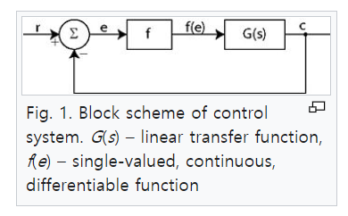
%%% kalman’s conjecture [3]
Consider a system with one scalar nonlinearity
$$\frac{dx}{dt}=Px+qf\left(e\right), e=r^{T}s , x∈R^{n}$$
Where
P is a stable matrix, $q, r$ constants with appropriate dimemsion, $f(e)$ is a scalar, $f\left(0\right)=0$
Suppose
$$k_{1}<\frac{df}{dt}<k_{2}$$
Then
$$x_{k}\left(t\right)=Px_{k}+qke, k∈(k_{1}, k_{2})$$
is stable
But there is a counter example to his conjecture.
- Aizerman’s Conjecture (before Kalman’s conjecture)
Suppose that the nonlinearity $f$ is sector bounded, meaning that for some real $k_{1}, k_{2}$ with $k_{1}<k_{2}$, the function satisfies
$$k_{1}<\frac{f\left(e\right)}{e}<k-2 , ∀e≠0.$$
However there are counter examples to Aizermans’ conjecture.
In general, eigenvalues of a matrix is not continuous(robust?) with respect to the variation of parameters.
However, in the frequency domain, bode plot is continuous w.r.t $ω$.(Bode plot is only in linear system until now) So in general to study the parameter variations we may deal it in the frequency domain.
%%%
- Block Diagram in MIMO
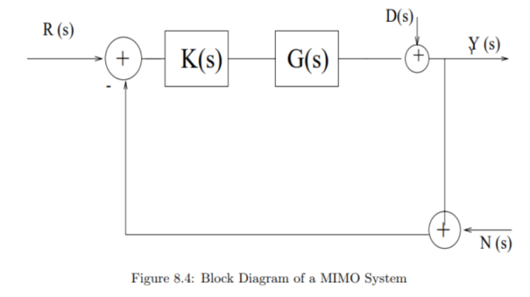

- Definition
- Sensitivity function , complementary function
$$S\left(s\right)={\left[I+G\left(s\right)K\left(s\right)\right]}^{-1} \\ T\left(s\right)= {\left[I+G\left(s\right)K\left(s\right)\right]}^{-1}G\left(s\right)K\left(s\right)$$
- The basic tool
Consider
$$Y \left(jω\right)=G\left(jω\right)U\left(jω\right)$$
Then
$$\underline{σ}\left(G\left(jω\right)\right){\left\|U\left(jω\right)\right\|}_{2}≤ {\left\|Y\left(jω\right)\right\|}_{2}≤ \overline{σ}(G\left(jω\right)){\left\|U\left(jω\right)\right\|}_{2}$$
- Control Objectives
  - Sensitivity of modelling
Let us assume
$$G\left(s\right)=G^{*}\left(s\right)+ ∆G$$
- Open loop system
$$∆Y = ∆G\left(s\right){\left[G^{*}\left(s\right)\right]}^{-1}Y\left(s\right)$$
- Closed loop system
$$∆Y = {\left[I+G\left(s\right)K\left(s\right)\right]}^{-1}∆G\left(s\right){\left[G^{*}\left(s\right)\right]}^{-1}Y\left(s\right)$$
- Closed loop system analysis
To small output variance due to the uncertainty
First
$S\left(s\right)= {\left[I +G\left(s\right)Y\left(s\right)\right]}^{-1}$ is small
- $\overline{σ}(S)$: to be small
- Since $\overline{σ}(A)=\frac{1}{\underline{σ}\left(A^{-1}\right)}$, $\underline{σ}\left(I+GK\right)$ is large
- Since $\underline{σ}\left(A\right)-1≤ \underline{σ}\left(I+A\right)≤ \underline{σ}(A)$ +1 , $\underline{σ}(GK)$ should be large
In conclusion :
$$\underline{σ}\left(GK\right)≥p\left(ω\right)$$
where $p(ω)$ , the desired level in the interest frequencies, is large in the low frequencies to ensure the little sensitivity in that frequency range.
  - Command following
- As in SISO case, assume $D=N=0$, then
$$Y\left(s\right)=T\left(s\right)R(s)$$
- To follow the command, $T\left(s\right) \sim \sim 1$
- $T\left(s\right)+S(s)=I$, $S\left(s\right)$ is small
$$\underline{σ}\left(GK\right)≥p\left(ω\right)$$
  - Disturbance rejection
As in SISO case, $S\left(s\right)$ is small, implies
$$\underline{σ}\left(GK\right)≥p\left(ω\right)$$
  - Noise attenuation
As in the case of SISO, $T(s)$ is small
- $\overline{σ}\left(T\right)≤ \overline{σ}\left(S\right)\overline{σ}\left(GK\right)==> \overline{σ}(GK)/(\underline{σ}\left(I+GK\right)$

[1] Brunton, “Data-Drive Science and Engineering”.Chapter 8.8
[2] S. Skogestad and I. Postlethwaite. Multivariable Feedback Control. Wiley, Chichester, 1996.
[3] https://en.wikipedia.org/wiki/Kalman%27s_conjecture

